COMP5047 Coursework

Task 2: Quality requirements for the tenant configuration system

For the Platform Operator, the functional requirement I will be analysing the quality requirements for is the tenant isolation and configuration. This function would allow the platform operator to configure a client’s system to their needs based on their tenants needs, and their university branding.

Security and Privacy
- The configuration system should only be able to be accessed by the platform operator
- Only able to be viewed and edited by registered users
- Users assigned role based permissions such as the accommodation office staff, so they can perform their duties based on the configuration
- Any high level edits to the configuration can be requested by those without permissions in the system

Performance
For the configuration of the client system, it should be able to be able to respond to changes and update the system within 5-10 seconds, depending on the scale of the changes and the quality of the connection the platform operator has with the UniDorm and client servers.
- Configuration system must respond to the users inputs and changes in 5-10 seconds, depending on internet connection quality
- Changes made must be uploaded to the server within 10 seconds and distributed to the associated client servers

Reliability
- There must be no more than 5-6 failures within a year of operation of the configuration system, and it should be able to operate continuously
- If there is a failure in the system, it should be down for no longer than 12 working hours
- The system should not be out of operation for greater than 200 working hours for maintenance or other server side technical issues.

Scalability
The client configuration system should be able to be used by up to 100 operators at any given time on UniDorm servers, and should be able to configure additional users without any architectural changes to the system or editing any of the system software.
- the configuration system should be able to be used by over 100 operators at any given time
- the system should be able to configure a scalable amount of users and university clients

Task 3a: Use Case Model

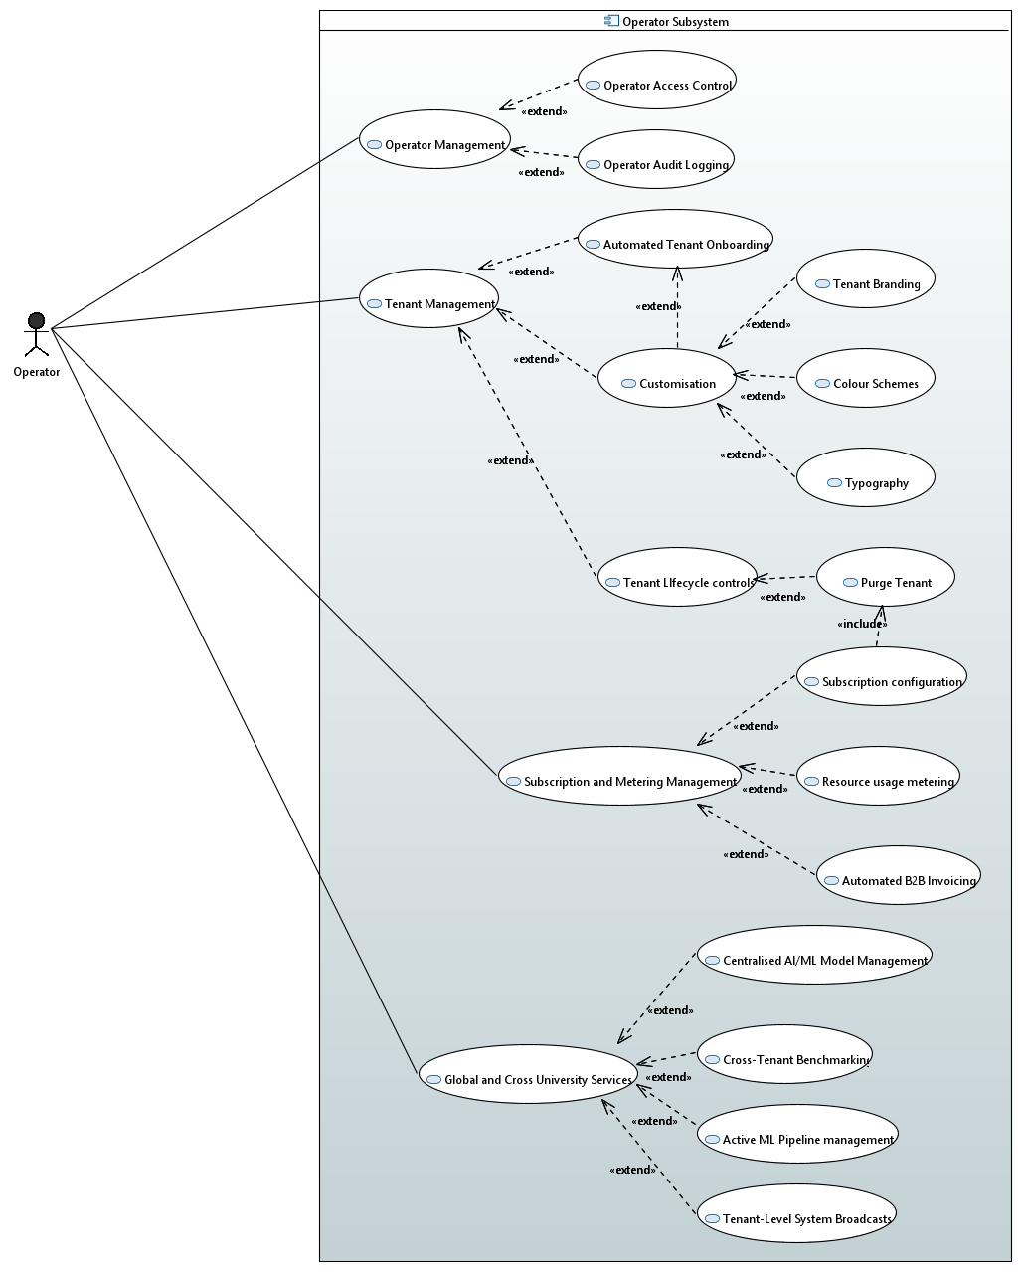

Task 3b: Activity Diagram
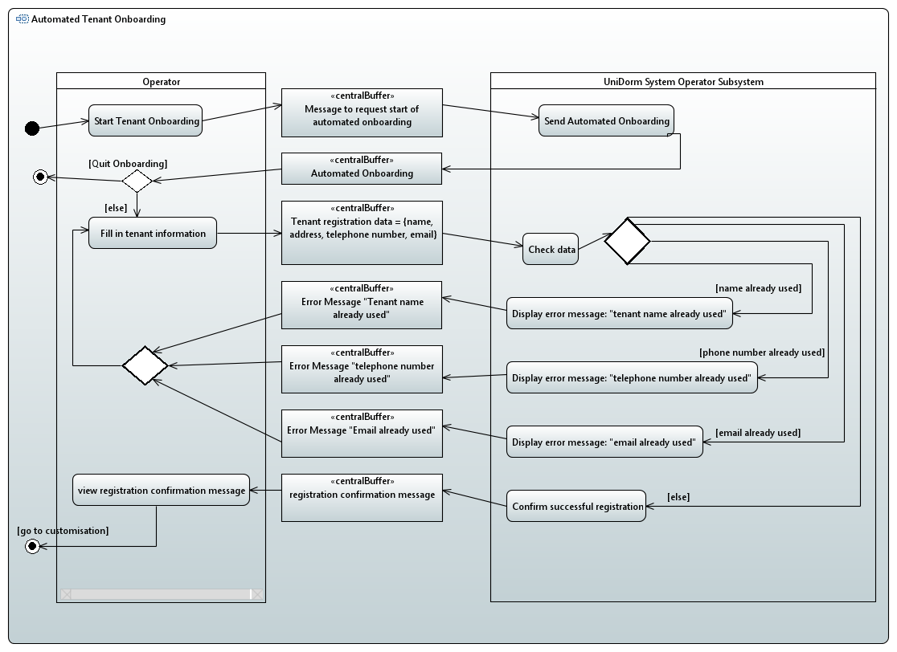

References
Zhu, H. (2026). Comp5047 Applied Software Engineering: Case Study for Coursework - UniDorm Functional Requirements, Version 1.0, Oxford Brookes University

