

HUMAN COMPUTER INTERACTION I

Presented to the
College of Information Technology



In Fulfillment
of the Requirements for the Course
IT 115 - Human Computer Interaction I

Submitted By:

Padilla, Niel E.
BSIT 2E

May 2026

- Source code (HTML, CSS, and optional JavaScript)
- Screenshots of the redesigned interface

- Written answers for:
- HCI Principles Applied
- User Flow

CORLEONE APP HUB FINAL REQUIREMENT
1. Source Code (HTML, CSS, optional JavaScript)
Below are selected source code parts from the Corleone App Hub redesigned interface. These show the main HTML structure, CSS styling, and optional JavaScript behavior used in the system.
HTML / Blade: Home Access Flow
<section class="hero-text">
<h1>Your secure access, all in one place.</h1>
<p>OTP login, validation, mailbox, and AI assistance in one clean SaaS-style workspace.</p>
</section>
<a class="feature-card primary-feature" href="{{ route('otp.phone') }}">
<span>Phone OTP</span>
<strong>Send verification code</strong>
<small>We will send a code to your mobile number.</small>
</a>
HTML / Blade: OTP Verification
<form method="POST" action="{{ route('otp.verify.submit') }}" data-server-otp="true">
@csrf
<div class="otp-box" aria-label="One-time password">
<input maxlength="1" name="otp_digits[]" class="otp" inputmode="numeric" aria-label="OTP digit 1">
<input maxlength="1" name="otp_digits[]" class="otp" inputmode="numeric" aria-label="OTP digit 2">
<input maxlength="1" name="otp_digits[]" class="otp" inputmode="numeric" aria-label="OTP digit 3">
<input maxlength="1" name="otp_digits[]" class="otp" inputmode="numeric" aria-label="OTP digit 4">
<input maxlength="1" name="otp_digits[]" class="otp" inputmode="numeric" aria-label="OTP digit 5">
<input maxlength="1" name="otp_digits[]" class="otp" inputmode="numeric" aria-label="OTP digit 6">
</div>
<button class="btn primary" type="submit">Verify OTP</button>
</form>
HTML / Blade: Mailbox Dashboard
<header class="topbar">
<div>
<h2 id="mailTitle">Inbox</h2>
<small><span>Corleone App Hub</span> / <span id="userEmail">Verified User</span></small>
</div>
<div class="topbar-actions">
<input id="searchMail" placeholder="Search mail..." onkeyup="filterMail()">
<button class="btn compact primary" type="button" onclick="openCompose()">Compose</button>
<a class="btn compact light" href="{{ route('ai-chatbot') }}">AI Chatbot</a>
</div>
</header>
CSS: Main Interface Styling
.hero-shell {
min-height: 100vh;
display: grid;
grid-template-columns: 1fr minmax(360px, 560px);
gap: 48px;
}
.card {
border-radius: 8px;
background: rgba(10, 18, 32, 0.84);
border: 1px solid rgba(96, 165, 250, 0.35);
}
.otp-box {
display: grid;
grid-template-columns: repeat(6, 1fr);
gap: 10px;
}
Optional JavaScript: OTP Input Behavior
function getOtpCode(inputs = document.querySelectorAll(".otp")) {
return Array.from(inputs).map((input) => input.value).join("");
}
document.querySelectorAll(".otp").forEach((input, index, inputs) => {
input.addEventListener("input", () => {
if (input.value && index < inputs.length - 1) {
inputs[index + 1].focus();
}
});
});
2. Screenshots of the Redesigned Interface
The screenshots below show the redesigned Corleone App Hub interface.
Home Access Screen
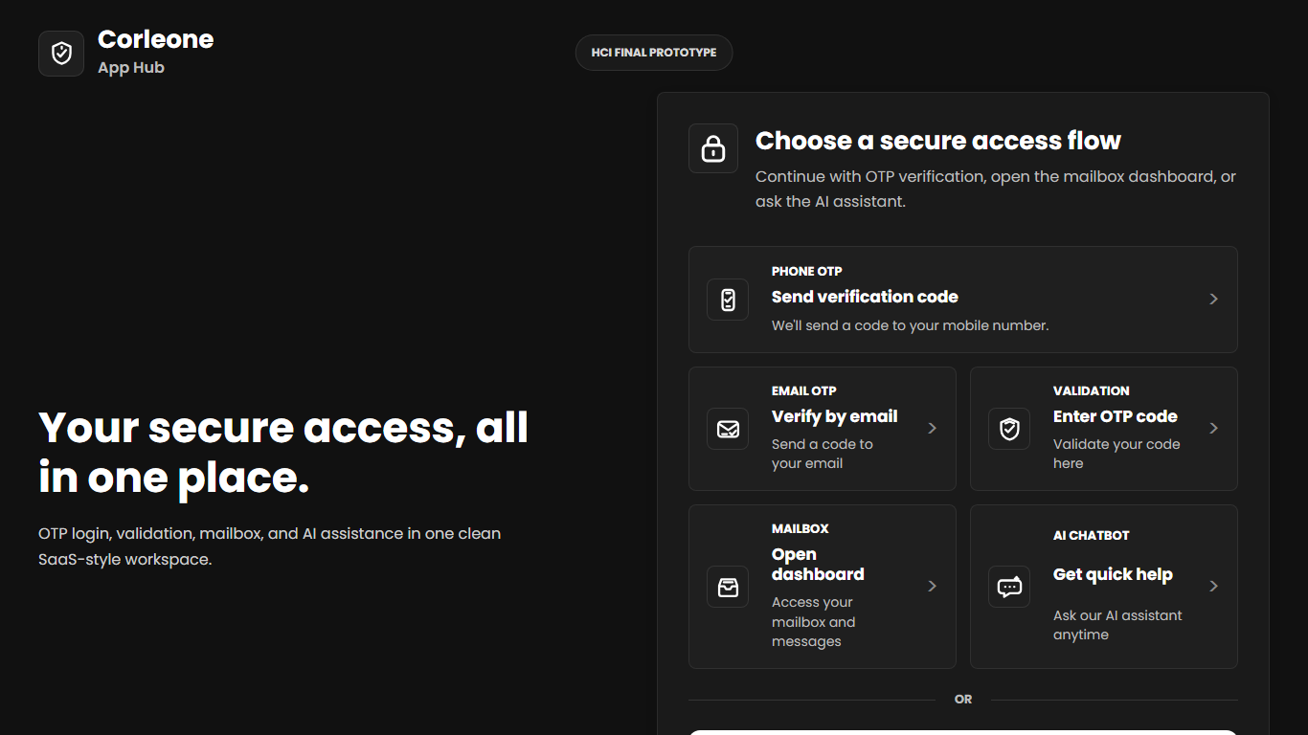
Email OTP Screen
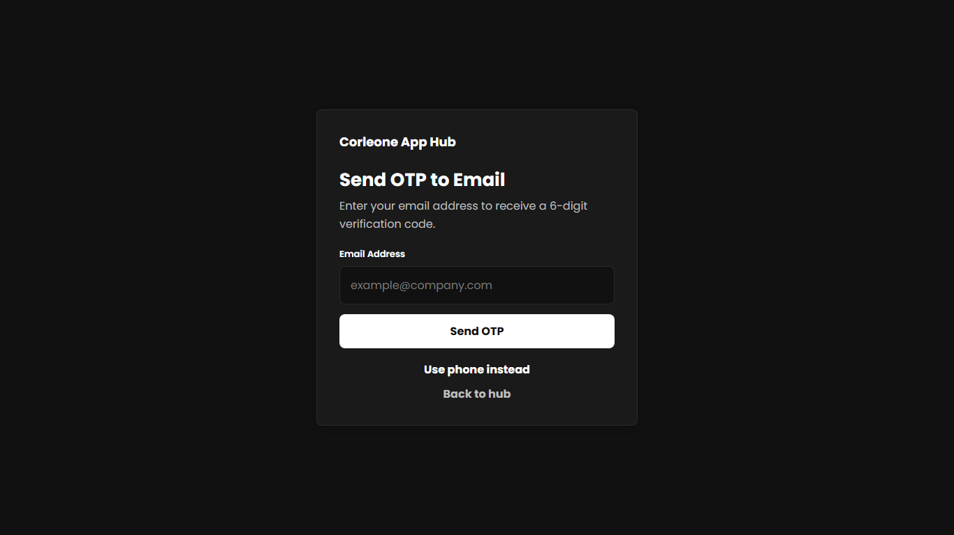
OTP Verification Screen
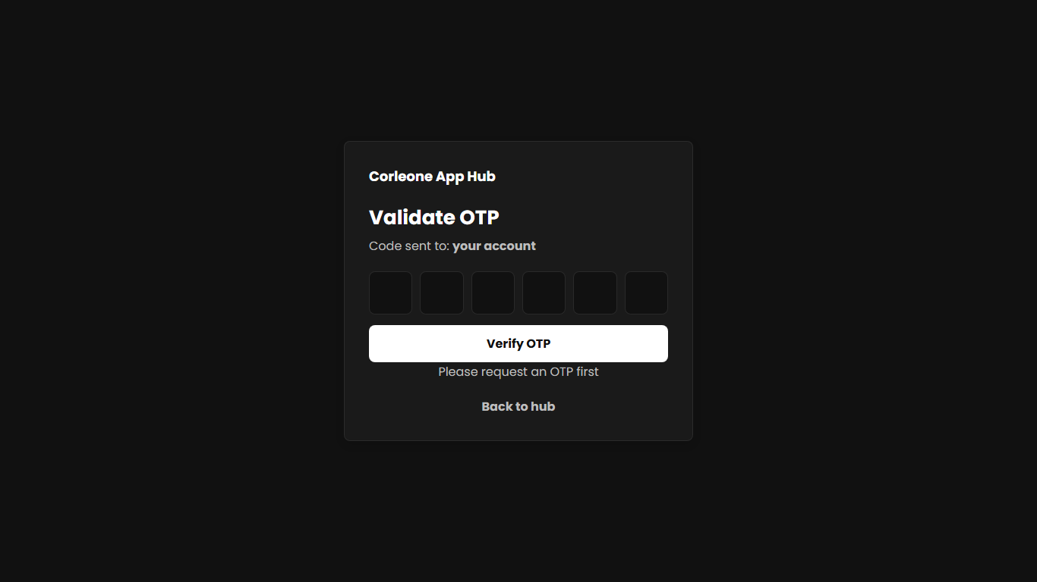
AI Chatbot Screen
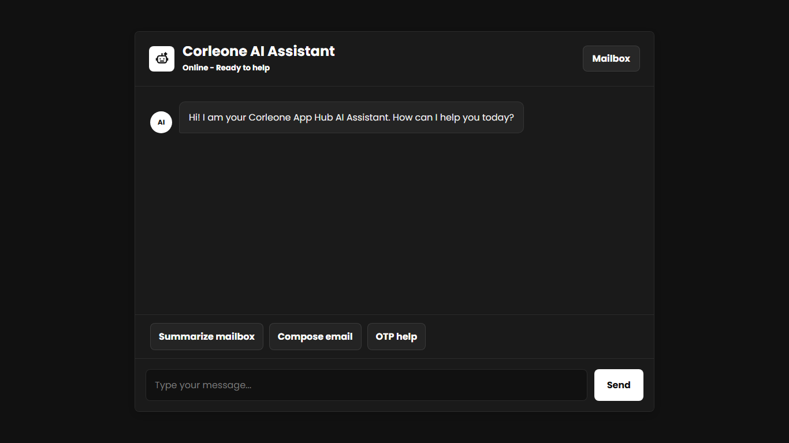
3. Written Answers
HCI Principles Applied
Visibility of system status: The system shows clear messages when OTP is sent, when validation is needed, and when the OTP is wrong.
Consistency: The pages use the same buttons, cards, labels, colors, and layout style. This helps users understand each screen faster.
Error prevention: Forms validate email, phone number, password, and OTP input. The OTP screen uses six separate boxes to guide the user.
Recognition rather than recall: The interface uses familiar labels like Phone OTP, Email OTP, Mailbox, Compose, Search, and Logout.
User control and freedom: Users can choose phone OTP or email OTP, go back to the hub, open the AI Chatbot, and log out.
Privacy and security: The OTP is not displayed on the screen. It is sent through SMS or email and stored only in the session.
User Flow
1. The user opens the Corleone App Hub home page.
2. The user chooses a secure access option such as Phone OTP, Email OTP, OTP Validation, Mailbox, or AI Chatbot.
3. The user enters a phone number or email address to request an OTP.
4. Phone OTP is sent using the Repohive SMS API. Email OTP is sent using Gmail SMTP through Laravel Mail.
5. The user enters the 6-digit OTP on the validation screen.
6. If the OTP is correct, the user is redirected to the Mailbox dashboard.
7. If the OTP is wrong, the system shows an error message and lets the user try again.
8. Inside the Mailbox, the user can view messages, search mail, compose a sample email, open the AI Chatbot, or log out.

