Backbone comparison for dish recognition
The dish-recognition model was trained three times with the same data, the same split and the same training procedure; only the backbone network changed. The three candidates are lightweight networks that can run on a phone: MobileNetV3-Large, EfficientNetB0 and EfficientNetV2-B0. MobileNetV3-Large was trained twice, once by each team member, to measure how much the result varies between independent runs.

Experimental setup
Table 1: Settings shared by all training runs
Item | Setting
Data | Four public datasets: VietFood67 (29,595 photos used), VinaFood21 (12,713), 30VNFoods (10,801), 20FoodVN (2,142)
Outputs | 52 dishes plus the class “khac” (food the app does not know); 25 components (model contract 1.3)
Split | 70/15/15 per dish with a fixed seed: 38,677 training, 8,287 validation and 8,287 test photos; duplicates across datasets removed with an 8×8 average hash
Input | 224×224 RGB; each photo shrunk once to a 384-pixel short side
Augmentation | Random square crop of 60–100% of the short side, horizontal flip, brightness ±20, contrast 0.85–1.15
Training | Phase 1: backbone frozen, 5 epochs, Adam 1e-3. Phase 2: top 40% of backbone layers unfrozen with batch normalisation kept frozen, 15 epochs, Adam 1e-4. Batch size 64, dropout 0.2
Loss | Cross-entropy for the dish; masked binary cross-entropy for components, so photos without component labels add no component loss
Hardware | Google Colab, one NVIDIA T4 GPU
Selection rule | Highest validation top-1; runs within 0.5 percentage points count as equal and the smaller model wins. The test set is reported only.

Results
Table 2 lists the full training runs. EfficientNetB0 reached the highest validation top-1 accuracy (69.0%) and also the best test top-1 (68.8%) and top-3 (83.9%) accuracy. EfficientNetV2-B0 was 0.5 points behind on validation, with a 3.7 MB larger file and a slower run time. MobileNetV3-Large was 1.1 points behind, but it is the smallest model and runs about twice as fast.
Table 2: Results of the full training runs
Backbone | Member | Val top-1 (%) | Test top-1 (%) | Test top-3 (%) | Component F1 | Params (M) | TFLite (MB) | CPU (ms) | Train (min)
EfficientNetB0 | B | 69.0 | 68.8 | 83.9 | 0.497 | 4.15 | 8.33 | 21.9 | 55
EfficientNetV2-B0 | B | 68.5 | 68.5 | 83.1 | 0.504 | 6.02 | 12.03 | 27.8 | 53
MobileNetV3-Large | A | 67.8 | 67.4 | 82.5 | 0.482 | 3.07 | 6.19 | 11.4 | 45
MobileNetV3-Large | B | 67.7 | 67.1 | 82.2 | 0.482 | 3.07 | 6.19 | 8.3 | 53
Member A and member B are the two team members who trained the runs. CPU time is the time to run one photo through the float16 TFLite model on the Colab machine’s CPU. It only compares the backbones with each other; times on a phone are different.
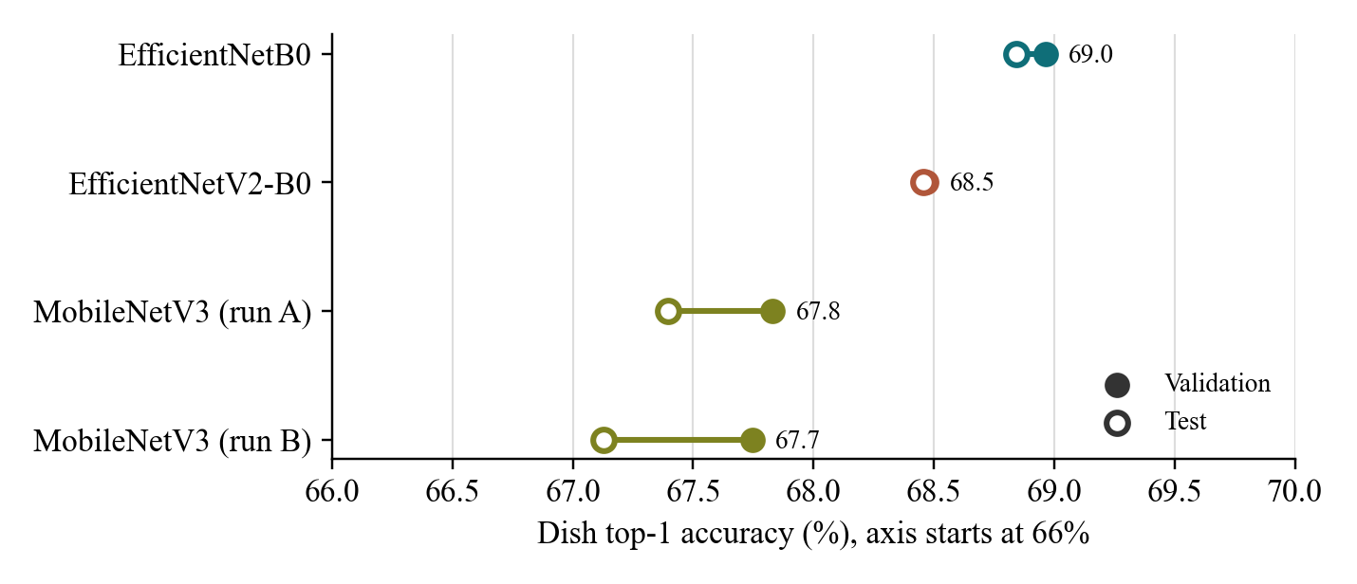
Figure 1: Validation and test top-1 accuracy of each run
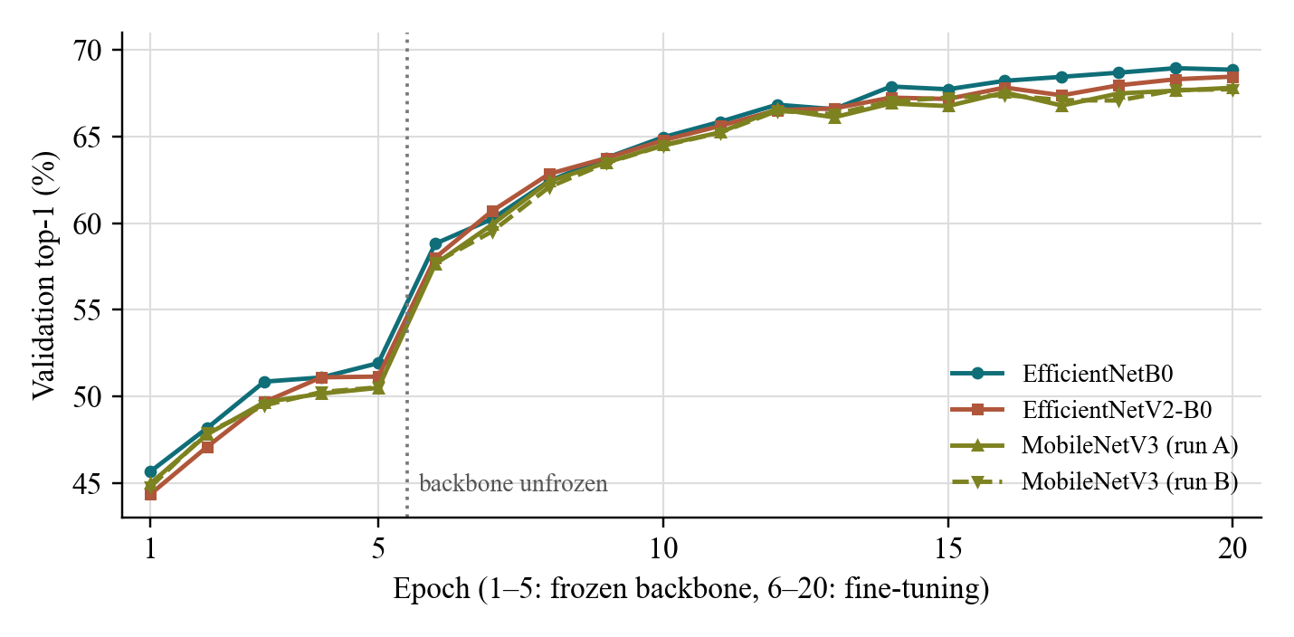
Figure 2: Validation top-1 accuracy per epoch
All runs follow the same pattern (Figure 2): accuracy rises slowly while the backbone is frozen, jumps when its top layers are unfrozen, and levels off after about epoch 15. No run stopped early.
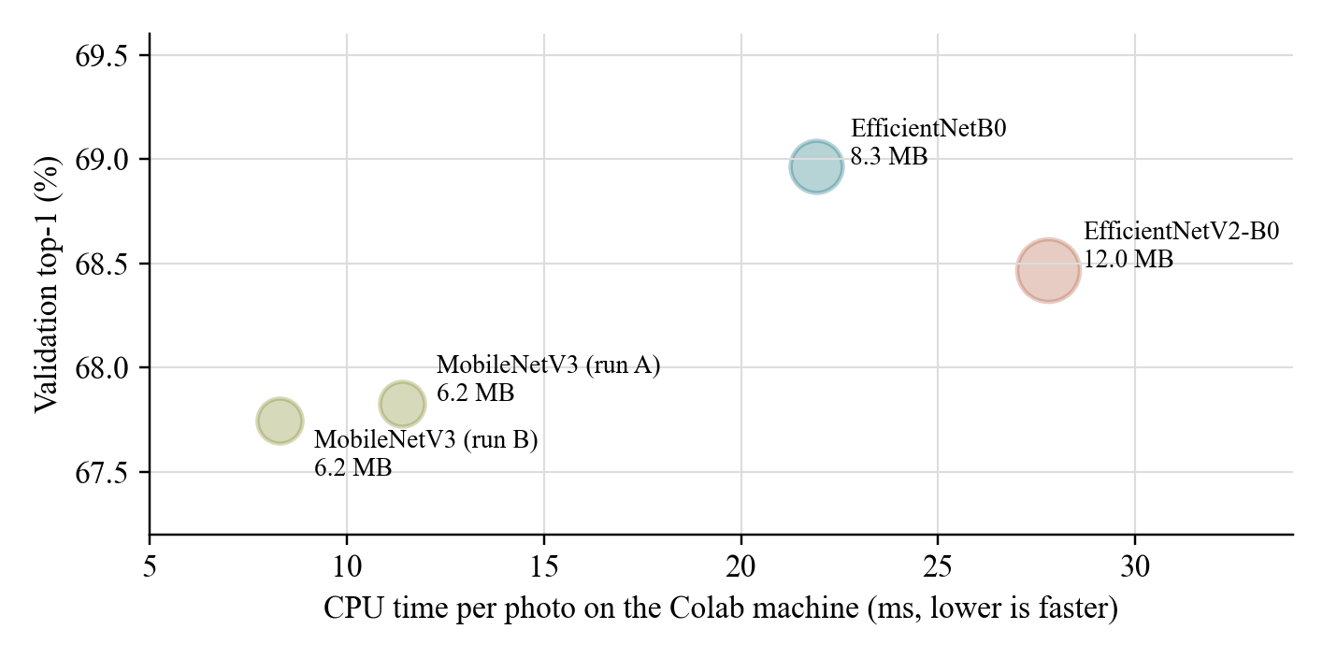
Figure 3: Accuracy against CPU time; the bubble size follows the TFLite file size

Stability between runs
The two independent MobileNetV3-Large runs differ by only 0.1 percentage points on validation and 0.3 on test. The 1.1-point gap between EfficientNetB0 and MobileNetV3-Large is therefore much larger than the variation between runs, and is unlikely to come from training noise.

Per-dish analysis
EfficientNetB0 improves most on noodle dishes that look alike, such as bún chả and hủ tiếu. It is weaker on cơm phần, a key home-cooked dish for the app (Tables 3 and 4).
Table 3: Dishes where EfficientNetB0 gains most over MobileNetV3-Large (test top-1, %)
Dish | MobileNetV3 | EfficientNetB0 | Change
Bún chả | 52.9 | 66.7 | +13.8
Hủ tiếu | 45.8 | 58.2 | +12.4
Xôi | 47.6 | 58.2 | +10.6
Bún riêu | 44.4 | 54.2 | +9.8
Bánh khọt | 61.3 | 71.1 | +9.8
Cơm chiên | 56.4 | 65.3 | +8.9

Table 4: Dishes where EfficientNetB0 loses most against MobileNetV3-Large (test top-1, %)
Dish | MobileNetV3 | EfficientNetB0 | Change
Cơm phần | 46.7 | 35.1 | −11.6
Hoành thánh nước | 78.7 | 69.3 | −9.4
Bún bò Huế | 64.9 | 57.3 | −7.6
Bánh ướt | 72.4 | 64.9 | −7.5
Bò kho | 60.9 | 53.8 | −7.1
Cao lầu | 65.8 | 60.4 | −5.4

Table 5 gives the test top-1 accuracy of every output class, sorted from the weakest to the strongest for EfficientNetB0. Cơm gà, phở gà and cháo gà do not appear because no public dataset contains them; they need the team’s own photos.
Table 5: Test top-1 accuracy per class (%); bold marks the best backbone for each class
Dish | EfficientNetB0 | EfficientNetV2-B0 | MobileNetV3 | B0 − MNv3
Cơm phần | 35.1 | 46.7 | 46.7 | −11.6
Khác (other, not in the app) | 39.3 | 37.3 | 39.3 | 0.0
Bún mắm | 43.6 | 52.4 | 47.6 | −4.0
Bánh canh | 47.1 | 49.8 | 44.4 | +2.7
Bò kho | 53.8 | 55.6 | 60.9 | −7.1
Bún riêu | 54.2 | 35.1 | 44.4 | +9.8
Bún bò Huế | 57.3 | 52.4 | 64.9 | −7.6
Hủ tiếu | 58.2 | 44.9 | 45.8 | +12.4
Xôi | 58.2 | 55.1 | 47.6 | +10.6
Cơm tấm | 60.0 | 69.3 | 63.1 | −3.1
Cao lầu | 60.4 | 73.3 | 65.8 | −5.4
Cà ri gà | 63.0 | 63.0 | 66.7 | −3.7
Bánh ướt | 64.9 | 64.9 | 72.4 | −7.5
Cơm chiên | 65.3 | 69.8 | 56.4 | +8.9
Mì Quảng | 65.3 | 65.8 | 64.0 | +1.3
Bánh cuốn | 66.2 | 63.6 | 64.9 | +1.3
Bún chả | 66.7 | 56.9 | 52.9 | +13.8
Bánh chưng | 66.7 | 64.9 | 62.2 | +4.5
Hoành thánh nước | 69.3 | 77.3 | 78.7 | −9.4
Cháo lòng | 69.3 | 68.4 | 72.0 | −2.7
Bánh mì | 69.8 | 73.8 | 68.0 | +1.8
Bánh xèo | 70.7 | 63.6 | 62.2 | +8.5
Bánh khọt | 71.1 | 68.9 | 61.3 | +9.8
Bánh bèo | 75.1 | 75.1 | 80.0 | −4.9
Bún đậu mắm tôm | 75.1 | 75.1 | 74.7 | +0.4
Bánh tráng trộn | 77.8 | 76.4 | 74.7 | +3.1
Bò lá lốt | 80.0 | 76.0 | 73.8 | +6.2
Phá lấu | 81.1 | 88.3 | 85.6 | −4.5
Bột chiên | 82.0 | 79.8 | 82.0 | 0.0
Cá kho | 82.0 | 86.9 | 85.2 | −3.2
Gà nướng | 83.2 | 86.6 | 80.7 | +2.5
Phở bò | 83.3 | 83.3 | 83.3 | 0.0
Trứng vịt lộn | 84.0 | 84.0 | 80.0 | +4.0
Chè | 85.4 | 90.2 | 82.9 | +2.5
Gỏi cuốn | 85.8 | 84.4 | 84.4 | +1.4
Thịt kho trứng | 86.3 | 94.1 | 82.4 | +3.9
Gỏi gà | 86.8 | 76.9 | 79.1 | +7.7
Canh khổ qua | 86.8 | 87.7 | 81.6 | +5.2
Canh khoai mỡ | 88.1 | 94.9 | 89.8 | −1.7
Nước mía | 88.2 | 94.1 | 88.2 | 0.0
Há cảo | 89.2 | 88.5 | 91.2 | −2.0
Canh chua | 89.3 | 83.6 | 83.6 | +5.7
Bún thịt nướng | 89.8 | 88.3 | 85.4 | +4.4
Bánh hỏi | 89.9 | 86.7 | 92.0 | −2.1
Bánh căn | 90.2 | 92.3 | 90.2 | 0.0
Bánh ú | 90.9 | 89.1 | 87.3 | +3.6
Bánh tét | 91.9 | 93.0 | 90.3 | +1.6
Tàu hũ nước đường | 93.2 | 88.1 | 84.7 | +8.5
Bắp nướng | 93.3 | 97.8 | 91.1 | +2.2
Bánh mì chảo | 96.7 | 91.2 | 96.7 | 0.0

Decision and limitations
EfficientNetB0 was selected and ships in the app because it has the highest validation top-1 accuracy under the selection rule agreed before training. The comparison has these limitations:
- The test set contains only public-dataset photos. The model contract asks for at least 30% of test photos taken by the team; accuracy on phone photos may be lower.
- Only VietFood67 photos carry component labels, so the component F1 of all three backbones is about 0.48–0.50 and the tuned tick threshold fell to the lowest value tried (0.3). The app therefore uses component outputs only for dishes the model card lists.
- The “khac” class reaches only 37–39% for every backbone, because it groups many very different dishes.
- EfficientNetB0 is weaker on cơm phần (35.1% against 46.7% for MobileNetV3-Large).
- Each EfficientNet backbone was trained once, so no confidence interval is available per backbone; the two MobileNetV3-Large runs give the only estimate of run-to-run variation.

