Cannot use import statement outside a module

Admin@Admins MINGW64 /e/Wampjune/www/ThapaTechnical/NodeJS/13

$ node index.js

(node:10844) Warning: To load an ES module, set "type": "module" in the package.json or use the .mjs extension.

(Use `node --trace-warnings ...` to show where the warning was created)

E:\Wampjune\www\ThapaTechnical\NodeJS\13\index.js:1

import chalk from "./node_modules/chalk/source/index";

^^^^^^

SyntaxError: Cannot use import statement outside a module

at Object.compileFunction (node:vm:352:18)

at wrapSafe (node:internal/modules/cjs/loader:1033:15)

at Module._compile (node:internal/modules/cjs/loader:1069:27)

at Object.Module._extensions..js (node:internal/modules/cjs/loader:1159:10)

at Module.load (node:internal/modules/cjs/loader:981:32)

at Function.Module._load (node:internal/modules/cjs/loader:822:12)

at Function.executeUserEntryPoint [as runMain] (node:internal/modules/run_main:77:12)

at node:internal/main/run_main_module:17:47

at Object.Module._extensions..js (node:internal/modules/cjs/loader:1159:10)

at Module.load (node:internal/modules/cjs/loader:981:32)

at Function.Module._load (node:internal/modules/cjs/loader:822:12)

at Function.executeUserEntryPoint [as runMain] (node:internal/modules/run_main:77:12)

at node:internal/main/run_main_module:17:47

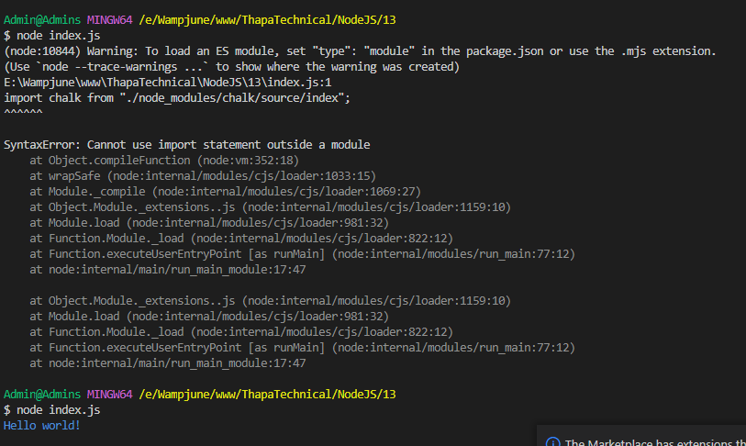

https://stackoverflow.com/questions/58384179/syntaxerror-cannot-use-import-statement-outside-a-module

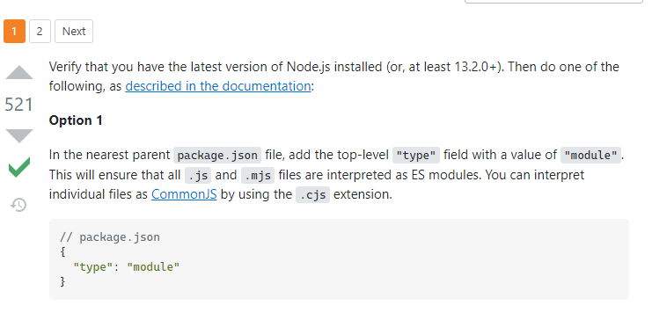

  "license": "ISC",

  "dependencies": {

    "chalk": "^5.0.1"

  },

  "type":"module"

}

