GEOSENSE AGENT
PHASE III — EXERCISE 5
LiDAR Terrain Analysis and Unified Site Profiling
Study area: Autzen Stadium / Eugene, Oregon, USA
Report generated: 14 October 2026
Technical Practical Report

Abstract
This report documents a Python-based LiDAR and terrain-analysis workflow for the Autzen Stadium area of Eugene, Oregon. It covers classified LiDAR inspection, ground-point extraction, DEM generation, hillshade/slope/aspect derivation, terrain metrics, existing street-scene segmentation summaries, unified site profiles and automated testing. Results are exploratory. Street-scene predictions have not been validated against manually labelled reference data, and the imagery has not been spatially matched to the LiDAR. This report does not claim validated walkability, site suitability, canopy cover, impervious-surface area or building-height estimates.

1. Aim and Objectives
Aim: build and test a reproducible Python workflow combining LiDAR-derived terrain information and existing street-scene segmentation summaries in a unified site-profile reporting structure.
- Inspect original classified COPC/LAZ and extracted ground-point cloud.
- Create a DEM from ground points and derive hillshade, slope and aspect.
- Summarize raster metadata and terrain metrics in CSV/JSON outputs.
- Include existing street-scene segmentation outputs as exploratory context.
- Generate unified site profiles and run automated tests.

2. Study Area, Data and Software
The study area is around Autzen Stadium in Eugene, Oregon, USA. The LiDAR data use Oregon GIC Lambert horizontal coordinates (EPSG:2992) and NAVD88 height (EPSG:6360), with elevation values expressed in US survey feet. These values must not be interpreted as metres.

2.1 Input data
- Original classified LiDAR: data/lidar/raw/autzen-classified.copc.laz.
- Ground LiDAR: data/lidar/processed/autzen_ground.laz.
- DEM: data/lidar/processed/autzen_dem.tif.
- Terrain derivatives: autzen_hillshade.tif, autzen_slope.tif and autzen_aspect.tif.
- Five Mapillary street-scene images and existing segmentation summaries, masks and overlays.
- Profile and analysis outputs under outputs/reports/.

2.2 Software
Python 3.11, PDAL, GDAL utilities, Rasterio, NumPy, JSON/CSV modules, python-docx and pytest. PyTorch inference in the current environment is CPU-based; CUDA was unavailable.

3. Methodology
- Inspect original classified LiDAR point count, bounds and coordinate information.
- Extract ground-class points to a separate LAZ file using the PDAL pipeline.
- Create a DEM from ground points with nominal 3 ft by 3 ft pixels.
- Generate hillshade, slope and aspect rasters from the DEM using GDAL utilities.
- Inspect raster dimensions, CRS, NoData and summary statistics.
- Read existing street-scene segmentation summaries and overlays as contextual outputs.
- Generate terrain_metrics.csv and unified/enhanced site-profile JSON outputs.
- Run automated tests for the analyzer, bounding boxes, coordinate utilities, profiles and terrain indicators.

4. Results

4.1 LiDAR point clouds
The original classified point cloud contains 10,653,336 points. The extracted ground cloud contains 6,909,405 points, with elevations approximately 406.56–482.58 US survey feet. These counts describe the datasets and do not independently establish classification accuracy.
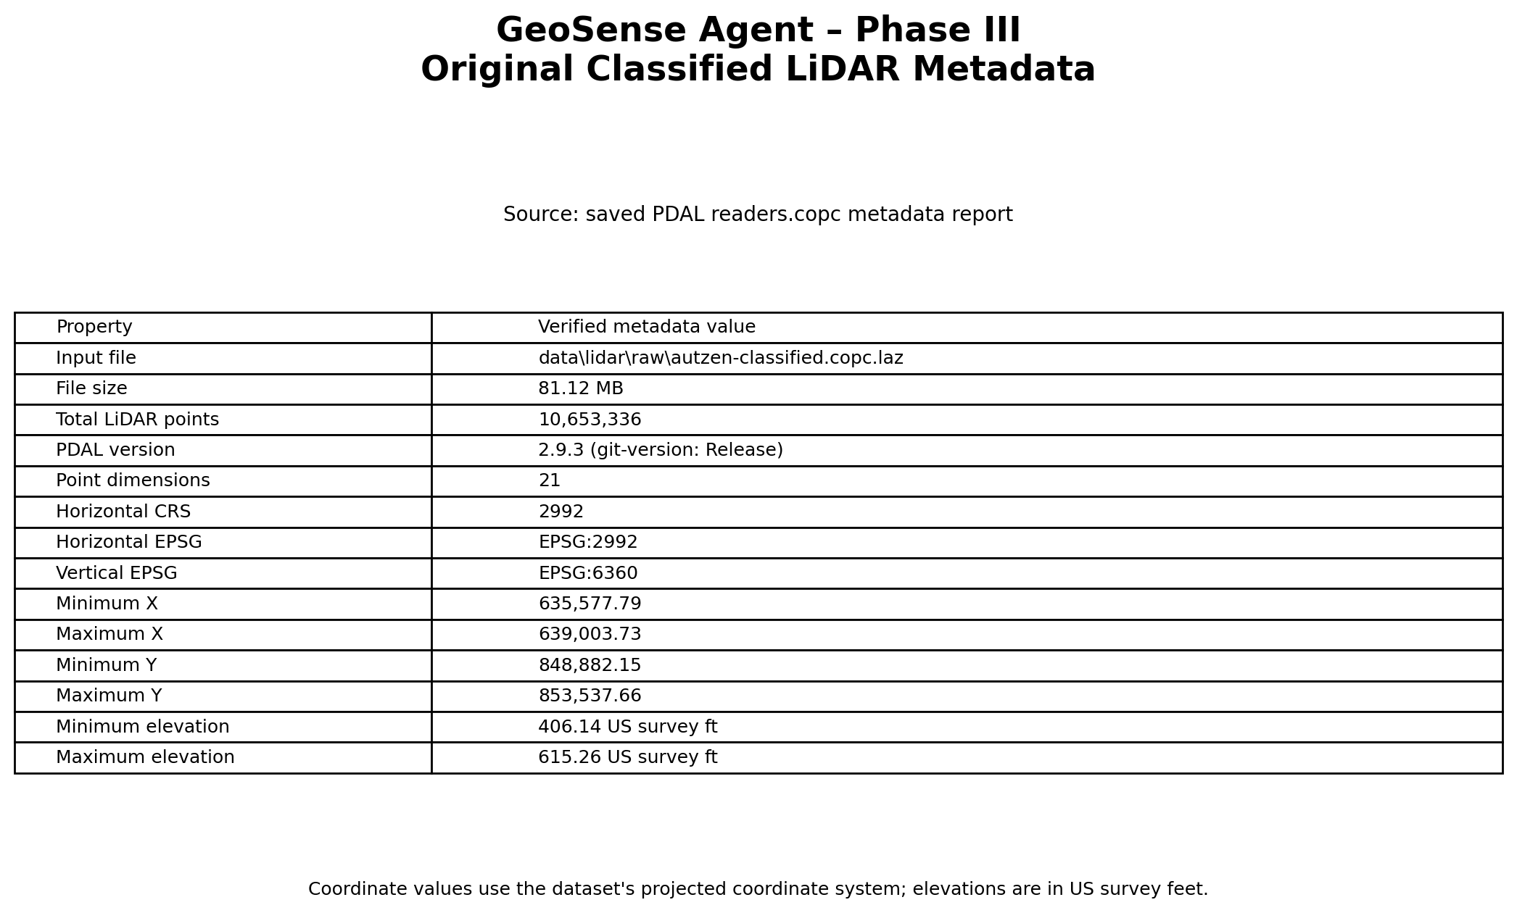
Figure 1. Summary of the original classified LiDAR point cloud.
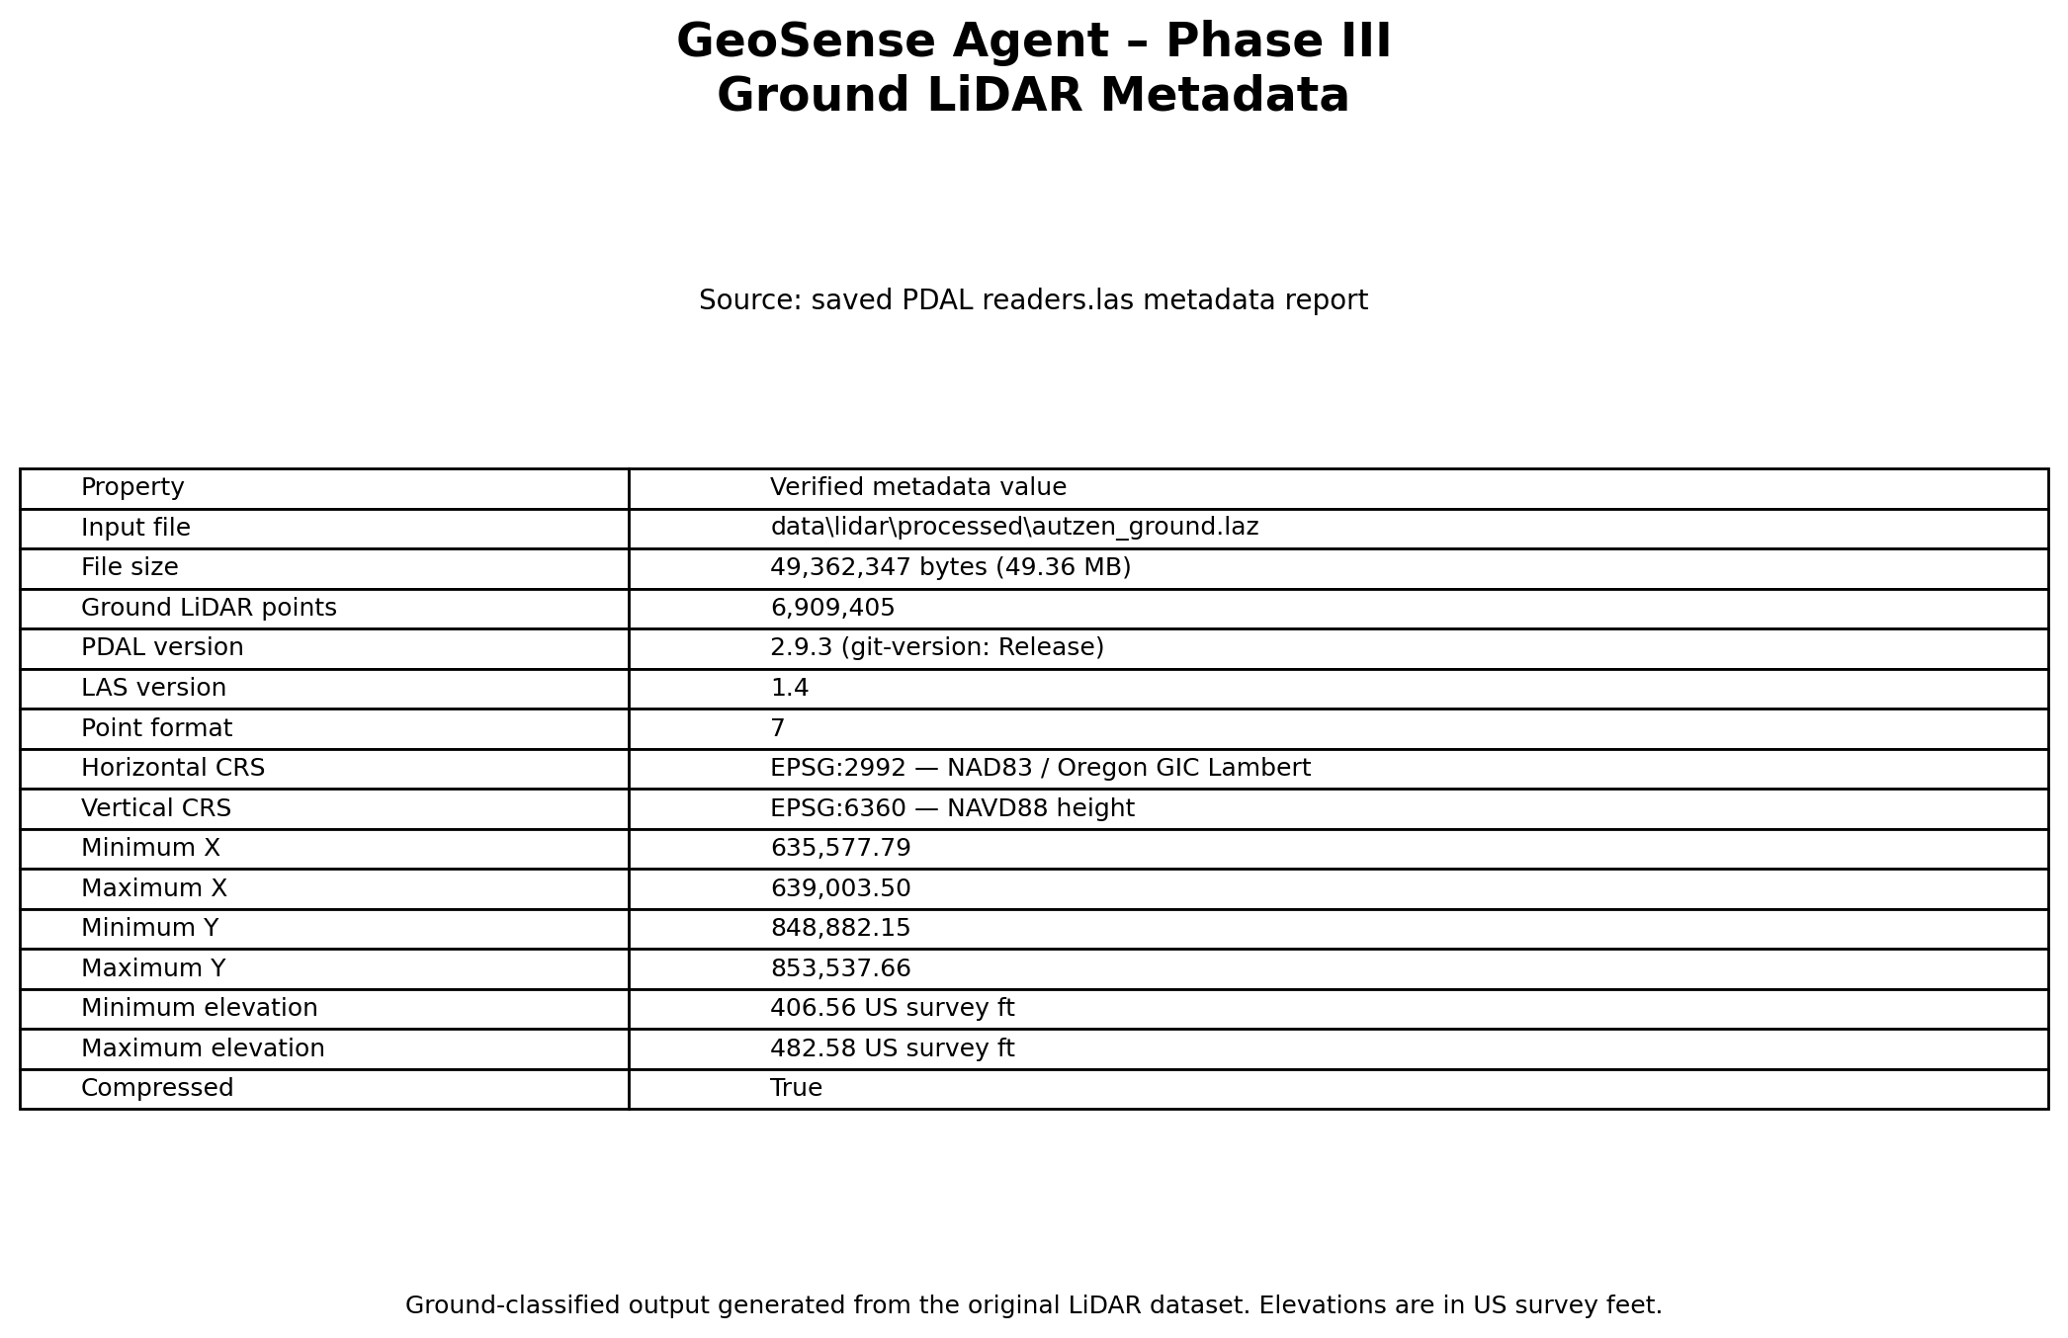
Figure 2. Summary of the extracted ground LiDAR point cloud.

4.2 DEM and terrain derivatives
The DEM is 1,143 columns by 1,553 rows with nominal 3 ft by 3 ft pixels. The latest GDAL metadata summary reports minimum elevation 406.9347 ft, maximum 482.19 ft, mean 423.3060 ft, standard deviation 7.2390 ft and 79.09% valid pixels. These statistics depend on the raster and its valid-data mask.
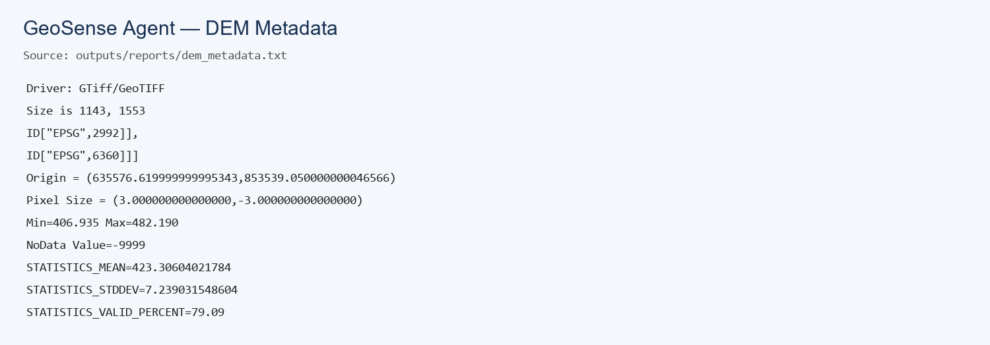
Figure 3. DEM metadata and summary statistics.
The mean slope is approximately 4.11 degrees. The arithmetic mean aspect is approximately 182.46 degrees; aspect is circular data, so its arithmetic mean is not necessarily a robust dominant direction.
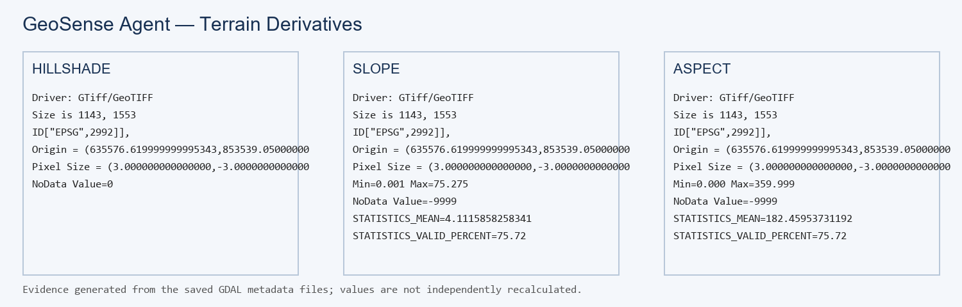
Figure 4. DEM-derived hillshade, slope and aspect products.

4.3 Street-scene segmentation
Five street-scene images and associated segmentation masks/overlays are available. They are exploratory context only: no manually labelled reference dataset or accuracy assessment is available, and the images are not spatially matched to the LiDAR.
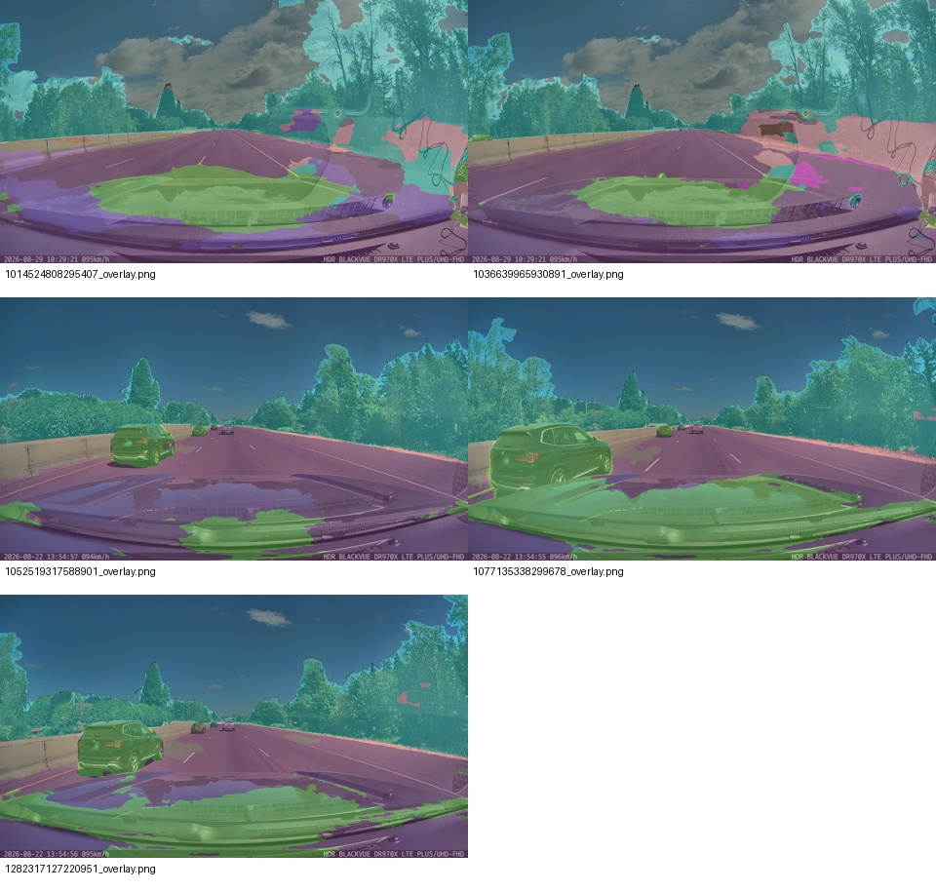
Figure 5. Contact sheet of existing street-scene segmentation outputs.

4.4 Analyzer, profiles and terrain metrics
Two 300 ft by 300 ft site-profile boxes were generated within the same general Autzen study area. They provide descriptive comparisons and are not proof of validated contrasting land-use settings.
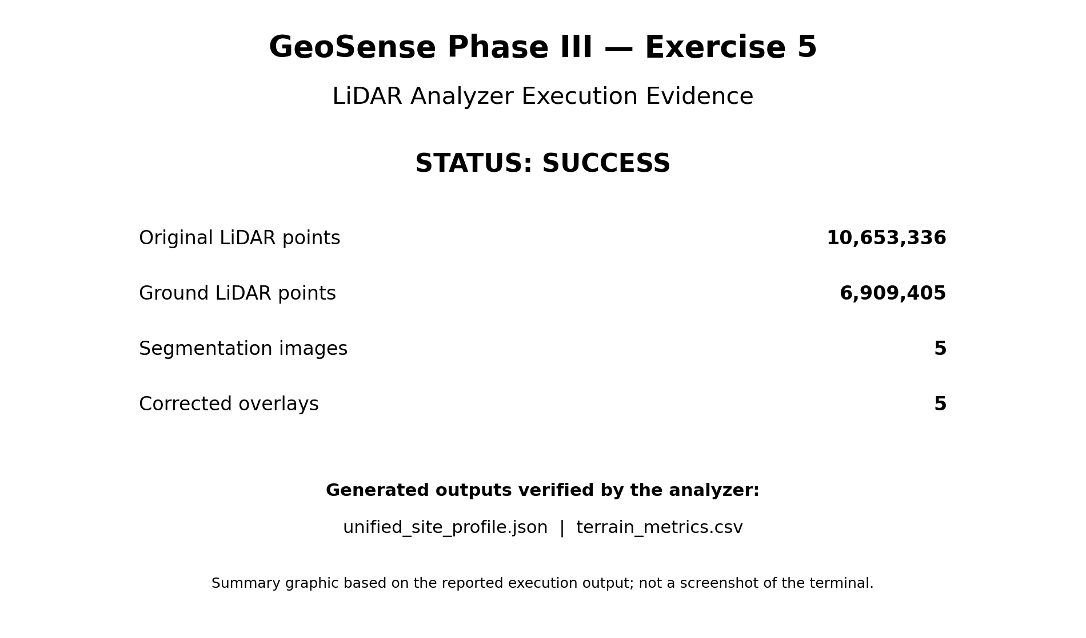
Figure 6. Evidence summary for the LiDAR analyzer.
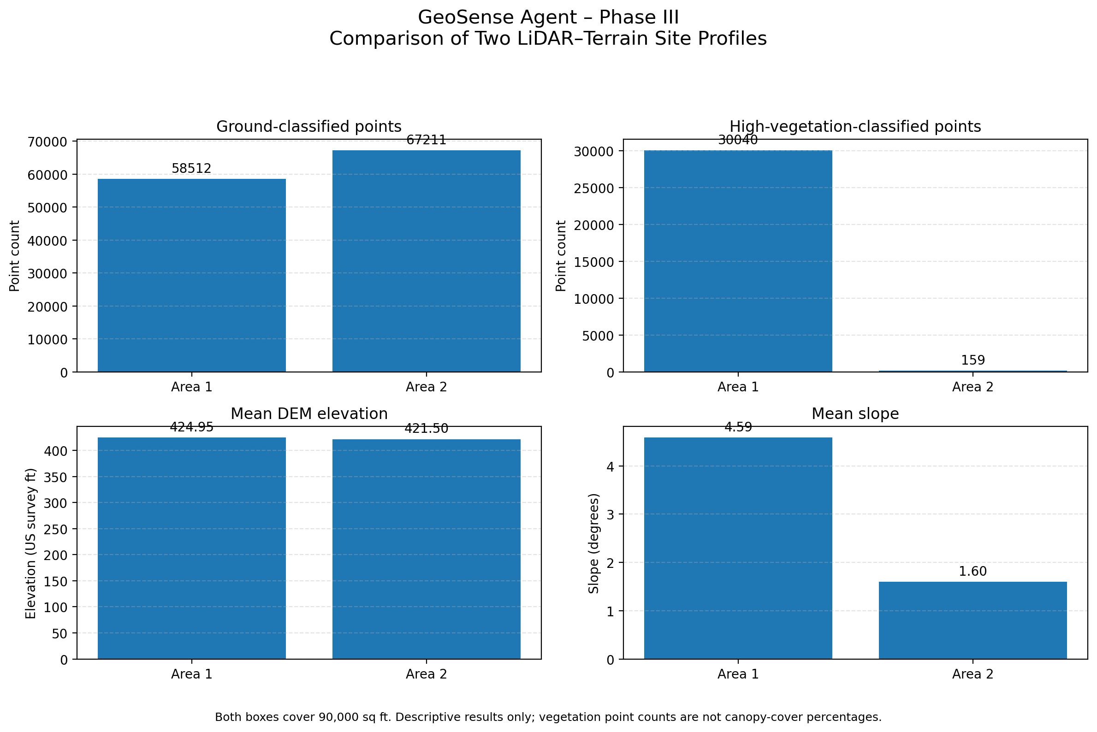
Figure 7. Descriptive comparison of the two Autzen-area profiles.
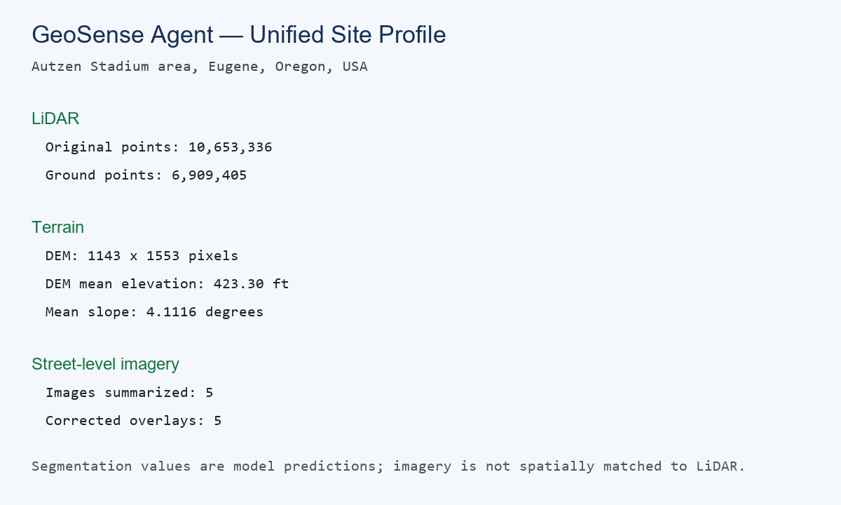
Figure 8. Summary of the unified site-profile JSON.
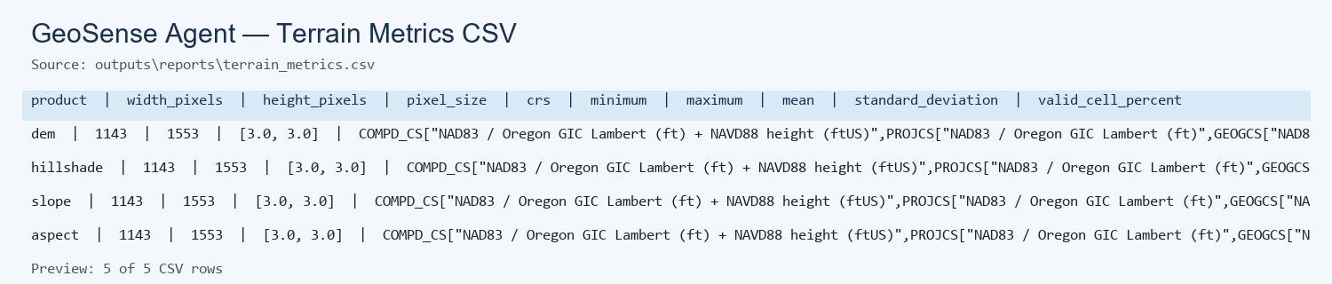
Figure 9. Preview of the terrain metrics CSV.

4.5 Automated testing
The latest saved test log reports 33 passed tests and 4 passed subtests in 19.09 seconds. This expanded test result supersedes the older 4/4 statement in the initial exercise notes. Passing tests cover code paths; they do not independently validate scientific accuracy.
tests/test_enhanced_profile.py::TestEnhancedProfile::test_unavailable_sources_are_disclosed PASSED [ 54%]
tests/test_lidar_analyzer.py::TestLidarAnalyzer::test_generated_json_profile PASSED [ 57%]
tests/test_lidar_analyzer.py::TestLidarAnalyzer::test_required_inputs_exist
tests/test_lidar_analyzer.py::TestLidarAnalyzer::test_required_inputs_exist PASSED [ 60%]
tests/test_lidar_analyzer.py::TestLidarAnalyzer::test_terrain_csv_exists PASSED [ 63%]
tests/test_lidar_analyzer.py::TestLidarAnalyzer::test_terrain_rasters_share_dimensions PASSED [ 66%]
tests/test_multiple_profiles.py::TestMultipleProfiles::test_both_profiles_exist PASSED [ 69%]
tests/test_multiple_profiles.py::TestMultipleProfiles::test_profile_index_lists_both_areas PASSED [ 72%]
tests/test_multiple_profiles.py::TestMultipleProfiles::test_profiles_have_different_bounds PASSED [ 75%]
tests/test_multiple_profiles.py::TestMultipleProfiles::test_profiles_have_independent_measurements PASSED [ 78%]
tests/test_slope_risk_indicator.py::TestSlopeRiskIndicator::test_indicator_discloses_limitations PASSED [ 81%]
tests/test_slope_risk_indicator.py::TestSlopeRiskIndicator::test_slope_class_percentages_sum_to_100 PASSED [ 84%]
tests/test_slope_risk_indicator.py::TestSlopeRiskIndicator::test_slope_classes_cover_all_valid_cells PASSED [ 87%]
tests/test_slope_risk_indicator.py::TestSlopeRiskIndicator::test_slope_summary_has_valid_values PASSED [ 90%]
tests/test_surface_metrics.py::TestSurfaceMetrics::test_area_and_point_density PASSED [ 93%]
tests/test_surface_metrics.py::TestSurfaceMetrics::test_invalid_bounds_are_rejected PASSED [ 96%]
tests/test_surface_metrics.py::TestSurfaceMetrics::test_point_density_is_not_cover_percentage PASSED [100%]
=================== 33 passed, 4 subtests passed in 19.09s ====================
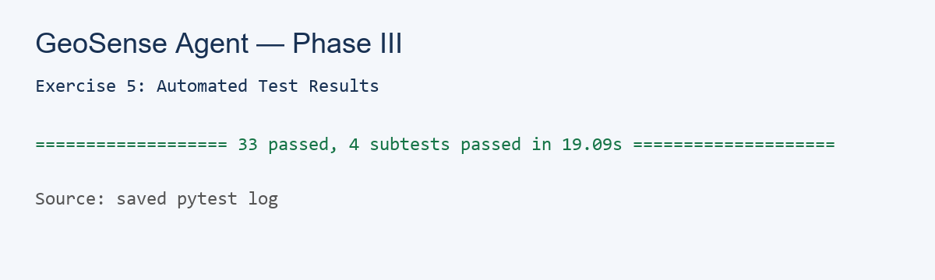
Figure 10. Evidence of the latest automated test run.

5. Additional Exploratory Indicators
- Class-5 vegetation occupancy is a grid occupancy proxy, not a validated canopy-cover percentage.
- Slope bins are descriptive terrain categories, not a validated hazard prediction.
- Building-height estimates are sensitive to the local-ground search radius and are exploratory, not reliable height measurements.
- Impervious surface cannot be reliably estimated because ground class 2 can include paved and unpaved ground.
- Phase I/II land-cover datasets were not available as inputs, so verified cross-phase land-cover fusion is not claimed.

6. Limitations
- Street imagery and LiDAR are not spatially matched at image-footprint level.
- Segmentation predictions have not been validated against manually labelled ground truth.
- No validated walkability or site-suitability model was produced.
- Vegetation occupancy is not canopy cover; available class labels do not support reliable impervious-surface estimation.
- Building-height estimates are exploratory and sensitive to the ground-neighbour search radius.
- The two profile boxes are within the same study area and are not proven representative or contrasting sites.
- Earlier notes contain slightly different DEM statistics from a prior raster summary. This report uses the latest stated GDAL values; differences can arise from statistics methods and NoData handling.
- If any figure is missing, the report records that it could not be inserted; check the local figure path.

7. Conclusion
Exercise 5 establishes a working, test-covered workflow for inspecting classified LiDAR, extracting ground points, deriving terrain rasters, summarizing metrics, creating JSON site profiles and incorporating existing street-scene segmentation outputs as exploratory context. The expanded test suite passed (33 tests and 4 subtests). Further work is needed before making scientific claims about canopy cover, impervious surfaces, building heights, walkability or site suitability. Recommended next steps are to verify all figures and parameters, validate segmentation against labelled samples, spatially align imagery and LiDAR where possible, and incorporate Phase I/II data only when available and documented.

Appendix A. Main output files
- outputs/reports/unified_site_profile.json
- outputs/reports/unified_site_profile_enhanced.json
- outputs/reports/terrain_metrics.csv
- outputs/reports/exercise5_test_results.txt
- docs/exercise5/figures/Fig_01 through Fig_10

