**Step by Step Guide:**

**Installing Python:**

1. Open google and go to <https://www.python.org/downloads/release/python-375/>
2. Scroll down to following:

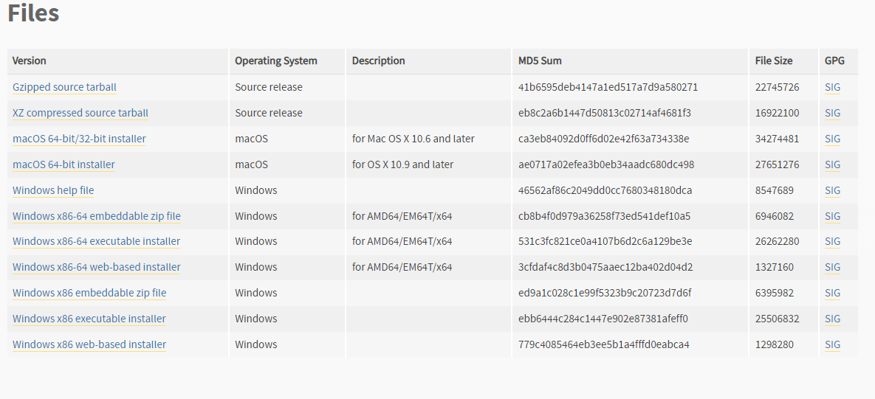

1. Click on below option



1. Following will be installed in downloaded folder:  
     
   Double Click It and following window will open:  
   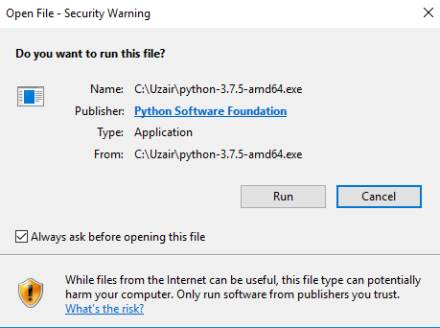  
     
   Click on RUN. Following window will open:  
   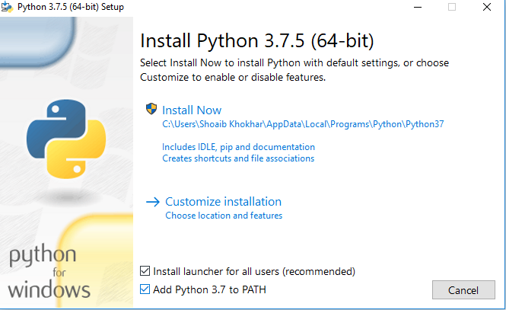  
     
   Make sure to check both checkboxes, especially “Add Python 3.7 to PATH”. Then Click on INSTALL NOW above. Wait until following window appears:  
   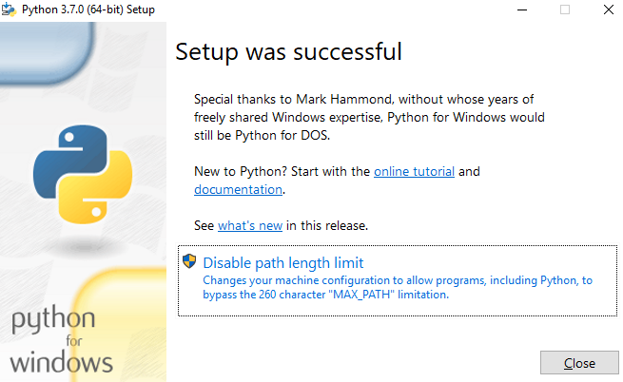  
     
   Click on Disable path length limit for safety and hit close.
2. Go to CMD in windows.  
   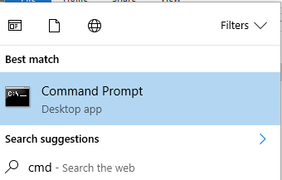
3. Write “where python” and hit Enter it. Copy the resulting file path that come in next line, make sure to copy first one only, and the first one is same as below ending “\Python37\python.exe”  
   
4. Go to folder where you have unzipped the files.  
   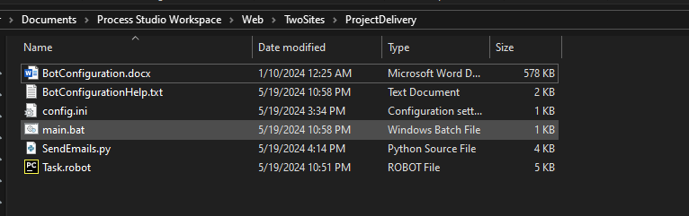
5. Right click on main.bat file and click edit  
   A screenshot of a computer program

   Description automatically generated
6. Edit it for python path from copied cmd results, and file path from folder. Save the file by pressing Ctrl+S.  
   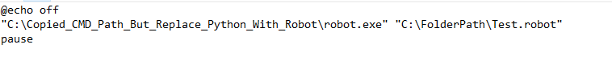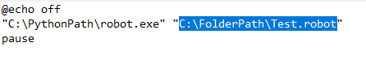
7. Go to CMD in folder by clicking on ribbon and changing path with CMD, and then hit enter as below.  
   A screenshot of a computer program

   Description automatically generated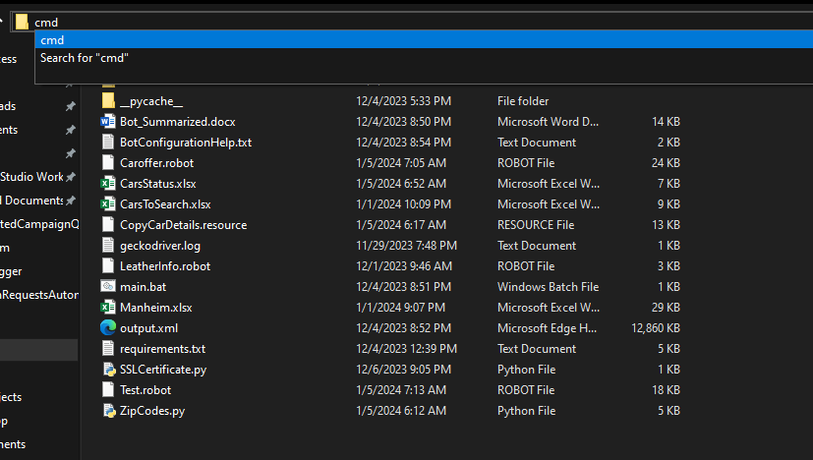  
   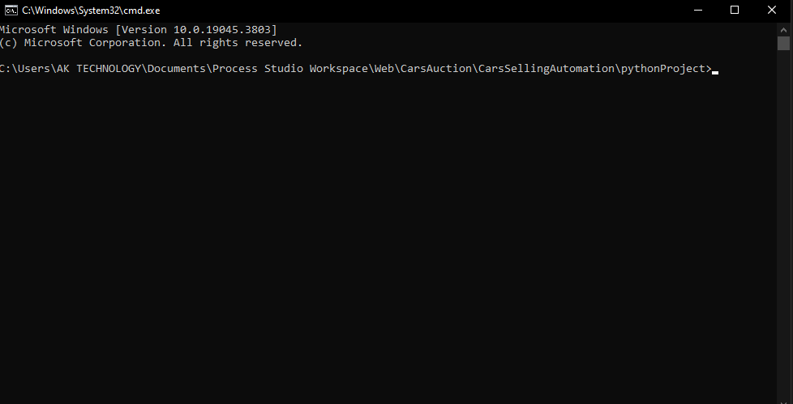
8. Write “pip install -r requirements.txt” and downloading will start. Wait until it ends like below(see BotConfigurationHelp.txt in folder for more reference):

