A cat, a Parrot, and a Bag of Seed

1. **Define the problem**
2. Do this in your own words

- A man has to carry a cat, a parrot, and a bag of seed in a boat. However, there are three problems.

1. What insight can you offer into the problem that is not immediately visible from the word problem alone?

* People can guess the man can carry the cat first and bring the parrot and a bag of seed later. However, the parrot could eat a bag of seed.
* People can think the man can carry all of them together. However, the boat does not have enough room for all of them.
* People can assume the man can carry a bag of seed first and bring the parrot and a cat later. However, the cat could eat the parrot.

1. What is the overall goal?

- The overall goal is that a man carries a cat, a parrot, and a bag of seed to the other side using a boat.

1. **Break the problem a part**
2. What are the constraints?

* The boat has room for only the man himself and one other item.
* In his absence, the cat eats the parrot and the parrot eats a bag of seed.

- The man should not leave the wrong ones alone together.

1. What are the sub-goals?

* Move all passengers several times.
* Avoid the wrong ones alone together.

1. **Identify potential solutions.**
2. For each of the sub-problems you’ve discussed in #2, what is a possible solution?

* To make sure the parrot does not eat a bag of seed, he would carry the parrot to the other side first and go back to another side to take the cat and a bag of seed.
* He could make the cat inside the bag of seed and carry them to the other side first and then carry the parrot later.
* He could put a bag of seed on the boat and make the parrot follow the bag of seed. The parrot can’t actually eat the bag of seed because the man is with them which means he can make sure the parrot does not eat a bag of seed. Bring the parrot when he gets back to another side where he departed first and leave the parrot alone in there and bring the cat only. After he carries the cat to the other side of the river, he could get back to another side to bring the parrot.

1. **Evaluate each potential solution**
2. Does each solution meet the goal?

- The first solution meets the goal. By carrying the parrot first, he could make sure the parrot does not eat the bag of seed. When the man is moving the parrot, the cat and a bag of seed are alone together. Since the cat does not eat a bag of seed, it is safe to leave them alone. After moving the parrot to the other side of the river, the man could come back to another side where he departed first and get a cat and a bag of seed. Since the boat has room for only him and one item he would grad a bag of seed on his knee and put the cat on another side of the boat.

* The second potential solution meets the goal but it can be hard to fulfill if the bag of seed is smaller than the cat.
* The third one meets the goal as well. If the parrot can fly, this solution meets the goal perfectly.

1. Will each solution work for ALL cases?

* The first and second solutions can be hard to work all cases. For the first one, he would not be able to grab the parrot when he is on the boat, it can’t be the best solution. For the second one, if the bag is smaller than the cat so he could not put the cat into the bag, this solution can't be good solution. However, the third one totally works for all cases.

1. **Choose a solution and develop a plan to implement it.**
2. Explain the solution full.

* First, he could put a bag of seed on the boat and he drives the boat. Make sure the parrot follows the bag of seed. He could put the bag of seed on the other side of the river. When he gets back to bring the cat, he should bring the parrot. He could put the parrot on the land and bring only the cat to the other side. After put the cat on the land bring the parrot.

1. Describe some test cases you tried out to make sure it works.

* The boat has room only for the man and one item. Since the parrot can fly, the man can carry a bag of seed and parrot together. If he leaves the parrot and a bag of seed alone together, the parrot could eat a bag of seed. Therefore, he needs to bring the parrot. There is no room for two items, he could not carry both cat and parrot so he would leave the parrot alone on the land and bring the cat first. Since the cat does not eat the seed he could leave the cat and a bag of seed alone together. Since the parrot is alone on the other side of the river, he needs to bring it back. After bringing the parrot, he could finally move all of them.

Socks In the Dark

1. **Define the problem**
2. Do this in your own words

- There are three different colors of socks. Find the probability to find matching pair.

1. What insight can you offer into the problem that is not immediately visible from the word problem alone?

* People would guess I could select at least one matching pair when I select 3 socks.
* People could guess if I select 6 socks.

1. What is the overall goal?

- Pick at least one matching pair and select or one matching of each color.

1. **Break the problem a part**
2. What are the constraints?

* The room too dark to check the colors of socks.
* There are three different colors.

1. What are the sub-goals?

* Find at least one matching pair.

1. **Identify potential solutions.**
2. For each of the sub-problems you’ve discussed in #2, what is a possible solution?

* Guess the probability.
* To have at least one matching pair, I would select four socks.
* To have at least one matching pair of each color, I would select 18 socks.

1. **Evaluate each potential solution**
2. Does each solution meet the goal?

- It meets the goal.

1. Will each solution work for ALL cases?

* It works for all cases.

1. **Choose a solution and develop a plan to implement it.**
2. Explain the solution full.

* To have at least one matching pair, I should select four socks. This is because there are just four white socks.
* To have at least one matching pair of each color, I should select at least 18 socks. If I select only 10 socks and they are all black ones, I could not have matching pairs of each color. If I select 16 socks and they are 10 black ones and 6 brown ones, I could not meet the goal.

1. Describe some test cases you tried out to make sure it works. 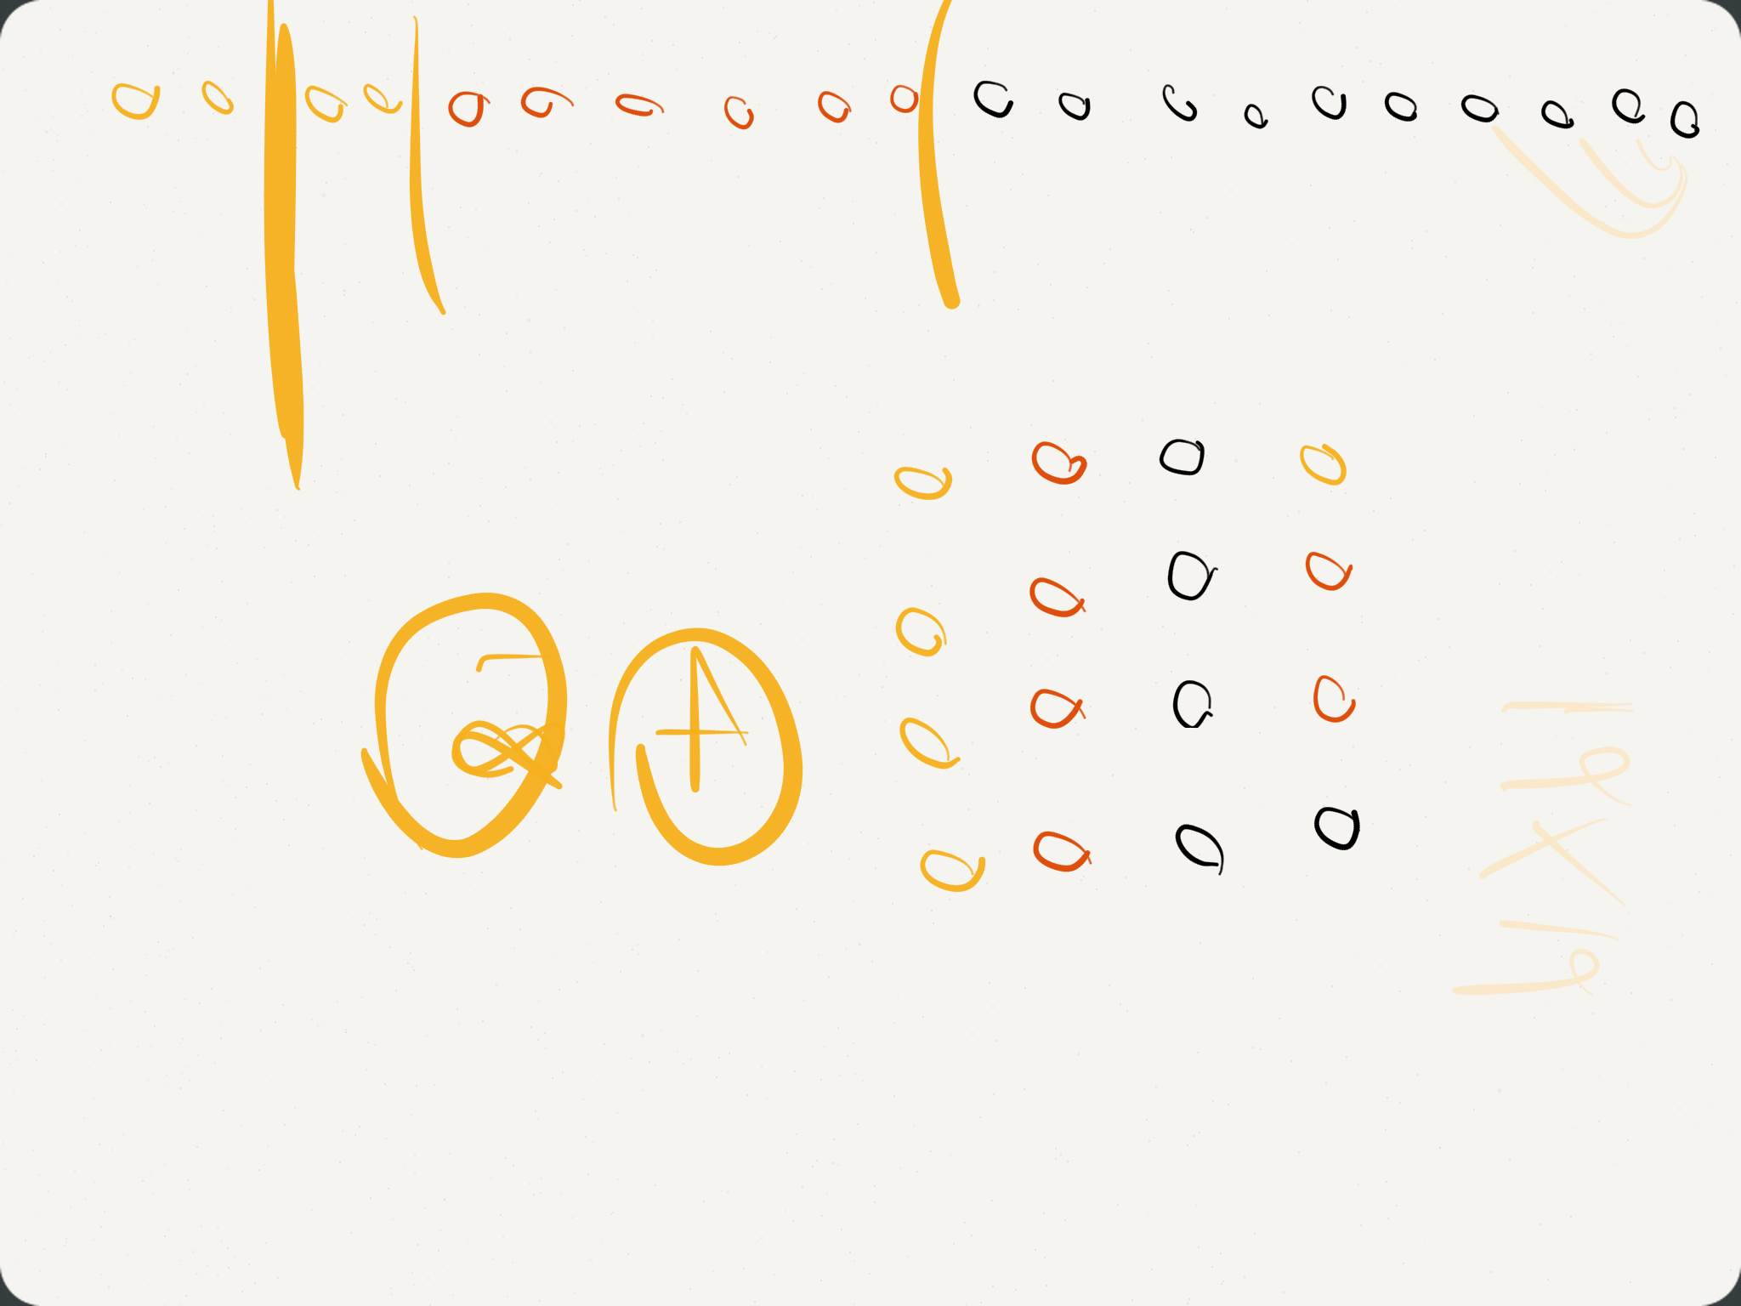

Predicting Fingers

1. **Define the problem**
2. Do this in your own words

- A girl counts using her fingers in her own way.

1. What insight can you offer into the problem that is not immediately visible from the word problem alone?

* I can offer a mathematical regulation.

1. What is the overall goal?

- Find out which finger will she stop when you counts 10, 100, and 1000.

1. **Break the problem a part**
2. What are the constraints?
3. What are the sub-goals?
4. **Identify potential solutions.**
5. For each of the sub-problems you’ve discussed in #2, what is a possible solution?

* Guess

1. **Evaluate each potential solution**
2. Does each solution meet the goal?

-

1. Will each solution work for ALL cases?
2. **Choose a solution and develop a plan to implement it.**
3. Explain the solution full.

* To
* .

1. Describe some test cases you tried out to make sure it works.