**Manual**

Main introduction

This game is designed to train the user’s response speed in an interesting way. It contains four modes: easy mode, medium mode, hard mode and special mode. The choices are shown in the main interface. The mode can be chosen by clicking the button directly. Different modes have different rules. Hence, these four modes will be introduced separately. Menu system is also introduced as a separate part because the menu system for all of the modes are the same.

Easy mode

This mode is designed to be an entry mode for rookie of this game. (Figure 1) The mission is to click as many squares in the screen as possible in one minute. There will be a square appearing at a random place in the screen. Each correct click contributes to one mark. If the square has not been clicked for 2 seconds, the screen will be refreshed and the square will appear at another random position. Remaining of the game is shown on the right top corner of the interface. The required shape to be clicked is shown on the right bottom corner. In the easy mode, the required shape is always a square. When time runs out, an interface will show the user’s mark on the screen. There is background music and sound effect in the game. A button for switching on/off of the sound is provided.

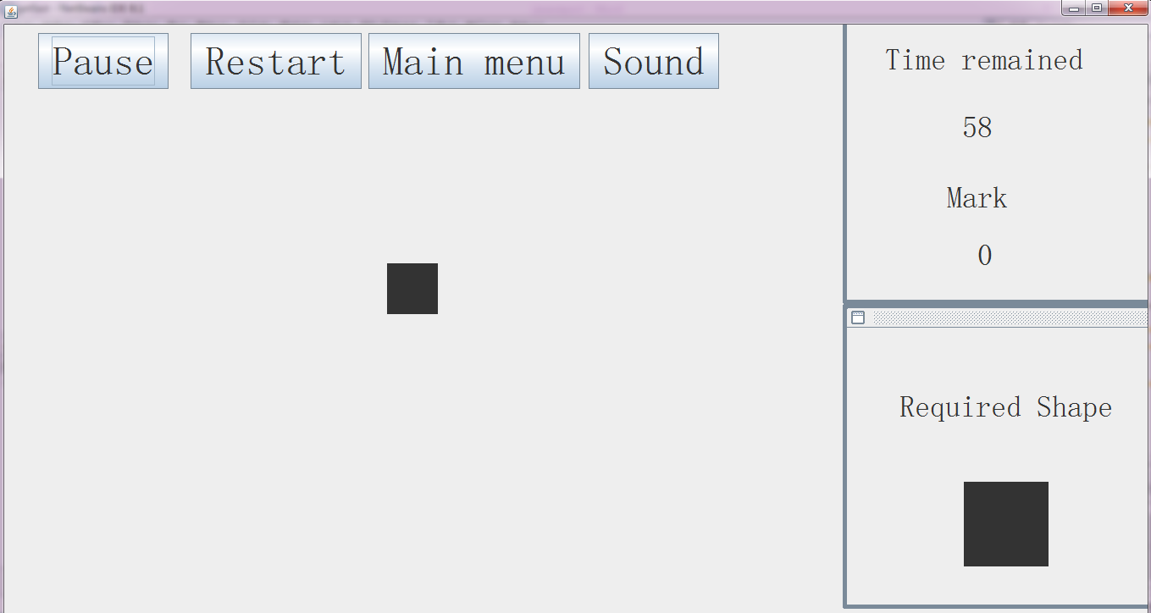

Figure 1: the interface of easy mode

Medium mode

This mode is harder than the easy mode, but it is still suitable for most players. (Figure 2) The required shape is shown on the right bottom corner. In the medium mode, what needs to be clicked is still a square. The difference is that there are a circle and a square appearing on the screen at the same. This design requires the player to make a right choice. If the player clicks a circle, the mark will not be added, it is reduced by 1 instead. If the square has not been clicked for two seconds, the square on the screen is replaced by another square at a random position instead. The time remaining is shown on the right top corner. The player’s make is shown on the screen when time runs out. Sound and its switching button are still available in this mode.

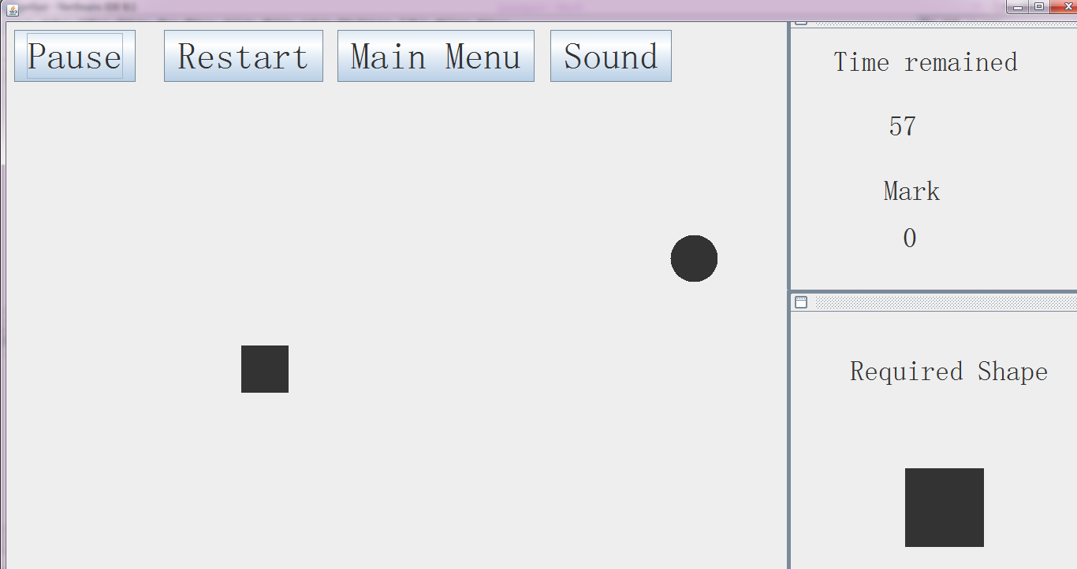

Figure 2: the interface of the medium mode

Hard mode

This mode is an advanced mode, which is designed for a player with short response time and wants to take the challenge. (Figure 3) There are a blue square, a black square, a blue circle, a black circle appearing randomly on the screen. The required shape could be any of these randomly. When a required shape is clicked, the mark increases by one. When a wrong shape is clicked, mark is reduced by one. There will be a “refresh” when a correct shape is clicked or a wrong shape is clicked or a correct shape has not been clicked for 2 seconds. The shapes shown in the screen and the required shape will be randomly set again in a “refresh”. Sound and its switching button are still available in this mode.

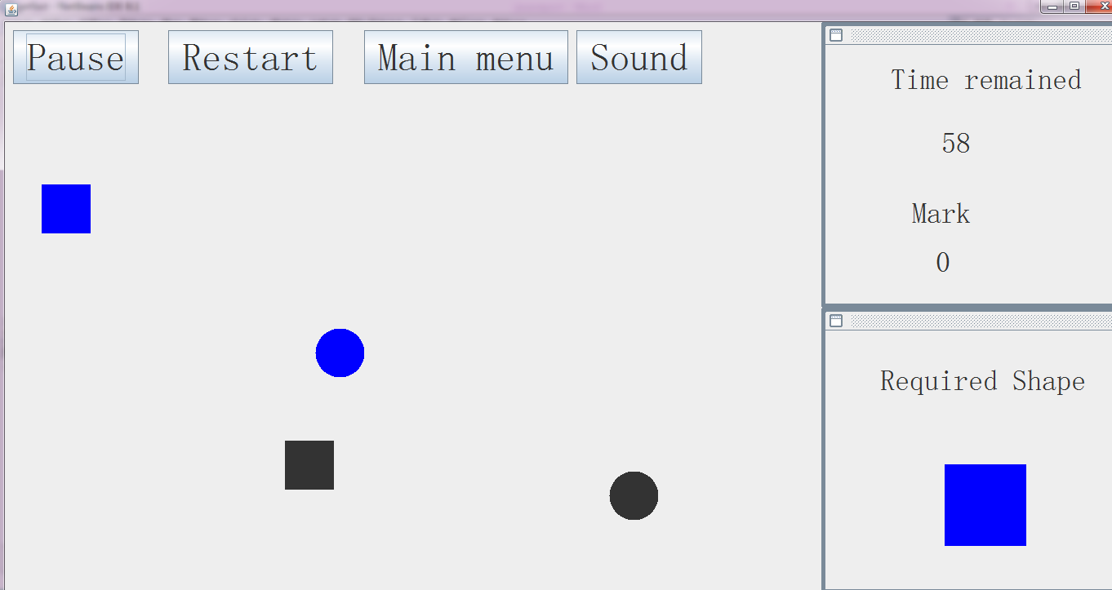

Figure 3: the interface of the hard mode

Special mode

This is an entertaining mode that is provided to make the game more interesting. (Figure 4) It is quite similar to some shooting games, but is designed in a simple way. The background is set as space and the shapes are replaced by Gundams (special fighting robots that can fly). The task is to shoot as many Gundams as possible before health becomes zero. A Gundam appears on the screen every 0.5 seconds and it will shoot the player if it has not been clicked for 2 seconds. Each kill of Gundam increases the mark by ten. Each shoot by a Gundam reduces health by ten. When health becomes zero, an interface shows the final mark on the screen. The image of Gundam, the image of the gun sight, the image of the shooting effect are specially designed to make the game enjoyable. There is background music and sound effect in this mode, but they are designed to be able to be turned off in this mode.

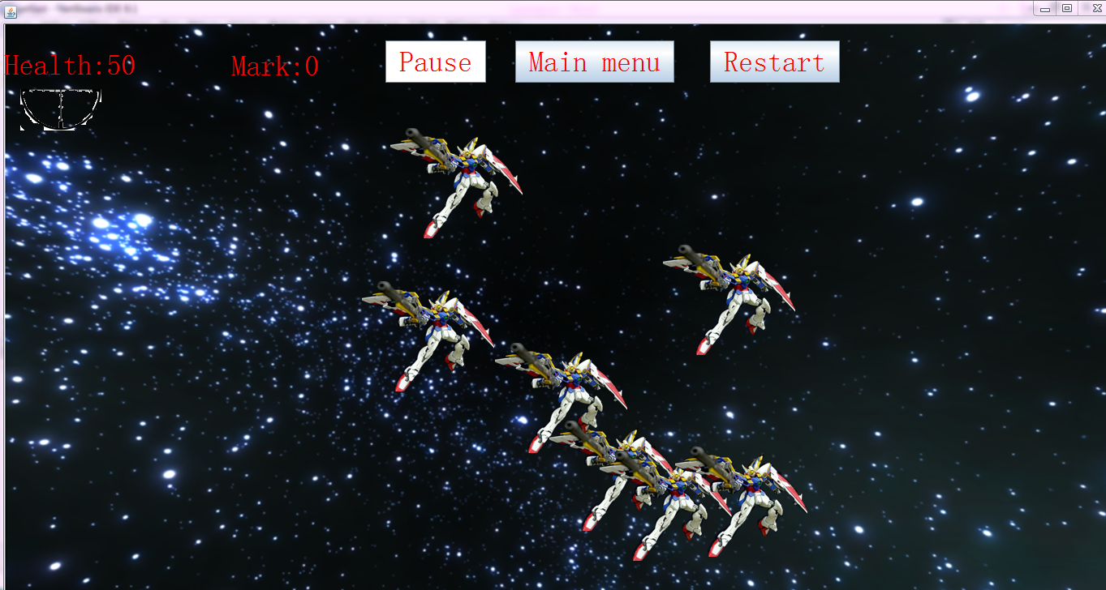

Figure 4: the interface of the special mode

Menu system

A menu system is designed in the game to connect the separate modes of the game together. In each game mode, a user can return to main menu ( Figure 5) and pause interface. A pause interface is shown when the pause button is clicked. (Figure 6) In the pause interface, options of resume, restart and main menu is designed. An interface for showing the final mark displays when a game ends. (Figure 7) A button can be clicked to return to the main menu.

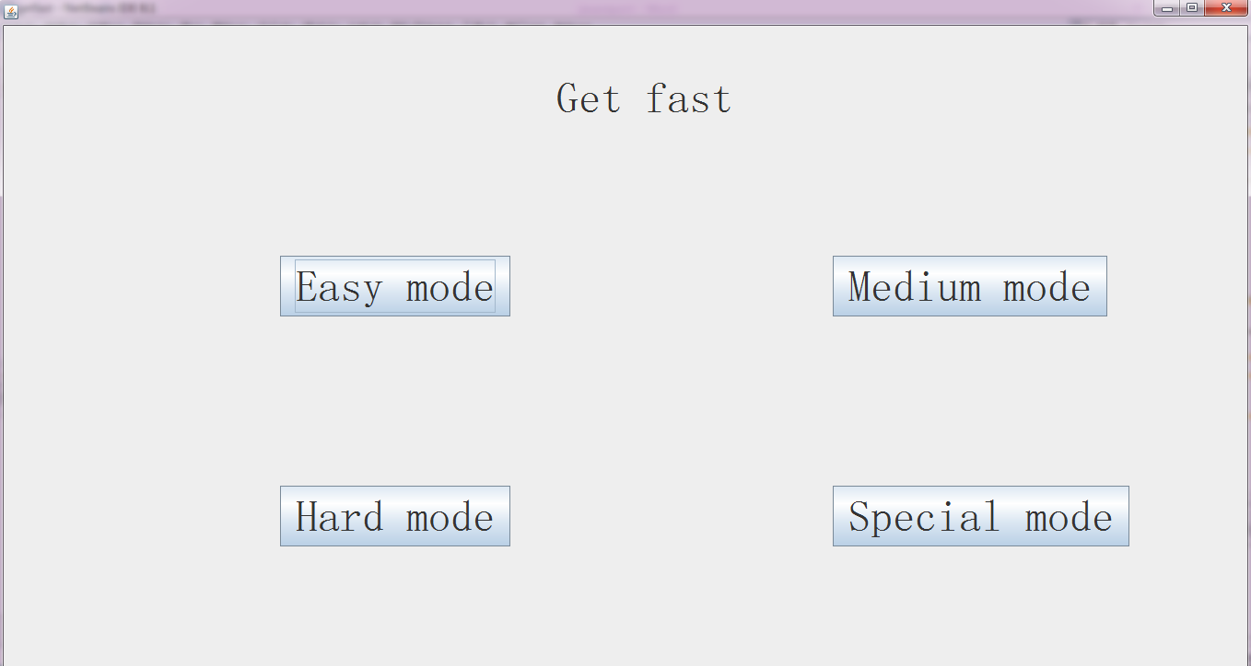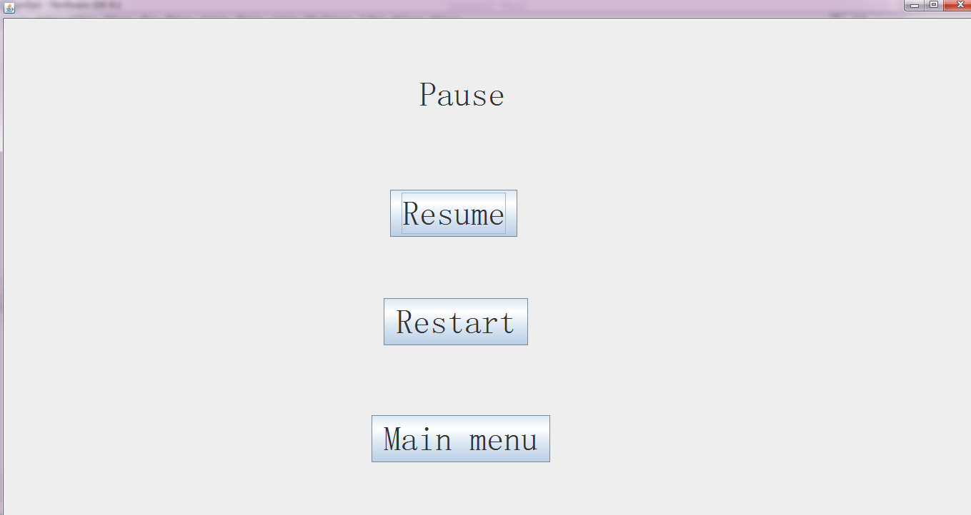

Figure 5: the interface of the main menu Figure 6: the pause interface

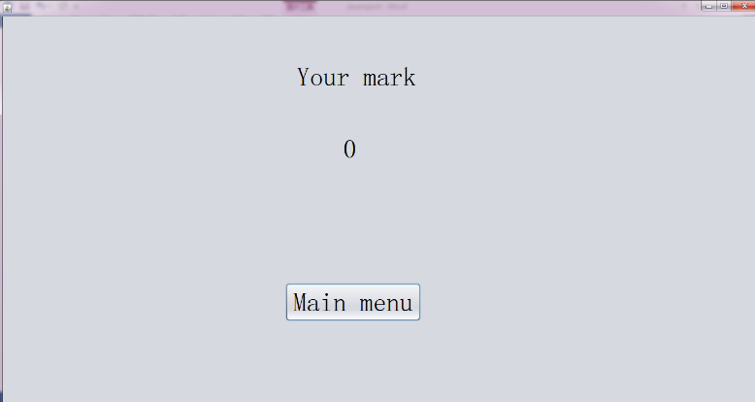

Figure 7: the interface to show the final mark

**Discussion**

The first of the project is that it is a game for training response speed. The project contains four games that can train the player’s response speed in an enjoyable way. Hence, the feature of ability to train response speed is achieved in this project.

The second feature is that the game combines different modes and interesting controlling experiences. This feature is also achieved. The easy mode just requires to click the square on the screen as quickly as possible. The medium mode adds the requirement of a judgement between circle and square. The hard mode is a more advanced mode, which has more requirements. The user needs to judge not only the shape but also the color from different objects and clicks the correct one. Special mode is included in the game to provide a totally different game experience. Thus, the feature of different game experience is satisfied.

The third feature there are effects in the game that make it interesting. In the normal modes, background music and sound effect when clicking the correct object are added in the game. But these effects can be closed during the game if the player thinks they are distracting. In the special mode, some effects on vision are designed to make it more similar to a real shooting game. The background picture, the enemies, the gun sight and the shooting effect are all designed in this game. Effects on sound still exist. The music in a relevant movie is chosen as background music. When an enemy is destroyed, the sound effect is played. Thus, this game contains many effects in the game, just like it is expected.

The fourth feature that is expected in the game is a convenient menu system. This target is achieved in the game. In each mode, options of pause, restart and back to main menu are provided for the user. The menu system should be user-friendly because it includes all the necessary options for the user to make the operation convenient.

The fifth feature that is achieved in the game is that the game is easy to understand. The game does not have an intricate rule for the player. The player can learn how to play the game with a manual in a short time. Even if the player does not have a manual, it is tested that most players can learn how to play it with less than three attempts of the game. This feature makes the game accessible for most players.

But there are also two features that are designed but not achieved in the game.

The first feature which is designed but not achieved in this game is a ranking list. It is first designed in the game to make the player eager to challenge the highest score. But it is found that it is time consuming to take this feature. Hence, this feature is finally abandoned in the game.

Another feature that is not achieved in the game is some advanced effects. In the special mode, it is expected to add many effects to make it compatible with some existing shooting game. One effect is not achieved is the shooting from a Gundam. It is designed to let the Gundam shoot a laser to the player. But it is found that it is hard to program this effect. Another effect designed in the special mode is that there are Gundams of different types and appearances. But this greatly increase the work of game development. It is abandoned in the last.