🔹 Slide 1: Introduction to Backend Pipeline (Technical View)
Title:
📊 Technical Foundation: Data Pipeline for Options Signal Prediction
Content:
- Objective: Predict market direction (CALL, PUT, NO ACTION) using AI.
- Data Source: Minute-level OHLCV data for NIFTY & BANKNIFTY from yfinance.
- Assets Covered: NIFTY, BANKNIFTY
- Timeframes Used: 1m → Aggregated to 5m, 15m, 30m, 60m
Core Steps:
- Fetch historical index data
- Clean & preprocess: handle missing values, cast datatypes
- Engineer features (technical indicators + price action)
- Label data based on future price movement
- Train XGBoost classifiers on labeled data
“We built a transparent, reproducible pipeline to train per-timeframe directional classifiers on labeled OHLCV data — fully offline and customizable.”

Slide 2 (Revised): Feature Engineering – What Drives the Prediction?
Title:
🧠 Feature Engineering in Backend.ipynb
Core Features Used:
Feature Name | Type | Purpose
Open, High, Low, Close, Volume | Price/Volume | Raw input for price dynamics
return_pct | Price Momentum | Used to derive future movement
future_close | Target Proxy | Determines label for prediction task
target | Label | 0: PUT, 1: NO ACTION, 2: CALL
“We use price-level features to infer directional movement and train multi-timeframe classifiers — future movement is encoded as one of three trading decisions.”

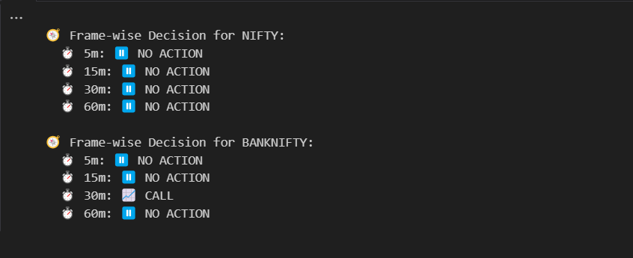

✅ Slide 8: Competitive Landscape – What Others Offer
Title:
📊 Competitive Platforms in Indian Options Trading
Platform | AI/ML Use | Options Direction Prediction | User Visibility | Strategy Builder | Broker Integration
Sensibull | ❌ Mostly rule-based | ❌ Only suggests strategies, not directional signals | ❌ Opaque | ✅ Yes | ✅ Zerodha, Upstox
Tradetron | ⚠️ ML-compatible (external import) | ❌ No native direction predictor | ❌ Code required | ✅ Strong | ✅ Yes
Kuants | ✅ Python-based ML | ✅ Custom models possible | ⚠️ Developer only | ✅ Code-based | ✅ Yes
Your Tool | ✅ XGBoost models | ✅ Predicts CALL/PUT/NO ACTION | ✅ Transparent | ❌ Strategy layer missing | ❌ Not integrated yet
Conclusion:
"While some platforms enable ML experimentation, none offer retail-ready, transparent, multi-timeframe directional predictions with model reasoning and 'NO ACTION' logic."

✅ Slide 9: Where We Stand Out – Feature Comparison
Title:
🚀 How We Outperform Current Offerings
Feature | Our Tool | Sensibull | Tradetron | Kuants
Multi-timeframe predictions | ✅ | ❌ | ❌ | ❌
CALL / PUT / NO ACTION classes | ✅ | ❌ | ❌ | ⚠️*
Transparency in feature input | ✅ | ❌ | ❌ | ✅
Works offline | ✅ | ❌ | ❌ | ❌
Suitable for non-coders | ✅ | ✅ | ❌ | ❌
AI-predicted restraint (NO ACTION) | ✅ | ❌ | ❌ | ❌
⚠️ Kuants supports ML, but user must code and train the model themselves.
📎 Devexperts (2023) – "Retail access to AI insights remains limited by technical complexity and lack of interpretability."
📎 IOSCO (2021) – "Retail clients often lack understanding of the AI/ML methods used by intermediaries."

✅ Slide 10: Why Our Training Approach Works
Title:
📈 Our Training Method Fills the Retail AI Gap
Your model does the following:
- Trains separate XGBoost classifiers per timeframe (5m, 15m, 30m, 60m)
- Uses historical directional labels based on future price movement
- Incorporates technical indicators: RSI, MACD, ATR, EMA
- Predicts when to AVOID trading – a rarely available AI feature
Supporting Research:
📎 Kumar & Bansal (2021) –
"Directional options prediction using ML significantly improves trading outcomes over rule-based systems."
IJFS Paper
📎 Zhang et al. (2020) –
"ML-based multi-frequency pattern recognition enhances intraday prediction accuracy."
ACM KDD Paper

