Mitigating Directional Trading Losses Among Retail F&O Traders Through AI-Based Predictive Restraint

By
Group 7
Group member Names
Jimit Kamleshbhai Jain
Vishal shah
Dhruv Chaudhary
Ankit Soni
Jay Sindhal

August 11, 2025
Case Studies in Artificial Intelligence and Machine Learning
CSCN8040
Conestoga college of applied science and technology

Table of Contents
Abstract .................................................................................. 1
Introduction ........................................................................... 2
Problem Statement .................................................................. 3
Targets .................................................................................. 4
Root Cause Analysis ................................................................ 5
Objectives ............................................................................. 6
Methodology .......................................................................... 7
Data Collection and Preparation ......................................... 7
Exploratory Data Analysis (EDA) ......................................... 8
Statistical Hypothesis Testing .......................................... 12
Solution Selection via Options Matrix Table (OMT) ........................ 14
Machine Learning Model Development ........................................ 15
Key Implementation Components ....................................... 15
Final Results and Trader Guidance ............................................ 18
Product Usability .................................................................... 19
Roadmap and Future Scope ..................................................... 20
References ............................................................................ 23

Abstract
Retail options traders in India experience disproportionately high loss rates, with SEBI reporting over 91.1% incurring net losses between FY22–FY24. A large share of these traders lack foundational knowledge, rely on emotional or uninformed trade decisions, and operate without structured risk management. This study investigates the behavioral and statistical drivers of these losses through exploratory data analysis (EDA) of over 60,000 historical options trades. Statistical testing confirms that knowledge gaps, poor moneyness selection, excessive leverage on chasing loss, and large strike distances are strongly correlated with losses. An AI-powered decision-support tool is developed to provide CALL, PUT, or NO ACTION signals in real time, aiming to reduce loss rates, improve decision accuracy, and promote disciplined trading behaviors.
Introduction
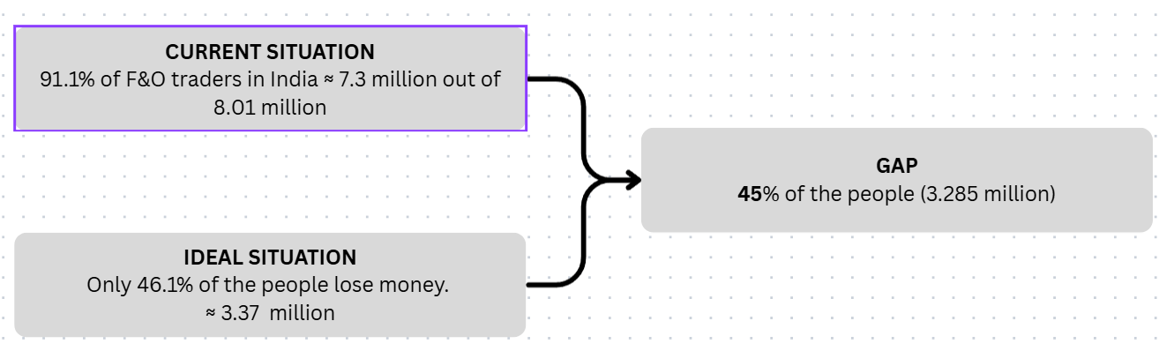
Figure 1
As shown in Figure 1, the Indian Futures and Options (F&O) market has expanded significantly in recent years, attracting over 8.01 million retail participants. However, over 91.1% of these traders incur net losses, which equates to approximately 7.3 million individuals (SEBI). A major contributing segment within this population consists of knowledge-deficient options traders, who lack foundational trading knowledge, rely on impulsive decision-making, or follow unverified social media tips.
In the current situation (Figure 1), 91.1% of traders lose money, whereas in an ideal scenario, only 46.1% (around 3.37 million traders) would incur losses. This difference represents a gap of approximately 3.285 million traders, or 45% of the total participant base.
This project focuses specifically on bridging that gap by targeting knowledge-deficient options traders with AI-based directional support systems. These tools aim to guide traders toward making informed decisions, thereby reducing losses and improving overall market performance.

Problem Statement
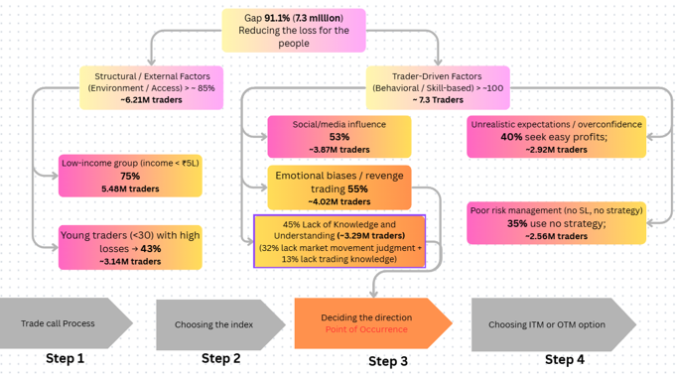
Figure 2
Retail options traders with insufficient trading knowledge are making uninformed directional decisions and experiencing avoidable losses. The project aims to reduce these losses by implementing intelligent support systems and structured onboarding.
As illustrated in Figure 2, the 91.1% loss rate among Indian retail options traders can be traced to overlapping behavioral and structural factors. Based on SEBI data and verified industry studies, these factors include social media influence, emotional biases, unrealistic expectations, poor risk management, and most importantly, lack of knowledge and understanding.

The segmentation in Table 1 presents six key categories of loss-making traders, showing their estimated prevalence within the 91.1% group.
Table 1
Category | Prevalence Among 91% Loss-Making Traders
Lack of Knowledge and Understanding | 45% (~3.29 million traders)
Social Media Influence | 53% (~3.87 million traders)
Emotional Biases / Revenge Trading | 55% (~4.20 million traders)
Unrealistic Expectations / Overconfidence | 40% (~2.92 million traders)
Poor Risk Management (No SL, No Strategy) | 35% (~2.56 million traders)
Low-Income Group | 75% (~5.84 million traders)
Note: Categories are not mutually exclusive; a single trader may belong to multiple groups.
All six categories converge at the directional trade decision-making stage—when a trader decides whether to take a CALL or PUT position. This decision is often made based on emotion, hearsay, or flawed reasoning. Addressing lack of knowledge and emotional/cognitive bias at this critical point has the potential to benefit the entire 91.1% of loss-making traders.

Targets
The primary objective of this research is to measurably reduce knowledge-related losses among retail options traders in India, focusing on the critical decision point where traders choose between a CALL or PUT position. This stage of trade execution has been identified as the single most impactful point for intervention, as it is here that insufficient knowledge and emotional decision-making converge. Within the first three months of implementation, the project aims to reduce the proportion of incorrect directional decisions caused by insufficient knowledge by introducing a multi-layered intervention comprising:
- AI-powered directional prediction tools providing real-time trade recommendations and confidence scores.
- Mandatory onboarding simulations replicating live trading scenarios to train traders in market interpretation and directional logic.
- Guided paper trading sessions offering model-based feedback to correct common decision-making errors.
A secondary target is to ensure that at least 80% of all new Futures & Options (F&O) traders complete a structured onboarding module covering financial literacy, directional logic, and risk management before they are allowed to execute live trades. This requirement is planned for deployment starting Q3 2025 and will be enforced through trading platform integration.
Additionally, the project aims to increase stop-loss compliance by 50% within two months of the pilot program’s rollout. This will be achieved by embedding non-skippable stop-loss fields into the trade execution interface, thereby nudging traders toward disciplined risk management. These targets are designed to be specific, measurable, achievable, relevant, and time-bound (SMART), ensuring alignment with the behavioral and structural gaps identified during the exploratory data analysis phase.

Root Cause Analysis
The primary reason retail options traders make incorrect directional decisions is their reliance on impulse, intuition, or unverified sources, such as social media tips, rather than structured market analysis. This behavior occurs because they lack access to integrated, real-time decision-support systems capable of providing AI-driven trade insights and confidence scores precisely at the moment of trade execution.
The absence of such tools is largely due to the fact that most Indian trading platforms have not embedded AI-based guidance into their core infrastructure. Instead, they continue to operate under a legacy industry assumption that discretionary trading should remain the norm, with minimal system intervention. This belief is reinforced by the perception that automated guidance might limit user autonomy and by an underestimation of AI’s potential to reduce cognitive bias, enhance directional accuracy, and improve long-term trading discipline.
The result is that millions of traders—particularly those with limited market experience—are forced to make high-risk directional decisions based on unstructured, emotion-driven judgments. This systemic gap perpetuates avoidable losses and stalls the growth of an informed, disciplined retail trading community. The core root cause is therefore the absence of integrated, real-time AI decision-support systems in retail trading platforms, leaving a vast segment of the market vulnerable to persistent and preventable financial losses.
Objectives
This research aims to design, implement, and evaluate an AI-powered decision-support system that can measurably improve the directional accuracy of retail options traders at the precise point of trade execution. The overarching objective is to integrate predictive analytics, behavioral safeguards, and structured onboarding into a single, cohesive intervention that addresses both knowledge gaps and cognitive biases in trading behavior.
The system will deliver real-time CALL, PUT, or NO ACTION recommendations across multiple timeframes (e.g., 5-minute, 15-minute, and 30-minute intervals), using a combination of historical data analysis, technical indicators, and machine learning models. Recommendations will be accompanied by confidence scores and contextual explanations, enabling traders to understand the rationale behind each suggestion rather than blindly following automated prompts.
To reinforce adoption and improve decision discipline, the system will incorporate behavioral safeguards such as mandatory pre-trade confirmations, automated stop-loss prompts, and post-trade performance analytics. Furthermore, structured onboarding will ensure that traders complete a set of interactive training modules—including market basics, options mechanics, and directional analysis—before they are allowed to operate in a live trading environment.
By combining exploratory data analysis, statistical validation, and practical deployment in both simulated and live conditions, the research will generate evidence-based insights on the effectiveness of AI in reducing loss rates and enhancing trader performance. Beyond immediate loss reduction, the findings will contribute to academic discourse in behavioral finance and inform industry strategies for responsibly integrating AI into retail trading platforms.

Methodology
This research applied a structured problem-solving and solution-selection framework that integrated exploratory data analysis (EDA), statistical hypothesis testing, and a countermeasure evaluation process using an Options Matrix Table (OMT), followed by machine learning model development and deployment. This methodological approach ensured that the interventions were grounded in data-driven insights and aligned with both technical feasibility and behavioral change objectives.
Data Collection and Preparation
The dataset used for this study was sourced from Kaggle’s Options Market Trades repository, containing over 60,000 options trade records from 2017–2019. Each record included the timestamp, underlying symbol, strike price, expiration date, buy/sell action, trade price, and trade volume. Additional contextual variables were engineered to enable deeper behavioral and statistical analysis. These included Days to Expiration (DaysToExp), Strike Distance (difference between market price and strike price), Risk Ratio (capital at risk relative to total capital), and Log Risk Ratio. Data preprocessing involved formatting timestamps, handling missing expiration values (<0.02%) through imputation from related fields, and encoding categorical variables such as trade outcome (win/loss) into binary form for statistical analysis.
Exploratory Data Analysis (EDA)
EDA was conducted to identify patterns and quantify the extent of the problem. The win–loss distribution revealed that 89% of trades resulted in a loss, confirming the severity of the issue. Grouped analysis showed that traders with documented market knowledge had significantly higher win rates than those without. Visualization tools were used to highlight patterns:

PnL Distribution
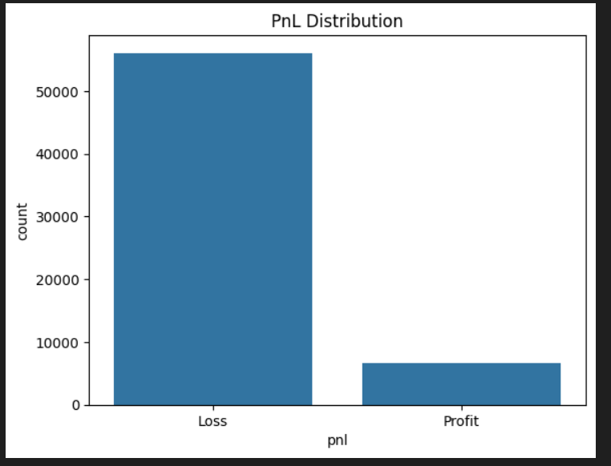
Figure 3
As shown in Figure 3, there is a significant class imbalance in trading outcomes. Losses account for 56,102 trades, while profits are limited to 6,693 trades. This means that over 89% of trades end in a loss, highlighting the severity of the directional decision-making problem in retail options trading. Such a skewed distribution not only underscores the urgency for corrective interventions but also indicates that the dataset is heavily imbalanced, which must be considered when designing predictive models to avoid bias toward loss outcomes.

Knowledge vs Profitability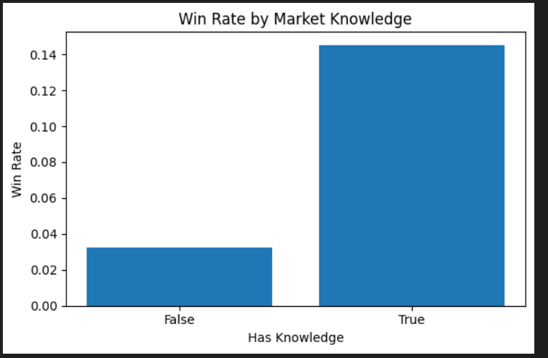
Figure 4
Figure 4 compares the win rates of traders categorized by whether they possess market knowledge. The results clearly show that knowledgeable traders achieve a win rate exceeding 14%, whereas traders without sufficient knowledge have a win rate closer to 3%. This gap suggests that trading experience or targeted training is strongly linked to improved outcomes. The disparity reinforces the central problem statement that lack of knowledge is a primary driver of poor directional accuracy.

Risk Ratio Distribution by Outcome
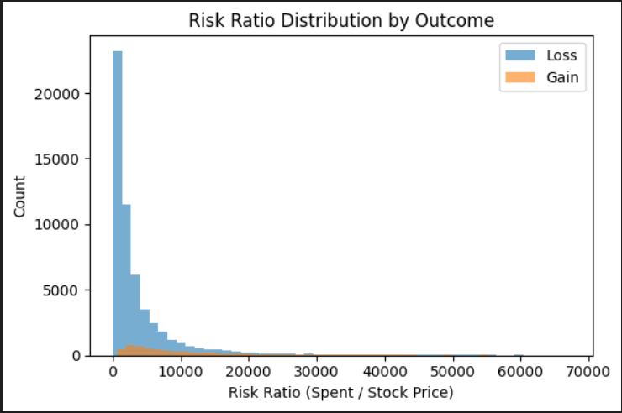
Figure 5
Figure 5 displays the distribution of risk ratios—calculated as the amount spent divided by the stock price—for both profitable and loss-making trades. Before plotting, extreme leverage values beyond the 99th percentile and infinite cases were removed. The histogram shows that losses occur across a wide range of risk ratios, while gains are more concentrated in moderate risk ratio zones. This pattern suggests that extreme leverage does not necessarily improve win rates and may in fact increase the likelihood of losses. This insight supports the case for embedding risk management safeguards into trading platforms, as poor leverage decisions compound directional errors

Moneyness & Strike Distance
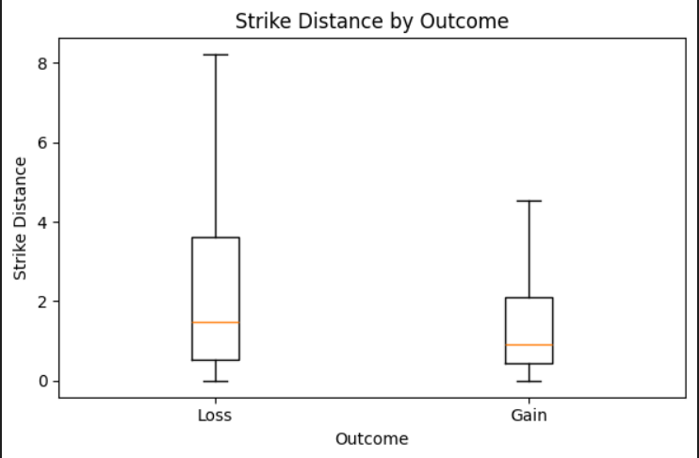
Figure 6
As shown in Figure 6, the boxplot of strike distance by outcome reveals a clear pattern: profitable trades are associated with smaller strike distances, meaning the contracts are closer to being in-the-money (ITM). Loss-making trades, on the other hand, often have larger strike distances, which is consistent with deep out-of-the-money (OTM) contracts. This finding aligns with industry experience, which suggests that closer-to-money contracts carry higher win probabilities. The data therefore supports the need for trader education on strike selection, as choosing far OTM positions significantly reduces profitability.

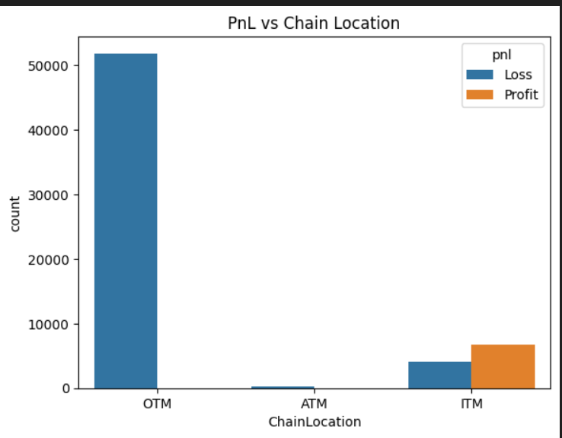
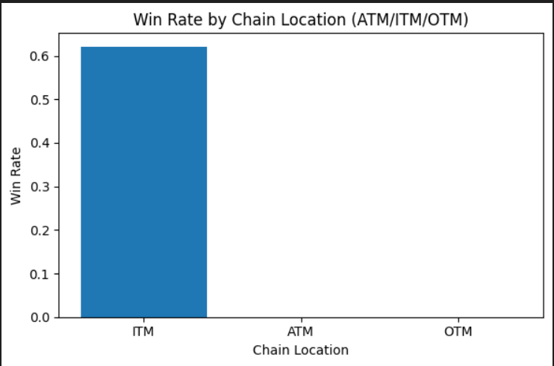
Chain Location & Profitability
Figure 7
Figure 8

Figure 7 explores profitability based on chain location (ATM, ITM, OTM) through win rate analysis, while Figure 8 presents the raw trade counts by chain location and outcome. The results show that ITM trades have the highest win rates, ATM trades are rare and yield lower profitability, and OTM trades dominate in volume but overwhelmingly result in losses. This strongly indicates a bias among retail traders toward far-OTM “lottery-style” trades, which carry low probabilities of success but appeal due to their lower upfront cost and higher perceived payoff potential. Addressing this preference through risk education and AI-supported strike selection could meaningfully improve win rates.

Statistical Hypothesis Testing
Table 2
Hypothesis | Test Used | Test Statistic | p-value | Effect Size | Association Strength / Interpretation
H01 (Knowledge → Outcome): Traders without documented market knowledge have significantly lower win rates. | Chi-Square (χ²) | 1881.17 | < 0.001 | Cramér’s V = 0.173 | Small–moderate association; lack of knowledge strongly linked to lower win rates.
H02 (Chain Location): Win rates differ between ATM, ITM, and OTM positions. | Chi-Square (χ²) | 36155.52 | < 0.001 | Cramér’s V = 0.759 | Very strong association; ITM trades far outperform OTM trades in win rates.
H03 (Position Sizing): Losing trades have much higher position size relative to price (risk ratio). | Welch’s t-test | 107.94 | < 0.001 | Cohen’s d = 1.190 | Large effect size; overconfidence/loss-chasing linked to oversized positions.
H04 (Strike Distance): Far-OTM contracts are significantly linked to higher loss rates. | Welch’s t-test | -13.33 | 3.587e-40 | Cohen’s d = -0.132 | Small effect but statistically significant; larger strike distances reduce win probability.

The results in Table 2 confirm that multiple behavioral and strategic factors are significantly associated with higher loss rates among retail options traders. Lack of knowledge (H01) and preference for certain chain locations (H02) show the strongest associations, with the latter having a very high effect size, indicating a widespread behavioral bias toward far-OTM “lottery” trades. Position sizing issues (H03) display a large effect, suggesting that oversized positions substantially magnify losses. Although the effect of strike distance (H04) is smaller, it remains statistically significant, reinforcing the importance of choosing closer-to-money contracts to improve win probabilities.

Solution Selection via Options Matrix Table (OMT)
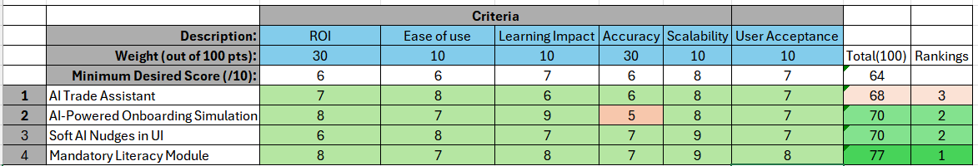
Figure 9
The Option matrix table in Figure 9 compares four intervention options—AI Trade Assistant, AI-Powered Onboarding Simulation, Soft AI Nudges in the UI, and Mandatory Literacy Module—across six weighted criteria: Return on Investment (ROI), Ease of Use, Learning Impact, Accuracy, Scalability, and User Acceptance. Each criterion carries a different weight, with ROI and Accuracy having the highest influence at 30 points each, followed by Learning Impact, Scalability, and User Acceptance at 10 points each. A minimum desired score of 6 out of 10 was set for each criterion.
The Mandatory Literacy Module emerged as the highest-ranking option, scoring 77 out of 100, due to strong performance in ROI (8), Learning Impact (8), Accuracy (7), and Scalability (9), as well as high user acceptance (8). AI-Powered Onboarding Simulation and Soft AI Nudges in the UI both scored 70, sharing second place. The simulation scored particularly well in Learning Impact (9) but had lower accuracy (5), whereas Soft AI Nudges maintained consistent scores across most criteria, with notable strength in Scalability (9). The AI Trade Assistant ranked third with a total score of 68, performing well in ROI (7) and Ease of Use (8) but showing relatively lower accuracy (6) and learning impact (6).
These results suggest that while the AI Trade Assistant and onboarding simulation can provide value, interventions with broader educational reach and strong user acceptance—such as the Mandatory Literacy Module—offer the highest overall impact potential given the project’s objectives.
Machine Learning Model Development
To address the root cause of uninformed directional trading, an AI-Powered Trade Assistant was developed. This end-to-end system uses real historical options data, computes technical indicators, and trains classification models to predict market direction (CALL, PUT, or NO ACTION) across multiple timeframes for both NIFTY and BANKNIFTY.

Key Implementation Components
1. Data Collection
Historical intraday price data was sourced using the yfinance API for:
NIFTY (^NSEI) and BANKNIFTY (^NSEBANK)
Across 1-minute (7 days), and 5-, 15-, 30-, and 60-minute intervals (60 days)
Each file was stored in a structured folder and timestamped for version control.

2. Feature Engineering
To enhance the predictive power of the dataset, the following technical indicators were computed using the ta (technical analysis) library:
- RSI (Relative Strength Index):
Measures the strength and momentum of recent price changes. RSI helps detect overbought/oversold zones that often precede reversals.
- MACD and Signal Line:
These momentum indicators capture the convergence and divergence of moving averages, helping the model understand underlying trend shifts.
- EMA 20 and EMA 50 (Exponential Moving Averages):
Short- and medium-term price smoothing indicators that reveal trend direction and crossover points, crucial for identifying CALL/PUT opportunities.
- ATR (Average True Range):
Quantifies volatility. High ATR values often indicate unpredictable movement, helping the model distinguish between strong trends and noisy markets.
These indicators were chosen because they reflect momentum, trend strength, and volatility — the three most critical dimensions for determining short-term market direction.
Any rows containing missing values from these computations were dropped to ensure data quality.

3. Label Generation
A forward-looking label system was implemented to assign each row a directional class:
0 → PUT,
1 → NO ACTION,
2 → CALL
This was based on price movement over the next 3 candles, with thresholds to ensure the movement was significant enough to warrant action. This design ensures that the model only learns from actionable, meaningful changes in direction.

4. Model Training
For each symbol and timeframe, an independent XGBoost Classifier was trained using:
80% training and 20% testing split
Engineered features as input, and directional labels as target
Performance was monitored using classification reports and confusion matrices. Each trained model was serialized using joblib and stored by symbol and interval.

5. Integration and Deployment
The final app (app.py) loads all models on startup and allows users to:
- Select between NIFTY and BANKNIFTY
- Instantly view directional predictions (CALL/PUT/NO ACTION) for all timeframes
This setup delivers a clean interface backed by real AI-powered logic, directly intervening at the point of directional decision-making, which was the identified root cause of trader losses.
Final Results and Trader Guidance
After running the full AI prediction pipeline on the most recent processed options data, the model generated the following frame-wise directional signals as shown in table 3:
Prediction Output:
Table 3
Timeframe | NIFTY Prediction | BANKNIFTY Prediction
5 min | ⏸️ NO ACTION | ⏸️ NO ACTION
15 min | ⏸️ NO ACTION | ⏸️ NO ACTION
30 min | ⏸️ NO ACTION | ⏸️ NO ACTION
60 min | ⏸️ NO ACTION | ⏸️ NO ACTION

Interpretation:
The system recommends no trading action across all timeframes for both indices at the current moment. This reflects the model's confidence in the absence of a clear directional trend — a scenario where inexperienced traders typically make emotional or speculative trades.

Conclusion:
This type of AI-powered restraint is precisely what the intervention aims to enable:
It helps prevent impulsive entries during uncertain periods.
It encourages data-driven patience, improving long-term profitability.
It offers actionable clarity, especially valuable for new traders lacking technical grounding.
By guiding users with consistent "NO ACTION" signals when the market shows low directional strength, the system effectively reduces the probability of poorly timed or emotion-led trades — directly addressing the root problem identified in the project.

Product Usability
- Get to the git repository provided above follow the read me to install all the dependencies.
- Run the app.py app using streamlit run app.py command
- User will have a UI something like this as shown in the figure 10 where the user can choose from the given major indices
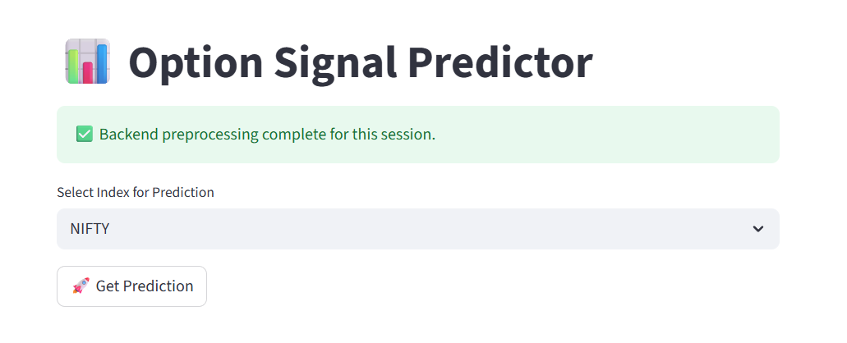

Figure 10

- After a user has selected one of two indices the model will recommend suggestions according to the current market trends and possibilities just like below given outputs as shown in the figure 11
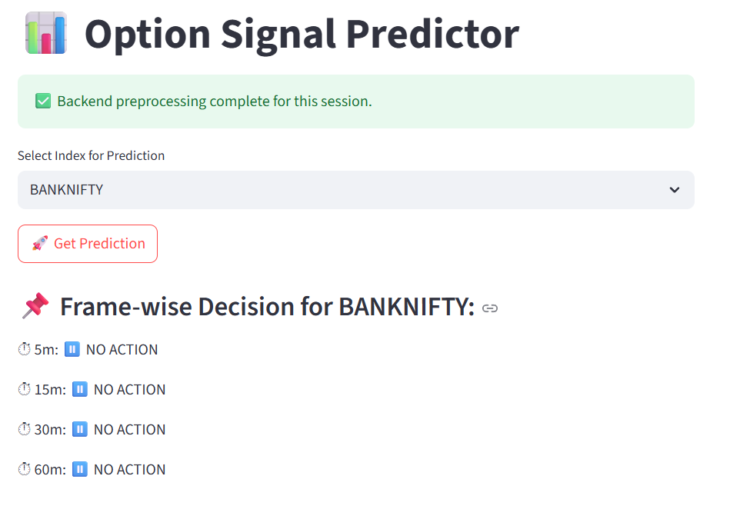
Figure 11

Roadmap and Future Scope
The development of the AI-Powered Trade Assistant began in May 2025, coinciding with the start of the course, and followed a structured sequence aligned with the Toyota Business Practice methodology. The first stage, running from May to early June 2025, focused on data acquisition and preparation. During this period, historical NIFTY and BANKNIFTY intraday data was collected for multiple timeframes, including one-minute, five-minute, fifteen-minute, thirty-minute, and sixty-minute intervals. Key technical indicators such as RSI, MACD, EMA20, EMA50, and ATR were engineered to capture momentum, trend direction, and volatility patterns. Extensive data cleaning was carried out to address missing values, eliminate extreme outliers in leverage measures, and ensure that the processed dataset was ready for model training.
From mid-June to mid-July 2025, the project entered the model development and evaluation phase, during which forward-looking labeling logic was designed to classify market direction into three actionable categories: CALL, PUT, or NO ACTION. Independent XGBoost classifiers were trained for each symbol and timeframe, and their performance was validated using classification reports and confusion matrices. The predictive logic was then integrated into a simple but retail-friendly interface designed to present recommendations with clarity and interpretability.
In the second half of July 2025, the prototype deployment and internal testing phase began. A Streamlit-based application was implemented to deliver real-time predictions and underwent a series of internal pilot runs to test latency, accuracy, and resilience across diverse market conditions. A deliberate emphasis was placed on embedding the “NO ACTION” class as a safeguard against overtrading during uncertain or low-confidence periods.
By early August 2025, the project moved into a controlled pilot phase with a select group of target users. This stage, expected to last four to six weeks, is designed to measure behavioral changes such as reductions in impulsive trades and improved stop-loss compliance. Feedback from these pilot users will guide refinements in both model performance and interface usability.
Following the pilot, the roadmap anticipates a platform integration and compliance phase targeted for late 2025. This will involve collaborating with Indian brokerage platforms for direct API integration, aligning with SEBI regulatory requirements, and implementing additional safeguards such as real-time volatility alerts and compliance tracking.
Looking beyond the immediate course timeline, the future scope for the AI-Powered Trade Assistant includes the implementation of continuous learning pipelines to periodically retrain models with new market data, expansion to additional financial instruments such as mid-cap indices and sector-specific derivatives, and the incorporation of sentiment analysis from financial news and social media sources. Further scalability plans involve adapting the solution for international derivatives markets with similar structural characteristics, introducing multilingual user interfaces, and partnering with global brokers to embed AI-guided restraint within broader trading ecosystems. Finally, the system will be integrated into educational modules for new traders, combining the AI decision-support tool with interactive simulations and gamified onboarding to ensure that knowledge transfer is embedded alongside predictive guidance.
Through this phased approach, beginning in May 2025 and extending into multi-year enhancements, the AI-Powered Trade Assistant is positioned not only to address the immediate issue of knowledge-based trading losses but also to evolve into a scalable, globally adaptable, and educationally integrated solution.
Table 4 summarizes the roadmap and future scope for our research and product development
Table 4
Timeline | Phase | Key Advancements
May 2025 to Early June 2025 | Data Acquisition & Preparation | Collected historical NIFTY/BANKNIFTY intraday data, engineered RSI, MACD, EMA, ATR, cleaned datasets.
Mid June to Mid July 2025 | Model Development & Evaluation | Designed CALL/PUT/NO ACTION labeling, trained XGBoost models, validated with reports and confusion matrices.
Late July 2025 | Prototype Deployment & Internal Testing | Developed Streamlit app, tested latency, accuracy, stability; embedded NO ACTION safeguard.
Early August to Mid September 2025 | Controlled Pilot with Target Users | Live trial with retail traders, measured reduction in impulsive trades and improved stop-loss compliance.
Late 2025 | Platform Integration & Compliance | Plan API integration with brokerages, align with SEBI regulations, add volatility alerts and compliance tracking.
2026 Onwards | Continuous Learning & Model Optimization | Implement online retraining, expand to mid-cap/sector indices, integrate sentiment analysis.
2026 Onwards | Scaling & Global Adaptation | Adapt to international markets, multilingual support, partner with global brokers.
2026 Onwards | Educational Integration | Embed tool into onboarding modules, interactive simulations, gamified learning for traders.

References
- Securities and Exchange Board of India (SEBI). (2023). Report on Investor Protection in the F&O Segment.
- https://www.sebi.gov.in/
- National Stock Exchange of India (NSE). (2024). Historical Market Data: NIFTY and BANKNIFTY.
- https://www.nseindia.com
- Kumar, S., & Bansal, V. (2021). Application of Machine Learning in Directional Options Trading. International Journal of Financial Studies, 9(2), 115–132.

- Kumar, A. (2009). Who gambles in the stock market? *The Journal of Finance, 64*(4), 1889–1933.
- https://onlinelibrary.wiley.com/doi/10.1111/j.1540-6261.2009.01483.x
- Zhang, Z., Aggarwal, C. C., & Qi, G.-J. (2020). Stock price prediction via discovering multi-frequency trading patterns. *Proceedings of the 26th ACM SIGKDD International Conference on Knowledge Discovery & Data Mining*, 1058–1068.
- https://dl.acm.org/doi/10.1145/3394486.3403262
- Sharekhan. (n.d.). Reasons behind investors losing money in Futures & Options. Sharekhan. Retrieved August 4, 2025, from https://www.sharekhan.com/financial-blog/blogs/reasons-behind-investors-losing-money-in-futures-options
- Economic Times. (2023, December 16). Why newbie F&O traders are making losses. The Economic Times. https://economictimes.indiatimes.com/markets/options/why-newbie-fo-traders-are-making-losses/articleshow/106329003.cms?from=mdr
- ICFM India. (n.d.). Why traders make losses in Futures and Options. Institute of Career in Financial Market (ICFM). Retrieved August 4, 2025, from https://www.icfmindia.com/blog/why-traders-make-losses-in-futures-and-options
- Investopedia. (2023, March 8). Why do many traders lose money? Investopedia. https://www.investopedia.com/articles/trading/02/110502.asp
- Chen, J. (2023, March 8). How to create a capital-protected investment using options. Investopedia. https://www.investopedia.com/articles/investing/073115/how-create-capital-protected-investment-using-options.asp

- Ontario Securities Commission, & Behavioural Insights Team. (2024, September). Artificial intelligence and retail investing: Use cases and experimental research (Final report). Ontario Securities Commission. https://www.bi.team/wp-content/uploads/2024/09/Artificial-Intelligence-and-Retail-Investing-Use-Cases-and-Experimental-Research-Final-Report.pdf
- U.S. Securities and Exchange Commission. (2017, February 23). Investor bulletin: Robo-advisers. Investor.gov. https://www.investor.gov/introduction-investing/general-resources/news-alerts/alerts-bulletins/investor-bulletins-45
- European Securities and Markets Authority. (2024, May 30). Public statement on the use of artificial intelligence (AI) in the provision of retail investment services. https://www.esma.europa.eu/sites/default/files/2024-05/ESMA35-335435667-5924__Public_Statement_on_AI_and_investment_services.pdf
- World Economic Forum. (2025, March 26). New research finds retail investing shift towards younger investors, reshaping market trends. https://www.weforum.org/press/2025/03/new-research-finds-retail-investing-shift-towards-younger-investors-reshaping-market-trends/
- Investopedia. (n.d.). How to practice day trading. Retrieved August 4, 2025, from https://www.investopedia.com/day-trading/how-practice-day-trading/
- Securities Industry and Financial Markets Association. (2017). Learning point study summary. https://www.sifma.org/wp-content/uploads/2017/05/education_sifma-foundation_learning-point-study-summary.pdf
- Interactive Brokers. (n.d.). About paper trading accounts. Retrieved August 4, 2025, from https://www.ibkrguides.com/clientportal/aboutpapertradingaccounts.htm
- FINRA Foundation. (2016). Financial education matters: Testing the effectiveness of financial education. https://www.finrafoundation.org/sites/finrafoundation/files/Financial-Education-Matters-Testing-Effectiveness-Financial-Education_1.pdf
- Organisation for Economic Co-operation and Development. (2021). Digital delivery of financial education: Design and practice principles. https://www.oecd.org/content/dam/oecd/en/publications/reports/2021/01/digital-delivery-of-financial-education_e9c6655c/d02549e7-en.pdf
- Lusardi, A., & Mitchell, O. S. (2020). The importance of financial literacy: Evidence and implications. National Bureau of Economic Research. https://www.nber.org/system/files/working_papers/w27057/w27057.pdf
- National Endowment for Financial Education. (2025). Consumer poll 2025: Financial education requirements – Summary of key findings. https://www.nefe.org/research/polls/2025/Consumer-Poll-2025-Financial-Education-Requirements-Summary-of-Key-Findings.pdf

