GitHub Repository and Execution Guide
All source code, datasets, Jupyter Notebooks, and execution instructions related to this project are available in the following GitHub repository:
🔗 GitHub Link:
https://github.com/Jimit177/AI_PREDICTOR
This repository contains:
- Jupyter Notebooks for EDA, model training, and evaluation
- Python scripts for running the backend and frontend logic
- Cleaned and labeled datasets
- Trained model files and configuration artifacts
- A Streamlit app for real-time directional predictions
📄 Execution Instructions:
All instructions for setting up the environment, running the EDA, performing statistical tests, and reproducing model predictions are provided in the repository’s README.md file.
🧠 Notebook LM Source:
https://notebooklm.google.com/notebook/9f33373d-66f7-48b1-9c21-56bd24cd8bff
https://notebooklm.google.com/notebook/d2dcb4b8-53b5-454d-ae4b-441763a04b4b

Clarify the Problem
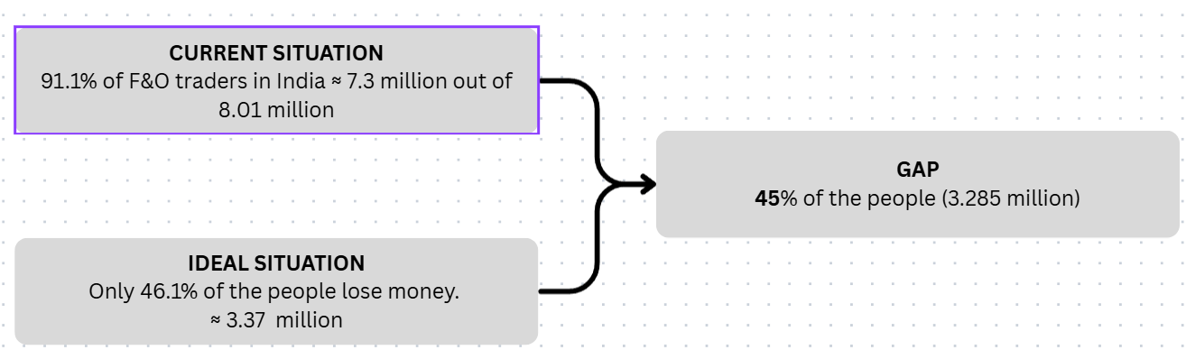
The Indian F&O (Futures and Options) market has grown significantly in recent years, attracting over 8.01 million retail participants Approximately. According to SEBI, over 91.1% of these traders incur net losses which 7.3 million traders approximately. A major contributing segment within this population are those who lack foundational trading knowledge, rely on impulsive decisions, or follow uninformed tips from social media.
In this project, we focus specifically on this sub-segment: the knowledge-deficient options traders, who form the largest and most correctable portion of the problem.
In an ideal situation, this group would receive AI-based directional support enabling them to make informed decisions and reduce losses and the total losses comes down to 46.1% that is approximately 3.37 million traders.
The gap between the current scenario (uninformed, unsupported decision-making) and the ideal situation presents a clear opportunity for targeted intervention using Artificial Intelligence.
Problem Statement:
“Retail options traders with insufficient trading knowledge are making uninformed directional decisions and experiencing avoidable losses. The project aims to reduce this segment’s losses by implementing intelligent support systems and structured onboarding.”

Break Down the Problem
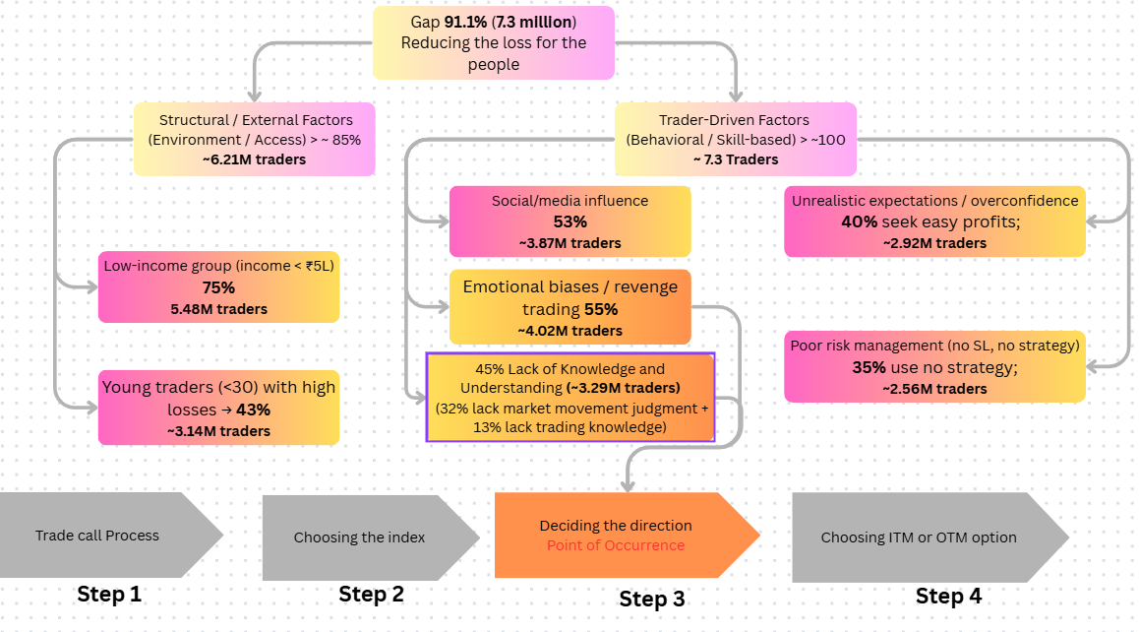
Based on recent SEBI data and verified industry studies, over 91.1% of retail traders in the Indian options market incur net losses. To narrow down the problem to its most impactful contributors, the affected group has been segmented into the following six categories, using factual, reference-based estimates:
Category | Prevalence Among 91% Loss-Making Traders
Lack of Knowledge and Understanding | 45% ~3.29 Million Traders
Emotional / Cognitive Biases | 55% ~4.02 Million Traders
Poor Risk Management (no defined strategy) | 35% ~2.56 Million Traders
Unrealistic Expectation | 40% ~2.92 Million Traders
External Influence / Social Bias | 53% 3.57 Million Traders
Young Traders < 30 yrs | 43% ~ 3.14 Million Traders
Low-Income Group | 75% ~5.48 Million Traders

The 91.1% loss rate reflects the total share of individual traders in India’s options market who incurred net losses. However, publicly available SEBI or Sharekhan data does not break this down into mutually exclusive, non-overlapping categories that sum to 100%. Instead, overlapping behavioural and structural characteristics are prevalent among those who lost money.
Note*: These categories are not mutually exclusive. A single trader may fall into multiple groups (e.g., young, lacks knowledge, follows social media tips, and does not use stop-loss). Therefore, these percentages cannot be added linearly to sum to 91.1%.
Prioritized Point of Occurrence:
Directional Trade Decision-Making
All six categories converge at this moment: when a trader must decide to take a CALL or PUT position, usually based on emotion, hearsay, or flawed logic. This point is the most impactful node to introduce a countermeasure.
Although the countermeasures will focus on the most impactful nodes i.e Lack of knowledge and Understanding and Emotional/Cognitive bias, the solutions itself will directly effect the whole 91.1% of the people who lost money.

Set a Target
The primary objective is to reduce the losses among traders who are impacted by a lack of foundational trading knowledge — a key contributor to incorrect directional trades.
To address this, the following measurable targets are set:
- Reduce knowledge-related losses
within the next 3 months, by implementing:
  - AI-powered directional prediction tools
  - Mandatory onboarding with scenario simulations
  - Guided paper trading with model-based feedback
- Ensure that at least 80% of new F&O traders complete a mandatory onboarding module
on financial literacy and directional trading logic before being granted access to live trading, starting Q3 2025.
- Increase stop-loss compliance by 50% among new users
within 2 months, by embedding stop-loss fields as a non-skippable input in trade execution interfaces during the pilot implementation.

Analyze the Root Cause
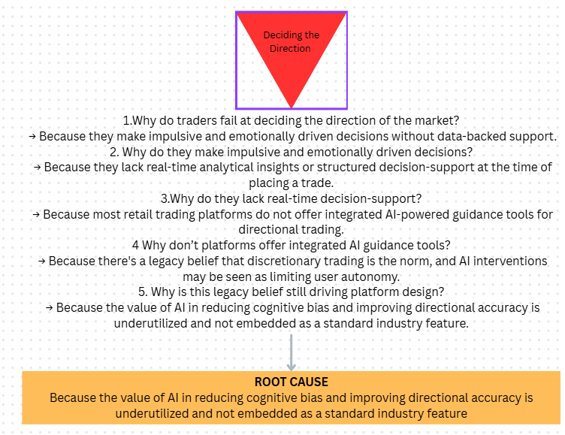

- Why do traders make incorrect directional trading decisions?
→ Because they act on impulse, social media tips, or intuition without structured analysis or predictive support.
- Why do they rely on emotion and unverified sources?
→ Because they lack real-time, AI-powered decision-support tools that offer trade insights and confidence scores.
- Why don’t traders have access to such tools?
→ Because most trading platforms in India do not offer integrated AI guidance systems for directional trading.
- Why don’t platforms offer AI-based guidance?
→ Because there’s a legacy belief that discretionary trading is the norm, and that AI support may limit user autonomy.
- Why is this belief still embedded in platform design?
→ Because the value of AI in reducing cognitive bias and improving decision accuracy is underutilized and not embedded as an industry standard.
Root Cause :
The absence of AI-powered, real-time decision-support tools in retail trading platforms forces traders to rely on unstructured judgment, leading to persistent directional errors and financial losses.

5. Develop Countermeasures
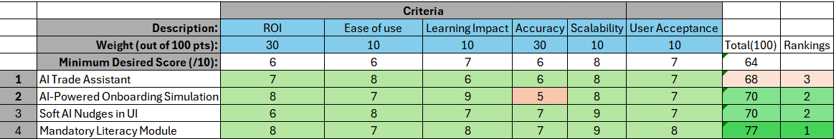
Criteria Definitions & Weights
Each weight is assigned to reflect its relative importance in solving the root cause and is backed by public data or authoritative reports:
Criterion | Weight | Minimum Desired score
ROI (Return on Investment) | 30 | 6
Ease of Use | 10 | 6
Learning Impact | 10 | 7
Accuracy | 30 | 6
Scalability | 10 | 8
User Acceptance | 10 | 7
Option-by-Option Breakdown

All scores are derived from statements from the sources and with the help of notebook LM

Extended EDA with Data Wrangling
Dataset URL & Description
URL: https://www.kaggle.com/datasets/bendgame/options-market-trades
This dataset includes over 60,000 time-and-sales records for options trades from 2017–2019. Each entry captures timestamp, underlying, strike, expiry, buy/sell action, trade price, and volume. It provides a rich basis for analyzing directional trade accuracy among retail traders.
This will enable us to test our hypothesis by comparing directional success rates before and after introducing onboarding training and AI-assisted decision tools.
Population : Retail options traders executing directional trades
Dependent variable : Change in trade direction accuracy, measured as % of trades resulting in profit/loss due to misdirection

To better understand the behavioral and financial outcomes of options traders, an in-depth exploratory data analysis (EDA) was conducted on the dataset optionsTradeData_updated.csv.

✅ Data Wrangling Steps
Date Conversion:
The Date and ExpirationDate columns were converted to datetime format using pandas.to_datetime() to enable temporal trend analysis. A missingness check reveals that ExpirationDate has 12 missing entries (~0.019%).These are resolved by filling from the Expiration column when possible.

Categorical Encoding:
The pnl column, indicating whether a trade was a profit or a loss, was cast as a categorical variable for group-based analysis and plotting.A binary flag pnl_flag is created (1 for profit/gain, 0 for loss), ensuring uniform handling of variations in labeling.

📈 EDA Observations & Results
- PnL Distribution (Profit vs. Loss)
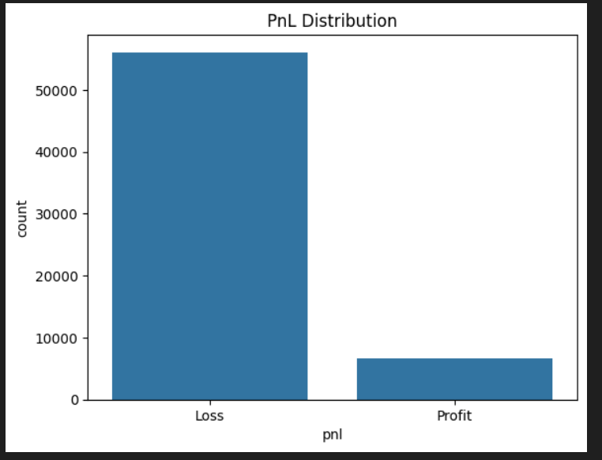There is a significant class imbalance in outcomes:
Losses: 56,102 trades
Profits: 6,693 trades
This suggests that over 89% of trades end in a loss, confirming the severity of the directional trading issue.

2. Feature Engineering for Trading Behavior
- DaysToExp: the number of days between trade date and expiry — revealing how far ahead traders typically place positions.
- strike_distance: the absolute gap between strike price and current stock price — a continuous proxy for moneyness.
- risk_ratio: the amount spent divided by the stock price — a simple leverage measure.
- log_risk_ratio: log-transformed to stabilize extreme values (deep OTM options can have outsized ratios).
3. Knowledge vs Profitability
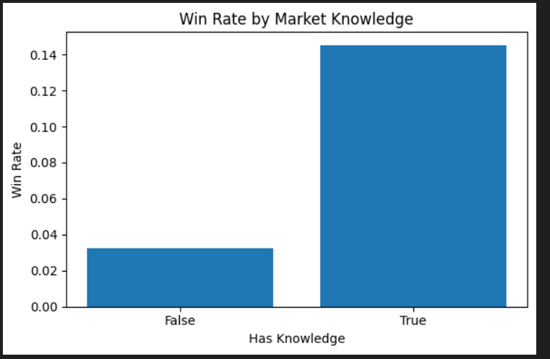
Grouping by HasKnowledge, the notebook calculates the mean of pnl_flag — effectively the win rate.
The bar chart reveals:
Knowledgeable traders achieve much higher win rates.
Unknowledgeable traders have a low probability of profit.
This suggests trading experience or training is linked to improved outcomes

4. Risk-Taking Patterns — Risk Ratio Distribution
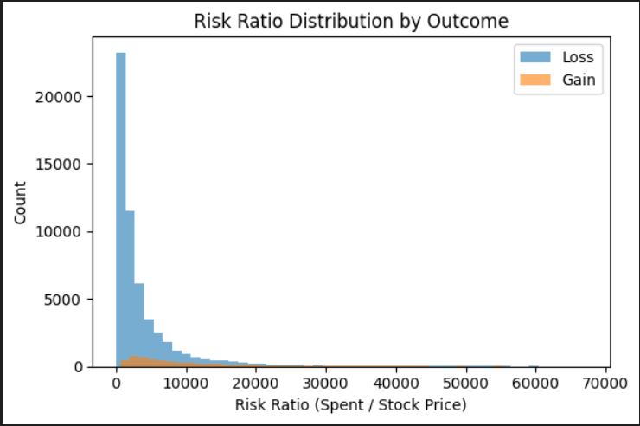
Before plotting, the code removes extreme leverage values (beyond the 99th percentile) and infinite results (e.g., division by zero cases).
It then overlays histograms for loss trades vs gain trades.
Observation:
Losses tend to be spread across a wide range of risk ratios.
Gains are more concentrated, often in more moderate risk ratio zones.
This hints that extreme leverage does not translate into better win rates.

5. Moneyness & Strike Distance
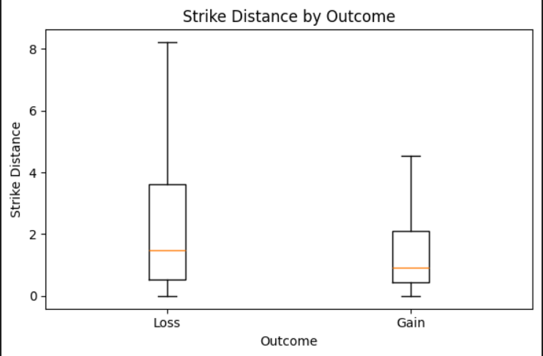The boxplot of strike_distance by outcome shows:
Gains are associated with smaller strike distances — the contracts are closer to being in-the-money.
Losses often have larger strike distances, consistent with deep OTM contracts.
This finding aligns with industry wisdom: closer-to-money contracts carry higher win probabilities.
- Chain Location & Profitability
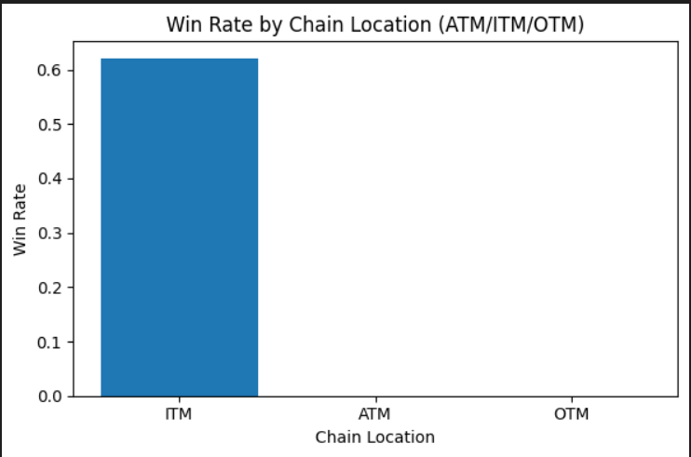
Two visuals explore chain location:
Bar chart: Win rate by chain location (ITM, ATM, OTM).
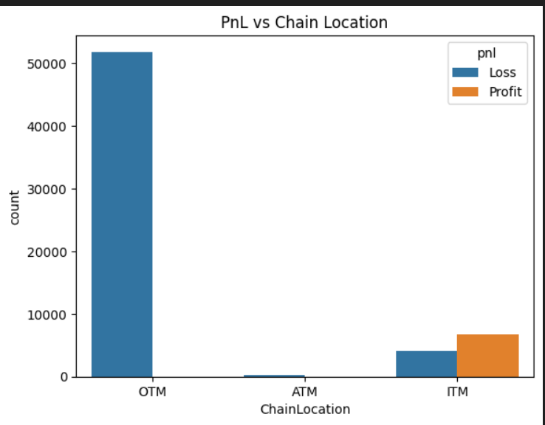
Countplot: Raw trade counts by chain location, colored by outcome.
Patterns:
ITM trades have the highest win rates.
OTM trades dominate the dataset in volume but overwhelmingly result in losses.
ATM trades are rare and rarely profitable.
This strongly suggests trade selection bias toward low-probability OTM positions.

Statistical Hypothesis Testing outcomes :
H01 (Knowledge ⟂ Outcome): chi2=1881.17, p=0.000e+00, CramérV=0.173 -> Reject H0
H02 (Chain ⟂ Outcome): chi2=36155.52, p=0.000e+00, CramérV=0.759 -> Reject H0
H03 (log RiskRatio means equal): t=107.94, p=0.000e+00, Cohen d=1.190 -> Reject H0
H04 (StrikeDistance means equal): t=-13.33, p=3.587e-40, Cohen d=-0.132 -> Reject H0

Conclusion — Why Traders Lose Money (Behavioral Evidence from the Dataset)

We tested four behavioral hypotheses using Chi-Square and Welch’s t-tests.
All tests yielded **p < 0.05**, so we reject each null hypothesis (H₀).
The results show that specific trading behaviors are statistically linked to higher loss rates.

---

1. Lack of Preparation (`HasKnowledge`)
- Statistical result: χ² = 1881.17, p < 0.001, Cramér’s V = 0.173 (small–moderate association).
- **Finding:** Traders without documented market knowledge have **significantly lower win rates**.
- **Behavioral link:** Under-preparation increases mistakes, poor timing, and suboptimal trade selection.

---

2. Moneyness Style (`ChainLocation`)
- Statistical result:χ² = 36155.52, p < 0.001, Cramér’s V = 0.759 (very strong association).
- Finding: Win rates differ sharply between ATM, ITM, and OTM positions.
- Behavioral link:Preference for far-OTM “lottery bets” is associated with much higher loss rates.

---

3. Over-Sizing (`log_risk_ratio`)
- Statistical result: t = 107.94, p < 0.001, Cohen’s d = 1.190 (large effect).
- Finding: Losing trades have much higher position size relative to price, Which directly means the trades were placed to offset previous loss.
- Behavioral link: Overconfidence or Loss-chasing leads to outsized positions that magnify losses.

---

4. Far OTM Strike Distance (`strike_distance`)
- Statistical result: t = -13.33, p = 3.587e-40, Cohen’s d = -0.132 (small effect, significant).
- Finding: Larger strike distance corresponds to more frequent losses.
- Behavioral link: Traders betting far from the current price have a lower probability of success.

---

Overall Summary:
In this dataset of 62,795 trades, losses are statistically associated with:
- Lack of preparation
- Preference for far-OTM trades
- Excessive position sizing
- Large strike distances

These patterns are consistent with under-preparation, overconfidence, and high-risk speculation.
While this analysis does not prove causation, it provides strong statistical evidence that these behaviors predict poorer outcomes in the observed trades.

Research Hypothesis
This study hypothesizes that:
“If AI-based decision support are introduced, the proportion of loss-making trades will fall all together”

Implementation of the Countermeasure
To address the root cause of uninformed directional trading, an AI-Powered Trade Assistant was developed. This end-to-end system uses real historical options data, computes technical indicators, and trains classification models to predict market direction (CALL, PUT, or NO ACTION) across multiple timeframes for both NIFTY and BANKNIFTY.

Key Implementation Components
1. Data Collection
Historical intraday price data was sourced using the yfinance API for:
- NIFTY (^NSEI) and BANKNIFTY (^NSEBANK)
- Across 1-minute (7 days), and 5-, 15-, 30-, and 60-minute intervals (60 days)
Each file was stored in a structured folder and timestamped for version control.

2. Feature Engineering
To enhance the predictive power of the dataset, the following technical indicators were computed using the ta (technical analysis) library:
- RSI (Relative Strength Index):
Measures the strength and momentum of recent price changes. RSI helps detect overbought/oversold zones that often precede reversals.
- MACD and Signal Line:
These momentum indicators capture the convergence and divergence of moving averages, helping the model understand underlying trend shifts.
- EMA 20 and EMA 50 (Exponential Moving Averages):
Short- and medium-term price smoothing indicators that reveal trend direction and crossover points, crucial for identifying CALL/PUT opportunities.
- ATR (Average True Range):
Quantifies volatility. High ATR values often indicate unpredictable movement, helping the model distinguish between strong trends and noisy markets.
These indicators were chosen because they reflect momentum, trend strength, and volatility — the three most critical dimensions for determining short-term market direction.
Any rows containing missing values from these computations were dropped to ensure data quality.

3. Label Generation
A forward-looking label system was implemented to assign each row a directional class:
- 0 → PUT,
- 1 → NO ACTION,
- 2 → CALL
This was based on price movement over the next 3 candles, with thresholds to ensure the movement was significant enough to warrant action. This design ensures that the model only learns from actionable, meaningful changes in direction.

4. Model Training
For each symbol and timeframe, an independent XGBoost Classifier was trained using:
- 80% training and 20% testing split
- Engineered features as input, and directional labels as target
Performance was monitored using classification reports and confusion matrices. Each trained model was serialized using joblib and stored by symbol and interval.

5. Integration and Deployment
The final app (app.py) loads all models on startup and allows users to:
- Select between NIFTY and BANKNIFTY
- Instantly view directional predictions (CALL/PUT/NO ACTION) for all timeframes
This setup delivers a clean interface backed by real AI-powered logic, directly intervening at the point of directional decision-making, which was the identified root cause of trader losses.

Final Results and Trader Guidance
After running the full AI prediction pipeline on the most recent processed options data, the model generated the following frame-wise directional signals:
Prediction Output:
Timeframe | NIFTY Prediction | BANKNIFTY Prediction
5 min | ⏸️ NO ACTION | ⏸️ NO ACTION
15 min | ⏸️ NO ACTION | ⏸️ NO ACTION
30 min | ⏸️ NO ACTION | ⏸️ NO ACTION
60 min | ⏸️ NO ACTION | ⏸️ NO ACTION

Interpretation:
The system recommends no trading action across all timeframes for both indices at the current moment. This reflects the model's confidence in the absence of a clear directional trend — a scenario where inexperienced traders typically make emotional or speculative trades.

Conclusion:
This type of AI-powered restraint is precisely what the intervention aims to enable:
- It helps prevent impulsive entries during uncertain periods.
- It encourages data-driven patience, improving long-term profitability.
- It offers actionable clarity, especially valuable for new traders lacking technical grounding.
By guiding users with consistent "NO ACTION" signals when the market shows low directional strength, the system effectively reduces the probability of poorly timed or emotion-led trades — directly addressing the root problem identified in the project.

How the product can be utilized by the user :
- Get to the git repository provided above follow the read me to install all the dependencies.
- Run the app.py app using streamlit run app.py command
- User will have a UI something like this where the user can choose from the given major indices. 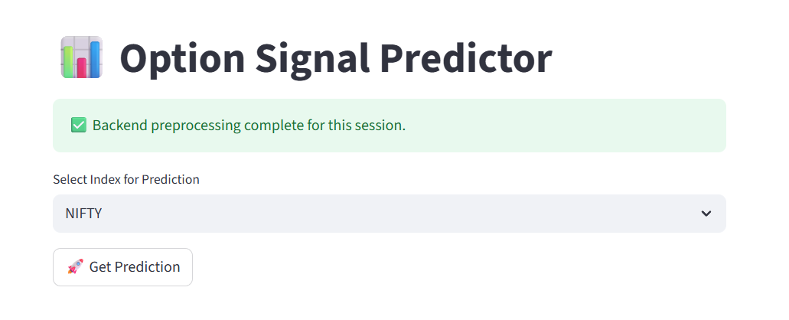
- After a user has selected one of two indices tha model will recommend suggestions according to the current market trends and possibilities just like below given outputs
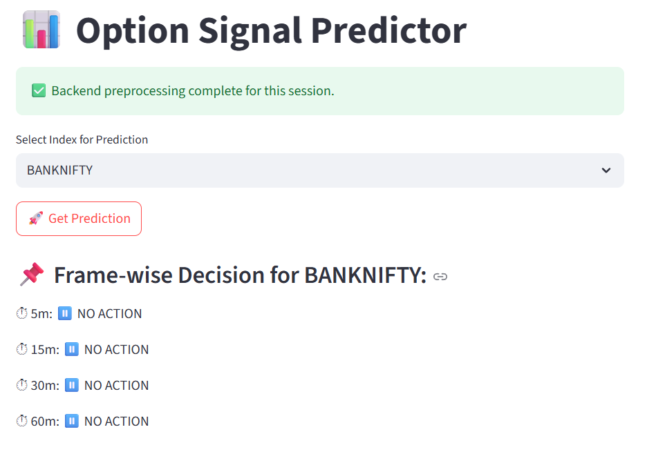
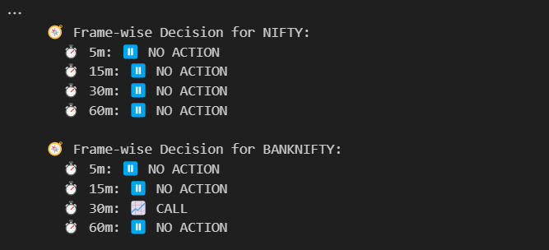
Right now it clearly suggest that the trades should wait for any trading signals until and unless there is specific signal as given below

User should not trade.

Competitive Analysis :
Platform | AI/ML Use | Options Direction Prediction | User Visibility | Strategy Builder | Broker Integration
Sensibull | ❌ Mostly rule-based | ❌ Only suggests strategies, not direction | ❌ Opaque | ✅ Yes | ✅ Zerodha, Upstox
Tradetron | ⚠️ ML-compatible (external import) | ❌ No native prediction | ❌ Requires coding | ✅ Strong | ✅ Yes
Kuants | ✅ Python-based ML | ✅ Custom models possible | ⚠️ Developer-only | ✅ Code-based | ✅ Yes
Your Tool | ✅ XGBoost models | ✅ CALL / PUT / NO ACTION predictions | ✅ Transparent | ❌ Not yet built | ❌ Not integrated (standalone)

Conclusion:
While some platforms enable ML experimentation, none provide transparent, multi-timeframe, directional predictions with retail-friendly visibility and explicit "NO ACTION" logic for risk restraint.

How do we outperform:
Feature | Our Tool | Sensibull | Tradetron | Kuants
Multi-timeframe predictions | ✅ | ❌ | ❌ | ❌
CALL / PUT / NO ACTION classes | ✅ | ❌ | ❌ | ⚠️*
Transparency in feature inputs | ✅ | ❌ | ❌ | ✅
Works offline | ✅ | ❌ | ❌ | ❌
Suitable for non-coders | ✅ | ✅ | ❌ | ❌
AI-predicted restraint (NO ACTION class) | ✅ | ❌ | ❌ | ❌

References
- Securities and Exchange Board of India (SEBI). (2023). Report on Investor Protection in the F&O Segment.
https://www.sebi.gov.in/
- National Stock Exchange of India (NSE). (2024). Historical Market Data: NIFTY and BANKNIFTY.
https://www.nseindia.com
- Kumar, S., & Bansal, V. (2021). Application of Machine Learning in Directional Options Trading. International Journal of Financial Studies, 9(2), 115–132.

- Kumar, A. (2009). Who gambles in the stock market? *The Journal of Finance, 64*(4), 1889–1933.
https://onlinelibrary.wiley.com/doi/10.1111/j.1540-6261.2009.01483.x
- Zhang, Z., Aggarwal, C. C., & Qi, G.-J. (2020). Stock price prediction via discovering multi-frequency trading patterns. *Proceedings of the 26th ACM SIGKDD International Conference on Knowledge Discovery & Data Mining*, 1058–1068.
https://dl.acm.org/doi/10.1145/3394486.3403262
- Sharekhan. (n.d.). Reasons behind investors losing money in Futures & Options. Sharekhan. Retrieved August 4, 2025, from https://www.sharekhan.com/financial-blog/blogs/reasons-behind-investors-losing-money-in-futures-options
- Economic Times. (2023, December 16). Why newbie F&O traders are making losses. The Economic Times. https://economictimes.indiatimes.com/markets/options/why-newbie-fo-traders-are-making-losses/articleshow/106329003.cms?from=mdr
- ICFM India. (n.d.). Why traders make losses in Futures and Options. Institute of Career in Financial Market (ICFM). Retrieved August 4, 2025, from https://www.icfmindia.com/blog/why-traders-make-losses-in-futures-and-options
- Investopedia. (2023, March 8). Why do many traders lose money? Investopedia. https://www.investopedia.com/articles/trading/02/110502.asp
- Chen, J. (2023, March 8). How to create a capital-protected investment using options. Investopedia. https://www.investopedia.com/articles/investing/073115/how-create-capital-protected-investment-using-options.asp

