Date : 05/08/2021

Given Task : Build Basic Website using HTML

1. Home Page
2. About Us Page
3. Contact Us Page
4. Education Details (use table)
5. Registration Form

Time duration : 2 Days

My Task Description : Completed work of Today

1. Home page (Used division for header, body, fixed footer. Links set for profile information, Used CSS for better UI)
2. About Us page (Detailing part for profile using different tags)
3. Contact Us Page (API link of Google Maps to show address/location , profile picture, contact/email address)

All pages are responsive, CSS applied.

ScreenShots of Output :

1. Home Page

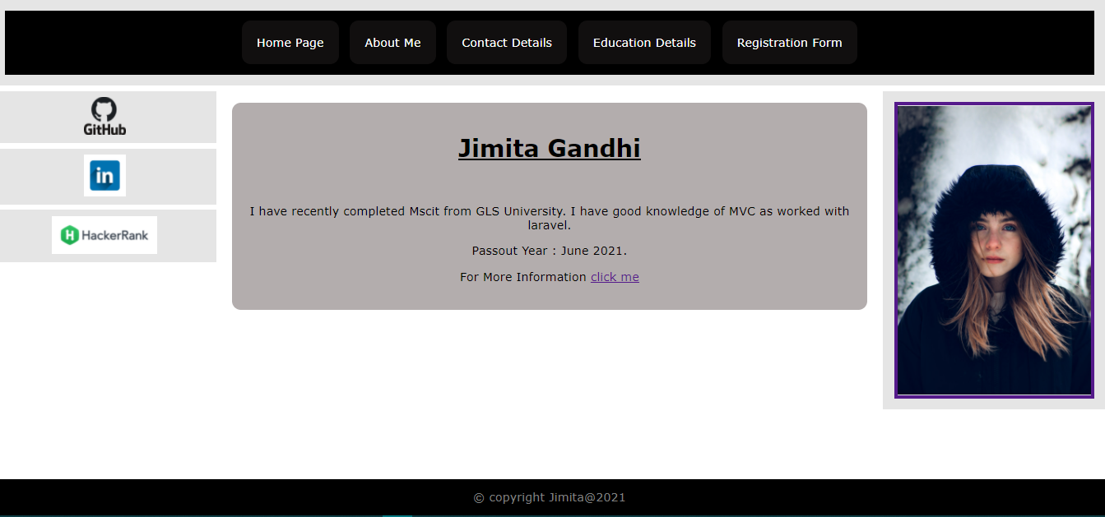

1. About Us Page

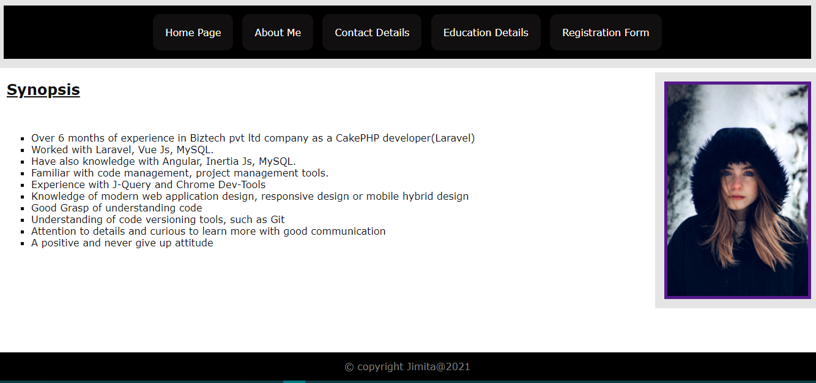

1. Contact Page

