Date : 11/08/2021

Task Given : Html, CSS custom layouts

Topics:

Html controls

style sheets,css selector, css properties, font, links, list properties

position, overflow property, table, tooltips, form property, hover, cursors, float & opacity property  
CSS3 :- different properties

Added : map api, different animations and its properties, used carosel for image slidding, tooltip, rext shadows, fonts, css icons etc

ScreenShots of outputs :

HOME PAGE

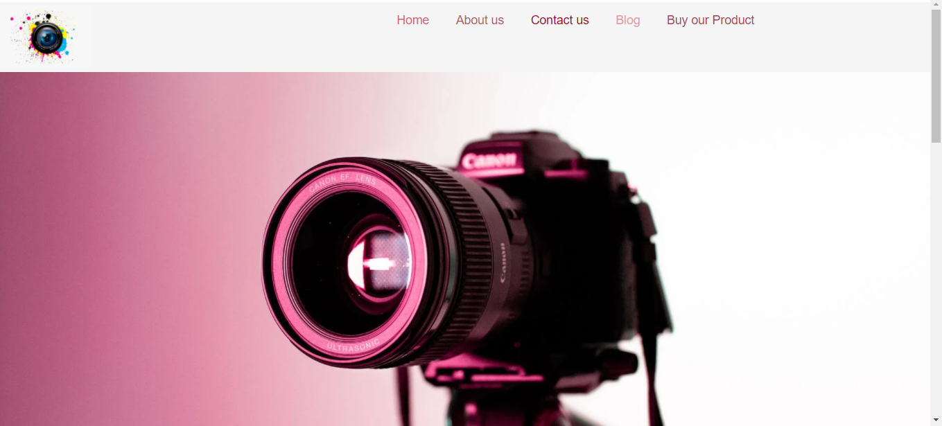

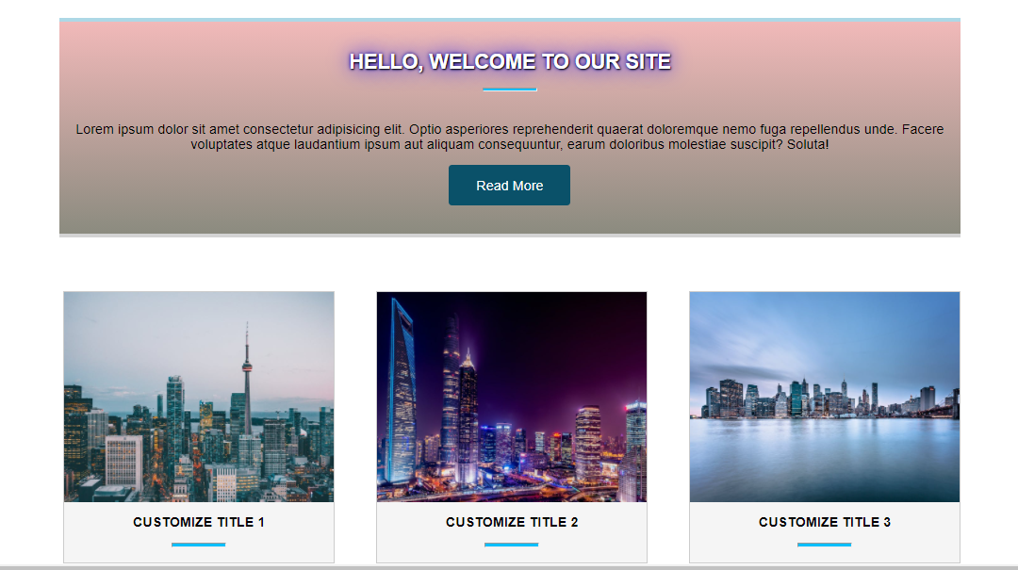

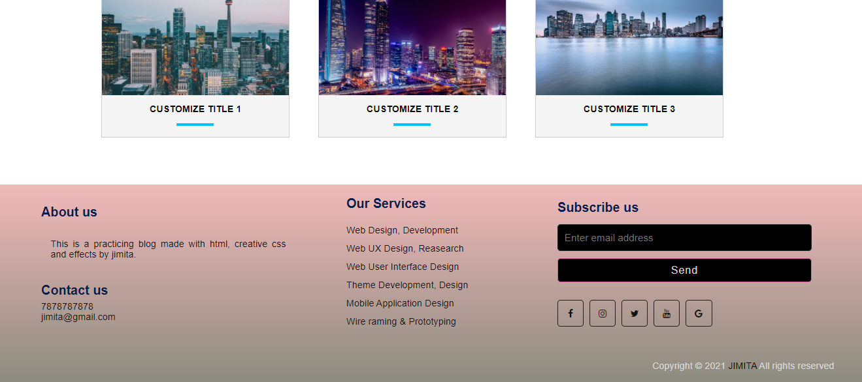

ABOUT US PAGE

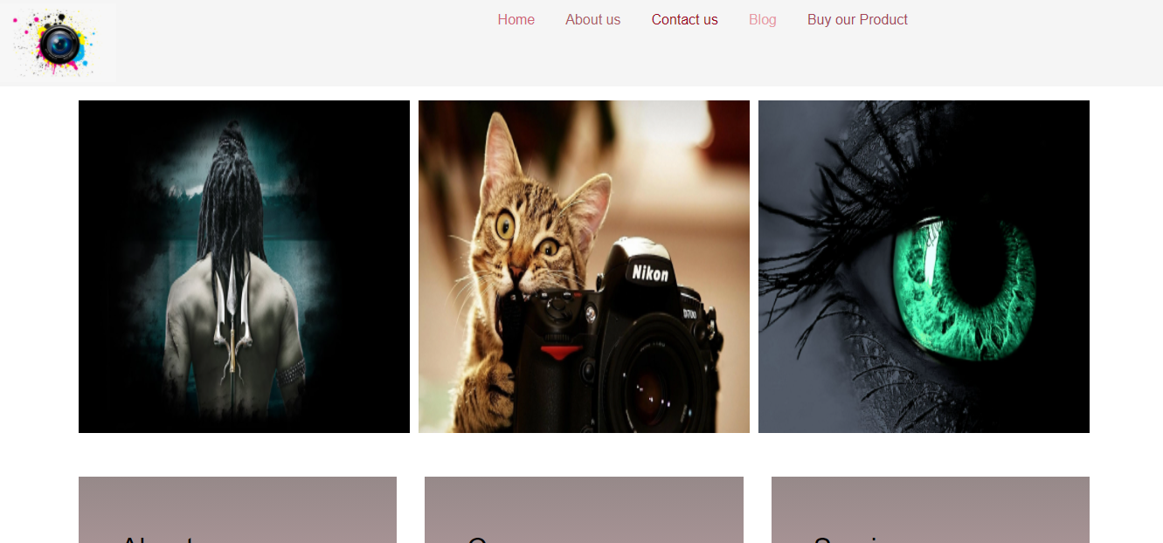

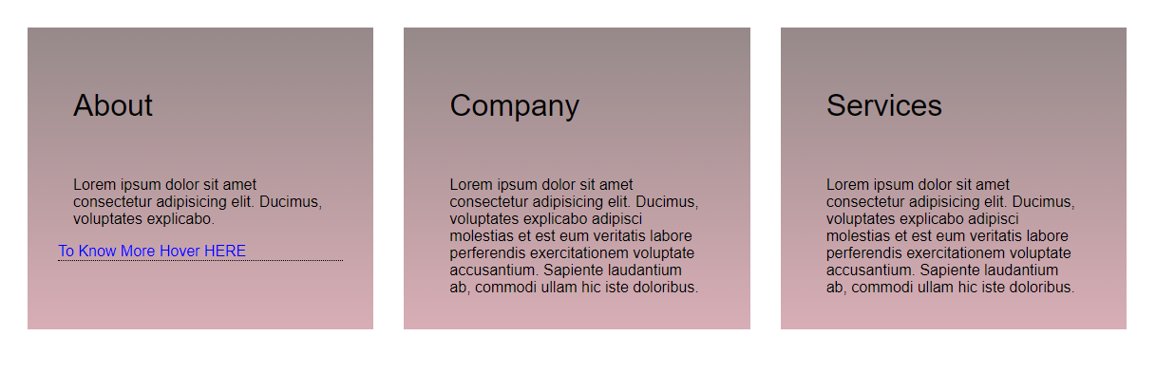

CONTACT US PAGE

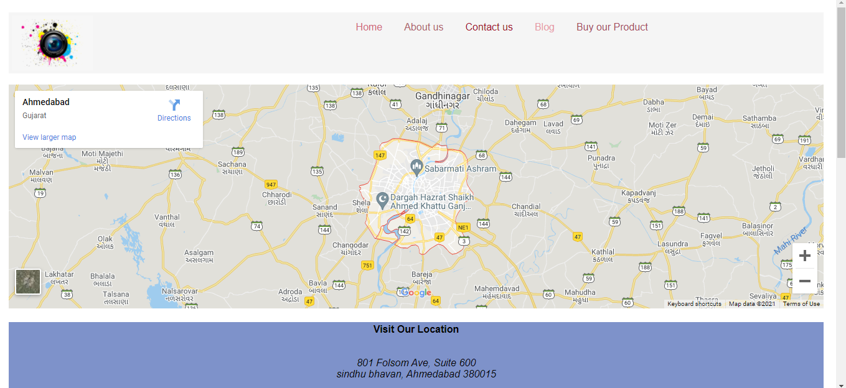

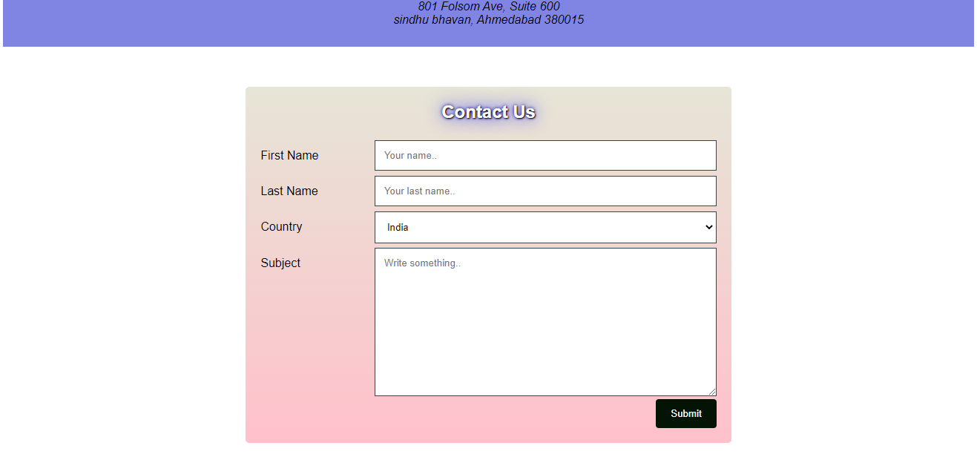

BLOG PAGE

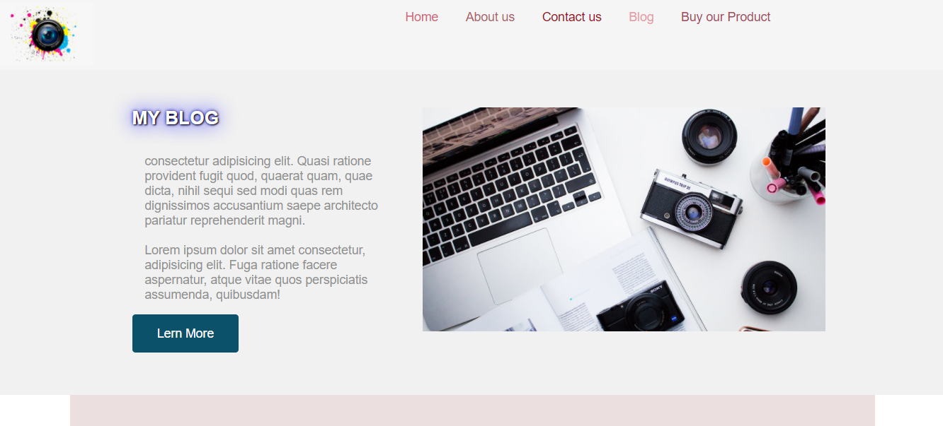

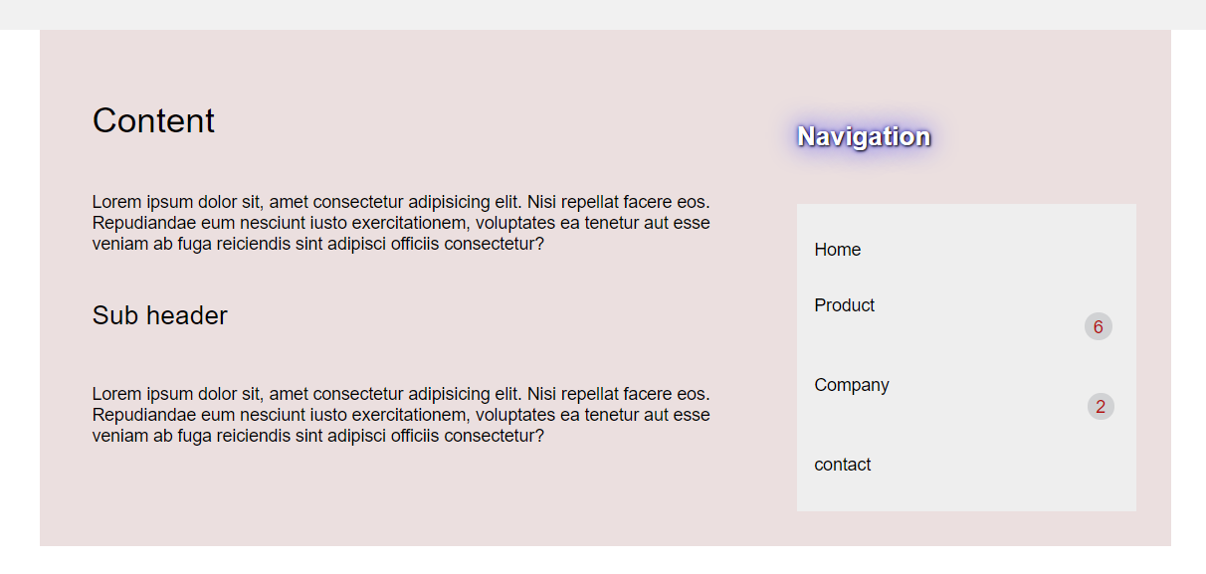

PRODCUT PAGE

