Date: 21/08/2021 and 23/08/2021

Task Given :     1-Simple Demo Both Plugins

2-Form and Datatable in Single Page

3-Registration form With All Validation

  Name,Mobile,email,DOB,Age,File(Images),Password Confirm Password,Minmim Character.

4-Lightbox Plugin,CKEditor Plugin

    1-https://lokeshdhakar.com/projects/lightbox2/

    2-https://ckeditor.com/ckeditor-5/

    3-https://bxslider.com/

    4-https://harvesthq.github.io/chosen/

ScreenShot of DataTables :

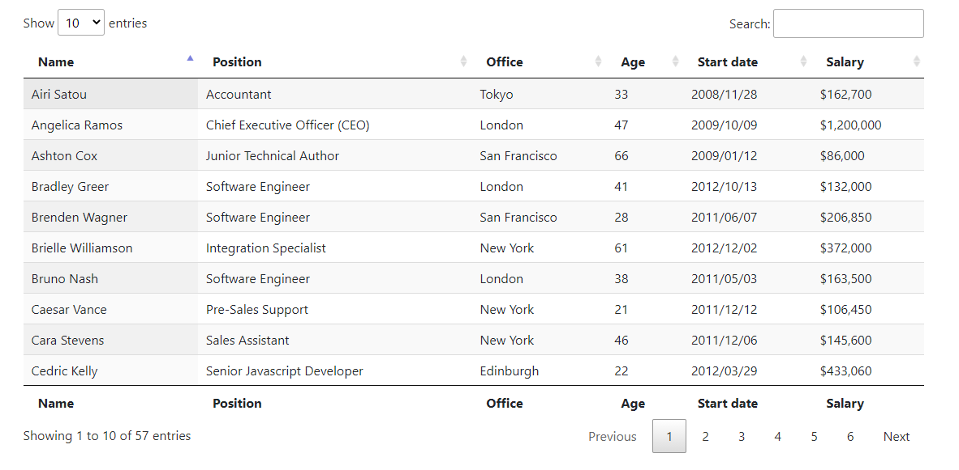  
Screenshots of form validator plugin:

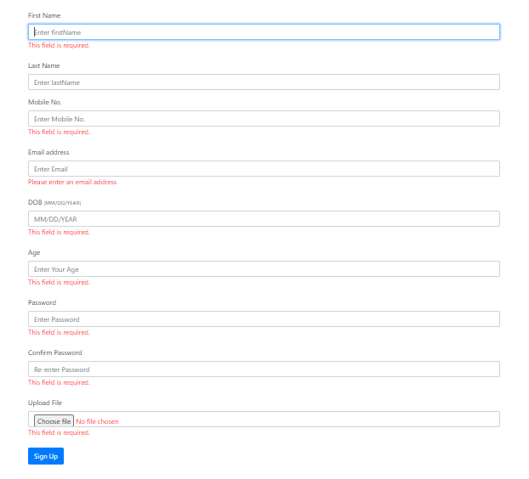

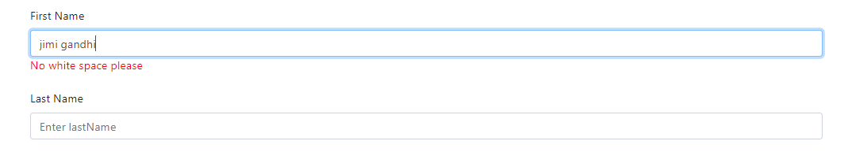

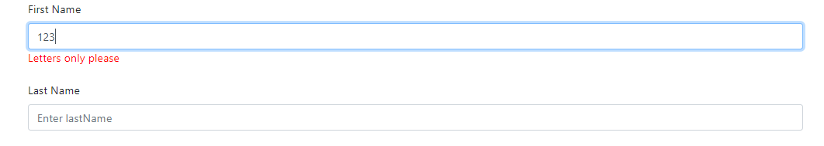

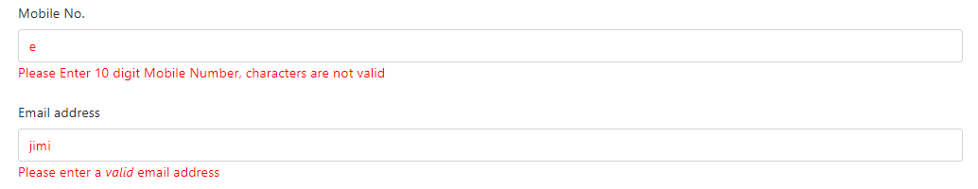

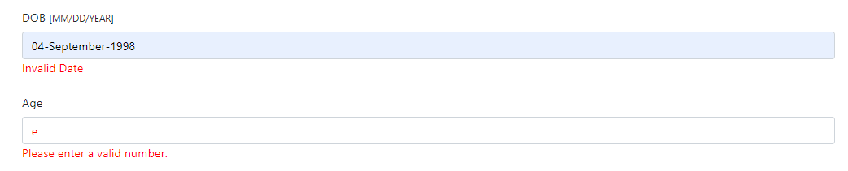

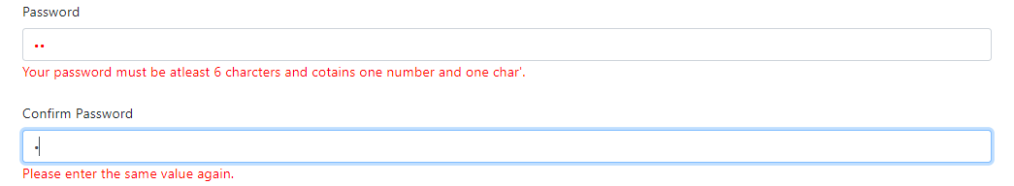

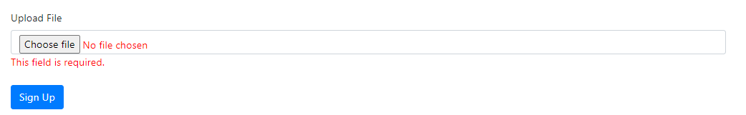

Screenshots of popup lightbox plugin:

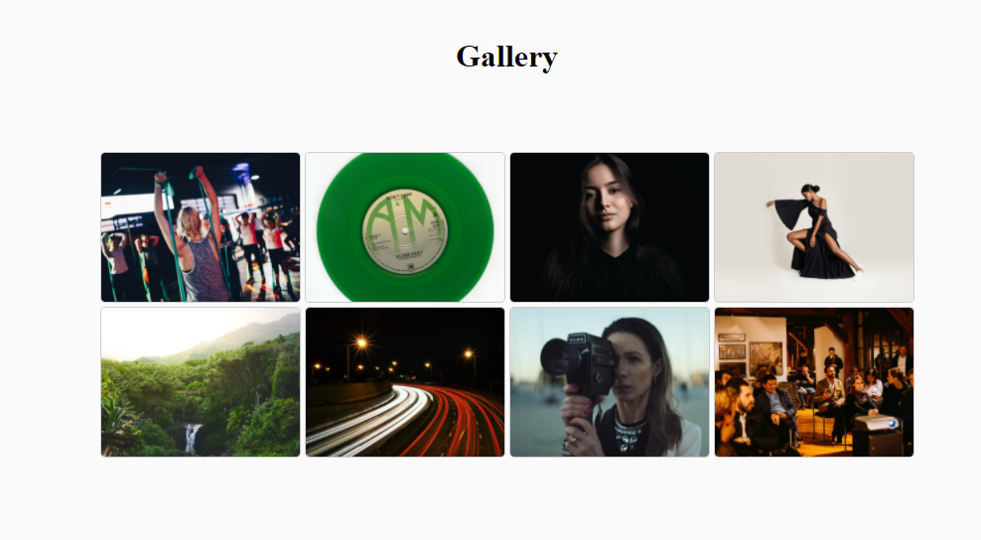

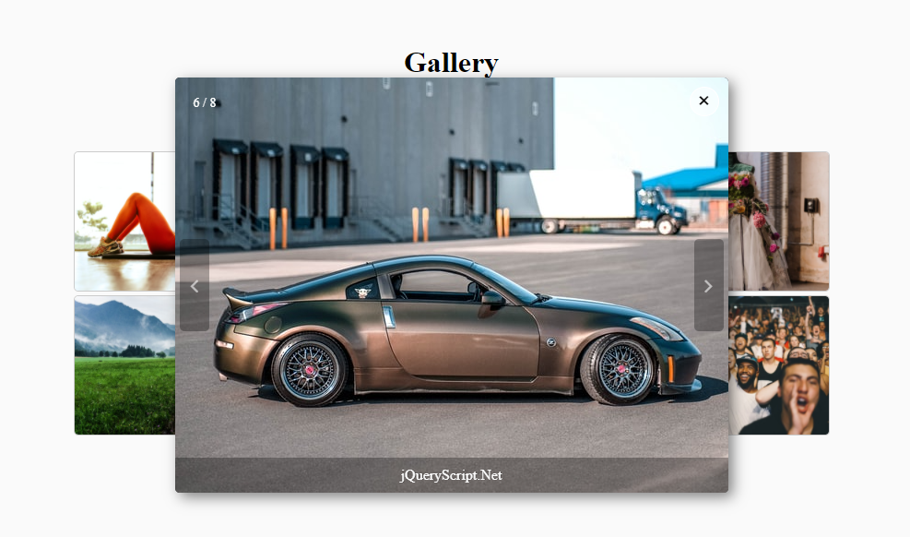

Screenshot of ckEditor:

