NorthgateArinso  730 Waterside Drive  Aztec West  Bristol  BS32 4UE  UNITED KINGDOM | 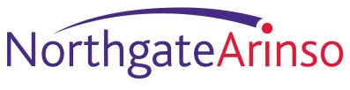

SAML access to MyView
Overview Information
CORE-TN-004
Version: 1.2

This document provides an overview of the level of support for the SAML protocol for the NorthgateArinso product MyView.

Warning

This document contains confidential information, which is proprietary to NorthgateArinso. No part of its contents may be used, disclosed or conveyed to any party, in any manner whatsoever, without prior written permission from NorthgateArinso.

© Copyright 2010, NorthgateArinso. All rights reserved.

Table of Contents
Author: Jim Ball

Title: Core Engineering-Java Developer

Contact point: james.ball@northgatearinso.com (+44 (0)1454 621075)

Document treated as: CONFIDENTIAL

Version | Author | Date | Comments
1.1 | JB | 07/09/2010 | First draft
1.2 | JB | 04/03/2010 | Following clarification of the usage of encryption and signing in SAML2 response bodies to remove any chance of misunderstanding.
1 Introduction 2
2 High-level architecture 3
3 MyView and SAML feature overview 5

- Introduction
When a customer wants our product suite to integrate with their own existing identity infrastructure, an emerging trend is for the customer to expect our web applications to cope with access demands they send us such that their users do not need to provide “yet another” username and password to access our functionality.
A SAML assertion is a security standard compliant access demand that can be used to hold identity information that can travel securely from a customer’s domain to our domain, can be trusted, and can be used to silently login a user at our application without the user having to re-enter their credentials.
Driven by customer requirements, and by an understanding that SAML assertions are a key mechanism used in secure cross-domain application usage, NorthgateArinso provides a simple mechanism to allow access to the MyView product that involves the minimum interaction between a customer's network and our own.
With SAML, this mechanism is called Identity Provider Initiated SSO Post binding and is illustrated in section 5.1.4 of the document SAML v2 overview and use cases. SAML1.1 also provides an equivalent of this flow which can be less secure because the assertion content is not encrypted, and which is covered in section 4.2.1 of the document SAML1.1 use cases.
Within the Northgate environment we provide SAML middleware that acts as a service gateway to the MyView application. This middleware can process either SAML1.1 or SAML2 assertions that come from customer sites.
The addition of SAML to the MyView product now gives customers the opportunity to allow their users to access MyView as a link from their own website without needing to provide MyView credentials. This facility works concurrently alongside a customer’s existing usage of MyView, so giving customer’s the ability to incrementally provide cross-domain single sign on to our product with minimal impact on the services they already provide.
- High-level architecture
The following diagram shows the high-level sequence of events should MyView be accessed via SAML 1.1 or SAML2 assertions originating from a customer site.
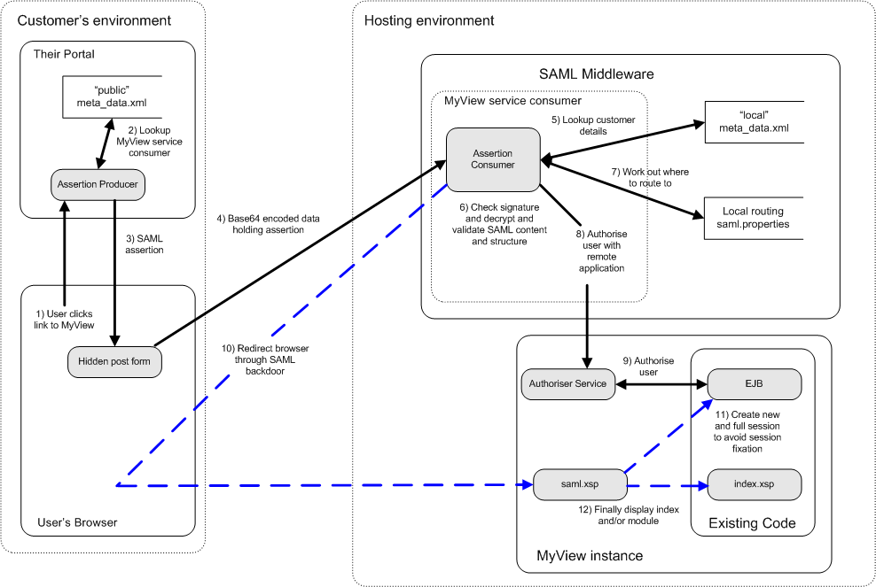
The diagram illustrates the following key points:
- The customer’s infrastructure is responsible for authenticating users when they login to the customer’s portal.
- The customer’s infrastructure, usually in the form of an identity management system, maintains a mapping between a customer’s domain users, and the user’s MyView application identifier.
- The customer’s portal/infrastructure has itself been SAML enabled to allow the creation of, and sending of SAML1.1 or SAML2 assertions to Northgate.
- In order to correctly send SAML, the customer’s infrastructure shares a common standards based contract with Northgate, expressed in SAML metadata. This metadata is something we exchange with each other when setting up a SAML circle of trust. It tells the customer side how to encrypt SAML sent to Northgate and where to send it to. Conversely it tells the Northgate side how to check the digital signature of any SAML received from customers.
- On arrival, any assertion sent to Northgate is validated according to the common metadata contract, and behind the scenes the Northgate infrastructure then asks the target application if the user is authorised to see the application.
- If the user is authorised, the user will be redirected to the application without asking for credentials.
- If either the SAML sent is invalid, or the user is not authorised to see the application, the user will be redirected to a destination that can be specified by the customer, at which the customer can reveal the reason for the problem if they so wish.
- MyView and SAML feature overview
The following MyView SAML features have been provided:-
- SAML2 support for identity provider initiated single sign on.
- SAML1.1 support for Browser Post Profile.
- In both cases Northgate support standard bearer provided identifiers that match MyView identifiers.
- We assume a shared cryptography or trust infrastructure. For SAML2 the customer sends us a public key we use to validate the digital signature they apply on SAML response bodies they send us, and we send them an X509 public key they can use to encrypt the assertion they send us within those response bodies.
- For SAML1.1 the customer sends us a public key we use to validate the digital signature they apply on SAML response bodies they send us and that is it, as encryption is not supported fully by SAML1.1, which is the key difference from a customer perspective between SAML1.1 and SAML2, in SAML2 the assertions are encrypted, and in SAML1.1 they are not.
- We use SAML2 metadata to express this shared trust infrastructure. We send the customer a piece of metadata that tells them how to encrypt the assertions they send us if using SAML2, and where to send their encapsulating SAML response bodies to, and they send us a piece of metadata that expresses who they are, where they are from, and how they sign the response body encapsulating the encrypted assertion (in SAML2) and unencrypted assertion (in SAML1.1).
- We allow the customer to access modules within MyView to facilitate “deep-linking”. Deep-linking is the act of exposing specific parts of a remote application by providing application specific context in the SAML sent to Northgate.
- The MyView module name must be provided as part of the SAML response body sent. In SAML2 it is called the relayState and in SAML1.1 it is called the TARGET.
- Without a specific deep-link module, the customer will end up at the MyView home panel.
- MyView will not display secondary authentication dialogs to the user following SAML login.
- MyView will not display the password change dialog to a user following SAML login, to ensure application level security integrity.
- If an error occurs either in the processing of the assertion or on the establishment of a session at MyView, the customer can provide us with a URL to which we should redirect the user’s browser to indicate an error. This forms part of a customer’s configuration information outside the basic SAML specification.
- Auditing can be performed via our middleware logging output that can be used to trace when an assertion for a given user arrives at our middleware and is either successfully validated or not, so we can trace system and application usage on behalf of any customer, and manage any contractual or trust disagreements that may occur given system usage.
- The SAML middleware will protect itself against denial of service attacks by checking for replay of the same assertion identifier within a default time period of 30 minutes. If an assertion is received with the same SAML assertion identifier within this time-period, it will be rejected.
- The SAML middleware will protect itself against malicious usage by checking the timeframe of reception of an assertion within a default time period of 3 seconds in the past to 30 minutes in the future.
For additional technical details on the SAML metadata exchange, the transfer of SAML from a customer’s environment to our own, the list of errors the middleware can report, the auditing, and the MyView deep-linking features please contact your Northgate representative, for them to furnish you with the right documentation.
Please note that as per Northgate standard policy, custom work for SAML processing outside this list can be considered on a case by case basis as bespoke work. For more details please contact your Northgate representative.

Last page of document

