NorthgateArinso  730 Waterside Drive  Aztec West  Bristol  BS32 4UE  UNITED KINGDOM | 

Testing the SAML middleware
Technical Note
CORE-TN-003
Version: 1.1

This document illustrates how to test the SAML middleware either from a QA perspective or from a deployment/hosting perspective.

Warning

This document contains confidential information, which is proprietary to NorthgateArinso. No part of its contents may be used, disclosed or conveyed to any party, in any manner whatsoever, without prior written permission from NorthgateArinso.

© Copyright 2010, NorthgateArinso. All rights reserved.

Table of Contents
Author: Jim Ball

Title: Core Engineering-Java Developer

Contact point: james.ball@northgatearinso.com (+44 (0)1454 621075)

Document treated as: CONFIDENTIAL

Version | Author | Date | Comments
1.1 | JB | 07/09/2010 | First draft
1 Introduction 2
1.1 Secondary Authentication 2
1.2 Maintaining operator data 3
2 Use Cases 4
2.1 Log In 4
2.2 Provide Answers 6
2.3 Setup Answers. 7
2.4 Change Answers 9
2.5 Change Password 10

- Introduction
This document describes how MyView authentication will be applied for Aurora operators.
The following Use Case diagram can be provided, and is explained further in the following sections:
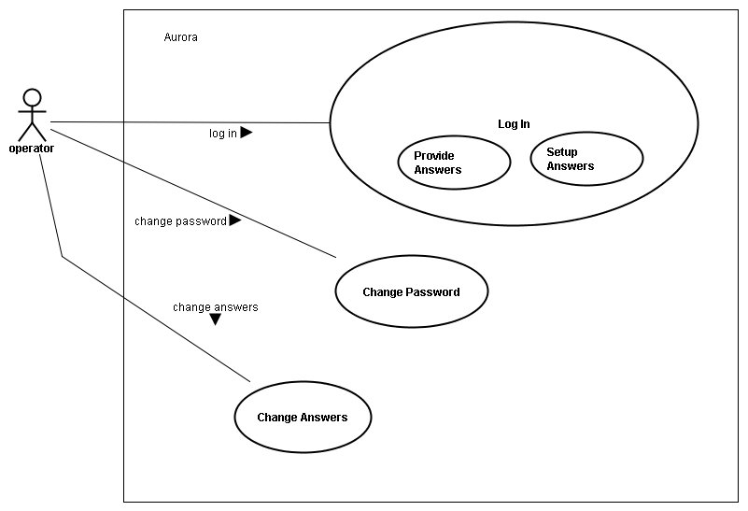

- Secondary Authentication
When they log into Aurora, an operator may or may not have to answer additional authentication questions, and may or may not have to setup un-configured answers to additional authentication questions.
Whether secondary authentication is active or inactive for operators within Aurora depends on whether the system holds secondary authentication questions for operators.
Secondary authentication questions for operators will be setup by a ResourceLink administrator from an existing ResourceLink screen, and will be stored in the table D1901M.
There are two types of operator questions, ones that are mandatory, so must be answered, and ones that are random, so where only one of the possible set will need to be answered. The D1901M column value SEC_QUESTION_OPR_LOGON can be set to “R” for a random question or “M” for a mandatory question.
If the value of the column SEC_QUESTION_OPR_LOGON is not “R” or “M” then the question is deemed inapplicable for operator login at Aurora, so is ignored.
Having applicable operator questions isn’t the complete picture. Operator secondary authentication questions also match operator defined answers that are setup by the operator from an Aurora screen, and will be stored in the table D1904M.
If a question already has an operator defined answer in D1904M then it is eligible for being answered on login, if it doesn’t then it will need to be setup with an answer.
So, during the login process described in use case [Log In], before an operator can see the Aurora desktop, if the system has applicable operator questions for them, up to two new sequential use cases may need to be performed:
- The operator may need to provide correct answers to the questions that can be answered. So this means following the use case [Provide Answers].
- The operator may need to setup their un-configured answers. So this means following the use case [Setup Answers].
The operator will only see the Aurora dashboard if all steps are completed successfully otherwise they will be returned to the login screen.
Please see the applicable use cases for more details.
- Maintaining operator data
Borrowing MyView authentication when it comes to maintenance of operator data takes two forms
- The MyView algorithm used to enforce a given level of password security will be used when an operator enters a password from the change password screen. See use case [Change Password].
- The same dialog used on login for setting up un-configured answers also needs to be available from the Aurora dashboard, so an operator can change their expected answers if they need to. See use case [Change Answers].
- Use Cases
The following section covers these use cases in more detail. It is anticipated that these use case descriptions can/could be used as a basis for system and acceptance testing that the functionality has been met.
- Log In
Scenario | Operator logs into Aurora
Triggering Event | Accessing the Aurora application in a browser
Actors | Operator
Related Use Cases | [Change Password], [Provide Answers], and [Setup Answers]
Pre-Condition | Aurora is up and running in the network and accessible to the operator’s browser
Post-Condition | None
Requirements met | None defined
Main Success Scenario | - Operator enters username and password at login screen  - System displays dialog to operator requesting answers to additional security questions. Go to use case [Provide Answers]  - System displays dialog to operator for un-configured answers. Go to use case [Setup Answers].  - System displays dashboard
Alternative Scenarios | At step 1, User enters invalid credentials | - The system will display a simple error message on the login screen  - The operator will not progress past the login screen.
Alternative Scenarios | At step 1, system error | - System displays simple error message on login screen.
Alternative Scenarios | At step 1, password has expired | - Go to use case [Change Password]  - Continue to step 2
Alternative Scenarios | At step 1, Aurora is in single sign on mode | - Operator enters network username and password.  - System gets identity details from the Access Manager in the middle of the network.  - System establishes ResourceLink operator details given identity details.  - Continue to step 2
Alternative Scenarios | At step 2, No secondary authentication questions exist. | - Continue to step 4
Alternative Scenarios | At step 2, no answerable questions exist for the operator | - Skip display of dialog and continue to step 3
Alternative Scenarios | At step 2, Invalid answers provided | - Return to step 1  - Display simple error message on login screen
Alternative Scenarios | At step 2, operator attempts to cancel dialog | - Return to step 1  - Display simple error message on login screen
Alternative Scenarios | At step 2, system error | - Return to step 1  - Display simple error message on login screen
Alternative Scenarios | At step 3, no un-configured answers exist | - Continue to step 4
Alternative Scenarios | At step 3, invalid configuration provided | - Return to step 1  - Display simple error message on login screen
Alternative Scenarios | At step 3, system error | - Return to step 1  - Display simple error message on login screen
Notes | - The dialogs displayed at step 2 and 3 are modal, namely cannot be ignored.  - The behaviour of the system as a whole is the same when there is a system error and when invalid details are provided. This is as per Symantec penetration test expectations.  - The simple error message displayed on the login screen is Invalid logon attempt  - The screens and the sequence of events need to be internationalised as per the rest of Aurora.  - The configuration for the answers expected for operator questions are kept in a separate ResourceLink table D1904M. The details of the ResourceLink database changes made to support operator second level authentication at Aurora are to be found in the document { Document reference unknown }
- Provide Answers
Scenario | Operator provides answers to secondary authentication questions
Triggering Event(s) | Operator logs in
Actor(s) | Operator
Related Use Cases | [Log In]
Pre-Conditions | - Operator has provided correct name and password at login  - There are secondary authentication questions to ask the operator
Post-Conditions | None
Requirements Met | None defined
Main Success Scenario | - System obtains list of mandatory questions with defined answers  - System obtains list of random questions with defined answers  - System display dialog holding all the mandatory questions obtained at step 1, and one of the questions obtained at step 2.  - Operator provides valid answers
Alternative Scenarios | At step 4, Invalid answers provided | - Return to step 1 on use case [Log In]  - Display simple error message on login screen
Alternative Scenarios | At step 4, operator attempts to cancel dialog | - Return to step 1 on use case [Log In]  - Display simple error message on login screen
Alternative Scenarios | At step 4, system error | - Return to step 1 on use case [Log In]  - Display simple error message on login screen
Notes | - The dialog displayed at step 3 is modal, namely cannot be ignored.  - The behaviour of the system as a whole is the same when there is a system error and when invalid details are provided. This is as per Symantec penetration test expectations.  - The dialog needs to be internationalised as per the rest of Aurora.

- Setup Answers.
Scenario | Operator sets up answers to un-configured secondary authentication questions
Triggering Event(s) | Operator logs in, see the sequence of events in use case [Log In]
Actor(s) | Operator
Related Use Cases | [Log In]
Pre-Conditions | - Operator has provided correct name and password at login  - There are un-configured authentication questions for the operator to configure
Post-Conditions | None
Requirements Met | None defined
Main Success Scenario | - System obtains list of un-configured questions, both mandatory and random  - System display dialog holding all the questions and empty input fields for their configured answers.  - Operator provides configured answers
Alternative Scenarios | At step 3, Incomplete answers provided | - Display simple error message on dialog
Alternative Scenarios | At step 3, invalid answers provided | - Display simple error message on dialog
Alternative Scenarios | At step 3, operator attempts to cancel dialog | - Return to step 1 on use case [Log In]  - Display simple error message on login screen
Alternative Scenarios | At step 3, system error | - Return to step 1 on use case [Log In]  - Display simple error message on login screen
Notes | - The dialog displayed at step 3 is modal, namely cannot be ignored.  - The behaviour of the system as a whole is the same when there is a system error and when invalid details are provided. This is as per Symantec penetration test expectations.  - The dialog needs to be internationalised as per the rest of Aurora.  - The simple error message provided on the dialog following invalid answers is Invalid details provided.  - The simple error message provided on the dialog following incomplete answers is Incomplete details provided

- Change Answers
Scenario | Operator amends answers to secondary authentication questions
Triggering Event(s) | Operator clicks on change answers button on dashboard. Martin, how do you want this done, namely when do you want it launching?
Actor(s) | Operator
Related Use Cases | [Setup Answers]
Pre-Conditions | There are secondary authentication questions for the operator
Post-Conditions | None
Requirements Met | None defined
Main Success Scenario | - System obtains list of all secondary authentication questions  - System display dialog holding all the questions and their current answer values  - Operator provides valid answers  - Operator submits details
 | At step 3, invalid answers provided | - Display simple error message on dialog
 | At step 3 or step 4, operator cancels dialog | - Clear dialog  - Focus on dashboard
Notes | - The dialog displayed at step 3 is modal, namely cannot be ignored.  - The dialog needs to be internationalised as per the rest of Aurora.  - The simple error message provided on the dialog following invalid answers is Invalid details provided.  - Invalid answers mean nulls or mean values that fail the inherited MyView string validation mechanisms I expect/assume this functionality will lift.

- Change Password
Scenario | Change operator password details
Triggering Event | - Operator invokes change password functionality from dashboard  - Password has expired on attempted login
Actors | Operator
Related Use Cases | [Log In]
Pre-Condition | Aurora is up and running in the network and accessible to the operator’s browser
Post-Condition | None
Requirements Met | None defined
Main Success Scenario | - System displays change password screen  - Operator enters new password  - Operator clicks to save details  - System updates ResourceLink operator password  - System removes change password screen
Alternative Scenarios | At step 2, operator attempts to close dialog box without entering new password. | - If the operator chose to enter the change password screen, operator is returned to dashboard display.  - If the operator was put at the change password screen due to password expiry, then the operator will be returned to the login screen of Aurora, and the simple error message will be displayed. See use case [Log In] for details.
Alternative Scenarios | At step 3, operator cancels. | - If the operator chose to enter the change password screen, operator is returned to dashboard display.  - If the operator was put at the change password screen due to password expiry, then the operator will be returned to the login screen of Aurora, and the simple error message will be displayed. See use case [Log In] for details.
Alternative Scenarios | At step 4, invalid details provided | - Simple message displayed on change password screen.  - Return to step 2
Alternative Scenarios | At step 4, system error | - Standard Aurora error dialog displayed to operator.  - Session ended.  - System displays login screen
Alternative Scenarios | At step 4, Aurora is in single sign on mode | - System also updates the Access Manager in the middle of the network with the new (and hashed) password details for the implied identity given the ResourceLink operator identifier.  - Continue to step 5
Notes | - The dialog displayed at step 1 is modal, namely cannot be ignored.  - The simple error message displayed on the change password dialog is Invalid password details  - The screens and the sequence of events need to be internationalised as per the rest of Aurora.  - Password expiry is detected only during attempted Aurora login, see scenario [Log In], and not asynchronously during an established operator session. Once you are past login, you are in for the duration of your session.

Last page of document

