James Daniel Holby
Templergasse 1
55116 Mainz
Mainz, 26. May. 2014

Continental Automotive GmbH
Attn.: Katja Wachter
VDO-Straße 1
64832 Babenhausen
Softwareentwickler / Funktionsverantwortlicher (m/w) im Bereich Infotainment
JobID: 267832
Guten Tag Frau Wachter:
Sven Maurer, one of your employees and friend of mine, sent me a job opening from your career portal that I feel I would be a good fit for: Softwareentwickler / Funktionsverantwortlicher (m/w) im Bereich Infotainment.
I have been a permanent resident of Mainz for the past year now and am searching within Mainz and the surrounding area for a more challenging position as a developer. Currently, I am leading a project here in Rüsselsheim working with local as well as distributed developers to build and deploy mobile in-vehicle apps for Opel/General Motors in the area of Infotainment.
For the past year and a half I have been actively involved in the software development within the General Motors Infotainment area. While this development was for customer facing applications (HTML/JS/CSS) it has given me intimate knowledge of the workings of HMI units as well and although I have educational knowledge with C/C++ I am more than capable of learning and growing into becoming an expert in that area as well.
Please feel free to contact me and I look forward to hearing from you soon.
Grüße/Best,
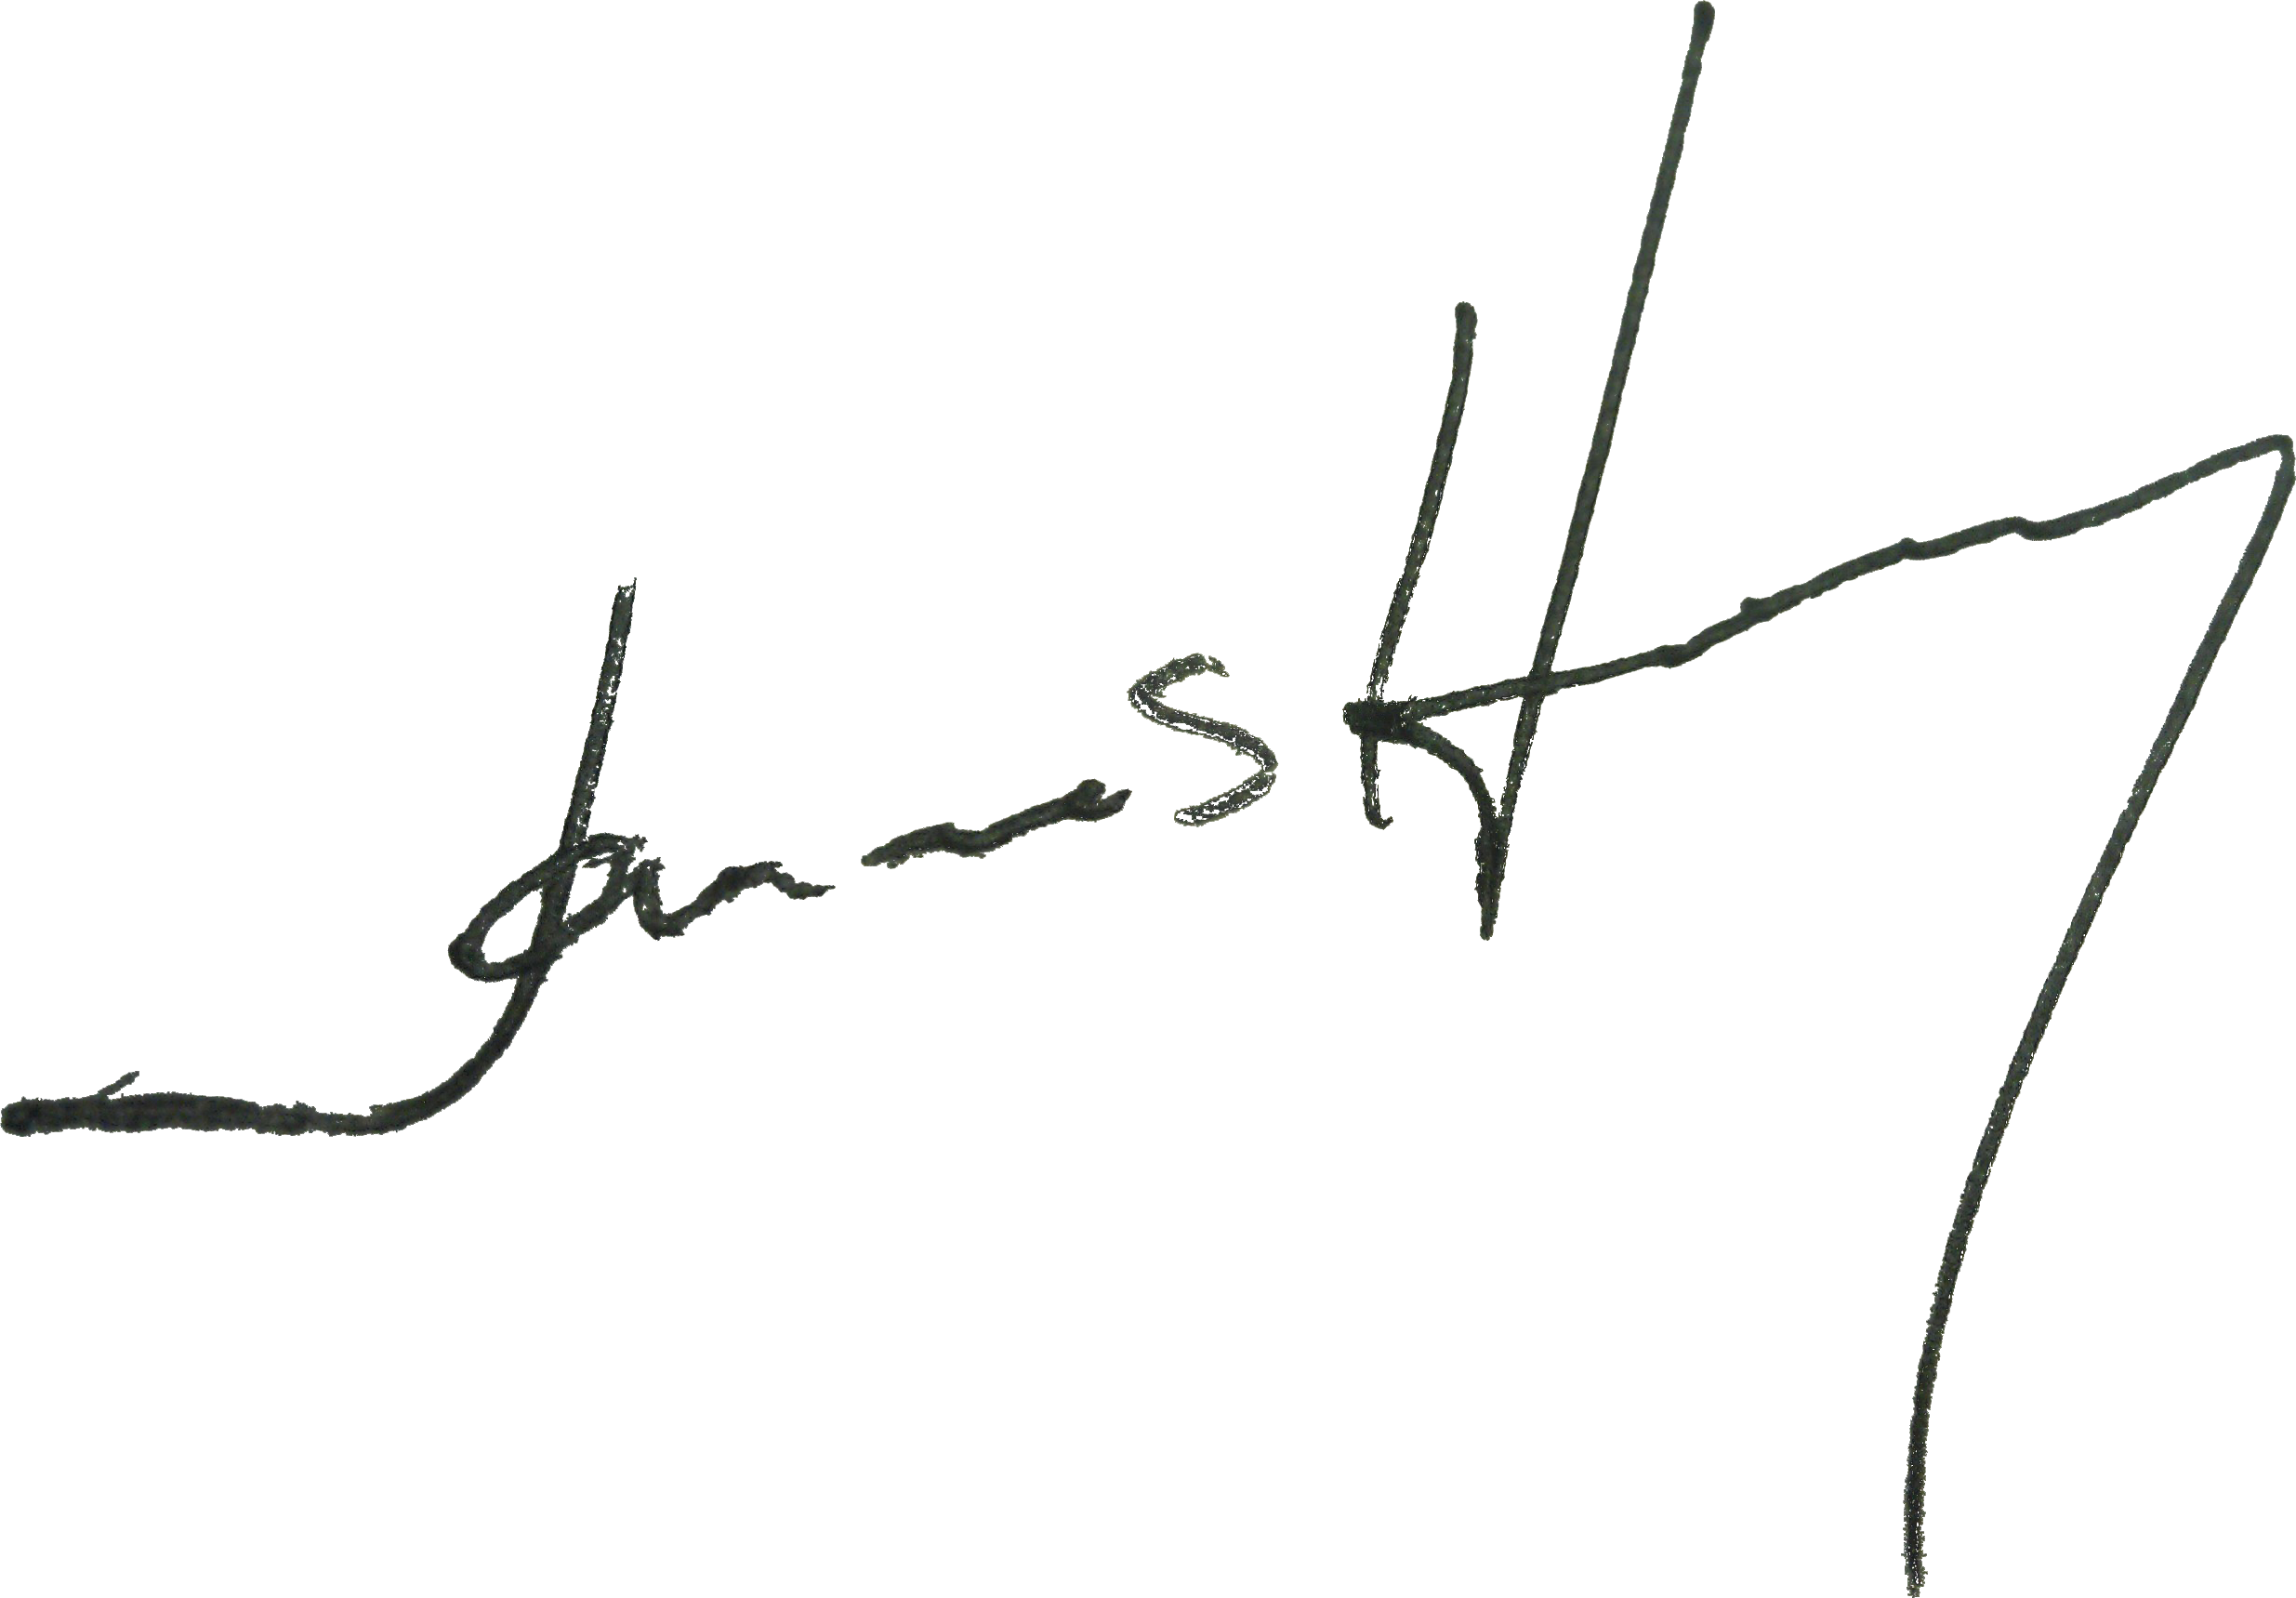

James Holby

