James Daniel Holby
Templergasse 1
55116 Mainz
Mainz, 26. May. 2014

Continental Automotive GmbH
Attn.: Bettina Hofmann
VDO-Straße 1
64832 Babenhausen
Softwareentwickler / Funktionsverantwortlicher (m/w) im Bereich Infotainment
JobID: 222129
Guten Tag Frau Hofmann:
Sven Maurer, one of your employees and friend of mine, sent me a job opening from your career portal that I feel I would be a good fit for: Software-Entwickler (m/w) Applikationsentwicklung Embedded Systems.
I have been a permanent resident of Mainz for the past year now and am searching within Mainz and the surrounding area for a more challenging position as a developer. Currently, I am leading a project here in Rüsselsheim working with local as well as distributed developers to deploy mobile in-vehicle apps for Opel/General Motors.
My professional experience mostly consists of front end mobile development (PHP,HTML,CSS,JavaScript), however, my educational experience with C/C++ as well as professional experience with C# I believe will allow me to succeed in this position. Along with that my intercultural endeavors display my initiative and communication skills, and automotive experience also are a perfect fit for this specific position.
Please feel free to contact me and I look forward to hearing from you soon.
Grüße/Best,
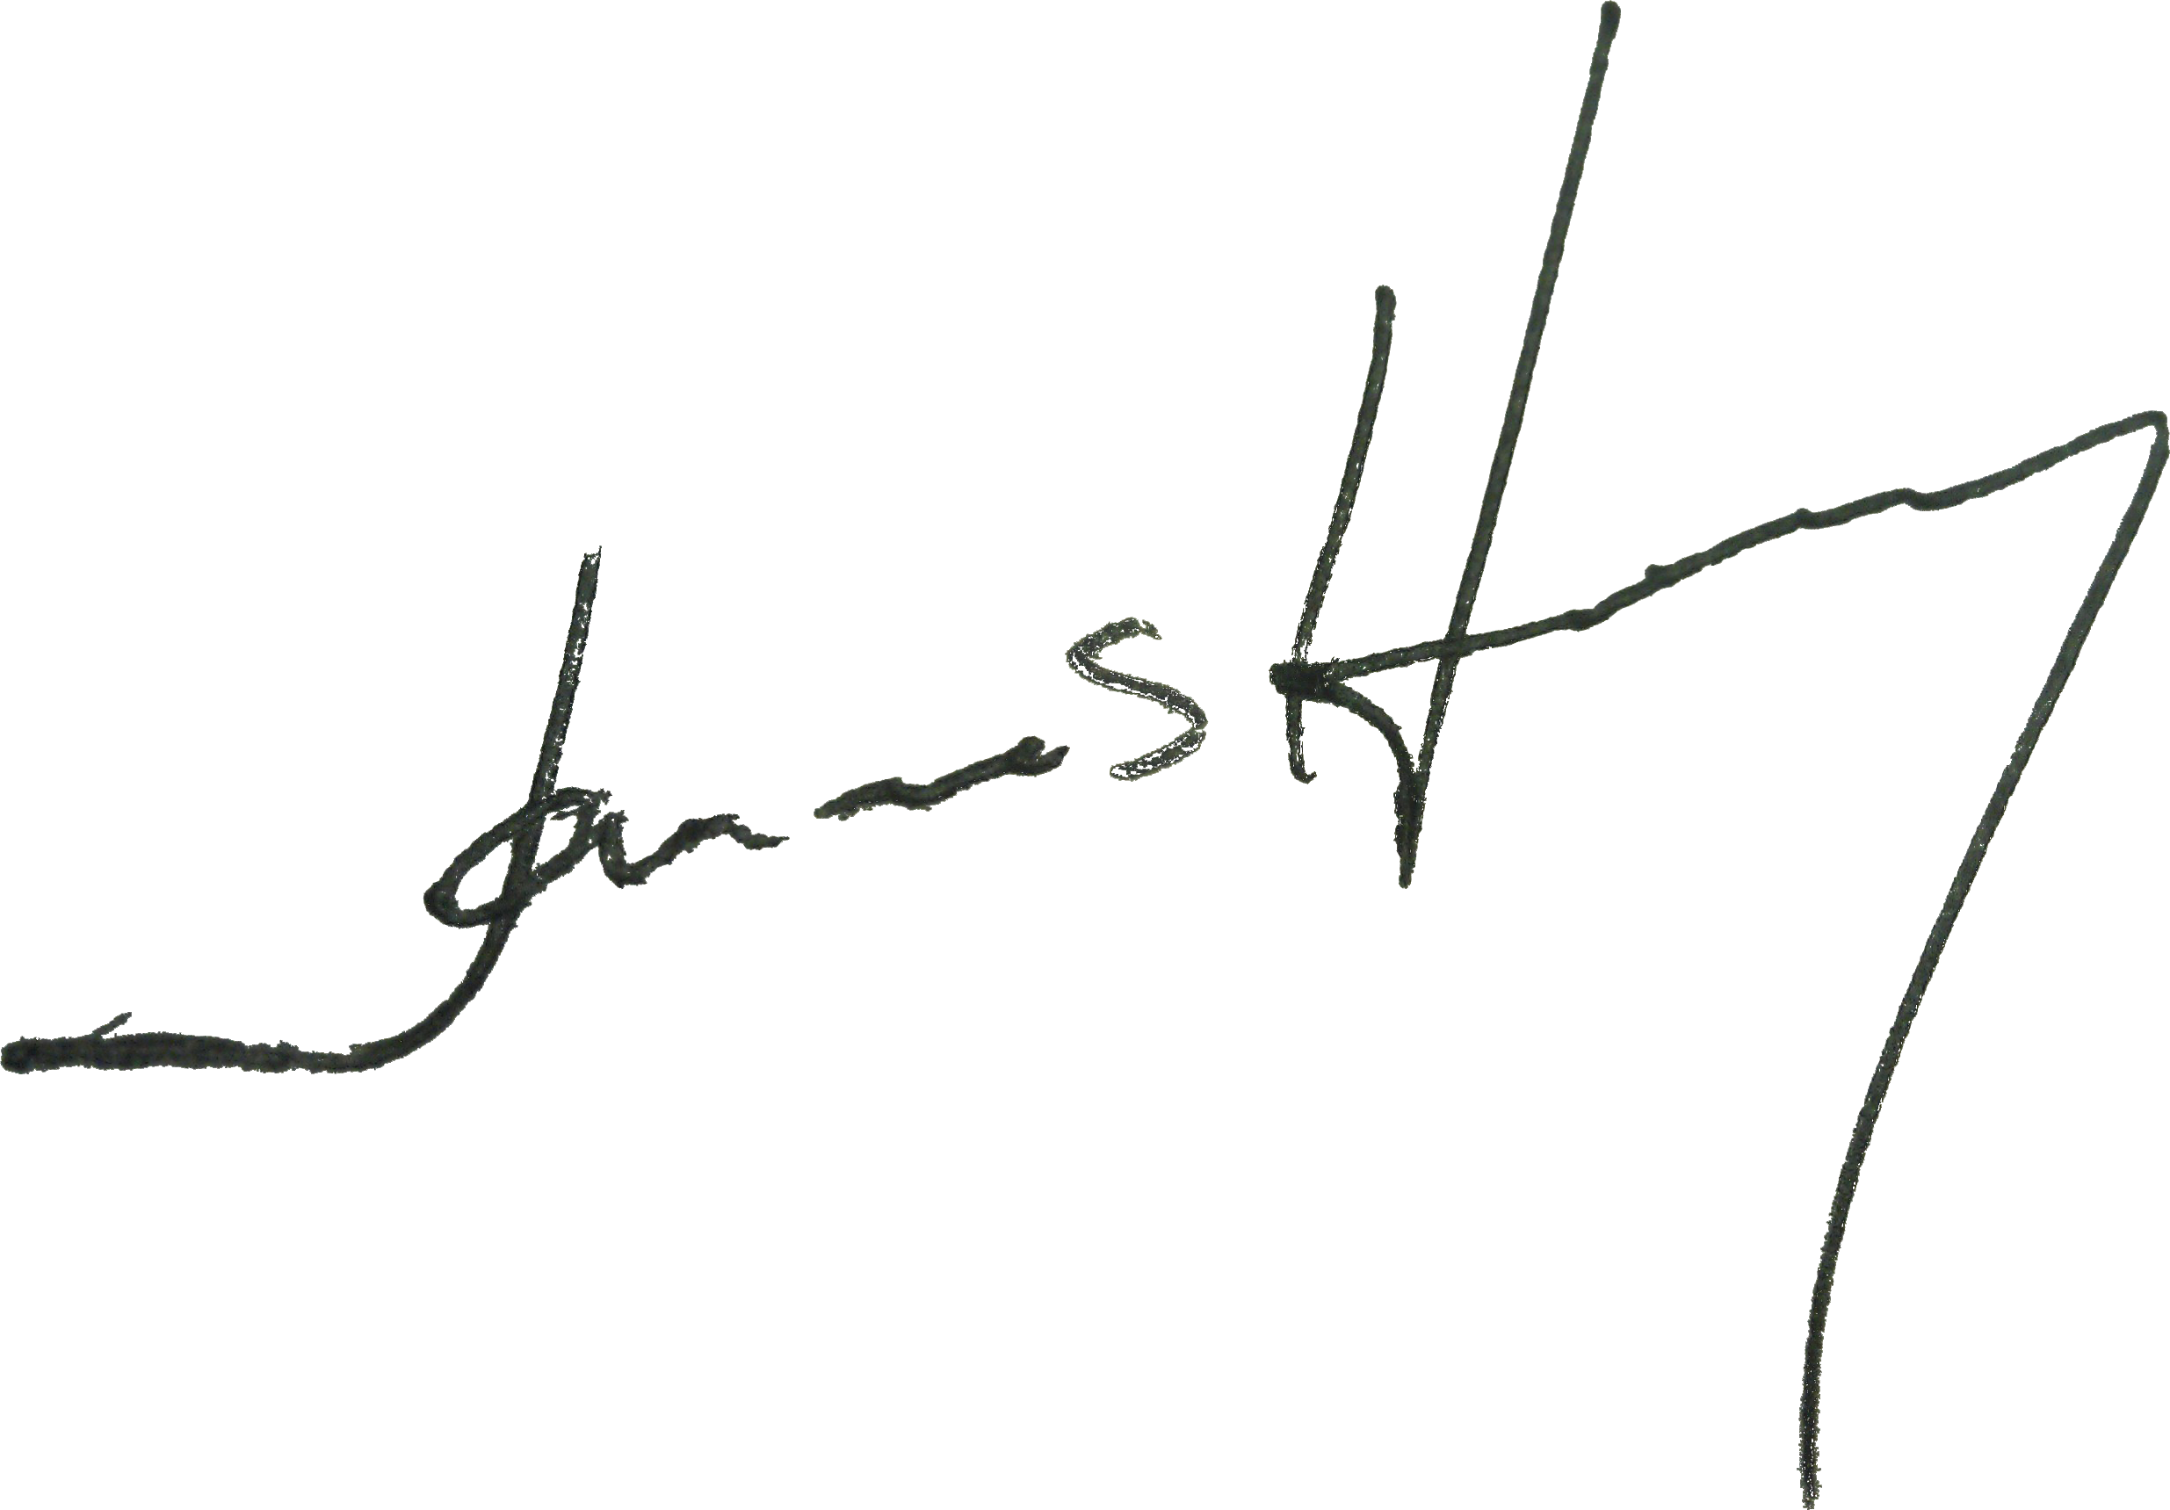

James Holby

