Washer Image Analysis
Report

Prepared By:
Jimmie Neese
Professor Zambotti
CSA 201: Digital Forensics I
14 Nov. 2025
Executive Summary
Throughout this report, there will be information and evidence that was obtained from an exact copy of a hard drive from a computer named “Washer.e01”. The user of the computer being investigated has the name John Washer. There were multiple different tools that were used to investigate. All the tools being used are open-source tools. Open-source means that they are free for anyone to use. The hard drive was searched for multiple different forms of criminal evidence and also for the correlation of crimes with a recent suspect. John Washer seems to be a very normal individual who likes fishing. This being said, he was also found to be committing multiple crimes. These crimes include Credit Card fraud, check fraud, Credit card skimming, drugs, and also being an accomplice in Wes Mantooth’s crimes. All of the evidence included in the report is screenshots that were taken. The screenshots are all backed up by an explanation and explained thoroughly. Included in the following report and the methods, findings and evidence, timeline of the user activity, timeline of the investigation, and the conclusion.
Methods
Tool | Used For:
Forensic Toolkit (FTK) Imager | Used to make a bit-by-bit copy of the hard drive being examined
Autopsy | Used to search through the bit-by-bit copy of the hard drive in order to find evidence within the drive
Windows Registry Explorer | Used to look through multiple different hives found within the image
PrefetchWindows Event Viewer | Used to look through the event log found in the image. Used to search for the last use of the drive
PicPick (Screenshot Tool) | Used to document the evidence found within the screenshots taken

Findings
While investigating the “Washer.e01” image, multiple forms of evidence brought up questions. (See below)
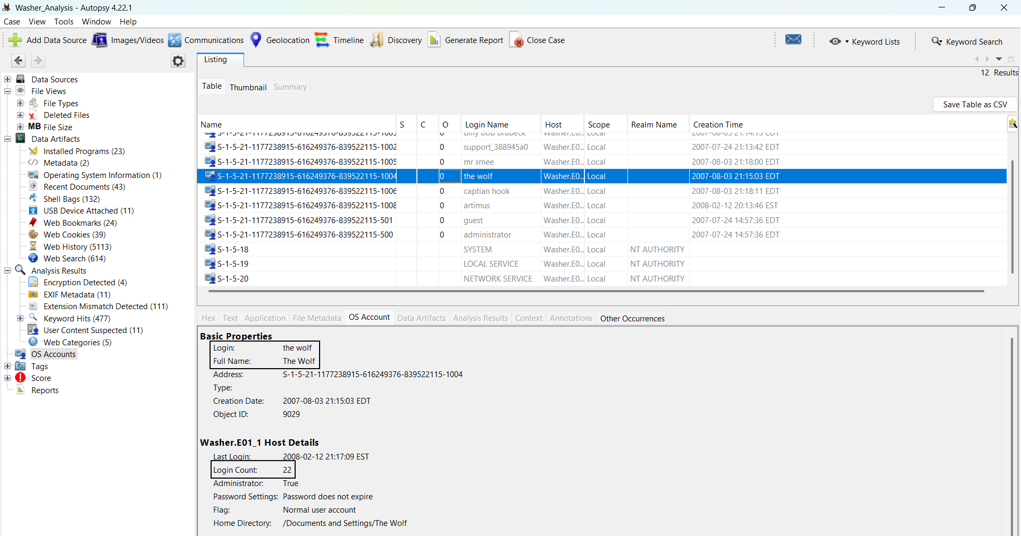
Figure 1 (Above): The screenshot above was taken to determine the main user of the computer being examined. The main user of the computer was determined to be “The Wolf” otherwise known as “John Washer”. This was determined because this OS account had the highest number of logins on the computer, at 22 logins.
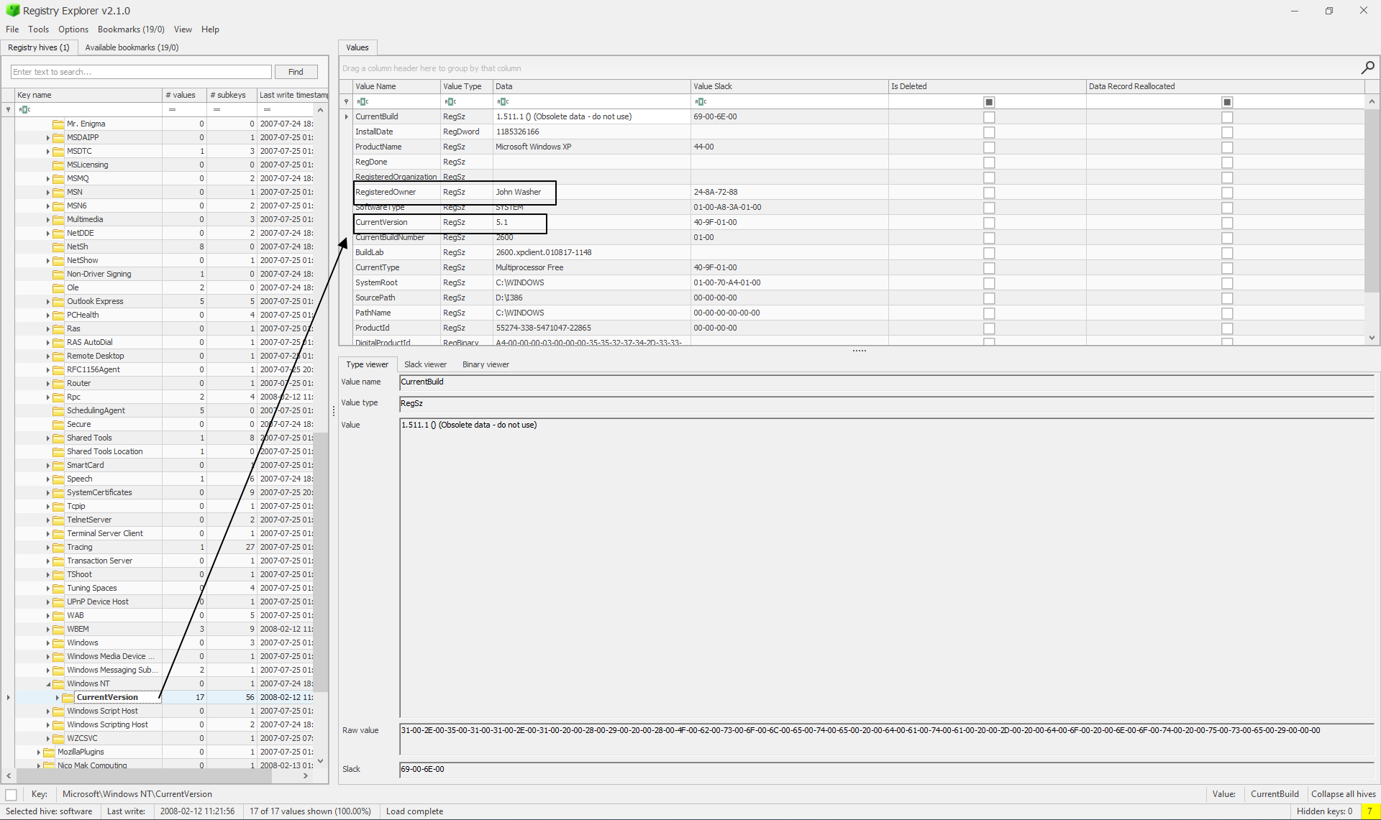
Figure 2 (Above): The screenshot above shows the current version of the computer being examined. It is determined to be Windows 11 v5.1, with the Registered Owner being John Washer.
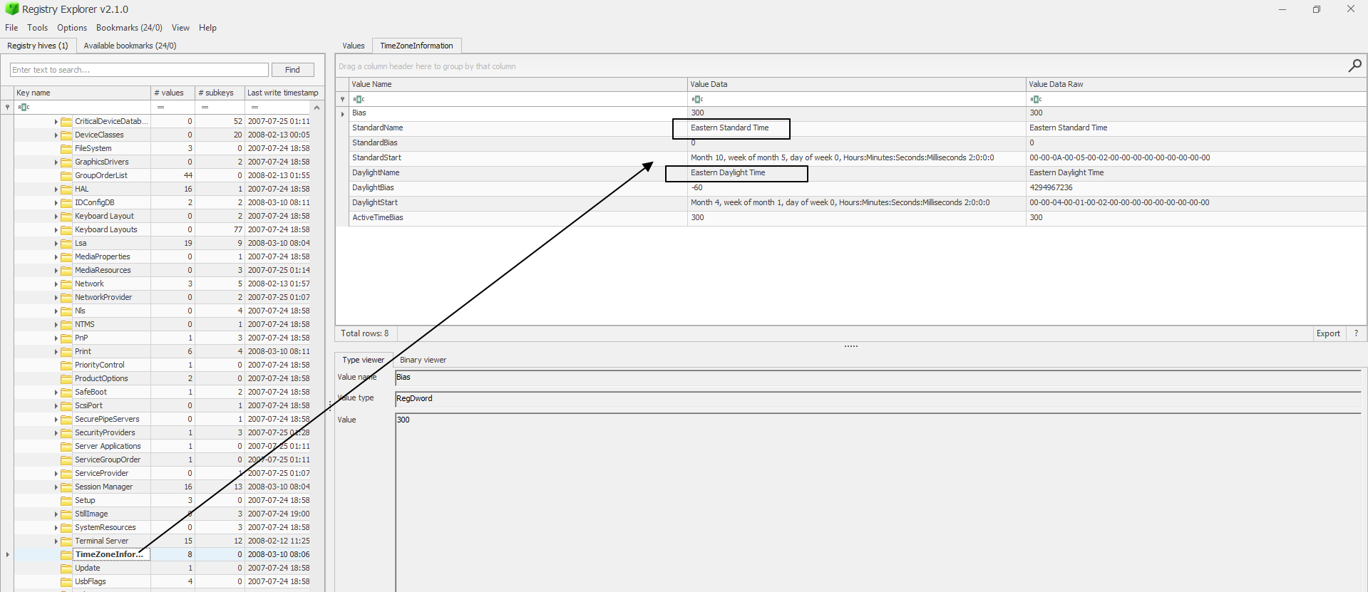
Figure 3 (Above): The figure above was found in the System hive using the Windows Registry Explorer. This figure shows the Time Zone that the computer was used in, which was determined to be Eastern Standard Time.
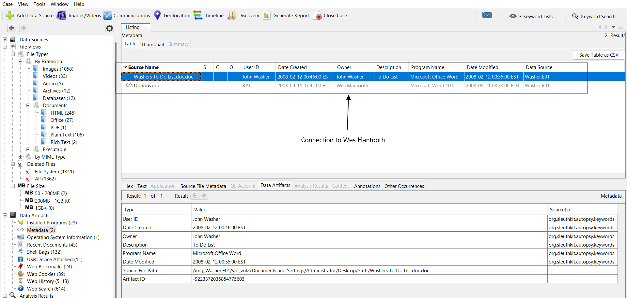
Figure 4 (Above): The figure above brought up multiple different questions. This was found in the metadata section of Autopsy while examining the hard drive. As you can see above, the owner of the “Options.doc” file is Wes Mantooth. Wes Mantooth’s hard drive was previously examined, which brings up the question of whether or not Mantooth and Washer were correlating crimes together.
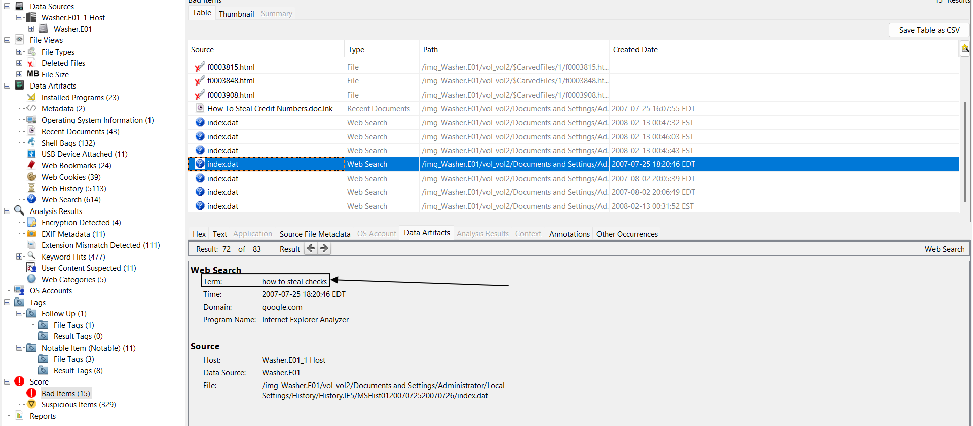
Figure 5 (Above): The screenshot above was found in Autopsy and was flagged as a bad item. This item is a web search saying, “how to steal checks”. This brings up questions about the user possibly being involved in some fraudulent activity. It also brings up some more evidence of the user committing the same crimes as Mantooth, furthering the idea that they could have been partners in crime.
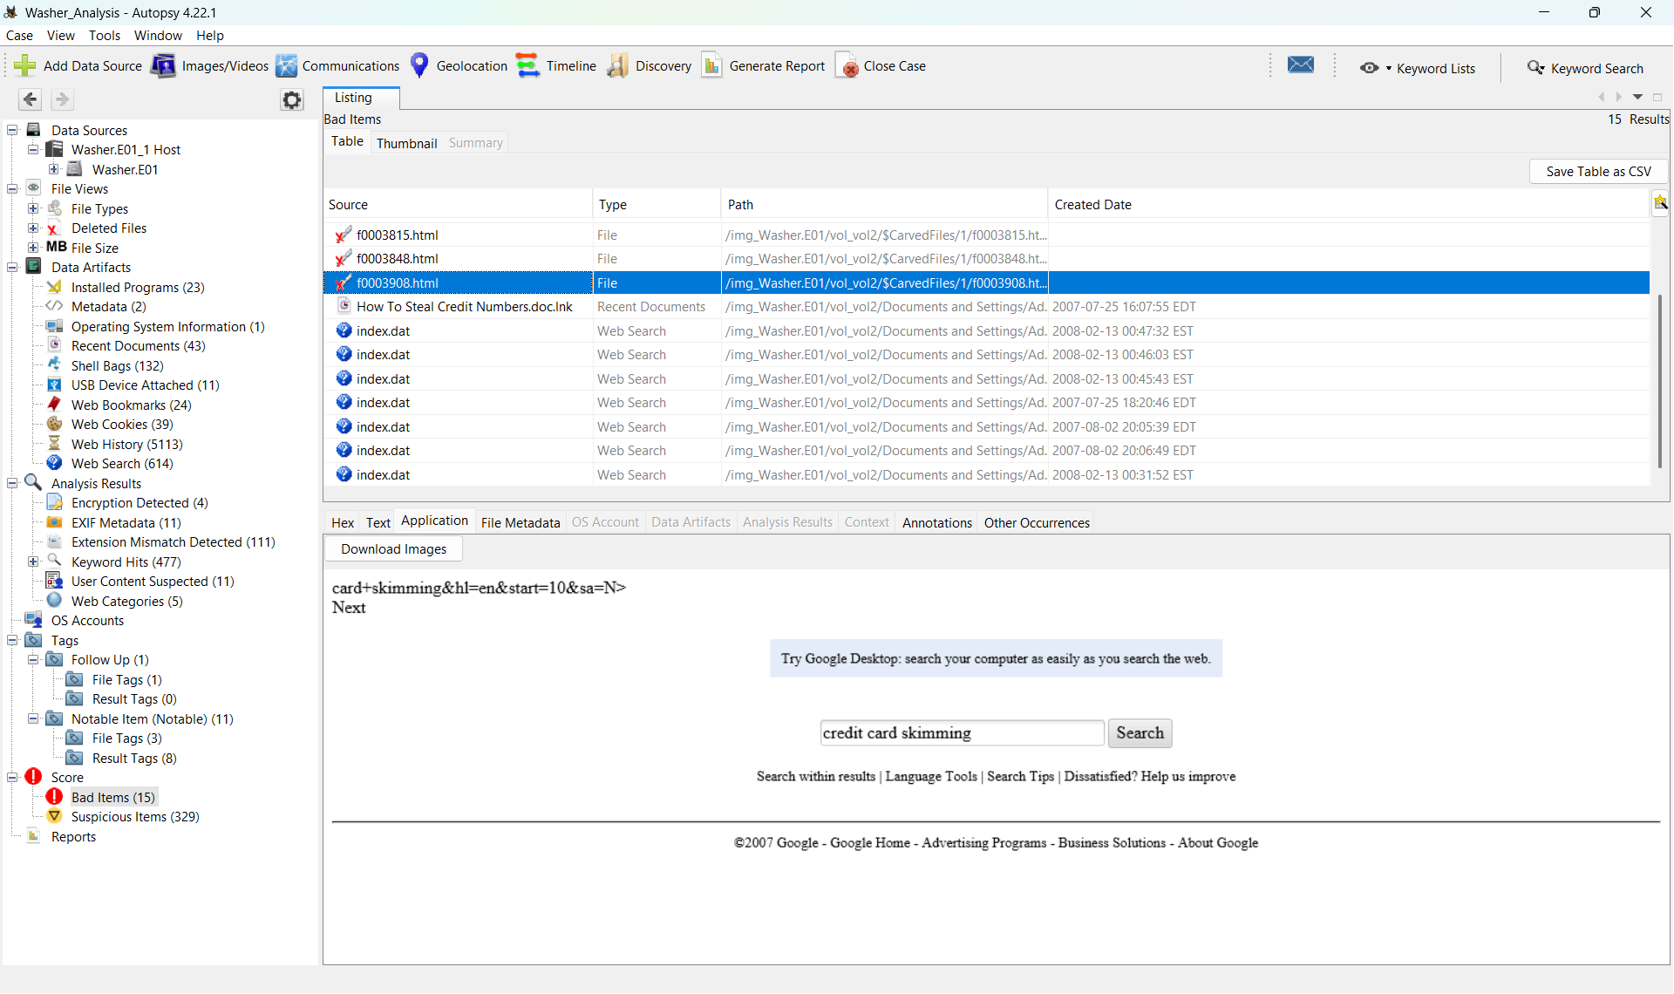
Figure 6 (Above): Above is another web search that was made by the user, indicating that he may have been interested in Credit Card skimming. This idea reinforces both the idea that he could have been committing some fraudulent crimes and also is connected to Wes Mantooth.
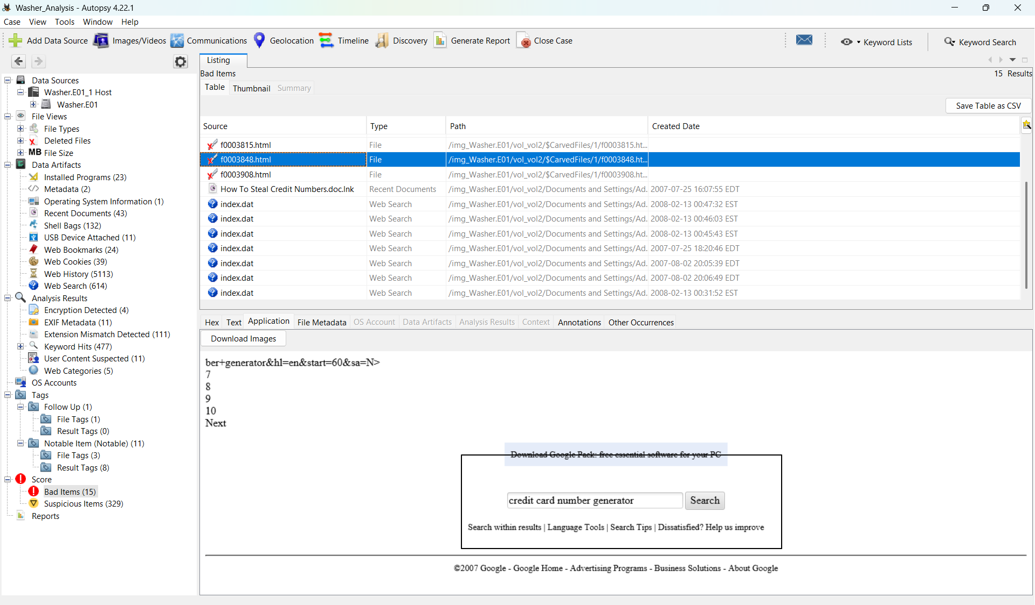Figure 7 (Above): The figure above shows the user making the web search “credit card number generator”. This evidence also reinforces the idea that the user was committing some fraud.

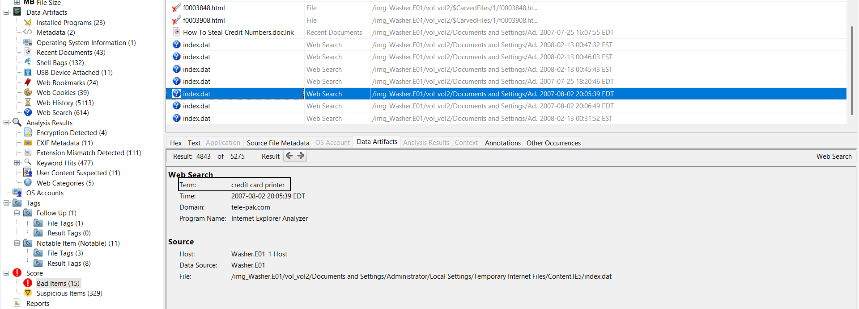
Figure 8 (Above): The figure above really starts to create the story of the user. John Washer has been seemingly very interested in credit cards and checks, and the search above is for a credit card printer. This almost certainly forms the idea that the user wanted to create credit cards to use for fraudulent activity.
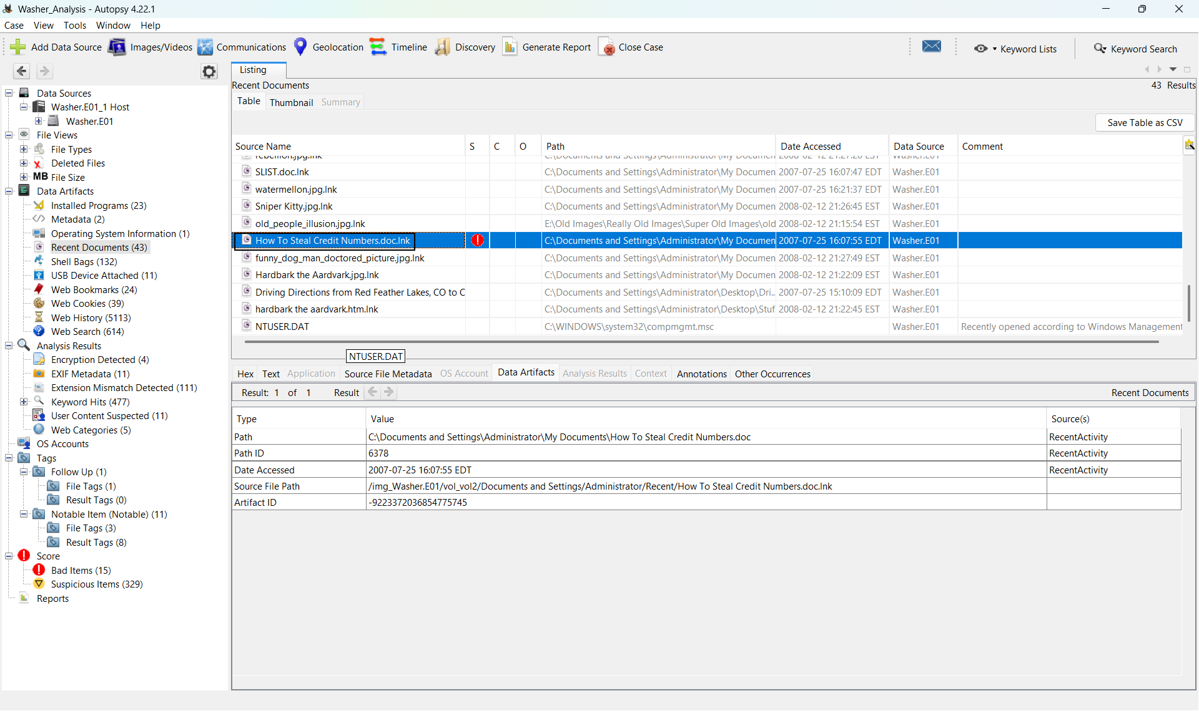
Figure 9 (Above): Above is a document that was found using Autopsy. The document is titled “How to Steal Credit Card Numbers”. This same document was found while examining the Mantooth.e01 image. This further supports the idea that Mantooth and Washer were in correlation while committing the crimes.
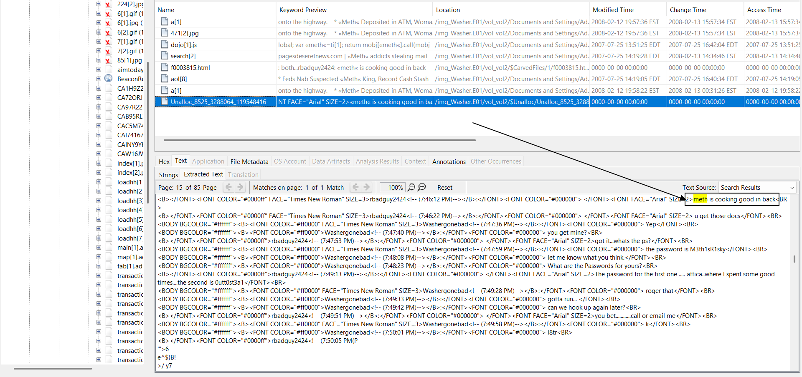
Figure 10 (Above): The figure above was found by using the keyword search “meth”. This document was found that says “meth is cooking good in back”. This now brings up a new question to the user being involved in drugs.
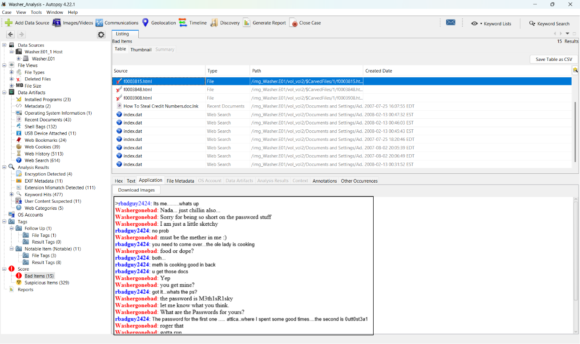
Figure 11 (Above): The figure above shows a conversation between two people that contains information about two documents. The conversation includes the passwords for both documents. This was found in the bad items section of Autopsy.
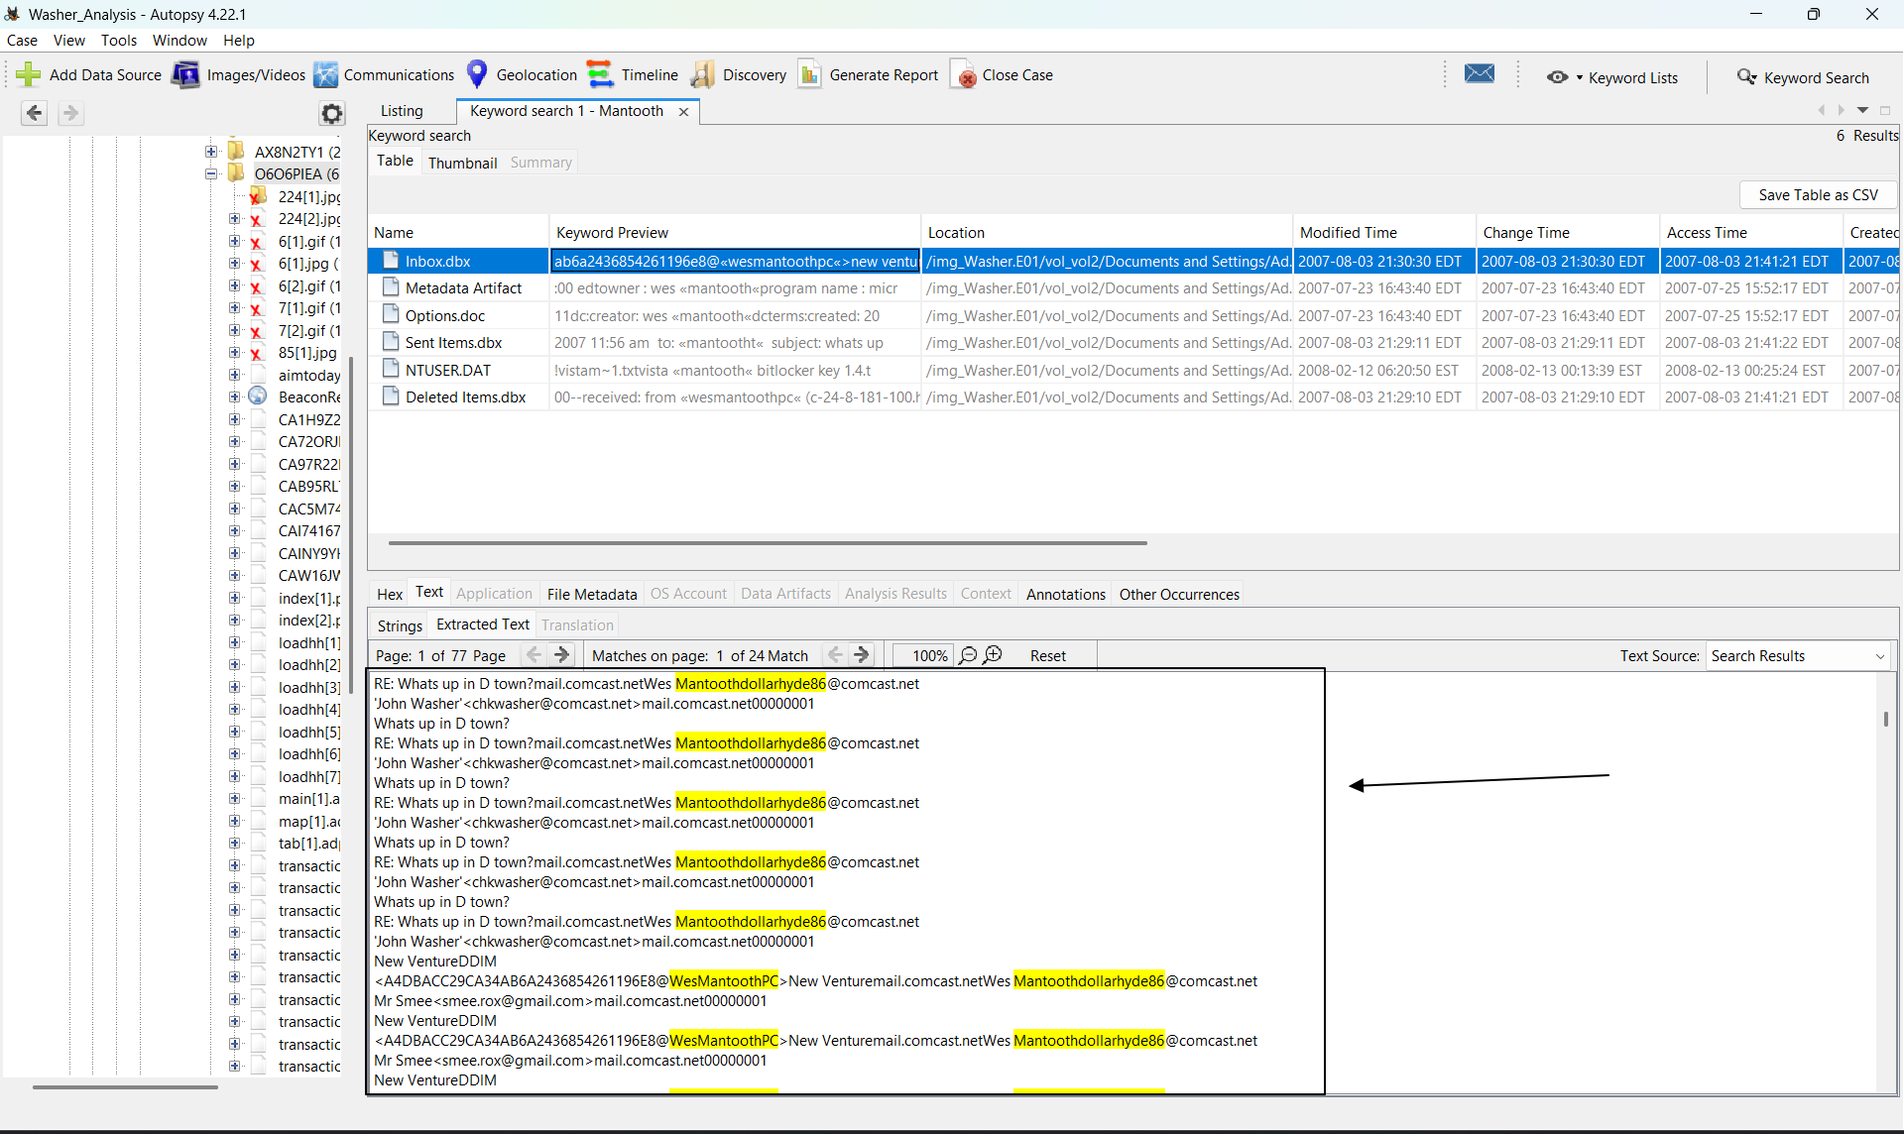
Figure 12 (Above): The figure above shows a conversation that happened over email. The conversation is between Wes Mantooth and John Washer. This email was also found while examining the Mantooth image, which furthers the idea that the two were involved in the same crimes.
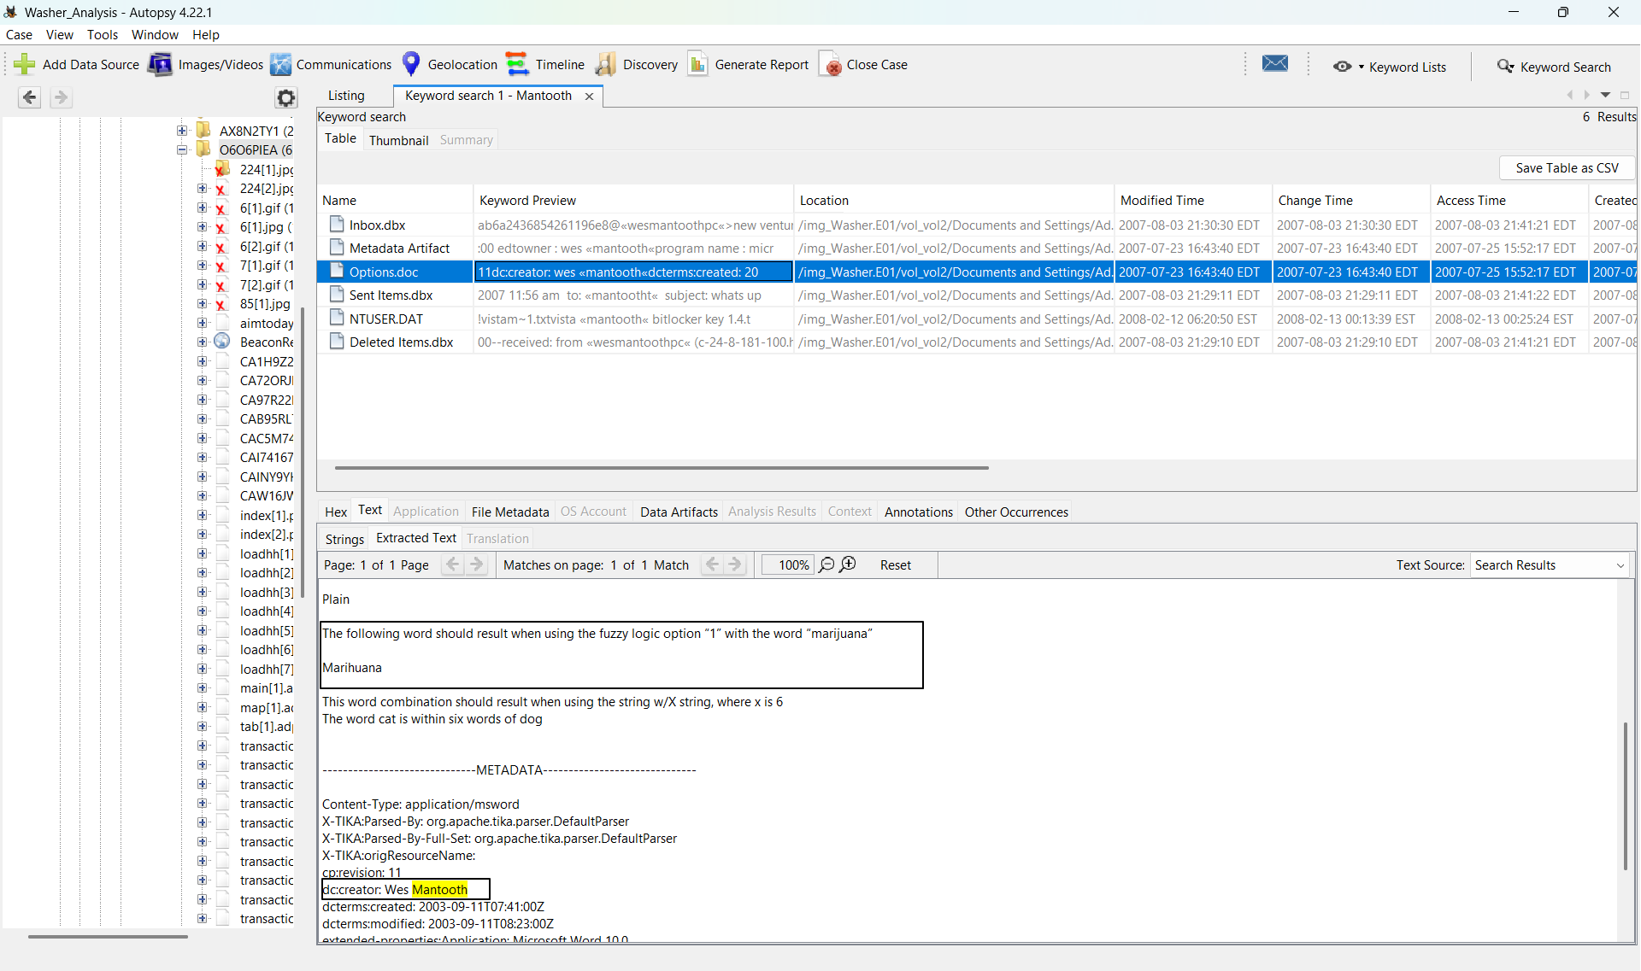
Figure 13 (Above): The figure above shows a conversation created by Wes Mantooth. This conversation gives the idea that there may be a secret language being used between Mantooth and Washer.
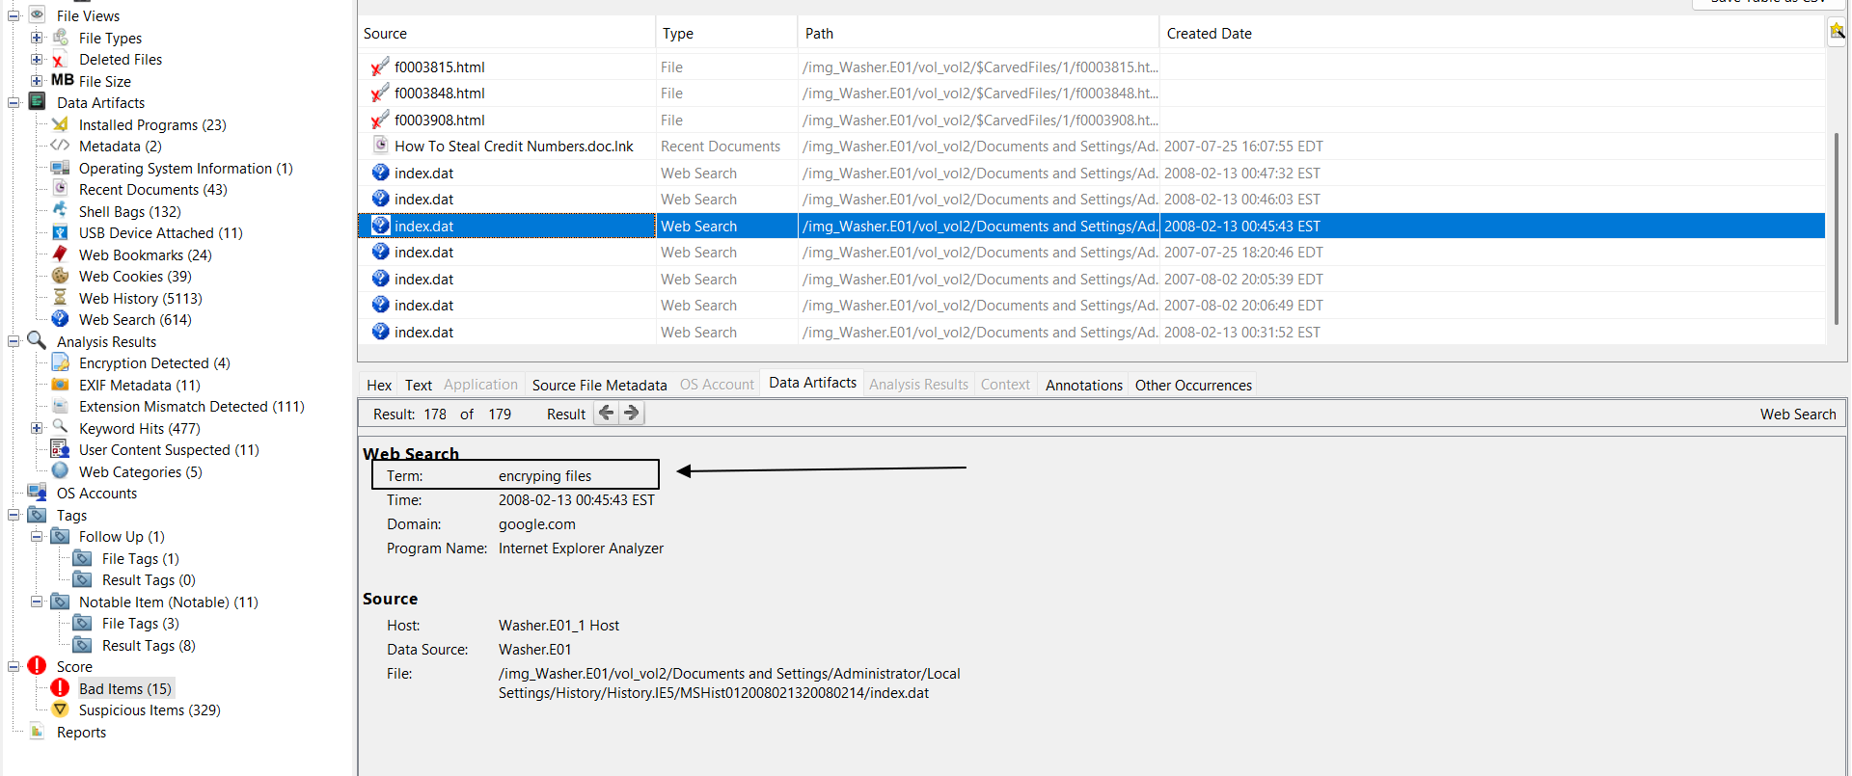
Figure 14 (Above): The figure above shows that the user may have some interest in encrypting files. This furthers the idea that the user wanted to keep things secretive and possibly use a secret language.

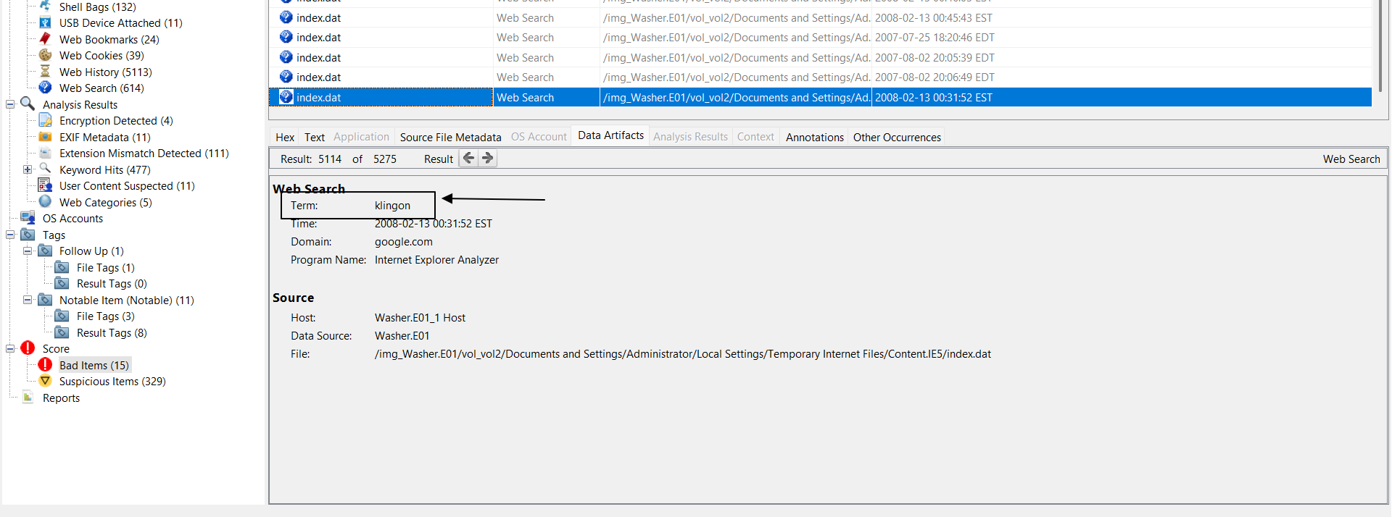
Figure 15 (Above): This web search was found using Autopsy. “Klingon” is a fictional language that is from the movie “Star Trek”. This reinforces the idea that Mantooth and Washer were using a secret encoded language, which could have been incorporated in their language.

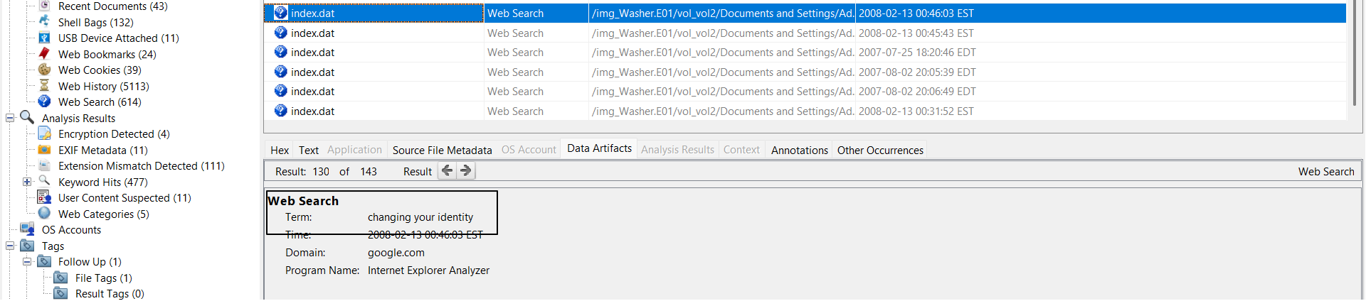
Figure 16 (Above): The above image was found in Autopsy and is of a web search “changing your identity”. This brings up the question that the user could have wanted to change their identity. This could have been due to multiple reasons. The user could have wanted to hide, protect their actual identity, etc.
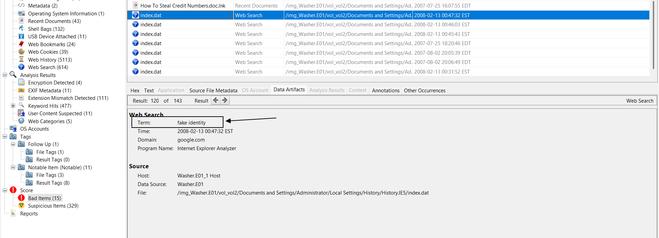
Figure 17 (Above): This figure above is a search for a “fake identity,” which supports the idea that the user could have possibly wanted to disappear. This was also found in Autopsy.
Timeline
Below is a timeline created of the user John Washer’s suspicious activity on the computer:
Date: | Time: | Event:
25 July 2007 | 4:07:55 EDT | HowToStealCreditNumbers.doc was created by the user
25 July 2007 | 6:20:46 EDT | The user searched “how to steal checks”
2 August 2007 | 8:05:39 EDT | The user searched for “credit card printer”
2 August 2007 | 12:31:51 EDT | The user searched for “Klingon”
13 February 2008 | 12:45:43 EDT | The user searched “encrypting files”
13 February 2008 | 12:46:03 EDT | The user searched “changing your identity”
13 February 2008 | 12:47:32 EDT | The user searched “fake identity”

Below is a timeline of the investigation taken place on the “Washer.E01” image:
Date: | Time: | Event:
6 Nov. 2025 | 3:56 PM EST | A connection with Mantooth was found and documented
13 Nov. 2025 | 2:30 PM EST | The Main User of the computer was found and documented
13 Nov. 2025 | 2:33 PM EST | The System, Security, and Software hives were found and extracted
13 Nov. 2025 | 2:37 PM EST | The time zone of the computer was found and documented
13 Nov. 2025 | 2:40 PM EST | The current version of the software was found and documented
13 Nov. 2025 | 2:42 PM EST | “How To Steal Credit Cards.doc” was found and documented
13 Nov. 2025 | 2:55 PM EST | A conversation containing passwords to documents was found and documented
13 Nov. 2025 | 2:57 PM EST | A web search for “changing identity” was found and documented
13 Nov. 2025 | 3:06 PM EST | Credit card skimming web search was found and documented
14 Nov. 2025 | 3:35 PM EST | Credit card generator web search was found and documented
14 Nov. 2025 | 4:00 PM EST | A “Klingon” web search was found and documented
15 Nov. 2025 | 2:25 PM EST | An email was found that makes connections to Wes Mantooth
15 Nov. 2025 | 2:34 PM EST | A message was found indicating a possible secret language
15 Nov. 2025 | 2:44 PM EST | A doc containing information on Meth was found and documented

Conclusion
Following the examination of “Washer.e01”, many different things can be taken into consideration. The investigation of the hard drive was done using multiple different online tools. These tools include FTK Imager, Autopsy, Windows Registry Explorer, PrefetchWindows Event Viewer, and PicPick. The tools were used in different ways and occurrences to help to find all the evidence and connections made within the report. The main user of the computer was determined to be John Washer. John Washer seems to be involved in multiple different activities that could prove him to be a criminal. These activities include many fraudulent activities including check fraud, credit card fraud, etc (Figure 5-9). This was determined due to the multiple different forms of evidence found and included within this report. Many forms of concrete evidence prove that John Washer committed these crimes. There was also evidence that brings into question that John Washer was involved in drugs, mainly including marijuana and meth (Figure 10,11). Finally, John Washer was found to have multiple forms of connection with Wes Mantooth, who was recently examined and determined to be a criminal. These connections were determined through multiple different forms of evidence (Figure 4,5,9,12,13,14). These figures all show connections between Wes Mantooth and John Washer. There is evidence that shows that they could have been correlating crimes together and even could have had a secret language they used to try to stay secretive. The secret language was further examined and was determined to be “Klingon” from the movie Star Trek (Figure 15). This also shows that John Washer and Wes Mantooth could have some sort of friendship through crime. Lastly, Washer was also determined to commit some identity crimes as he searched for multiple ways to change/fake his identity (Figure 16,17). Overall, John Washer could be determined to be a criminal in multiple different aspects, including drugs, fraud, identity fraud, and also being an accomplice in crime with Wes Mantooth.

