                   CarTrack

by

   Jimmol Singh

Table of Content

Cover Page                                                                                                                                           1

Table of Content                                                                                                                                 2

Problem Statement                                                                                                                              3

Problem Solution                                                                                                                                  4

Technology Process Analysis: Actors and Events                                                                            5

Technology Process Analysis: Swim Lane                                                                                         6

Technology Function Assessment: Function and Requirement                                                    7

Technology Function Assessment: Use Cases                                                                                 8

Technology/Product: Project Plan                                                                                                     11

Use Case Diagram 12

Glossary 13

Problem Statement

Employees at Community Water System (CWS) are using the company vehicle to travel to a different location in the state of New York to fix and maintain the state’s water system. The problem is, when an employee use a vehicle, they sometime go to another site, leave the vehicle and come back with another. This creates a problem because now there is a shortage of vehicles which prevents workers from traveling to other locations to fix issues.

Problem Solution

To fix this issue, the IT team at CWS proposed a website that can be developed in house and deployed onto the company’s intranet where it can be accessed only by users who work at CWS. With this website, employees will have the ability to check in and check out a vehicle before using, which will allow the company to keep track of their property as well as knowing who the person was using vehicle.

Technology Process Analysis: Actors and Events

|  |  |
| --- | --- |
| Actors | Events |
| User | The user is the person who will be using the website to either check in a vehicle or check out a vehicle. |
| Computer | The computer is the employee’s computer that the employee will use in order to access the website. |
| Manager | The manager is the person the employee must go to in order get approved who will then send a request to the admin who will then set the employee’s account permission to log into the website. |
| Admin | The person or people who manages the website overall. |
| Account     Database | The account database is the database in which all user accounts are stored. |
| Website | The website is the tool employees will use to check in or checkout a vehicle. |
| Website     Server | This is the technology that will allow the website to run. |
| Car     Database | This is the database that will be connected to the website which the website will pull from to get current information about the company vehicle. |
| Email  Server | This server will allow the user to report bugs they find on the website. |

Technology Process Analysis: Swim Lane

Technology Function Assessment: Function and Requirement

|  |  |
| --- | --- |
| # | Function Area / Requirement |
| **1** | **USER ACCOUNT** |
| 1.1 | Have permission to enter the website |
| 1.2 | Have the ability to view history |
| **2** | **VEHICLE CATALOG** |
| 2.1 | Allow the user to see the list of vehicles available and not available |
| 2.2 | Allow the user to select and add item to cart |
| **3** | **SHOPPING CART** |
| 3.1 | Items that are added to cart can get deleted |
| 3.2 | Item that are added to the cart can get checked out |
| **4** | **ITEM SEARCH** |
| 4.1 | Allow user to search for specific item |
| 4.2 | Display the searched item |
| **5** | **EMAIL NOTIFICATION** |
| 5.1 | User will receive receipt once the item is checked out |
| **6** | **BUG REPORT** |
| 6.1 | User can report bug to admin |

Technology Function Assessment: Use Cases

Requirement 1: User Account

U.C. 1.1 – Permission to enter the website.

Name: Permission to enter the website.

Identifier: U.C. 1.1

Base Course of Action:

* Users use the same login credentials they use to login into their computer.
* User accounts may only login if they are approved by the manager who must submit a request to the Administrator.

U.C. 1.2 – View History.

Name: View History.

Identifier: U.C. 1.2

Base Course of Action:

* Users will have the ability to view their history of check in and check out.

Requirement 2: Vehicle Catalog

U.C. 2.1 – Listing vehicle available and not available.

Name: – Listing vehicle available and not available

Identifier: U.C. 2.1

Base Course of Action:

* When a user clicks the check in option, they will be able to see a list of vehicles that are currently checked in and vehicles that are currently checked out.
* Provide users with basic car information and which includes the identification numbers.

U.C. 2.2 – Add selected item to cart.

Name: – Add selected item to cart.

Identifier: U.C. 2.2

Base Course of Action:

* Users can click on the item to add the item to the cart

Requirement 3: Shopping Cart

U.C. 3.1 –Delete cart item.

Name: – Delete cart item.

Identifier: U.C. 3.1

Base Course of Action:

* When users add the item from the catalog, all items go into the shopping cart. If a user makes a mistake by adding the wrong item or change their mind, they can simply delete that item from the shopping cart.

U.C. 3.2 – Checkout cart item.

Name: – Checkout cart item.

Identifier: U.C. 3.2

Base Course of Action:

* When users add the item from the catalog, they can check out the item from the shopping cart by filling out a form so the system can know who's checking it out and store that information.

Requirement 4: Searching

U.C. 4.1 – Search for specific item.

Name: – Search for specific item.

Identifier: U.C. 4.1

Base Course of Action:

* Users will have the ability search for a specific vehicle using a search bar.

U.C. 4.2 – Display searched item.

Name: – Display searched item.

Identifier: U.C. 4.2

Base Course of Action:

* When users search for a specific item using the search bar, the item will show. If it is not available, there will be a notification on the item that lets the user know.

Requirement 5: Email Notification

U.C. 5.1 – Receive email notification.

Name: – Receive email notification/

Identifier: U.C. 5.1

Base Course of Action:

* User checks an item out; they will receive an email notification with all the important information.

Requirement 6: Report Bug

U.C. 6.1 – Reporting a bug.

Name: – Reporting a bug.

Identifier: U.C. 6.1

Base Course of Action:

* If the user encounters a bug, they will have the ability to report the bug directly to the admin.

Technology/Product: Project Plan

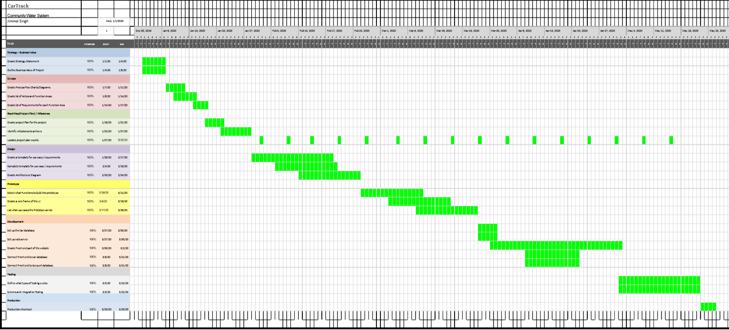

Use Case Diagram

Glossary

**Architecture diagram** - A graphical representation of a set of concepts, that are part of an architecture, including their principles, elements and components.

**Bug** - An error.

**Database** – A structured set of data held in a computer, especially one that is accessible in various ways.

**Gantt chart** - A timeline that is used as a project management tool to illustrate how the project will run.

**Server** – A computer or computer program which manages access to a centralized resource or service in a network.

**Use case** – A specific situation in which a product or service could potentially be used.