Readme

Run Application

The Init class in the default package provides a main method. When the system is started a couple of threads are initialized. The threads are placing orders, changing the dividend from time to time and display the current state and values of the stock exchange to the console.

Assumptions

General

First I have differentiated between a trade and an order. Because I think a trade is an exchange. I can not buy shares of a stock if another person does not intend to sell shares of the same stock for an equal price. Therefore the calculation of a new stock price is done at the stock exchange by balancing supply and demand. The last trade is the new price.

When money comes into play accuracy is really important. Therefore I have added a Fraction class because Fractions are the most accurate way to represent a number. But we do not pay shares with scalars, we pay it with pennies. That is why I added a Quantity class and a Unit class to represent pennies.

As far as I understood the requirements one should be able to record a order(trade) for a stock. But the requirements also say that I do not need to provide an user interface. Since humans can not place orders with the power of their minds I let the system take over that task.

Formula

I had my problems with the calculation of the dividend yield for a preferred stock. I interpreted it as ((fixed dividend/100) * par value)/ticker price. This formula was the most confusing thing to me because the last dividend of the preferred stock is 8. I assumed that the stock type does not change anymore but then I can not explain where the 8 comes from. Because when the type does not change and the par value does not change and the fixed dividend also does not change – because it is fixed – then 8 can not be the last dividend. (Since I assumed the dividend of a preferred stock is (fixed dividend/100) * par value)...

Who decides the dividend is not given in the requirements so I made it random, because if the dividend does not change from time to time it is pretty boring.

Stock price is only used for calculating the geometric means and does not represent the market value of a stock.

Things that I would like to add/should have done better

The quantity pattern is really simple implemented. Currencies, Conversion rates etc. are all missing.

I used Fractions as a representation for money. I thought this was quite the idea but later on I realized I had to get the nth root for the geometric means. The root function provided by me looses a lot of the accuracy but implementing a different one would have taken me more time.

The balancing of the stock exchange is not “real” it is simplified a lot.

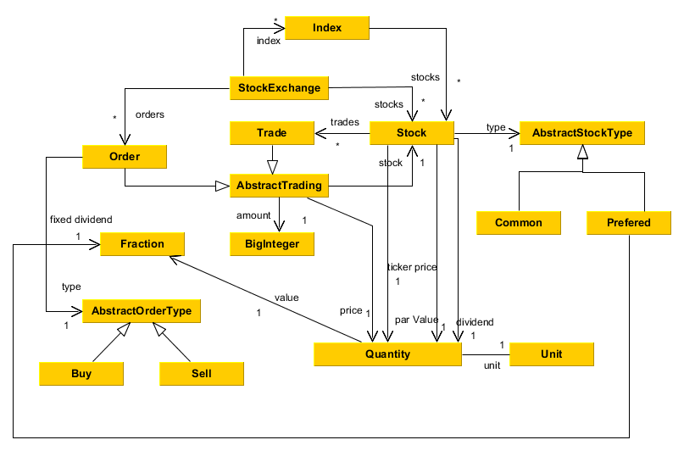
Class Diagramm

