LEASE AGREEMENT

This agreement is made the day day of Month Year in Nicosia, Cyprus,

Between

- ALIVENTE LIMITED Reg. No. HE283373
Address: 13^{A} Dikaiosynis Street, Egkomi, Nicosia, 2412
Telephone: +357 96 668557
Email: demetrimanias@gmail.com
(hereinafter referred to as the Landlord), of the one part,

and

- Name: SACHA MAMOU

Passport:
Number: 19ED75974

Country of Issue: France

Address: Apartment 201, 3 Evagora Pallikaridi, Agios Dometios, Nicosia, 2369

Telephone: +33 6 51 20 04 65

Email: sacha.mamou2@gmail.com

AND

Name: JAMES ELIE MOISE LUC-SEBAOUN

Passport:
Number: 19AP071760

Country of Issue: France

Address: Apartment 201, 3 Evagora Pallikaridi, Agios Dometios, Nicosia, 2369

Telephone: +33 7 69 67 23 29

Email: james.ls@icloud.com

(hereinafter referred to as the Tenant), of the other part,

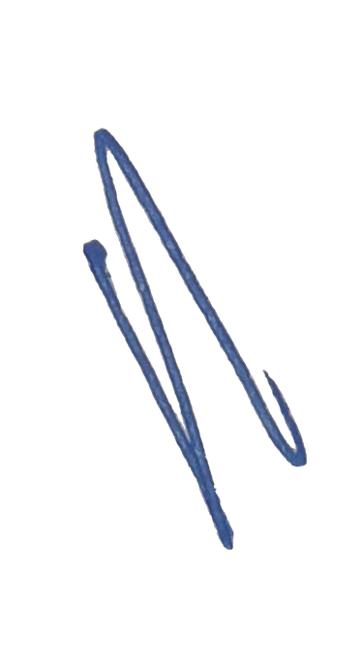WHEREAS the Landlord is the legal owner and entitled to lawful possession of {{ prop_address1 }}, {{ prop_address2 }}, {{ prop_suburb }}, {{ prop_city }}, {{ prop_province }}, {{ prop_pcode }}, (hereinafter referred to as the Premises), and

WHEREAS the Tenant wishes for consideration, to take the Premises on rental.

Now it is hereby agreed between the parties as follows:

1. PROPERTY
In consideration of the rent hereby mentioned, the Landlord hereby agrees to let, and the Tenant agrees to take the Premises subject to the terms and conditions hereinafter provided.

2. DURATION
The tenancy shall commence on the 1st September 2025 and continue for the term of 12 (Twelve) months until the 31st August 2026.

3. RENT – MODE OF PAYMENT
The rent during the tenancy period shall be €970.00 (Nine Hundred and Seventy Euro) per month plus monthly Communal Expenses (which are currently €30 (Thirty Euro)).
The rent plus communal expenses shall be payable by the Tenant for every month, in advance, by the 3rd day of each month to the Landlord. The rent plus communal fees will be paid into the following account every month:
Account Name: ALIVENTE LIMITED
Bank Name: Hellenic Bank
IBAN number : CY11 0050 0109 0001 0901 8563 1501
SWIFT Code: HEBACY2N
If the Tenant fails to pay the rent for any month during the tenancy agreement then the Landlord shall have the right to terminate the lease and to take legal action for recovery of any unpaid rental and damages.

4. RENEWAL – NEW RENT
If the Tenant wishes that the tenancy continues for a further 12 (Twelve) months then he must notify the Landlord 2 (Two) months prior to the termination of the agreement of his intention to renew the lease. Upon mutual agreement (between Landlord and Tenant), the lease will extend for a further 12 (Twelve) months until 31st August 2027. The tenancy for the renewal will be under the same terms except as regards the monthly rent for the Premises. It is agreed between the parties that the monthly rent for any renewal of the tenancy by the Tenant after the 31st August 2026 will bear an increase of 5% per each 12-month period.



5. DEPOSIT
Upon signing of this Lease Agreement, the tenant will pay one month’s rent as a deposit to the Landlord. This deposit will be held by the Landlord and will be returned to the Tenant if, at the end of the Lease Agreement, all rentals have been paid and there is no damage to the property, appliances, or furniture.

6. FURNITURE AND APPLIANCES
The Premises is fully furnished, and the following items are supplied by the Landlord, for use by the Tenant during the lease agreement:
Appliances:
- 1 x Television
- Washing Machine
- Dishwasher
- Oven
- Extractor Fan
- Stove Hobs
- Fridge/Freezer
- Air-conditioners x 3
- Microwave
Furniture:
- 1 x Three-Seater Couch
- 2 x Lounge Chairs
- 1 x Glass Coffee Table
- 1 x Glass Corner Table
- 1 x Standing Lamp
- 1 x Table Lamp
- 1 x Four-Seater Dining Table with 4 x Chairs
- 2 x Single Beds and 1 x Bedside Table
- 1 x Queen Bed and 2 x Bedside Tables
- 1 x Outside Table with 6 x Chairs
The Tenant agrees to exercise utmost care in the use of the Appliances and Furniture and will be responsible for any damages caused by anything other than normal wear-and-tear.

7. KEYS
The Tenant has been supplied with the following keys and these need to be returned upon termination of the lease agreement:
- 2 x Apartment Building Keys
- 2 x Apartment Front Door Keys
- 2 x Storeroom Keys
- 2 x Post Box Keys

8. OBLIGATIONS OF THE TENANT
The Tenant agrees with the Landlord:
8.1 To pay the agreed rent at the time and in the manner aforesaid.
8.2 Not to assign the benefit of this agreement, or part with the possession of the Premises or assign or sublet or permit to be sublet or give license for the use of the Premises or part thereof to others at any time during the continuation of the tenancy.
8.3 Not to do or permit to suffer or to be done upon the Premises anything which may damage the said Premises or building, or may be a nuisance or annoyance to or in any way interfere with the quiet comfort of the other neighbours of the said Premises and / or building.
8.4 The Tenant shall yield up, at the expiration or termination of lease, the Premises in the same condition in which they were at the time of delivery, he shall NOT be liable for any reasonable and fair wear and tear. However, the Tenant shall be liable for any loss or damage caused to the property due to his acts and/or omissions and for any loss or damage attributed or related to the wrongful acts or omissions of the Tenant including any fire, damage or theft caused to the Premises by any person entering the Premises whether lawfully or not during the term of the present lease.
8.5 Not to bring upon the Premises any articles of combustible, inflammable or dangerous nature, or use the property for any immoral or illegal practices or to use or suffer it to be used for dangerous acts.
8.6 To pay for his own consumption of electricity and water, according to the indications of the meter, subject matter of this lease. The Tenant shall also pay the communal fees of the building to the Landlord as well as the annual refuse fees.
8.7 To keep the demised Premises and the Landlord’s fixtures, fittings, appliances and furniture therein, in good and tenantable repair and condition throughout the term and not to make any alterations except such as shall be sanctioned in writing by the Landlord and to yield up the same in such repair and condition, except as aforesaid at the termination of the tenancy.
8.8 Not to affix such fixture and fittings on or in the Premises unless he receives the consent of the Landlord in writing. If the tenant affixes such fixtures or fittings then these shall remain the Landlord’s property at the expiration of the lease and the tenant shall be liable to repair any damage caused by the installation or removal of the said fixtures and fittings.
8.9 To permit the Landlord or his agent at all reasonable time, after giving notice to the Tenant, to enter upon and examine the condition of the Premises.
8.10 To insure the property for the term of this agreement and for such period or periods as it may be extended so that the Tenant and the Landlord are protected from liability for any death, injury or damage to persons visiting or entering the Premises.

9. OBLIGATIONS OF THE LANDLORD
9.1 That the Tenant paying the rent and observing the stipulations hereinbefore contained, shall have use of the premises.
9.2 To keep the electrical and plumbing installations of the Premises in good tenantable repair and condition.

10. GENERAL PROVISIONS
If the agreed rent or any part thereof shall remain unpaid for a period of 21 (twenty one) days after it shall become due and payable, or if the Tenant shall neglect to perform or observe any term whatsoever on his part herein before contained, then the Landlord is entitled to terminate the present agreement without prejudice to his right of action for the recovery of the arrears and / or for damages for breach of contract or otherwise.

11. INSURANCE
The Tenant takes the responsibility to insure against fire, floods, burglary and Act of God, all his belongings contained in the Premises. The Landlord takes no responsibility in case of damage of the Tenant’s belongings due to fire, floods, burglary, or Act of God.

12. FORUM
The present agreement shall be subject to Laws of Cyprus and any dispute shall be resolved by the courts of Cyprus.

13. NOTICE
Any notice must be in writing and sent to the other side either by registered post or service with a BAILIFF to the address stated at the beginning of this agreement or to the last known address of the other party. Notice will be taken to have been received if the post office returns to the sender a receipt showing that the notice has been duly received or sent but not picked up at the post office.

No alteration of the terms of the present agreement will be permitted unless made in writing and signed by both parties to the present contract.



In witness whereof, the parties to the present agreement have hereunto set their respective hands in the presence of witnesses, the day and year first above mentioned.

PARTIES

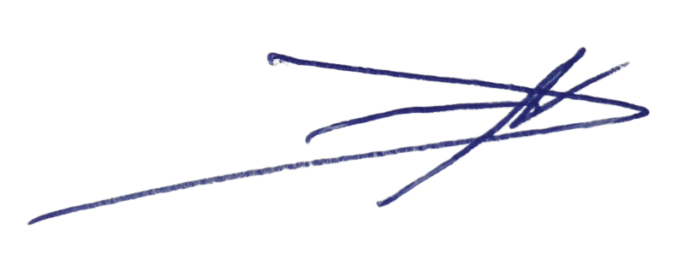
___________________ Signature: _______________________________
Dimitrios Manias Name: SACHA MAMOU
ALIVENTE LIMITED The Tenant
The Landlord

Signature: _______________________________
Name: JAMES ELIE MOISE LUC-SEBAOUN
The Tenant

WITNESSES:

1.____________________ _________________________
Signature Name

2.____________________ _________________________
Signature Name



