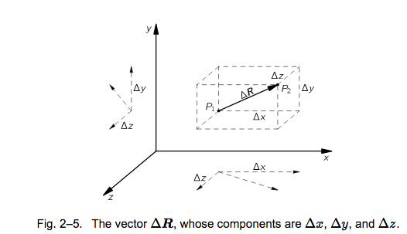

(Feynman, Volume 2, Chapter 2)

How does temperature change as you go from point 1 to point 2?

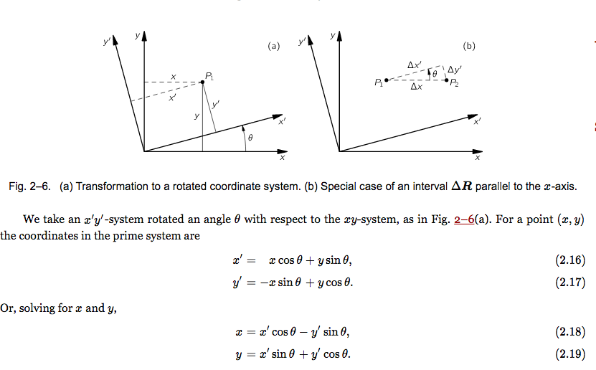

N

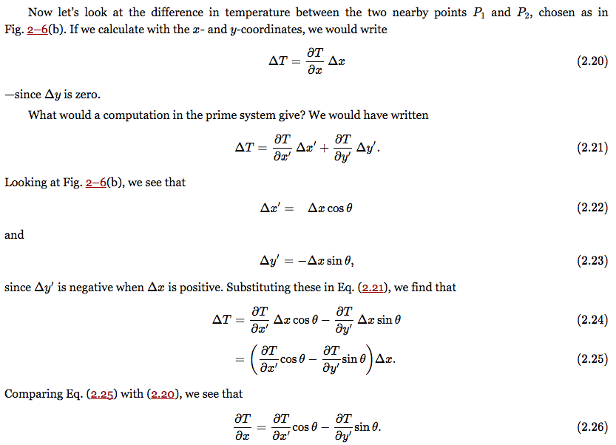

N

N

N

N

N

N