**Flux from vector field, flux from cube**

Getting started: flux from a vector field

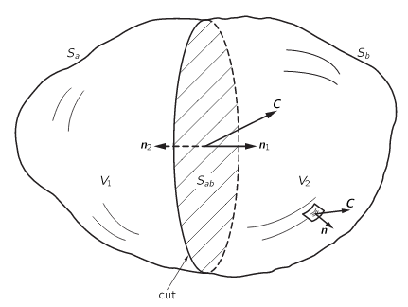

For any vector field ***C***, what is the flux through S1? Through S2?

**The main point: We want to find the flux through an arbitrary volume. We’ll begin by finding the flux through a tiny little cube:**

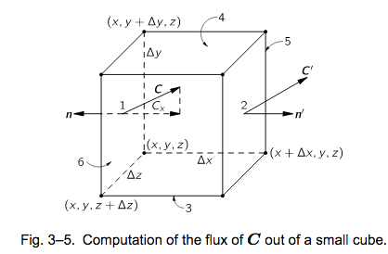

**Why do we start with this cube?**

**In integral form, how would you find the flux through face 1?**

**How would you approximate it?**

**How would you approximate the flux through face 2?**

**Now, what’s the sum of the fluxes through faces 1 and 2? How would your answer here change if you’d made different approximations for the flux through face 2?**

Hint: your answer to that last question should end up looking like a derivative times a volume if you’ve done things correctly.

**Overall strategy:** we now have an expression for the flux through two sides of our little cube. What is our main goal again? What’s our strategy for getting from here to there?

**Go for it! When you’re done, you should have an answer that looks like**

