**Circulation of a vector field**

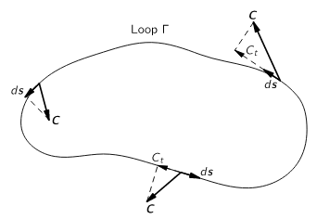

Write down an integral expression for the circulation around the curve.

Feynman next says “playing the same kind of game we did with the flux, we can show that the circulation around a loop is the sum of the circulations around two partial loops.” Draw a picture and make the argument. Generalize it to a surface bounded by a loop Gamma, with an arbitrary number of chunks/loops.

**The main point: We want to find the circulation through an arbitrary surface. We’ll begin by finding the flux through a tiny little cube square**

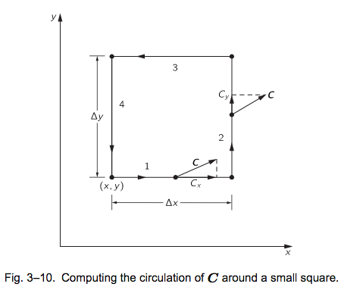

**Write down expressions for the circulation through face 1 and face 3. What assumptions are you making in order to simplify things?**

**What do you get if you add face 1 to face 3? What are the dimensions of your result?**