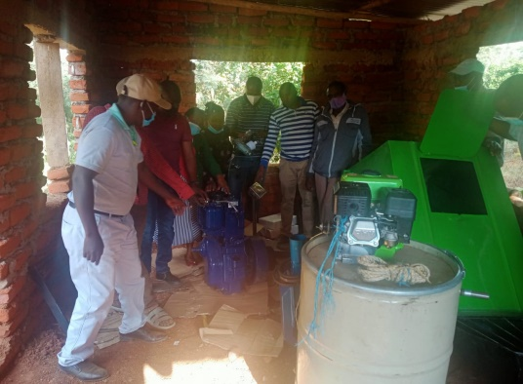

Chicky & fruits self-help group receiving their

procured feed miller, feed mixer, a digital scale

and a modern medium sealer.