**A CASE STUDY OF A SUCCESSIFUL BUSINESS MODEL FOR KAMAMI SELF HELP GROUP, KITUI COUNTY**

|  |  |  |  |  |
| --- | --- | --- | --- | --- |
| **DESCRIPTION** | | **KEY OBJECTIVES** | | |
| Kamami shg is an input supply group (feeds, premixes, raw materials, brooding, hatching)  as well as service providers training on feed formulation | | * Formulation of low-cost feeds by use of locally available materials * Enhance access of raw materials at lower cost to all the feed formulating groups in Kitui county * Enhance knowledge transfer through trainings. | | |
| **CUSTOMER TARGETS** | **CUSTOMER CHALLENGES** | **OUR SOLUTION** | **OUR VALUE** | **OUR PRICING** |
| All poultry groups within and outside the county | Higher prices of feeds  Preference of other brands  Low customer awareness on the product | * High quality feeds from locally grown raw materials at lower costs * Effective service provision on on farm feed formulation. | Kamami SHG is the leading brand in feed formulation, with a coverage in the entire lower eastern and north eastern counties.  We are also leaders in training trusted by multi sectoral organizations such as ASDSP, NARIGP, FAO among others. We offer services across the country. | * Grower’s mash – ksh. 2800 * Chick mash- ksh. 3200 * Layers mash- ksh. 3000 * Kienyeji mash- ksh 2400 * Day old chicks- ksh. 100 * 4 weeks old – ksh. 300 * Training- * Individuals- ksh. 3000 per day * Group – ksh. 8000 per day * Raw materials and premix – based on prevailing market prices |
| **OUR MONTHLY SALES** | | **GO TO MARKET** | | |
| Sale of feeds- Ksh. 97,400  Trainings- Ksh. 20,000  Sale of premix and raw materials-Ksh. 30,000  Brooding- Ksh. 125,000  Sale of day-old chicks- Ksh. 30,000  Total monthly income= Ksh. 302,400 | | Unyaa- along kitui Machakos road | | |
| **INVESTMENT** | | **GROWTH OPPORTUNITY** | | |
| Feed miller and mixer – Ksh. 400,000  Marketing- Ksh. 30,000  Operating cost- Ksh. 100,000 | | Expansion into mainstream market eg, agrovets  Expansion of chicken value chain and ready market through KICOPO  E- commerce platforms | | |

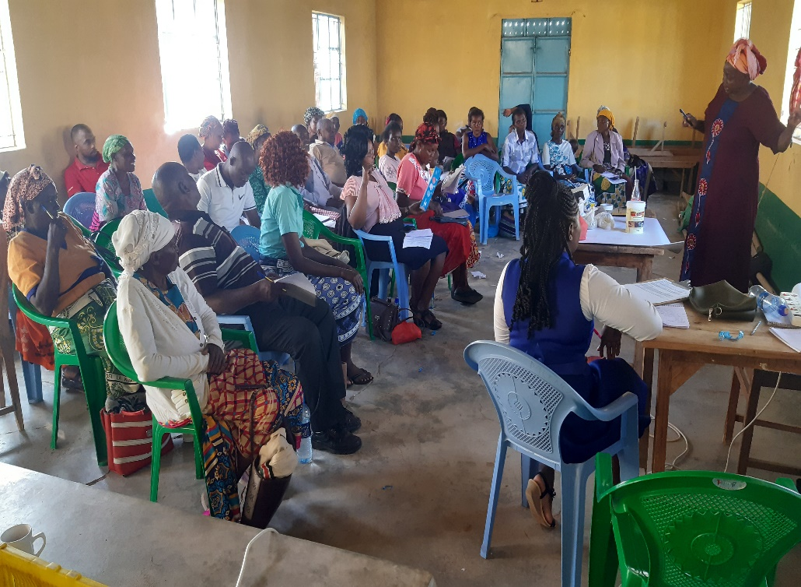

Figure Kamami Shg training on feed formulation