**A CASE STUDY OF A SUCCESSIFUL BUSINESS MODEL FOR MAVO COOPERATIVE, KITUI COUNTY**

|  |  |  |  |  |
| --- | --- | --- | --- | --- |
| **DESCRIPTION** | | **KEY OBJECTIVES** | | |
| MAVO Cooperative is located at Mutha ward, kitui south sub county, kitui county. It has a membership of 128 and 42 active share holders. It is a sorghum growing group and has expanded to seed multiplication and bulking for sorghum, green grams, pearl millet and pegion peas. | | * Promote adoption and use of climate smart agriculture through trainings and campaigns * Be the leading sorghum producer and supplier within and beyond the county * Commercialize dry land farming | | |
| **CUSTOMER TARGETS** | **CUSTOMER CHALLENGES** | **OUR SOLUTION** | **OUR VALUE** | **OUR PRICING** |
| * EAML * ICRISAT * Cereal growers association * KALRO * Local farmers | * Low access of raw materials by EAML * Low adoption of use of certified seeds and use of CSA/GG technologies | * Timely and supply of quality sorghum * Multiplication and supply of affordable certified seeds. | * Quality assurance * Professionalism * Networking | * Sorghum at ksh. 56 per kg * Green grams at 100 per kg * Green grams seed (karembo, biashara) at 200 per kg * Pegion peas at 200 per kg * Biofortified pearl millet at ksh. 100 per kg |
| **OUR OND,MAM SALES** | | **GO TO MARKET** | | |
| Sale of sorghum to EAML, - Ksh. 1,232,000  Other seeds- ksh. 1,069,320  Trainings- Ksh. 20,000  Sale of inputs (seeds, agro chemicals)-Ksh. 30,000  Threshing services- Ksh. 100,000  Total income= Ksh. 2,451,320 | | Mathima market, -Mutomo, kitui south | | |
| **INVESTMENT** | | **GROWTH OPPORTUNITY** | | |
| Marketing- Ksh. 20,000  Operating cost- Ksh. 100,000 | | * Expansion to stock into mainstream market eg, agrovets after certification * Cleaning and destoning service provision | | |

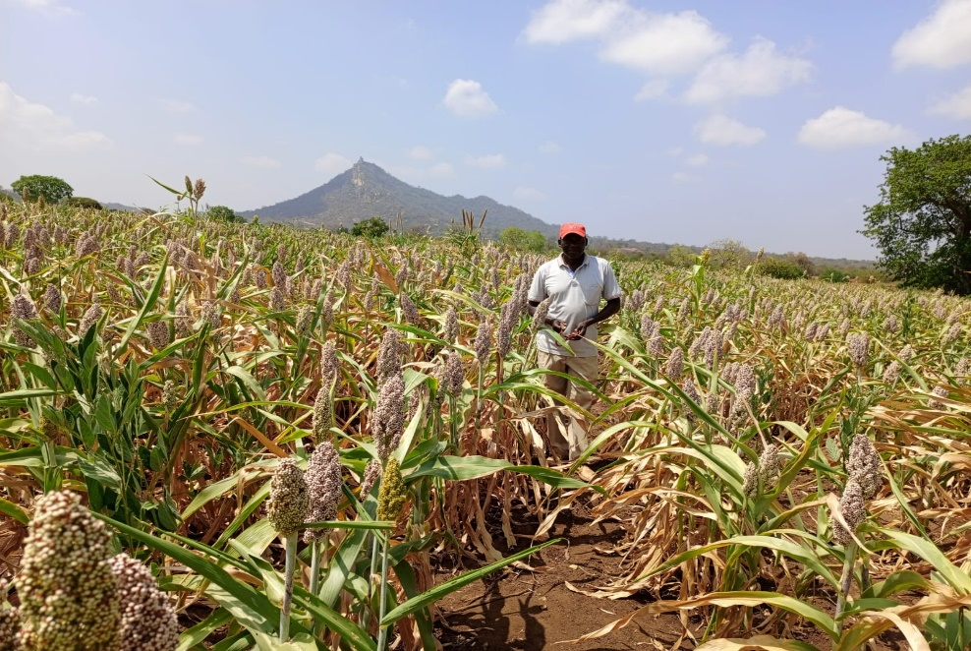

Figure Japheth Mulu in his sorghum farm