IOT SECURITY LAB
Assignment #3 — IoT Security Lab: Final Report (V2.2)
Evidence-backed written report · Frozen specification V2.2

Experiment | Final run | Verdict
E1 · ARP Spoofing / MITM | 20261028T202401Z | PASS
E2 · Replay | 20261028T202400Z | PASS
E3 · SQL Injection | 20261028T202401Z | PASS

Final acceptance: PASS · Clean-room checks: 20 passed, 0 failed, 0 skipped
Canonical specification: docs/ASSIGNMENT3_IOT_SECURITY_LAB_V2_2_FROZEN.md
All reported values are reproduced from committed evidence under evidence/<experiment>/<run_id>.
Submission date: 30 October 2026

1. Introduction
IoT security is not device-only security. A connected device participates in a trust chain spanning Device → Network → Transport → Application → Data. A control at one layer protects one failure domain only; a gap at any other layer still breaks the system. This lab demonstrates that claim empirically with three attacks at three different trust boundaries, each with its own distinct attacker.

2. Assignment Requirement
- Primary attack: ARP Spoofing / MITM (E1).
- Cross-layer extensions: Replay (E2) and SQL Injection (E3).
- Fallback order (spec §3/§33): if E1 network feasibility FAILs → E3 becomes
primary → then E2. In this run E1 feasibility PASSed, so E1 is the primary experiment as intended.

3. Architecture
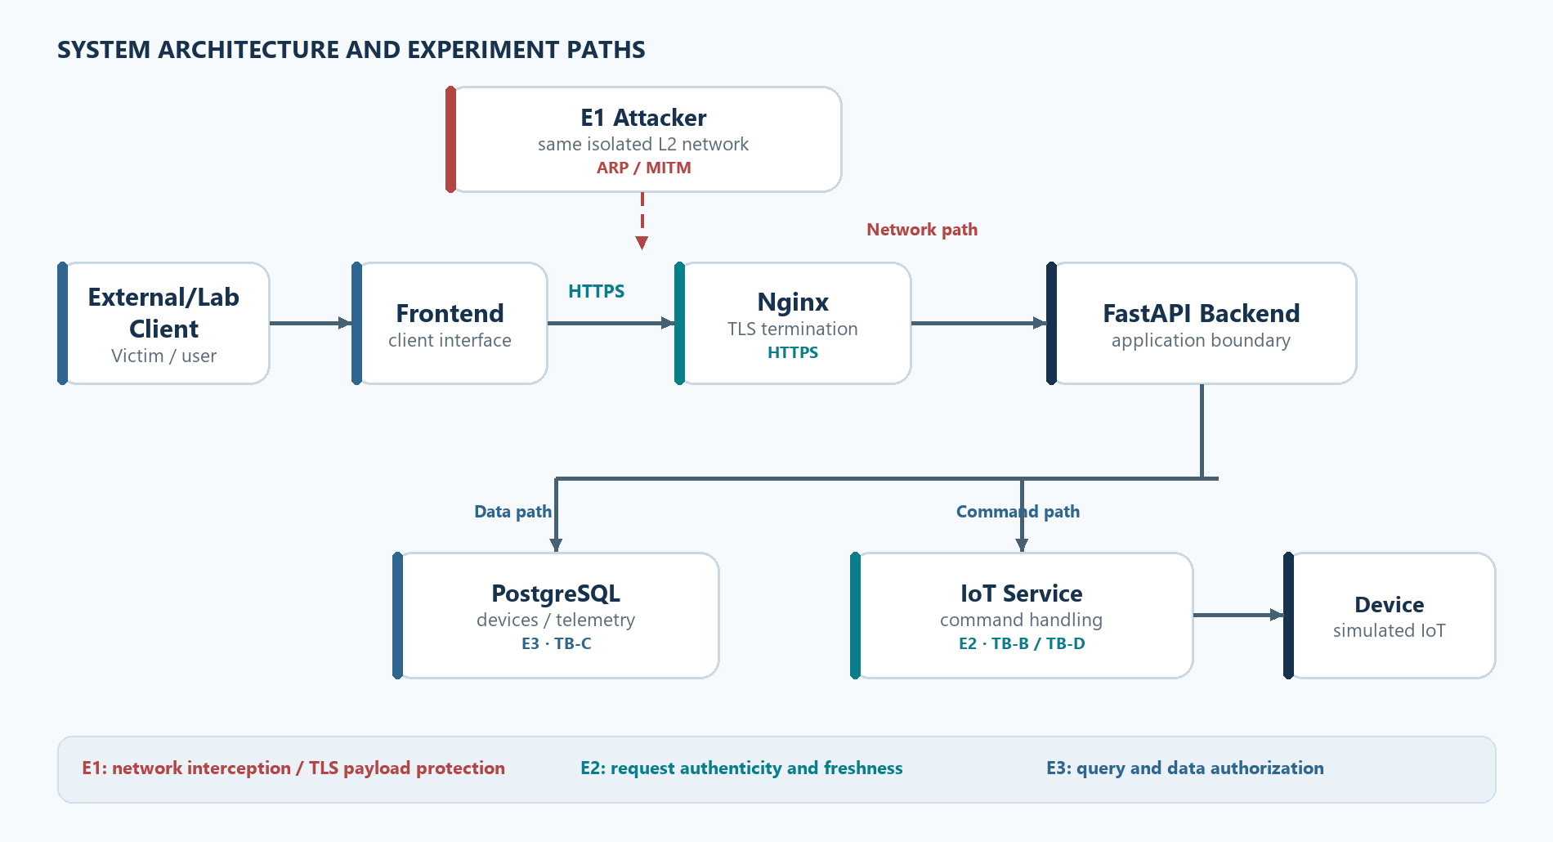
Figure 1. Application architecture and the E1, E2, and E3 experiment paths.
The database is not on every IoT command path. See COMMON_BASELINE.md for the mapping from this architecture to the runnable artifacts.

4. Threat Model
Exp | Attacker position | Capability | Explicit assumption
E1 | same L2 network | ARP manipulation, interception | HTTP observable; correct TLS protects payload
E2 | holds one captured legitimate request | replay / modify it | request from log leak / post-TLS internal; TLS not broken
E3 | can reach Backend API | supply malicious input | request already reached Application layer

Three distinct attackers — not one omnipotent adversary.

5. Primary Experiment — ARP Spoofing / MITM (E1)
Table 1. E1 before/after evidence summary — final run 20261028T202401Z.
Check | Before / attack state | After control / recovery | Evidence
ARP mapping | Gateway 10.77.0.2 resolves to attacker MAC 32:83:f3:8c:36:6f. | After restore, gateway MAC 8e:2e:67:45:e0:fd is present again. | E1-01, E1-02, E1-08
Payload visibility | HTTP capture exposes the test token twice. | HTTPS capture has 0 token occurrences; the victim still receives a valid response. | E1-04, E1-05, E1-06
TLS validation and service | Without forwarding, traffic breaks (DoS); this alone is not MITM. | Trusted CA succeeds (exit 0); untrusted CA is rejected (exit 60, HTTP 000); normal HTTP/TLS works after restore. | E1-DOS, E1-07, E1-08

Environment (spec §2/§5). An isolated private Docker L2 network e1_net (10.77.0.0/24), three project-owned containers: victim .10, gateway .2, attacker .66. Not bridged to any real LAN; targets are fixed by the topology (scope §0).

5.1 Network Feasibility Gate (P0, spec §2.1) — PASS
Condition | Result
SAME_L2_DOMAIN | YES
ARP_TABLE_VISIBLE | YES
ARP_MAPPING_CAN_CHANGE | YES
ATTACKER_IP_FORWARDING | YES
TRAFFIC_CONTINUES_THROUGH_ATTACKER | YES
PCAP_EVIDENCE_AVAILABLE | YES

Evidence: feasibility_gate.json, E1-01_baseline_arp.txt, E1-02_poisoned_arp.txt.

5.2 Root cause (spec §7.1)
ARP has no authentication. The attacker sends unsolicited ARP replies binding the gateway IP → attacker MAC (and victim IP → attacker MAC at the gateway). The victim ARP entry for 10.77.0.2 changed from the gateway MAC (8e:2e:67:45:e0:fd) to the attacker MAC (32:83:f3:8c:36:6f). Evidence E1-01 vs E1-02.

5.3 MITM vs DoS (spec §7.2)
- Forwarding dropped (ARP poisoned, attacker drops forwarded packets): victim
request to the gateway broke (empty response). This is DoS/disruption, not MITM. Evidence E1-DOS_http_response.txt.
- Forwarding enabled: victim traffic flows victim → attacker → gateway and
back; the victim still receives a valid response → true MITM path. Evidence E1-05_mitm_http_response.txt.

5.4 Confidentiality: HTTP vs HTTPS (spec §7.3, §10)
- HTTP: the plaintext token SECRET_TELEMETRY_TOKEN_12345 appears in the
attacker's capture (2 occurrences). Payload exposed. Evidence E1-04_mitm_http_pcap.txt, E1-05.
- HTTPS (certificate validation ENABLED): under the same MITM path, the token
does not appear in the attacker's TLS capture (0 occurrences), while the victim still gets a valid response. Payload confidentiality preserved. Evidence E1-06_mitm_https_pcap.txt, E1-06_https_response_validated.txt.
- Cert validation is genuinely enforced (no verify=false): with the trusted
CA the connection succeeds (curl exit 0); without the CA in the trust store the connection is rejected (curl exit 60, HTTP code 000). Evidence E1-07_cert_validation.txt.

5.5 CIA (spec §7.5)
Integrity: ARP mapping modified. Confidentiality: plaintext HTTP exposed, HTTPS protected. Availability: dropping forwarding degrades service (DoS case).

5.6 Defense & Regression (spec §7.6, §7.7, §13)
Implemented defense: TLS + certificate validation. After stopping the attack and restoring ARP, normal traffic works: HTTP OK, valid TLS OK, and the victim's ARP entry is restored to the gateway MAC — the control passes without relying on "block everything". Evidence E1-08_restored_arp.txt, E1-REGRESSION.

5.7 Residual risk (spec §7.8)
TLS protects payload confidentiality/integrity but not network availability or endpoint security. If an endpoint is compromised, plaintext is exposed before encryption / after decryption. DAI, segmentation, static ARP and ARP monitoring are conceptual here (not implemented).

6. Replay Extension (E2)
Table 2. E2 before/after evidence summary — final run 20261028T202400Z.
Check | Before control | After control | Evidence
First request | Accepted; action_count = 1. | Accepted once with HMAC over raw body, timestamp, and nonce. | result.json
Exact replay | Accepted again; action_count changes 1 → 2. | Rejected with HTTP 401 because the nonce was already consumed; action_count stays 1. | result.json, audit_log.json
Modified request | No request authentication in the vulnerable baseline. | Old signature with changed nonce, timestamp, or body is rejected for signature mismatch. | result.json, audit_log.json
Audit trail | No protection audit in the vulnerable baseline. | Five ACCEPT/REJECT events recorded for the protected cases. | audit_log.json

Boundary TB-B/TB-D. Attacker holds one captured legitimate request and does not break TLS (spec §9).
- Vulnerable baseline: no authentication → exact replay accepted →
action_count 1 → 2. Evidence E2-VULN-EXACT-REPLAY.
- Protected: HMAC-SHA256 over the raw received body bytes + timestamp
window + nonce cache, compared with hmac.compare_digest (constant-time), per-device secret (spec §11–§18.1).
Gate | Result
FIRST_REQUEST | ACCEPT (action_count=1)
EXACT_REPLAY | REJECT (nonce already consumed)
MODIFIED_NONCE + old signature | REJECT (signature mismatch)
MODIFIED_TIMESTAMP + old signature | REJECT (signature mismatch)
MODIFIED_BODY + old signature | REJECT (signature mismatch)
ACTION_COUNT on replay | UNCHANGED (=1)
AUDIT_LOG_CREATED | YES (ACCEPT + REJECT events)

The canonicalization rule is FROZEN: the client signs the exact bytes it transmits; the server verifies the exact bytes it received — never JSON parse-then-reserialize (a unit test proves two byte-different but semantically-equal JSONs yield different signatures).
Replay ≠ Idempotency (spec §17). Replay protection (nonce = security freshness) is IMPLEMENTED; idempotency (idempotency_key = retry semantics) is CONCEPTUAL / future work.
Residual risk (spec §18/§19): compromised device secret defeats HMAC; in-memory nonce cache is lost on restart (previously-used nonce within the timestamp window could be re-accepted) — E2_RESIDUAL_RISK; clock drift. A global shared fleet secret is rejected in favor of per-device secrets; hardware key protection (TPM/SE/TEE) is conceptual only.

7. SQL Injection Extension (E3)
Table 3. E3 before/after evidence summary — final run 20261028T202401Z.
Check | Before control | After control | Evidence
Normal query | sensor-alpha returns 1 row. | Parameterized query still returns 1 row. | result.json
Injection semantics | Raw SQL input ' OR '1'='1 returns 4 rows instead of 1. | Same input returns 0 rows through the parameterized query. | E3-01, E3-02, result.json
Privilege boundary | Least-privilege controls are not part of the vulnerable SQL-interpolation baseline. | iot_search_reader can read allowed tables; sensitive read, UPDATE, and DROP are denied; database row count remains 4 → 4. | result.json

Boundary TB-C. Attacker reaches the Backend API and supplies input (spec §6).
- Vulnerable baseline (genuine raw SQL interpolation, spec §21.1): normal
input sensor-alpha → 1 row; injection ' OR '1'='1 → 4 rows. Input changes query semantics. Evidence E3-01…E3-02, E3-VULN-SEMANTICS.
- Fix — Parameterized query (PREVENT, spec §24): the same injection input
now returns 0 rows; normal input still returns 1. SAME_INPUT_CHANGES_QUERY = NO.
- Containment — least-privilege role `iot_search_reader` (CONTAIN, spec §25–27):
Gate | Result
Allowed-table SELECT (devices/telemetry) | permitted
SENSITIVE_TABLE_READ (UNION → users) | DENIED (InsufficientPrivilege)
UNAUTHORIZED_UPDATE | DENIED (InsufficientPrivilege)
UNAUTHORIZED_DROP | DENIED (must be owner)
DB state before/after | unchanged (4 = 4)
NORMAL_QUERY_REGRESSION | PASS

Least privilege limits blast radius but is not a root-cause fix — injection on an allowed table could still read all permitted telemetry (spec §27).

8. Cross-Layer Analysis
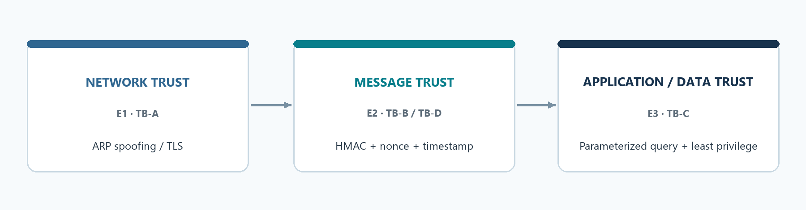
Figure 2. Cross-layer trust boundaries and their corresponding controls.
Each control protects exactly one failure domain. Correct TLS (E1) does nothing against a replayed authenticated request (E2); replay protection (E2) does nothing against malicious SQL from a legitimate client (E3); parameterized queries (E3) do nothing against L2 interception (E1). Hence defense must span layers.

9. Defense-in-Depth (spec §14/§29) — [I] implemented+verified, [C] conceptual
Exp | Prevent | Detect | Contain | Recover
E1 ARP/MITM | [I] TLS + Cert Validation / [C] DAI | [C] ARP anomaly monitoring | [C] Network segmentation | [C] Restore trusted network state
E2 Replay | [I] HMAC + Nonce + Timestamp | [I] Invalid-sig / duplicate-nonce audit | [I] Reject request / [C] revoke device key | [C] Key rotation / session recovery
E3 SQLi | [I] Parameterized Query | [C] DB/API anomaly monitoring | [I] Table-level Least Privilege | [C] DB restore / credential rotation

This lab implements Prevent + partial Detect + Contain. A complete Detect/Recover pipeline is not claimed.

10. Residual Risk (spec §32.10)
Endpoint compromise (pre-/post-encryption plaintext); HMAC key leakage; in-memory nonce-cache restart; clock drift; idempotency (conceptual); application-accessible SQL data still readable within granted privileges even after the injection fix.

11. Limitations
Controlled lab; simulated IoT device; no public target; no destructive operations; no Internet DDoS; no production credentials. E2 driven in-process for determinism (same application logic as the canonical FastAPI backend).

12. Conclusion
IoT security is a cross-layer trust-management problem. Each experiment confirms a single control secures a single failure domain: TLS protected the HTTPS payload but not availability; HMAC+nonce stopped replay but not a leaked key; parameterized queries removed the injection root cause while least privilege only contained blast radius. Therefore defense-in-depth across Network, Message, and Application/Data boundaries is required.

13. References
- Course slides — IoT Application Information Security & Risk Management.
- Assignment #3 slides (DVWA SQL Injection option).
- RFC 826 — Address Resolution Protocol (ARP).
- RFC 2104 — HMAC: Keyed-Hashing for Message Authentication.
- RFC 8446 — TLS 1.3.
- OWASP Top 10 — A03:2021 Injection.
- OWASP — SQL Injection Prevention Cheat Sheet (parameterized queries).
- PostgreSQL documentation — GRANT / role privileges (least privilege).
- CWE-287 (Improper Authentication), CWE-294 (Replay), CWE-89 (SQL Injection).
- Real-world context: Mirai botnet (2016) — IoT device trust failure at scale.

