RaceDay
Portfolio of Evidence — Part 1
System Planning and Database

1. Introduction
RaceDay is an event management system designed for the South African road running, cycling, and walking community. The platform allows Event Organizers to create and manage events, categories, and participant results, while Participants can browse upcoming events, enter events, track their personal performance history, and prepare for race day.
This document is my Part 1 submission for the RaceDay Portfolio of Evidence (POE). It sets out the full system plan produced before any application code was written: Section A covers the Entity Relationship Diagram (ERD) and the reasoning behind it; Section B covers the full API Endpoint Plan; Section C covers the SQL Server database script; and a final section shows the UI designs produced in Figma to plan the look and flow of the application ahead of Part 3.

3. System Roles
The system supports two distinct user roles:
Organizer
- Can create, edit, and delete events
- Can manage event categories
- Can capture participant results
- Can view all event enrollments
Participant
- Can create an account
- Can browse events
- Can enter an event by selecting a category
- Can view their own enrollments
- Can track their personal results

4. Section A — Entity Relationship Diagram (ERD)

Purpose of the ERD
The Entity Relationship Diagram shows all the data that will be stored in the RaceDay system and how the different pieces of data relate to each other. This is an important planning step because it helps us understand what information we need to store, how different parts of the system connect, and what relationships exist between different entities.

ERD Diagram
The diagram below shows the six entities (tables) in the RaceDay database and how they relate to each other. Primary keys are underlined and foreign keys are shown in italics.
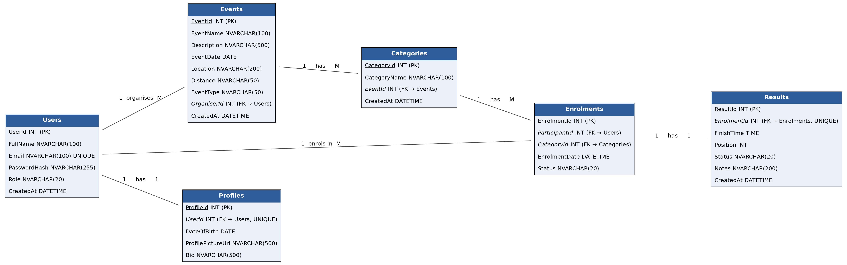

ERD Design Decisions
When designing the database, I considered the following:
1. Users
The system needs to store information about both Organizers and Participants. Using a single Users table with a Role field is simpler than having separate tables for each role, since both roles share the same core attributes (name, email, password) and authenticate through the same login endpoint.
2. Events
Each event belongs to one Organizer. Events can have many categories (e.g. a marathon can have a Full Marathon category and a Half Marathon category).
3. Categories
Each category belongs to one event. This allows Organizers to create different race distances within the same event.
4. Enrollments
This table connects Participants to Categories. It shows which participant has enrolled in which category. This is called a 'junction table' because it links two other tables together, resolving the many-to-many relationship between Users and Categories.
5. Results
Each enrollment can have one result. The result stores the participant's finish time, position, and status (Finished, DNF, DNS, or Pending).
6. Profiles
Additional user information that isn't required for login but adds more detail to a user's profile, such as date of birth, a profile picture, and a short bio. Keeping this separate from Users means the core login table stays lean, and profile details are optional per user.

5. Section B — API Endpoint Plan

Purpose of the Endpoint Plan
Before writing any code, I planned all the API endpoints that the RaceDay system will need. This planning ensures that all required functionality is covered, role-based access is properly enforced, the API is consistent and follows RESTful principles, and developers know exactly what to build.

Endpoint Design Decisions
RESTful Principles
I followed RESTful design principles when planning the endpoints:
- Resources are nouns: /events, /categories, /enrollments
- HTTP methods show actions: GET (read), POST (create), PUT (update), DELETE (remove)
- Consistent naming: all routes start with /api/
- Nested resources show relationships: /api/events/{eventId}/categories
Role-Based Access
Each endpoint has a clear role requirement:
- Public: anyone can access (register, login)
- Any (logged in): only users with a valid JWT token
- Organizer: only users with the Organizer role
- Participant: only users with the Participant role
Authentication and Security
- All endpoints except register and login require a JWT (JSON Web Token)
- The JWT contains the user's ID and role
- The API checks the role before allowing access

Authentication Endpoints
HTTP Method | Route | Description | Role Required | Request Body | Expected Response
POST | /api/auth/register | Register a new user (Organizer or Participant). | None | FullName, Email, Password, Role | 201 Created; 400 Bad Request - validation failed or email already in use
POST | /api/auth/login | Authenticate a user with email and password and issue a JWT token. | None | Email, Password | 200 OK (JWT Token); 401 Unauthorized - invalid credentials

Profile Endpoints
HTTP Method | Route | Description | Role Required | Request Body | Expected Response
GET | /api/profile | View the logged-in user's own profile. | Any | None | 200 OK - profile details; 401 Unauthorized
PUT | /api/profile | Update the logged-in user's own profile. | Any | FullName, Email | 200 OK - updated profile; 404 Not Found

Event Endpoints
HTTP Method | Route | Description | Role Required | Request Body | Expected Response
GET | /api/events | Retrieve all events. | Any | None | 200 OK - list of events
GET | /api/events/{id} | Retrieve a specific event by id. | Any | None | 200 OK - event details; 404 Not Found
POST | /api/events | Create a new event. | Organizer | EventName, Description, EventDate, Location, Distance, EventType | 201 Created; 400 Bad Request
PUT | /api/events/{id} | Update an existing event. | Organizer | Updated event details | 200 OK; 404 Not Found
DELETE | /api/events/{id} | Delete an event. | Organizer | None | 200 OK; 404 Not Found

Category Endpoints
HTTP Method | Route | Description | Role Required | Request Body | Expected Response
GET | /api/events/{eventId}/categories | Retrieve all categories for a specific event. | Any | None | 200 OK - list of categories; 404 Not Found
POST | /api/events/{eventId}/categories | Add a new category to an event (e.g. 5km, 10km). | Organizer | CategoryName | 201 Created; 404 Not Found - event does not exist
PUT | /api/categories/{id} | Update an existing category's name. | Organizer | CategoryName | 200 OK; 404 Not Found
DELETE | /api/categories/{id} | Delete a category. | Organizer | None | 200 OK; 404 Not Found

Event Enrollment Endpoints
HTTP Method | Route | Description | Role Required | Request Body | Expected Response
POST | /api/categories/{categoryId}/enroll | Enroll the logged-in participant into a category for an event. | Participant | None | 201 Created - enrollment record; 409 Conflict - already enrolled
GET | /api/enrollments/my | View the logged-in participant's own enrollments. | Participant | None | 200 OK - list of enrollments
GET | /api/events/{eventId}/enrollments | View all enrollments for a specific event. | Organizer | None | 200 OK - list of enrollments; 404 Not Found
DELETE | /api/enrollments/{id} | Cancel/withdraw an enrollment. | Participant | None | 200 OK; 404 Not Found

Result Endpoints
HTTP Method | Route | Description | Role Required | Request Body | Expected Response
POST | /api/enrollments/{enrollmentId}/result | Capture a result (finish time, position, status) for an enrollment. | Organizer | FinishTime, Position, Status | 201 Created; 404 Not Found - enrollment does not exist
GET | /api/results/my | View the logged-in participant's own result history. | Participant | None | 200 OK - list of results
PUT | /api/results/{id} | Update a captured result. | Organizer | FinishTime, Position, Status | 200 OK; 404 Not Found

Endpoint Coverage Check
The endpoint plan covers all functional requirements identified for the system:
Requirement | Covered By
Authentication (register/login) | POST /api/auth/register, POST /api/auth/login
User Profile | GET /api/profile, PUT /api/profile
Event Management | GET/POST/PUT/DELETE /api/events
Category Management | GET/POST/PUT/DELETE /api/events/{id}/categories
Event Enrollments | POST /api/categories/{id}/enrolll, GET /api/enrollments/my
Results Management | POST /api/enrollments/{id}/result, GET /api/results/my
Role-Based Access | All endpoints specify role requirements

Example: A Participant Enrolling in an Event
To help demonstrate how the API works end to end, here is a worked example of a common operation.
Scenario
Andy Jacobs wants to enroll in the Half Marathon category for the Johannesburg City Marathon.
Step 1: Andy logs in
POST /api/auth/login
Request Body: { "email": "andy.jacobs@gmail.com", "password": "password123" }
Response: { "token": "jwt_token_here", "userId": 3, "role": "Participant" }
Step 2: Andy views available events
GET /api/events
Response: List of all events including Johannesburg City Marathon (EventId: 1)
Step 3: Andy views categories for the event
GET /api/events/1/categories
Response: [ { "categoryId": 1, "categoryName": "Full Marathon (42km)" },
{ "categoryId": 2, "categoryName": "Half Marathon (21km)" } ]
Step 4: Andy enrolls in Half Marathon (CategoryId: 2)
POST /api/categories/2/enroll
Headers: { "Authorization": "Bearer jwt_token_here" }
Response: 201 Created - { "enrollmentId": 5, "status": "Pending" }

6. Section C — SQL Database Script
The full script (RaceDay Database Script.sql) is listed at the end of this section and is also committed separately to the /docs folder of the GitHub repository. It creates the database, all six tables with their constraints, seeds them with sample data, and includes verification queries to confirm everything loaded correctly.

Summary
Users
Column | Data Type | Constraint / Notes
UserId | INT IDENTITY | PRIMARY KEY
FullName | NVARCHAR(100) | NOT NULL
Email | NVARCHAR(100) | NOT NULL, UNIQUE
PasswordHash | NVARCHAR(255) | NOT NULL
Role | NVARCHAR(20) | NOT NULL, CHECK IN ('Organizer','Participant')
CreatedAt | DATETIME | DEFAULT GETDATE()
Events
Column | Data Type | Constraint / Notes
EventId | INT IDENTITY | PRIMARY KEY
EventName | NVARCHAR(100) | NOT NULL
Description | NVARCHAR(500) | NULL
EventDate | DATE | NOT NULL
Location | NVARCHAR(200) | NOT NULL
Distance | NVARCHAR(50) | NOT NULL
EventType | NVARCHAR(50) | NOT NULL, CHECK IN ('Running','Walking','Cycling')
OrganizerId | INT | FOREIGN KEY REFERENCES Users(UserId)
CreatedAt | DATETIME | DEFAULT GETDATE()
Categories
Column | Data Type | Constraint / Notes
CategoryId | INT IDENTITY | PRIMARY KEY
CategoryName | NVARCHAR(100) | NOT NULL
EventId | INT | FOREIGN KEY REFERENCES Events(EventId), ON DELETE CASCADE
CreatedAt | DATETIME | DEFAULT GETDATE()
Enrollments
Column | Data Type | Constraint / Notes
EnrollmentId | INT IDENTITY | PRIMARY KEY
ParticipantId | INT | FOREIGN KEY REFERENCES Users(UserId)
CategoryId | INT | FOREIGN KEY REFERENCES Categories(CategoryId)
EnrollmentDate | DATETIME | DEFAULT GETDATE()
Status | NVARCHAR(20) | DEFAULT 'Pending', CHECK IN ('Confirmed','Pending','Cancelled')
Results
Column | Data Type | Constraint / Notes
ResultId | INT IDENTITY | PRIMARY KEY
EnrollmentId | INT | FOREIGN KEY REFERENCES Enrollments(EnrollmentId), UNIQUE
FinishTime | TIME | NULL
Position | INT | NULL
Status | NVARCHAR(20) | DEFAULT 'Pending', CHECK IN ('Finished','DNF','DNS','Pending')
Notes | NVARCHAR(200) | NULL
CreatedAt | DATETIME | DEFAULT GETDATE()
Profiles
Column | Data Type | Constraint / Notes
ProfileId | INT IDENTITY | PRIMARY KEY
UserId | INT | FOREIGN KEY REFERENCES Users(UserId), UNIQUE
DateOfBirth | DATE | NULL
ProfilePictureUrl | NVARCHAR(500) | NULL
Bio | NVARCHAR(500) | NULL

Sample Data
The script seeds 2 Organizers and 2 Participants into Users, 4 Events, Categories for every event, Enrollments linking participants to categories, sample Results, and a Profile for each user — plus a set of verification SELECT queries at the end to display the data for the video walkthrough.

Full Script Database
-- ============================================
-- RaceDay Database
-- Part 1: System Planning and Database
-- ============================================

-- Create the database
CREATE DATABASE RaceDayDB;
GO

-- Use the new database
USE RaceDayDB;
GO

-- ============================================
-- TABLE CREATION
-- ============================================

-- ============================================
-- 1. USERS Table
-- Stores all user accounts (Organizers and Participants)
-- ============================================
CREATE TABLE Users (
UserId INT IDENTITY(1,1) PRIMARY KEY,
FullName NVARCHAR(100) NOT NULL,
Email NVARCHAR(100) NOT NULL UNIQUE,
PasswordHash NVARCHAR(255) NOT NULL,
Role NVARCHAR(20) NOT NULL CHECK (Role IN ('Organizer', 'Participant')),
CreatedAt DATETIME DEFAULT GETDATE()
);
GO

-- ============================================
-- 2. EVENTS Table
-- Stores all events created by Organizers
-- ============================================
CREATE TABLE Events (
EventId INT IDENTITY(1,1) PRIMARY KEY,
EventName NVARCHAR(100) NOT NULL,
Description NVARCHAR(500) NULL,
EventDate DATE NOT NULL,
Location NVARCHAR(200) NOT NULL,
Distance NVARCHAR(50) NOT NULL,
EventType NVARCHAR(50) NOT NULL CHECK (EventType IN ('Running', 'Walking', 'Cycling')),
OrganizerId INT NOT NULL,
CreatedAt DATETIME DEFAULT GETDATE(),
CONSTRAINT FK_Event_Organizer FOREIGN KEY (OrganizerId) REFERENCES Users(UserId)
);
GO

-- ============================================
-- 3. CATEGORIES Table
-- Stores categories within events (e.g., 5km, 10km)
-- ============================================
CREATE TABLE Categories (
CategoryId INT IDENTITY(1,1) PRIMARY KEY,
CategoryName NVARCHAR(100) NOT NULL,
EventId INT NOT NULL,
CreatedAt DATETIME DEFAULT GETDATE(),
CONSTRAINT FK_Category_Event FOREIGN KEY (EventId) REFERENCES Events(EventId) ON DELETE CASCADE
);
GO

-- ============================================
-- 4. ENROLLMENTS Table
-- Tracks participant enrollments in categories
-- ============================================
CREATE TABLE Enrollments (
EnrollmentId INT IDENTITY(1,1) PRIMARY KEY,
ParticipantId INT NOT NULL,
CategoryId INT NOT NULL,
EnrollmentDate DATETIME DEFAULT GETDATE(),
Status NVARCHAR(20) DEFAULT 'Pending' CHECK (Status IN ('Confirmed', 'Pending', 'Cancelled')),
CONSTRAINT FK_Enrollment_Participant FOREIGN KEY (ParticipantId) REFERENCES Users(UserId),
CONSTRAINT FK_Enrollment_Category FOREIGN KEY (CategoryId) REFERENCES Categories(CategoryId),
CONSTRAINT UQ_Enrollment_Unique UNIQUE (ParticipantId, CategoryId)
);
GO

-- ============================================
-- 5. RESULTS Table
-- Stores finish results for enrollments
-- ============================================
CREATE TABLE Results (
ResultId INT IDENTITY(1,1) PRIMARY KEY,
EnrollmentId INT NOT NULL UNIQUE,
FinishTime TIME NULL,
Position INT NULL,
Status NVARCHAR(20) DEFAULT 'Pending' CHECK (Status IN ('Finished', 'DNF', 'DNS', 'Pending')),
Notes NVARCHAR(200) NULL,
CreatedAt DATETIME DEFAULT GETDATE(),
CONSTRAINT FK_Result_Enrollment FOREIGN KEY (EnrollmentId) REFERENCES Enrollments(EnrollmentId)
);
GO

-- ============================================
-- 6. PROFILES Table
-- Stores additional user profile information
-- ============================================
CREATE TABLE Profiles (
ProfileId INT IDENTITY(1,1) PRIMARY KEY,
UserId INT NOT NULL UNIQUE,
DateOfBirth DATE NULL,
ProfilePictureUrl NVARCHAR(500) NULL,
Bio NVARCHAR(500) NULL,
CONSTRAINT FK_Profile_User FOREIGN KEY (UserId) REFERENCES Users(UserId)
);
GO

-- ============================================
-- INSERT SAMPLE DATA (SEED DATA)
-- ============================================

-- Insert Organizers (2 organizers)
INSERT INTO Users (FullName, Email, PasswordHash, Role, CreatedAt)
VALUES
('Thabo Mokoena', 'thabo@racerun.co.za', 'hashed_password_1', 'Organizer', GETDATE()),
('Sarah Naidoo', 'sarah@capetowncycle.co.za', 'hashed_password_2', 'Organizer', GETDATE());
GO

-- Insert Participants (2 participants)
INSERT INTO Users (FullName, Email, PasswordHash, Role, CreatedAt)
VALUES
('Andy Jacobs', 'andy.jacobs@gmail.com', 'hashed_password_3', 'Participant', GETDATE()),
('Pamela Jim', 'pamela.jim@yahoo.com', 'hashed_password_4', 'Participant', GETDATE());
GO

-- Insert Events (4 events - 3 running, 1 cycling)
INSERT INTO Events (EventName, Description, EventDate, Location, Distance, EventType, OrganizerId)
VALUES
('Johannesburg City Marathon', 'Annual marathon through the streets of Johannesburg', '2026-09-15', 'Johannesburg, Gauteng', '42.2km', 'Running', 1),
('Pretoria Park Run', 'Community park run in Pretoria', '2026-10-01', 'Pretoria, Gauteng', '5km', 'Running', 1),
('Cape Town Cycle Classic', 'Premier cycling event in Cape Town', '2026-11-05', 'Cape Town, Western Cape', '55km', 'Cycling', 2),
('Bloemfontein City Marathon', 'Marathon event in the heart of Bloemfontein', '2026-12-10', 'Bloemfontein, Free State', '42.2km', 'Running', 2);
GO

-- Insert Categories for Johannesburg City Marathon (EventId = 1)
INSERT INTO Categories (CategoryName, EventId)
VALUES
('Full Marathon (42km)', 1),
('Half Marathon (21km)', 1);
GO

-- Insert Categories for Pretoria Park Run (EventId = 2)
INSERT INTO Categories (CategoryName, EventId)
VALUES
('5km Run', 2),
('5km Walk', 2);
GO

-- Insert Categories for Cape Town Cycle Classic (EventId = 3)
INSERT INTO Categories (CategoryName, EventId)
VALUES
('55km Fun Ride', 3),
('25km Family Ride', 3);
GO

-- Insert Categories for Bloemfontein City Marathon (EventId = 4)
INSERT INTO Categories (CategoryName, EventId)
VALUES
('Full Marathon (42km)', 4),
('Half Marathon (21km)', 4);
GO

-- Insert Enrollments
INSERT INTO Enrollments (ParticipantId, CategoryId, Status, EnrollmentDate)
VALUES
-- Andy Jacobs (ParticipantId = 3) enrollments
(3, 2, 'Confirmed', GETDATE()), -- Half Marathon (21km) - Confirmed
(3, 5, 'Pending', GETDATE()), -- 55km Fun Ride - Pending
-- Pamela Jim (ParticipantId = 4) enrollments
(4, 4, 'Confirmed', GETDATE()), -- 5km Walk - Confirmed
(4, 7, 'Confirmed', GETDATE()); -- Full Marathon (42km) - Confirmed
GO

-- Insert Results
INSERT INTO Results (EnrollmentId, FinishTime, Position, Status, Notes)
VALUES
-- Andy Jacobs Half Marathon result (EnrollmentId = 1)
(1, '01:45:32', 45, 'Finished', 'Good performance'),
-- Pamela Jim 5km Walk result (EnrollmentId = 3)
(3, '00:35:15', 12, 'Finished', 'Personal best');
GO

-- Insert Profiles
INSERT INTO Profiles (UserId, DateOfBirth, Bio)
VALUES
(1, '1985-03-15', 'Experienced marathon organizer based in Johannesburg'),
(2, '1990-07-22', 'Cycling event organizer from Cape Town'),
(3, '1992-11-08', 'Avid runner and cycling enthusiast'),
(4, '1988-05-03', 'Walking and running participant');
GO

-- ============================================
-- VERIFICATION QUERIES
-- These queries help verify the data was inserted correctly
-- ============================================

-- Check all users
PRINT '=== All Users ===';
SELECT UserId, FullName, Email, Role, CreatedAt FROM Users;
GO

-- Check all events with organizer names
PRINT '=== All Events with Organizers ===';
SELECT
e.EventName,
e.Location,
e.EventDate,
e.EventType,
u.FullName AS Organizer
FROM Events e
JOIN Users u ON e.OrganizerId = u.UserId
ORDER BY e.EventDate;
GO

-- Check all categories with event names
PRINT '=== All Categories with Events ===';
SELECT
c.CategoryName,
e.EventName,
e.EventDate,
e.Location
FROM Categories c
JOIN Events e ON c.EventId = e.EventId
ORDER BY e.EventDate, c.CategoryName;
GO

-- Check all enrollments with participant and category details
PRINT '=== All Enrollments ===';
SELECT
u.FullName AS Participant,
c.CategoryName,
e.EventName,
en.Status,
en.EnrollmentDate
FROM Enrollments en
JOIN Users u ON en.ParticipantId = u.UserId
JOIN Categories c ON en.CategoryId = c.CategoryId
JOIN Events e ON c.EventId = e.EventId
ORDER BY en.EnrollmentDate;
GO

-- Check results with participant names
PRINT '=== All Results ===';
SELECT
u.FullName AS Participant,
c.CategoryName,
e.EventName,
r.FinishTime,
r.Position,
r.Status AS ResultStatus,
r.Notes
FROM Results r
JOIN Enrollments en ON r.EnrollmentId = en.EnrollmentId
JOIN Users u ON en.ParticipantId = u.UserId
JOIN Categories c ON en.CategoryId = c.CategoryId
JOIN Events e ON c.EventId = e.EventId
ORDER BY r.Position;
GO

-- Summary statistics
PRINT '=== Database Summary ===';
SELECT
(SELECT COUNT(*) FROM Users) AS TotalUsers,
(SELECT COUNT(*) FROM Users WHERE Role = 'Organizer') AS Organizers,
(SELECT COUNT(*) FROM Users WHERE Role = 'Participant') AS Participants,
(SELECT COUNT(*) FROM Events) AS TotalEvents,
(SELECT COUNT(*) FROM Categories) AS TotalCategories,
(SELECT COUNT(*) FROM Enrollments) AS TotalEnrollments,
(SELECT COUNT(*) FROM Results) AS TotalResults;
GO

7. UI Designs

Before Part 3 (the MVC web application), I used Figma to design and prototype the RaceDay screens. This let me plan the look, layout, and navigation flow of the application ahead of time. The frames below show the key screens for both the Participant and Organizer roles.

Figma Prototype Links
The links below open an interactive, clickable prototype of the designs (view-only, no Figma account required):
- https://www.figma.com/proto/lM8X2kvyGB441Lfour6pSE/RaceDay-UI-Design?node-id=17-233&p=f&t=JXmEQOZeRkbrqBKX-1&scaling=min-zoom&content-scaling=fixed&page-id=0%3A1&starting-point-node-id=14%3A83&show-proto-sidebar=1
- https://www.figma.com/proto/lM8X2kvyGB441Lfour6pSE/RaceDay-UI-Design?node-id=17-249&p=f&t=1s9XGH7798yNP7Ag-1&scaling=min-zoom&content-scaling=fixed&page-id=0%3A1&starting-point-node-id=17%3A249&show-proto-sidebar=1

Participant Screens
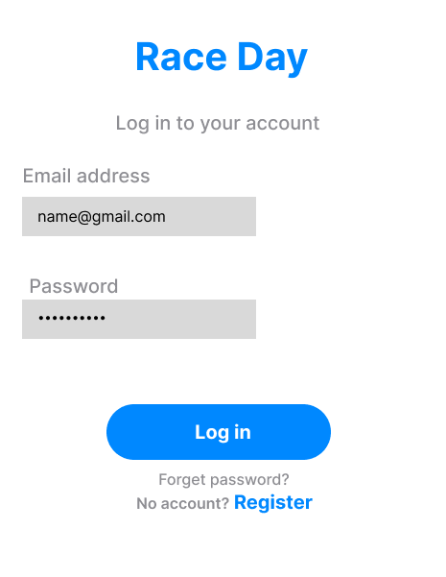  Login | 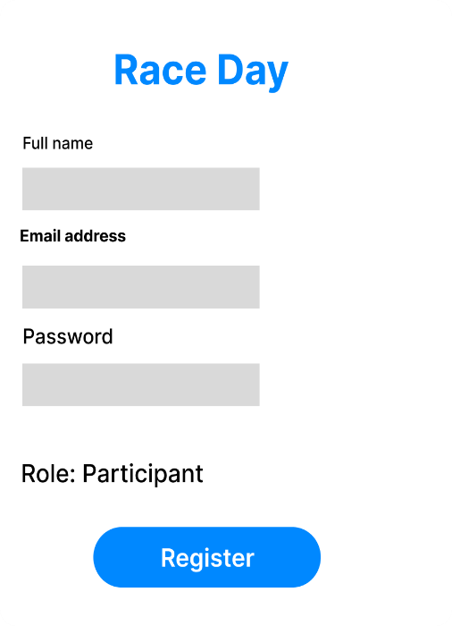  Register | 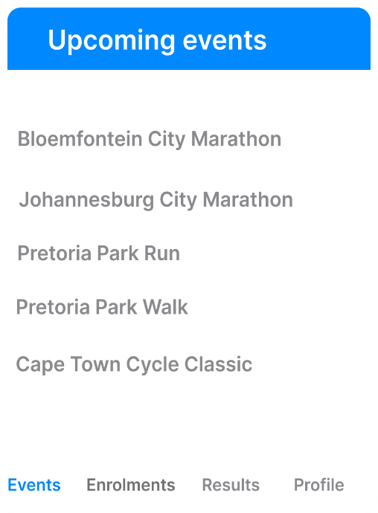  Browse Events | 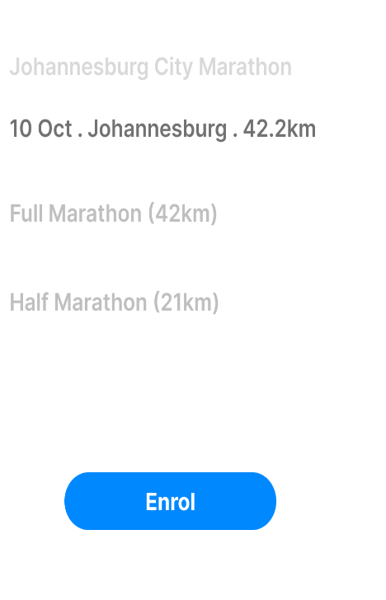  Event Details
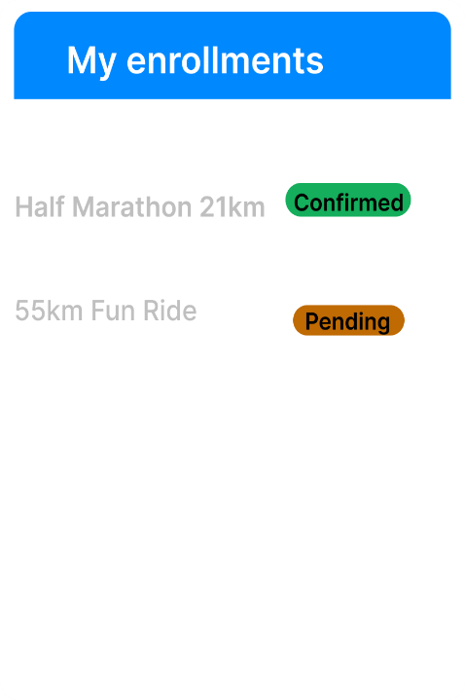  My Enrollments | 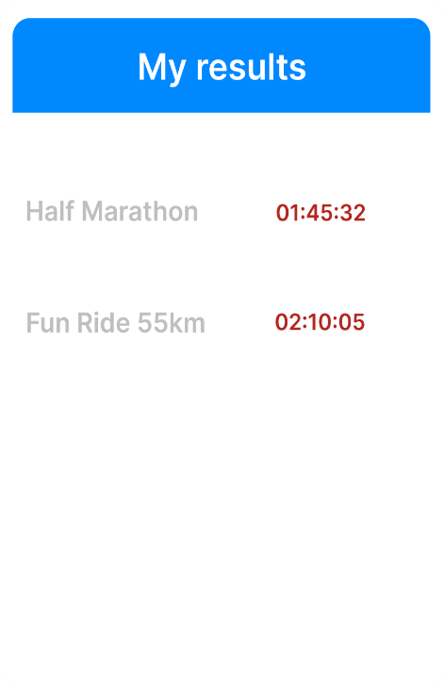  My Results | 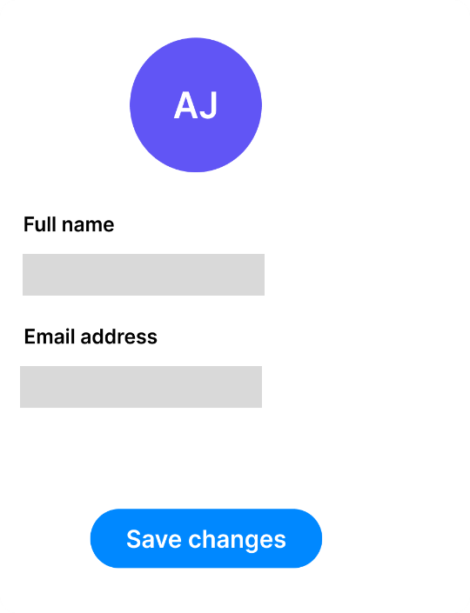  Profile

Organizer Screens
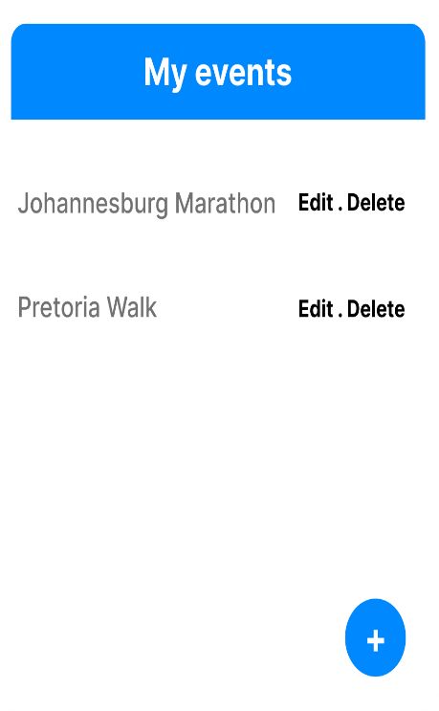  My Events | 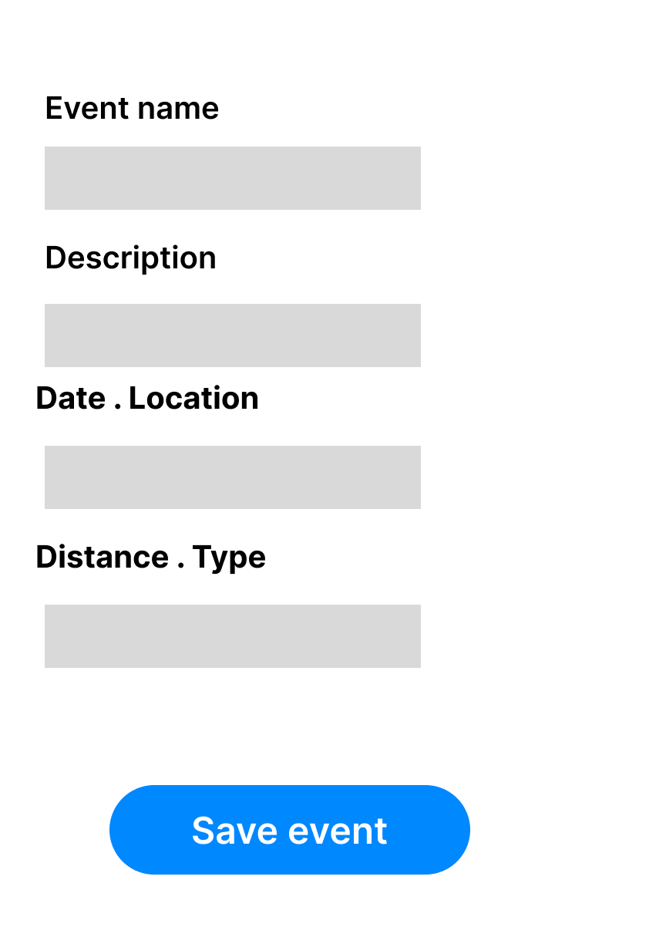  Create/Edit Event | 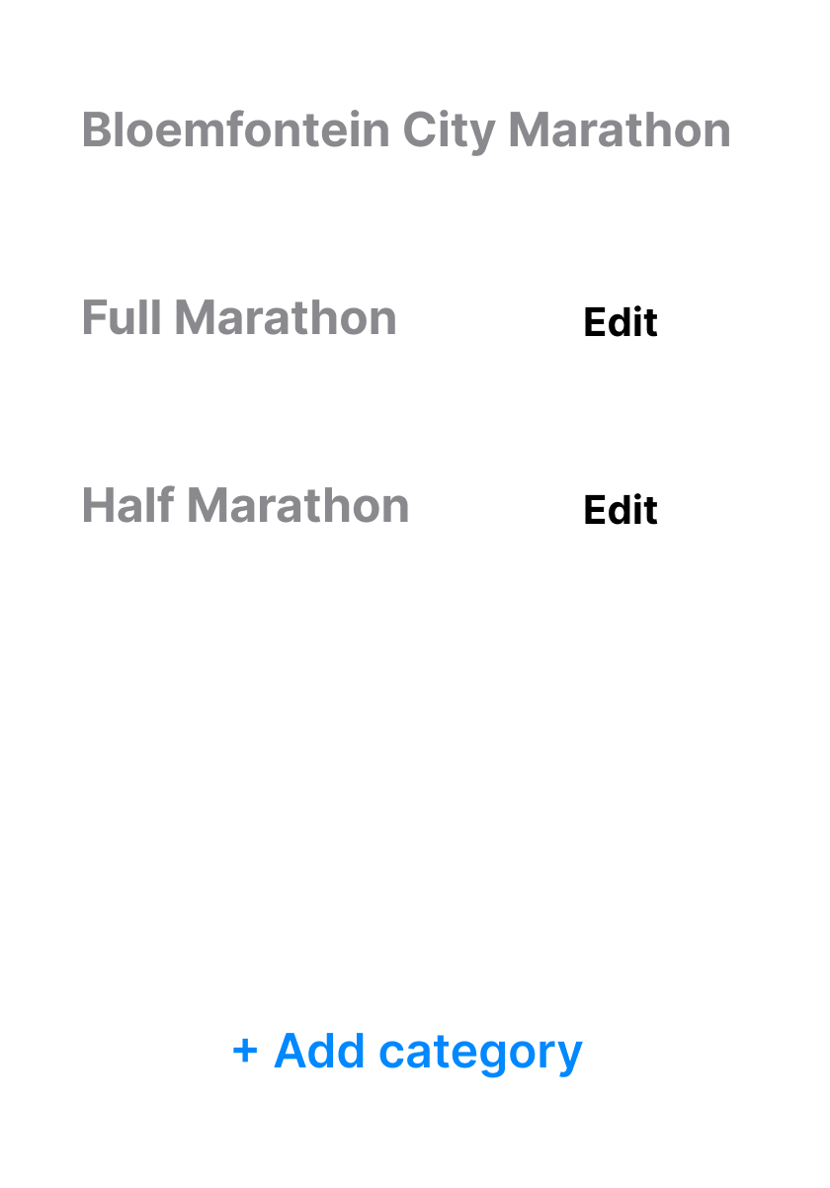  Manage Categories | 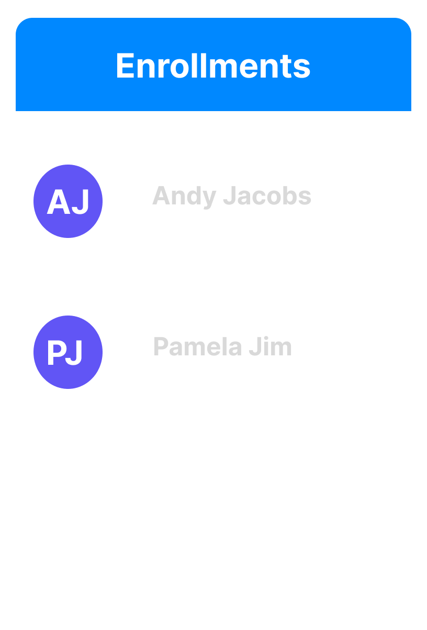  View Enrollments
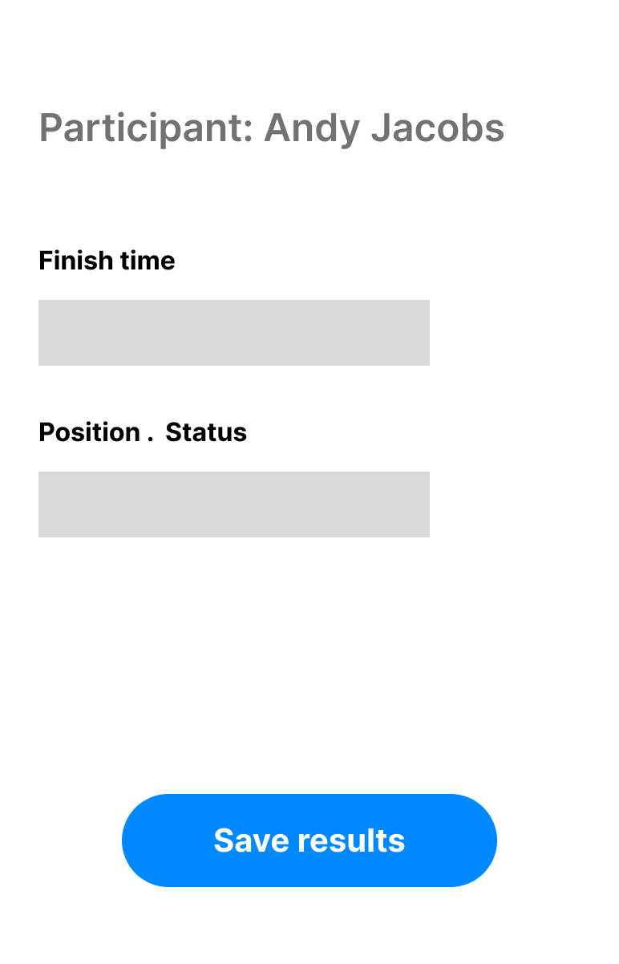
Capture Result

bhhbgd

