Analysis

By

Jimmy Sherpa

**Introduction**

Analysis is one of the early stages of software development where requirements for it are determined and specified by following certain steps. It also helps to find or determine the feasibility of a project.

The better the analysis, the better the software will be. So it is important to take time and think well while making analysis. The whole software or project depends on it.

There can be many ways to make analysis. However, I have used only one which is SWOT analysis for my project.

SWOT stands for Strengths Weaknesses Opportunities and Threats. As it’s full form states, it is the process of analyzing or accessing the strengths, weakness and opportunities along with threats. Strength refers to the strong points of a business or projects, weaknesses refers to the bad points of a business, opportunities refers to the chances that might be available to grab and convert it into strength and threats are those which can harm the business. They are described in detail as follows:

Strengths

Strengths are attributes and characteristics which hands the business advantages. It could be something like things a business does better than others which makes the business more favorable and attractive to others. Having good budget can be considered as strength of a company.

Weaknesses

Weakness are attributes and characteristics that weakens the company or business making others have the upper hand on them. However, these weaknesses can be converted to strengths by analyzing them and acting upon them to make the company or business better and stronger.

Opportunities

Opportunities can also be considered as strengths in a way which provide better situation and advantage over others. Some of the opportunities are created without the knowledge of the company.

Threats

Threats are those which can harm the company or business which can lead to problems in the future. Factors like new technologies are threats to business as they require knowledge and manpower to operate or interact with.

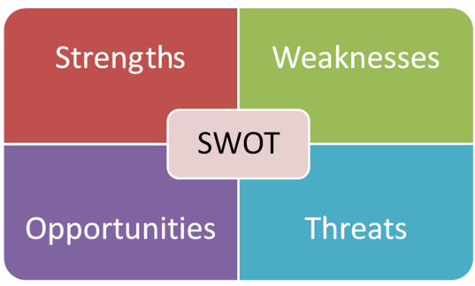

**Feasibility Study**

A feasibility study is an approach of analyzing all the appropriate factors of a project to find the possibilities of completing a project. It takes all of a project's relevant factors into account.

Economic Feasibility

It is the analysis of budget to see if the company can provide enough budget for the project and whether or not if the project will gain enough profit according to the budget invested.

Technical Feasibility

It sees if the current hardware and software is sufficient for the proposed project. It also checks if the required hardware and software are available.

Schedule Feasibility

Schedule Feasibility is the time given to complete project. The project has to be completed in time.

Operational Feasibility

It refers to whether the new developed system will be used or can be used by others.

Legal Feasibility

It refers to the legal and ethical matters of the project.

**Requirement Analysis**

Functional

Functional requirements describe the desired end function of a system operating within normal parameters. It describes the main behaviors of the product that the user expects from the system.

|  |  |  |  |  |
| --- | --- | --- | --- | --- |
| **FID** | **Function** | **Data** | **Dependency** | **Remarks** |
| F01 | Login | Username and Password | None | It restricts unauthorized access |
| F02 | Team Registration | Team Name and Player Names | F01 | Teams that will be participating |
| F03 | Update Tournament Progress | Team Name and current progress | F01 | To keep record of the current progress |
| F04 | Search Team Name | Team Name | None | Find the team name and their progress |
| F05 | Check Team Stats | Team Name | None | Check the team statistics |
| F06 | Check Player Stats | Player Name | None | Check the player statistics |

Non-Functional

Nonfunctional requirements are important for software systems. It **defines how the system works.**

|  |  |  |  |  |
| --- | --- | --- | --- | --- |
| **NID** | **Functions** | **Purpose** | **Dependency** | **Remarks** |
| N01 | Reliable | For accurate outputs | N01 | Makes software trustworthy |
| N02 | Security | To prevent unauthorized access | N02, N01 | Makes the software safe |
| N03 | Performance | For software effectiveness | N03 | Satisfies the users |
| N04 | Maintainability | To fix errors and keep updating | N01, N02 | Updates the software to keep functioning |

**Software Requirements Specification**

Software Requirements

-Windows 7/8/10 or Windows XP

- SQL Server

-Visual Studio

Hardware Requirements

-Processer i5 or higher

- Memory with at least 4gb

-50 GB HDD space

**Moscow Prioritization**

Moscow Prioritization is used to help key stakeholders understand the significance of initiatives in a specific release. It can be used to understand and manage priorities of behavior of the system.

Must Have:

It is important and project cannot work without it

Should Have:

Project would still work without it but it still plays noticeable role which could Impact the quality

Could Have:

They are not important but still could be included. The project would work fine without it,

Won’t Have:

Those which could make the project worse rather than good fall into this category

|  |  |  |
| --- | --- | --- |
| **FID** | **Title** | **Priority** |
| F01 | Login | Must Have |
| F02 | Team Registration | Must Have |
| F03 | Update Team Progress | Must Have |
| F04 | Search Team Name | Should Have |
| F05 | Check Team Stats | Should Have |
| F06 | Check Player Stats | Should have |

Moscow Table for Functional

|  |  |  |
| --- | --- | --- |
| **FID** | **Title** | **Priority** |
| F01 | Reliable | Should Have |
| F02 | Security | Must Have |
| F03 | Performance | Should Have |
| F04 | Maintainability | Should Have |

Moscow Table for Non-Functional

**Use Case**

A UML Use Case is the smallest unit of activity that is meaningful to the user. A Use Case must be self-contained, and leave the business of the application in a consistent state

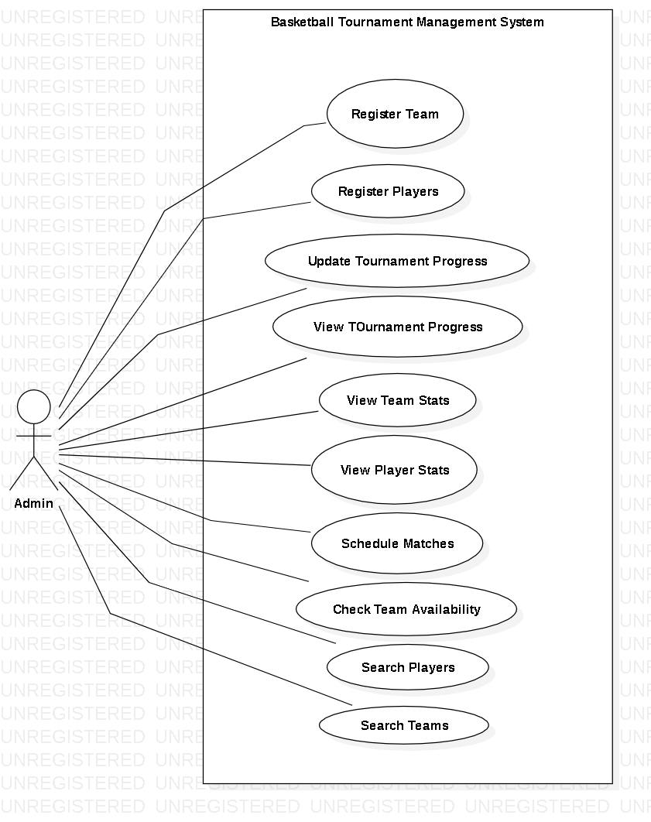

Figure: UseCase Diagram

**NLA**

NLA stands for Natural Language Analysis. It is the process of filtering nouns, verbs and adjectives from a scenario which are related to the project. It helps us in creating class diagrams.

Scenario

Basketball tournaments are held everywhere in which there are limited number of teams who can participate. Each team usually must have an exact number of players. Basketball tournaments are held for the purpose of popularity and bonding with others. The winners are awarded with prizes.

Basketball tournaments have been held continuously throughout years. There have been basketball tournaments in different levels like tournaments for school level, high school level, international level etc. Different people from different places and schools have been organizing this sort of tournaments and taking part. These factors have increased the basketball’s popularity and encouraged people to organize more.

The project will allow user to organize basketball tournament with the names of the participant and keep an eye on the progress. The user will be able to register teams and players along with editing their names. The user can search team or player names and view their stats and current progress. This will remove any confusion and allow a smooth going.

|  |  |
| --- | --- |
| Nouns | Verbs |
| Team, Player, Tournament | Register, Edit, View, Search, Schedule, Update |

Class Diagram

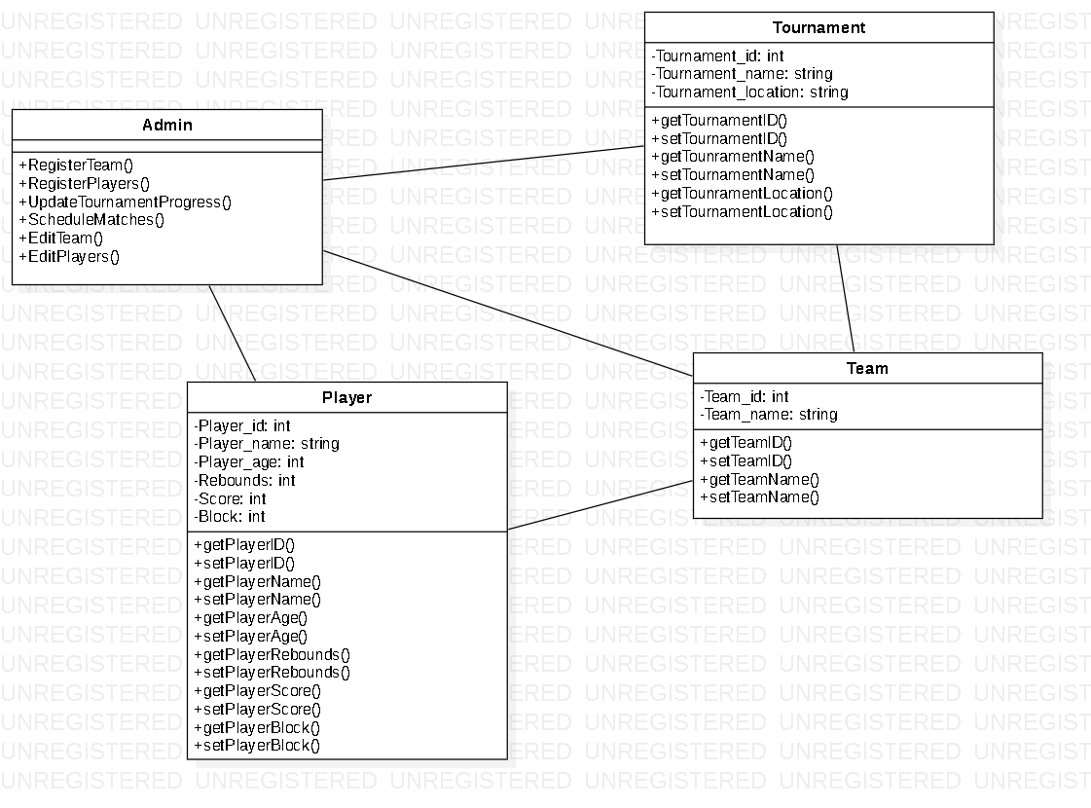

Figure: Class Diagram