Project Proposal Report

On

Basketball Tournament Management

System

Project Submitted by

Jimmy Sherpa

Section: 22 ‘B’

Semester: 4th

NCC ID: 00174395

Softwarica College of IT and Commerce

Dillibazar, Kathmandu, Nepal

Overview

1. Introduction

Basketball tournaments are held everywhere in which there are limited number of teams who can participate. Each team usually must have an exact number of players. Basketball tournaments are held for the purpose of popularity and bonding with others. The winners are awarded with prizes.

1. Background

Basketball tournaments have been held continuously throughout years. There have been basketball tournaments in different levels like tournaments for school level, high school level, international level etc. Different people from different places and schools have been organizing this sort of tournaments and taking part. These factors have increased the basketball’s popularity and encouraged people to organize more.

1. Description

The project will allow user to organize basketball tournament with the names of the participant and keep an eye on the progress. This will remove any confusion and allow a smooth going.

Features

* The participating teams are allowed to register
* Forms should be filled with individual’s bio
* Fake identity of a person are not accepted
* Limited number of teams who can participate
* An exact of ten members must be in a team
* The participant’s detail cannot be edited once registered
* Team members can be viewed
* The winning team are progressed to the next round
* The tournament name can be given in the beginning
* The progression of the tournament can be viewed

Scope of the project

1. Scope

Scope defines the importance and opportunity created by the project. It also helps to identify the limitation and functions.

1. Aims

The project aims to organize a basketball tournament without problems and keep track of the progression and statistics along with data of the participants.

1. Objectives

* Allow the registration of team with their team names
* The bios of the players to be registered
* To limit the number of teams allowed to participate
* To limit the number of members or players in a team
* To view the progression of the tournament
* To make the application easy to use
* To make the tournament fair
* To make sure the basketball tournament is successful

1. Overview of the scope

This project will help to create an application capable of organizing a basketball tournament and keep track of the progress. It also helps to build trust with the participants as they know that no fraud is involved. The data are saved and able to be used for future purpose.

Development Methodology

We need to have a development method in order to make this project successful or continue. Therefore, I have chosen to use the waterfall model also known as linear-sequential life cycle model. In this method, each step is done one after another which means the steps cannot be skipped. The reason I have chosen this method over others is because the requirements are clear and the project is a small one.

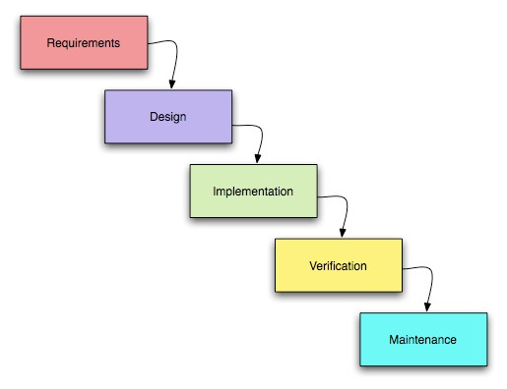

Figure: Waterfall Model

We should use waterfall model because

1. Simple, easy to use and understand.
2. Easy to manage because each phase has specific deliverables and a review process.
3. Phases are processed and completed one at a time they do not overlap.
4. Waterfall model works well for the smaller project where requirement are very well understood

Although there are setbacks like

1. High amount of risk and uncertainty.
2. Once the project is in testing stage, it is very difficult to go back and change something that was not well thought out in the concept stage.
3. Not suitable for the project where requirement are at a moderate to high risk of changing

Not suitable for long and ongoing project

I will be using MVC (Model View Controller) design pattern which helps the code to be reused along with SQL server for maintaining data. The MVC separates the tasks into three parts i.e. Model, View and Controller. The model handles the business and logic part, the view represents the display whereas the controller enables the model and view to collaborate and work together. The MVC also helps to reduce code and complexity of the application.

Project Planning

1.Work Breakdown Structure

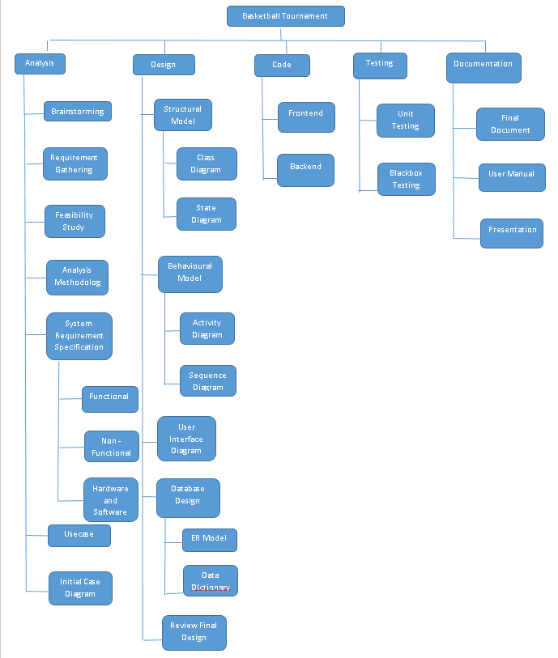

Figure: Work Breakdown Structure

A work breakdown structure is used in order to divide works for effectiveness as it is easy to work with the project. It can give futuristic estimation of time and money required.

Time Estimation

|  |  |  |
| --- | --- | --- |
| No. | Task Name | Estimation |
|  | Proposal | 10 days |
|  | Analysis |  |
| a | Brainstorming | 3 days |
| b | Requirement gathering | 4 days |
| c | Feasibility Study | 6 days |
| d | Analysis Methodology | 4 days |
| e | System Requirement Specification | 5 days |
| f | Use case diagram | 1 day |
| g | Initial Class diagram | 2 day |
|  | Total Days | 25 days |
|  |  |  |
|  | Design |  |
|  | Structural Model |  |
| a | Class Diagram | 1 day |
| b | State Diagram | 1 day |
|  | Behavioural Model |  |
| a | Activity Diagram | 2 days |
| b | Sequence Diagram | 3 days |
|  | User Interface Design | 6 days |
|  | Database Design |  |
| a | ER Model | 2 days |
| b | Data Dictionary | 2 days |
|  | Total Days | 17 days |
|  |  |  |
|  | Coding |  |
|  | Frontend | 10 days |
|  | Backend | 14 days |
|  | Total days for coding | 24 days |
|  | Testing |  |
|  | Unit Testing | 6 days |
|  | Black box Test | 9 days |
|  | Total Days | 15 days |
|  |  |  |
|  | Documentation |  |
|  | Final Document | 10 days |
|  | User Manual | 4 days |
|  | Presentation | 3 days |
|  | Total Documentation Days | 17 days |
|  | Total Days | 108 days |

Milestones

|  |  |  |
| --- | --- | --- |
| Task No | Task description | Deadline |
|  | Proposal | 13 April |
|  | Analysis | 12 May |
|  | Brainstorming | 16 April |
|  | Requirement gathering | 20April |
|  | Feasibility study | 26 April |
|  | Analysis Methodology | 30 April |
|  | System Requirement Specification | 5 May |
|  | Use case diagram | 6 May |
|  | Initial class diagram | 8 May |
|  | Design | 25 May |
|  | Structural Model | 10 May |
|  | Class diagram | 9 May |
|  | State diagram | 10 May |
|  | Behavioural Model | 21 May |
|  | Activity diagram | 12 May |
|  | Sequence diagram | 15 May |
| c) | User interface design | 21 May |
|  | Database design | 25 May |
|  | ER Model | 23 May |
|  | Data Dictionary | 25 May |
|  | Coding | 18June |
|  | Frontend | 4 June |
|  | Backend | 18 June |
|  | Testing | 3 July |
|  | Unit testing | 24 June |
|  | Black box testing | 3 July |
|  | Documentation | 20 July |
|  | Final Document | 13 July |
|  | User Manual | 17 July |
|  | Presentation | 20 July |
| Final Deadline 20 July 2018 | | |

Scheduling

A Gantt chart, commonly used in project management, is one of the most popular and useful ways of showing activities (tasks or events) displayed against time. (https://www.gantt.com/, n.d.). Gantt chart are developed using programs like Gantt project which I have used to create a Gantt chart. With the help of Gantt chart, I was able to estimate the time required to complete my project.

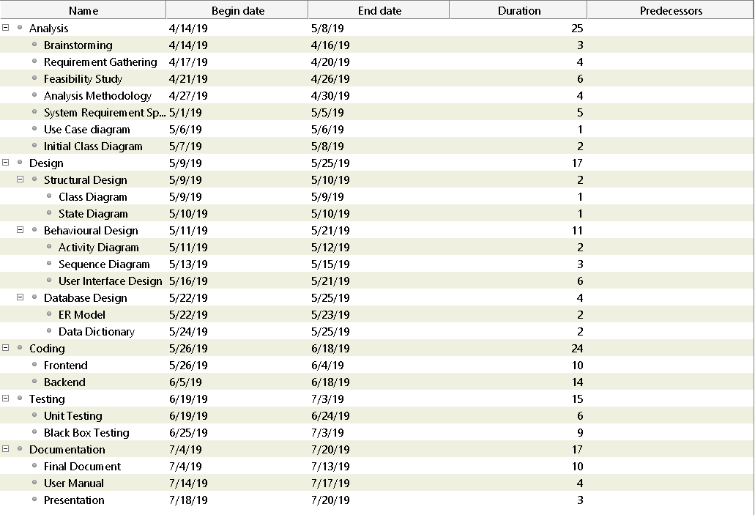

Figure: Left side of the Gantt Chart

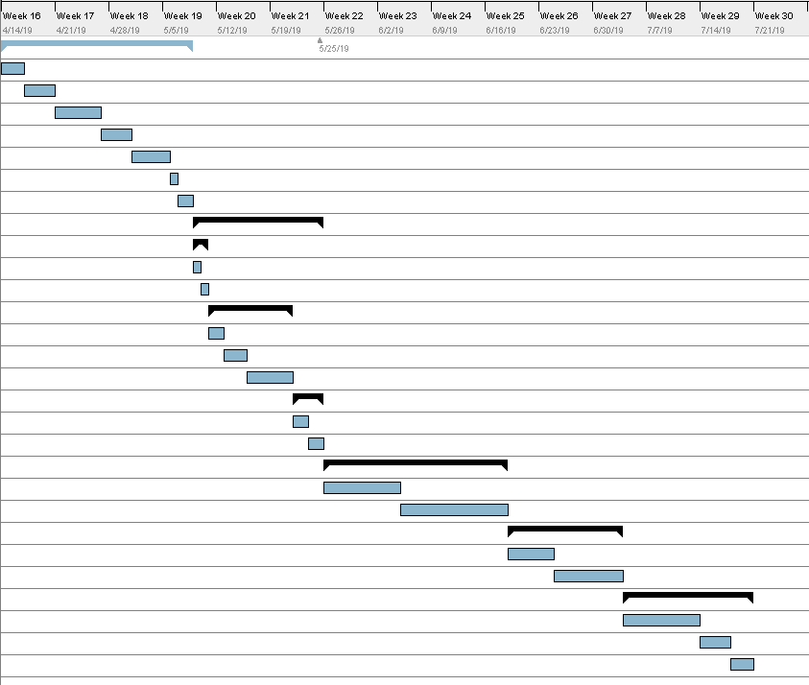

Figure: Right Side of the Gantt Chart

Other Project Activities

1.Risk Management

Risk is the most common thing that needs to be taken in order to gain something. We deal with it in everyday of our life. Risk is a term in [accounting](https://www.myaccountingcourse.com/accounting-dictionary/accounting) and finance used to describe the uncertainty that a future event with a favorable outcome will occur. In other words, risk is the probability that an investment will not perform as expected and the investor will lose the money invested in the project. (https://www.myaccountingcourse.com/accounting-dictionary/risk, n.d.) Therefore, risk is somewhat a very scary thing from a point of view which can lead to either good or bad result. There are few steps which can be taken for improving risk management.

* Identifying the risk
* Analyzing the risk
* Prioritizing the risk
* Treating the risk
* Monitoring the risk
* Identifying the risk

Anticipating possible pitfalls of a project doesn't have to feel like gloom and doom for your organization. Quite the opposite. Identifying risks can be not only a positive experience but also an experience that your whole team can take part in and learn from. (https://www.lucidchart.com/blog/risk-management-process, n.d.)

Identifying the risks helps us to move to next step of improving risk management. Without it, we it’s impossible to move to the next step since we won’t know what kind of risks are we dealing with and how to overcome it.

* Analyzing the risk

Analyzing is the process of making analysis of the risk we identified before the step. This step helps us to make assumption and helps us deal with it later. We estimate the probability and fallout of each risk to decide where to focus first in this step. We analyze the time taken, Cost and quality because they are the factors to be taken into account while taking any sorts of risk.

* Prioritizing the risk

In this step, we identify which risks should be given priority for dealing as they have greater influence than the other risks. It helps us in the future greatly. We do this by ranking each risk on the basis of the likelihood of the risk occurring and its influence on the project. This allows us to focus on the right thing and saves us time and effort. The project itself is not interrupted or delayed in significant ways during this stage.

* Treating the risk

Once the worst risks come to light, dispatch your treatment plan. While you can’t anticipate every risk, the previous steps of your risk management process should have you set up for success. Starting with the highest priority risk first, task your team with either solving or at least mitigating the risk so that it is no longer a threat to the project. (https://www.lucidchart.com/blog/risk-management-process, n.d.) In other words, we simply deal with the risk.

* Monitoring the risk

The final step will be to monitor the risk to ensure that everything is going as it should. Just like in case of cancer, when a person has been treated for it, doctors still monitor the patient and schedule appointments every once in a while to make sure everything is going fine. This helps us to avoid future threats or problems. In this stage, we also monitor, track and review the risks that occur during the time of the project. Risk management can be tricky, but it also can be mastered. We should defend against incoming harm, whether it’s coming from inside or outside.

Configuration Management

The [configuration management system](https://project-management-knowledge.com/definitions/c/configuration-management-system/) is a tool that serves as a subsystem of the top level project management system. It exists to provide formal and specific guidelines to the project management team in applying administrative and technical direction and supervision to a wide range of processes including the identification and documentation of descriptive characteristics of specific items within a project. These items can include products, services, or other assorted components. The configuration management system, when properly implemented, can also guide the [project management team](https://project-management-knowledge.com/definitions/p/project-management-team/) when they attempt to change any of these characteristics, demonstrating the proper way to record and document these changes to best meet requirements for documentation and [approvals](https://project-management-knowledge.com/definitions/a/approve-2/). Traditionally, the configuration management system is an umbrella system that encompasses many other small essential systems such as the [change control system](https://project-management-knowledge.com/definitions/c/change-control-system-tool/). I have used GitHub to store data and for backups.

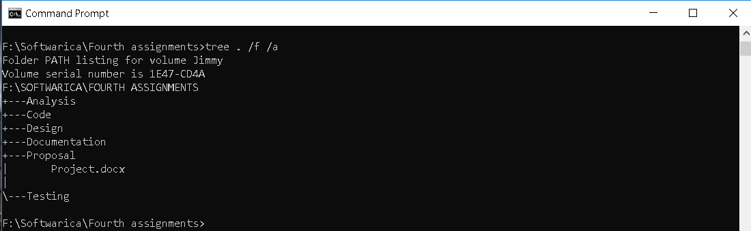

Conclusion

The project that I have created is capable of organizing a basketball tournament without problems and remove any confusions regarding the tournament. No team are allowed to register without team members and progress are viewable. Thus, the completion of the project is successful.

# References

https://www.gantt.com/. (n.d.).

*https://www.lucidchart.com/blog/risk-management-process*. (n.d.).

*https://www.myaccountingcourse.com/accounting-dictionary/risk*. (n.d.).