Testing by Jimmy Sherpa

Batch:22 ‘B’

Testing

Introduction

Testing is the process in a project which is done to check whether the project or software can run well and correct in different situations. Testing helps to improve the software or project quality and helps to maintain reputation within customers.

Importance

Testing is very important as it helps to find out the error or problems in a software that we are unaware of. This can prevent problems while software unveiling or dealing with customers. Due to this, we are able to maintain reputation and trust within customers helping in the future sales and others. Thus, we can consider our software a legit working one.

Types of Testing

There are different kind of testing. For example: Unit testing, Blackbox Testing (Behavioral Testing), Functional Testing, Integration Testing, Beta Testing, Acceptance Testing etc.,

The Testing that I will be implementing are Unit Testing and BlackBox Testing.

Unit Testing

Unit testing is a [software](https://searchmicroservices.techtarget.com/definition/software) development process in which the smallest testable parts of an [application](https://searchsoftwarequality.techtarget.com/definition/application), called units, are individually and independently scrutinized for proper operation. Unit testing can be done manually but is often [automated](https://searchitoperations.techtarget.com/definition/agile-test-automation-pyramid).

Test Name: Admin Login

|  |  |  |  |  |  |
| --- | --- | --- | --- | --- | --- |
| Test ID | Scenario | Input Data | Expected Result | Actual Result | Result |
| 1 | Login | Check Data | Login Successful | The Login was successful | Pass |

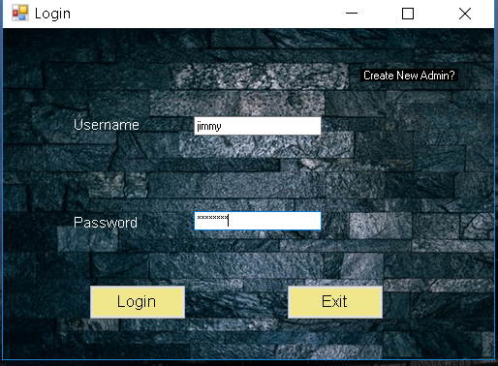

Figure: Admin login

Test Name: Create New Admin

|  |  |  |  |  |  |
| --- | --- | --- | --- | --- | --- |
| Test ID | Scenario | Input Data | Expected Result | Actual Result | Result |
| 2 | Create a new admin | Check data | Admin Created | Admin Created | Pass |

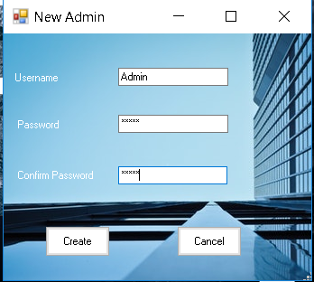

Figure: Creating a New Admin

Test Name: Create a Tournament

|  |  |  |  |  |  |
| --- | --- | --- | --- | --- | --- |
| Test ID | Scenario | Input Data | Expected Result | Actual Result | Result |
| 3 | Create a new tournament | Test user information | A Tournament should be created | A new tournament was successfully created | Pass |

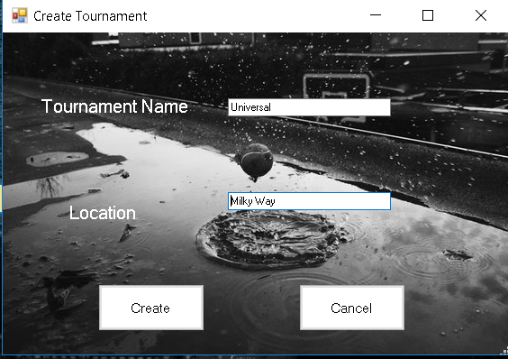

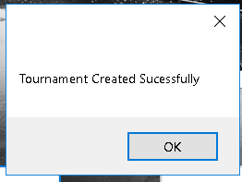

Figure: Creating a Tournament

Test Name: Load Tournament

|  |  |  |  |  |  |
| --- | --- | --- | --- | --- | --- |
| Test ID | Scenario | Input Data | Expected Result | Actual Result | Result |
| 4 | Load an existing tournament | Check selected data | The selected tournament should load successfully | The tournament was loaded | Pass |

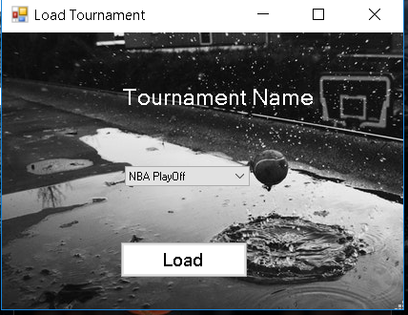

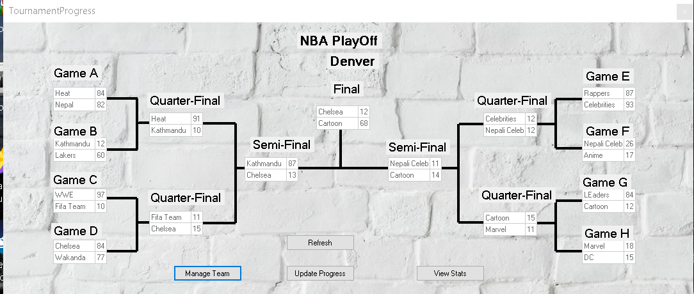

Figure: Loading an Existing Tournament

Test Name: Delete a Team

|  |  |  |  |  |  |
| --- | --- | --- | --- | --- | --- |
| Test ID | Scenario | Input Data | Expected Result | Actual Result | Result |
| 5 | Delete a Team | Check selected data for deletion | The selected tournament should be deleted | The selected team was deleted | Pass |

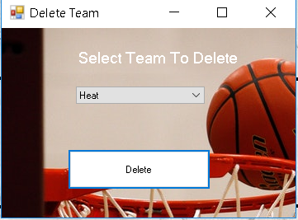

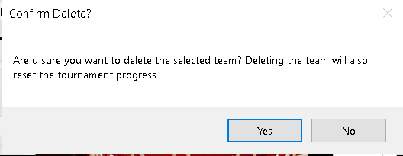

Figure: Deleting a Team

Test Name: Adding a Team

|  |  |  |  |  |  |
| --- | --- | --- | --- | --- | --- |
| Test ID | Scenario | Input Data | Expected Result | Actual Result | Result |
| 6 | Add a New Team | User Detail | A new team should be added | A team was added | Pass |

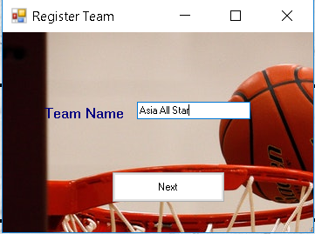

Figure: Adding a Team

Test Name: Adding a Player

|  |  |  |  |  |  |
| --- | --- | --- | --- | --- | --- |
| Test ID | Scenario | Input Data | Expected Result | Actual Result | Result |
| 7 | Add a New Player | User Detail | Players should be added | Players were added | Pass |

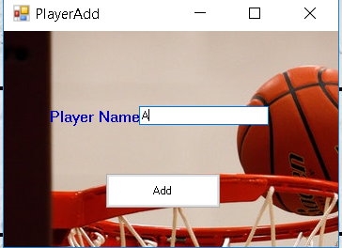

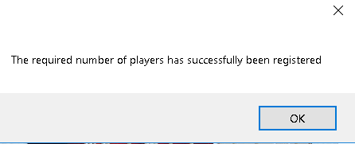

Figure: Adding Players

Test Name: Deleting a Tournament

|  |  |  |  |  |  |
| --- | --- | --- | --- | --- | --- |
| Test ID | Scenario | Input Data | Expected Result | Actual Result | Result |
| 8 | Delete Tournament | Check Selected Tournament | Tournament should be deleted | Selected Tournament was deleted | Pass |

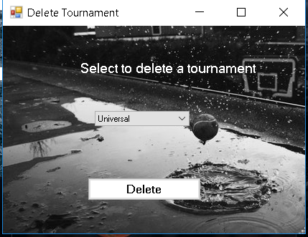

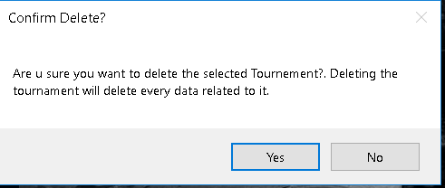

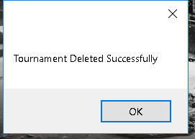

Figure: Deleting a Tournament

Test Name: View Player Stats

|  |  |  |  |  |  |
| --- | --- | --- | --- | --- | --- |
| Test ID | Scenario | Input Data | Expected Result | Actual Result | Result |
| 9 | View Player Stats | Check Selected Team | Stats should be shown | Stats were shown | Pass |

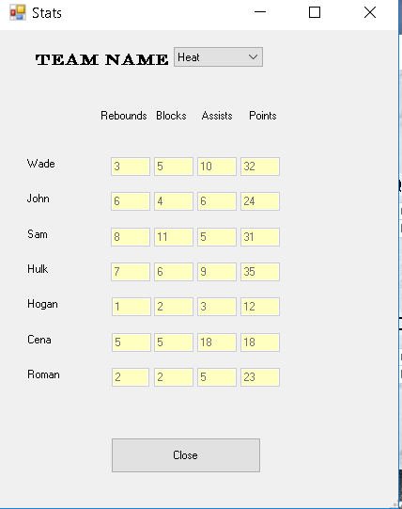

Figure: Player Stats

Test Name: Update Progress

|  |  |  |  |  |  |
| --- | --- | --- | --- | --- | --- |
| Test ID | Scenario | Input Data | Expected Result | Actual Result | Result |
| 10 | Update Data | User Data | Stats should be updated | Game progress was successfully updated | Pass |

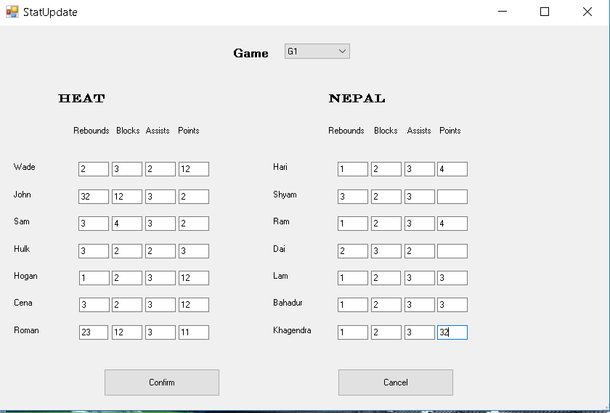

Figure: Updating Tournament Progress or Stat

Black Box Testing

Black-box testing is a testing strategy that ignores the internal mechanism of a system or component and focuses solely on outputs generated in response to selected inputs and execution conditions.

Test Name: Admin Login

Pre-Condition: Admin must be created before logging in

|  |  |  |  |  |  |
| --- | --- | --- | --- | --- | --- |
| Test ID | Scenario | Input Data | Expected Result | Actual Result | Result |
| 1 | Login | Username: jimmy  Password:  Password | The Username and Password should match to that of the admin and directed to the dashboard | The Username and password were valid and thus proceeded to the next step. | Pass |



Figure: Admin login

Test Name: Create New Admin

Pre-Condition: None

|  |  |  |  |  |  |
| --- | --- | --- | --- | --- | --- |
| Test ID | Scenario | Input Data | Expected Result | Actual Result | Result |
| 2 | Create a new admin after checking inserted data | Username; Admin  Password:  Admin  Confirmation Password: Password | The username should be available, the two password should match and the a new admin should be created. | The username was available and the passwords were confirmed thus new admin was created | Pass |



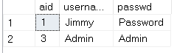

Figure: Creating a New Admin

Test Name: Create a Tournament

Pre-Condition: Need to be logged in as an admin

|  |  |  |  |  |  |
| --- | --- | --- | --- | --- | --- |
| Test ID | Scenario | Input Data | Expected Result | Actual Result | Result |
| 3 | Create a new tournament after checking inserted data | Tournament Name: Universal  Location: Milky Way | The tournament name should be available and should be created thus directed to the dashboard | A new tournament was successfully created and directed to the dashboard | Pass |





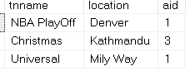

Figure: Creating a Tournament

Test Name: Load Tournament

Pre-Condition: Should be logged in as an admin

|  |  |  |  |  |  |
| --- | --- | --- | --- | --- | --- |
| Test ID | Scenario | Input Data | Expected Result | Actual Result | Result |
| 4 | Load an existing tournament | Tournament Name: NBA PlayOff (From Drop Down List) | The selected tournament should load successfully and should have access to the tournament | The tournament was loaded and access was given to the admin | Pass |





Figure: Loading an Existing Tournament

Test Name: Delete a Team

Pre-Condition: Should Load a tournament and team should be available to delete

|  |  |  |  |  |  |
| --- | --- | --- | --- | --- | --- |
| Test ID | Scenario | Input Data | Expected Result | Actual Result | Result |
| 5 | Deleting a Team without causing any other problems | Select a Team To Delete: Heat (Drop Down List) | The selected tournament should be deleted and the tournament progress reset | The selected team was deleted and the tournament progress was reset | Pass |





Figure: Deleting a Team

Test Name: Adding a Team

Pre-Condition: Tournament should be created and loaded. Team name should be different than others

|  |  |  |  |  |  |
| --- | --- | --- | --- | --- | --- |
| Test ID | Scenario | Input Data | Expected Result | Actual Result | Result |
| 6 | Add a New Team to the current tournament | Team Name: Asia All Star | A new team should be added(Team Name should be available) and proceeded to the next step of adding players | The team name was available and added thus proceeding to the next step | Pass |



Figure: Adding a Team

Test Name: Adding a Player

Pre-Condition: A tournament should be loaded and a team added

|  |  |  |  |  |  |
| --- | --- | --- | --- | --- | --- |
| Test ID | Scenario | Input Data | Expected Result | Actual Result | Result |
| 7 | Add a New Player to the right team without error | Player Name: A | 7 Players should be added to the corresponding team | 7 Players were added to the team | Pass |





Figure: Adding Players

Test Name: Deleting a Tournament

Pre-Condition: Tournament should be available to delete

|  |  |  |  |  |  |
| --- | --- | --- | --- | --- | --- |
| Test ID | Scenario | Input Data | Expected Result | Actual Result | Result |
| 8 | Delete a Tournament to see if it works | Select to delete a tournament: Universal (Drop Down List) | Tournament should be deleted and every of its corresponding data example: Team, Player, Progress etc. | Tournament was deleted including its related data | Pass |







Figure: Deleting a Tournament

Test Name: View Player Stats

Pre-Condition: Team and Team Player should be available

|  |  |  |  |  |  |
| --- | --- | --- | --- | --- | --- |
| Test ID | Scenario | Input Data | Expected Result | Actual Result | Result |
| 9 | View player full stats accurately | Team Name: Heat (Drop Down List) | Stats should be shown with the corresponding player names. | Players stats were shown accurately | Pass |



Figure: Player Stats

Test Name: Update Progress

Pre-Condition: Required numbers of team and players should be added

|  |  |  |  |  |  |
| --- | --- | --- | --- | --- | --- |
| Test ID | Scenario | Input Data | Expected Result | Actual Result | Result |
| 10 | Check if inserted data goes to the right team | Game: G1  Wade:2 3 2 12  Hari: 1 2 3 4 etc. | Stats should be updated accordingly and along with the tournament progress | Game progress was successfully updated along with the tournament progress | Pass |



Figure: Updating Tournament Progress or Stat

Conclusion:

Unit Testing and Black Box Testing helped us to see or test different aspects of the program in different view. It helps us to find the problem or error we could have faced and it also helps us to build a promising software in the future.