NLP to Graph

Use-Case Specification: Translate English sentences to graph-database queries in the Cypher query language

Version <1.0>

Revision History

|  |  |  |  |
| --- | --- | --- | --- |
| **Date** | **Version** | **Description** | **Author** |
| 03/09/2018 | 1.0 | Use case implementation | Jimmy Huynh |
|  |  |  |  |
|  |  |  |  |
|  |  |  |  |

Table of Contents

1. Use-Case Name 2

1.1 Brief Description 2

2. Flow of Events 2

2.1 Basic Flow 2

2.2 Alternative Flows 2

3. Special Requirements 2

4. Preconditions 2

5. Postconditions 2

6. Extension Points 2

Use-Case Specification:  Translate English sentences to graph-database queries in the Cypher query language

# Use-Case Name

## Brief Description

## This use case takes natural language query and parses it into a query which will be translated into a Cypher query which will run on NeoJ4 and call information from the database.

## Basic Flow

## https://lh3.googleusercontent.com/wmHoDzVcnBXZ4SwyCSxSCfmlctIPS8SKQ6bek_gl8LzLNKWNnxY3FVR7lh4kdG5ob7OLKDuirUvBk8CyL4VefRobyEvIczgWd73zSdep_m-nuD4lZEcYPOroPoGCWCgBnSgzefUm7EE

## Alternative Flows

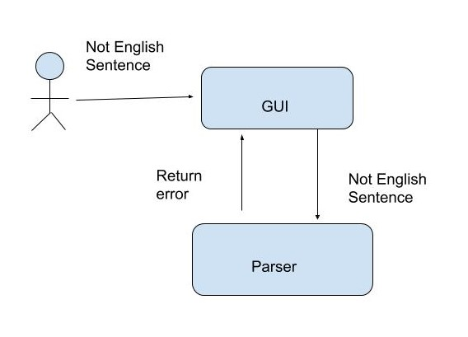

# Special Requirements

* Implemented for only Windows 10
* Database should have the required nodes and relationship to run the query

# Preconditions

* Must be in the English language
* Does not contain any special characters
* Needs a database to function
* Needs NeoJ4
* Uses a python GUI to input language
* Cypher Query must be able to run in any database
* Can translate slang into cypher language

# Postconditions

* Return data from database to user

# Extension Points

* Parser can detect invalid English statement
* Parser splits statement into spate words to run through translator
* Translator defines each word by its properties so NeoJ4 can understand the query