GainzJournal

Jimmy Blundell

University of Missouri – Kansas City

Table of Contents

Vision Statement 3

Requirements 4

Product Backlog 5

Sprint #1 6

Velocity: 0 (did not complete either task, as they were too vague) 6

Review 6

Retrospective 7

Sprint #2 8

Review 8

Retrospective 8

Sprint #3 9

Review 9

Retrospective 9

Sprint #4 10

Review 10

Retrospective 10

Sprint #5 11

Review 11

Retrospective 11

Sprint #6 12

Review 12

Retrospective 12

# Vision Statement

**Immediate Release:**

This application will be designed to help user’s track their progress in the gym. The user will initially create an account and sign up when first entering the app. From there, functionality works as such: the user will be presented with a home screen that contains their “workouts”, which are defined as a routine they create consisting of various lifts of their choice. They can add workouts anytime from this screen.

Clicking on a specific workout takes them to a new page that shows the specific lifts for that workout, complete with numbers of reps and sets. As the user works out, they will enter the number of reps and sets they complete at the weight they are using. This is incredibly useful in helping a user track their progress over time. That in itself is an important feature: the user must be able to look back on their past lifts and see how they have progressed over time.

Additionally, users will be able to leave notes for each lift. This is important as it allows users to take note of their insights they come to during each workout. Perhaps a user learns that a better warmup allowed them to reach a greater depth on their squats; this is something they could write about in the notes section for their specified lift to look back on next time. Additionally, it allows them to keep track of their overall “feeling” about a lift (perhaps a particular weight felt easier than normal, which they could note).

The above describe the core functionality that should be included in the immediate release: the ability to create workouts, comprised of individual lifts, all specified by the user. The user keeps track of the reps/sets/weight for each lift, can leave notes, and is able to look back on their progress over time.

**Stretch Goals:**

Other features I would like to implement include:

A simple bodyweight tracker where users can enter their bodyweight (and also track that over time).

In addition to notes, many users like to film their sets for form checks. I would like to allow users to enter pictures or videos into their “notes” (or at the very least, a link to a gif/YouTube/imgur containing their video).

Graphs to display their progress (for both lifts and bodyweight) in a more visually-accessible format.

# Requirements

A discussion of what your application is required to have in functionality. It should identify user roles and goals/actions, and what the key features of the app should be.

|  |  |
| --- | --- |
| **Actor** | **Goal** |
| User | Create account. |
| User | Login. |
| User | Create and name new workout. |
| User | Remove workout. |
| User | Add and name lift(s) to workout. |
| User | Remove lifts from workout. |
| User | Input the weight, sets, and reps completed for each lift. |
| User | Look at history of records on specified list. |
| User | Add notes for each workout. |
| User | View graph showing progress for particular lift. |
| User | Logout. |
|  |  |
|  |  |
|  |  |
|  |  |

### Product Backlog

This will be updated throughout the semester as new PBIs are added, larger items are broken into smaller ones, and completed items removed.

|  |  |  |  |  |
| --- | --- | --- | --- | --- |
| **Story ID** | **Story** | **Story Points**  **(in est. hours)** | **Priority** | **Status** |
| 1 | Design home screen layout | 5 | High | IP |
| 2 | Connect app to database | 6 | High | IP |
| 3 | Design/implement workouts | 8 | High |  |
| 4 | Add “notes” option for each workout. | 5 | Low |  |
| 5 | Design home screen that displays user’s workouts. | 8 | High |  |
| 6 | Design workout screen that displays user’s lifts. | 8 | High |  |
| 7 | Allow users to look at history of specific lift. | 15 | Med |  |
| 8 | Design/implement exercises | 5 | High |  |
| 9 | Connect exercises to database | 5 | Med |  |
| 10 | Connect workouts to database | 5 | Med |  |

# Sprint #1

Sprint Backlog

|  |  |  |  |
| --- | --- | --- | --- |
| **Story ID** | **Story / Task** | **Estimated**  **Hours** | **Actual**  **Hours** |
| 5 | Design home screen | 8 | 8 |
| 6 | Design workout screen | 8 | 0 |
|  |  |  |  |
|  |  |  |  |
|  |  |  |  |
|  |  |  |  |
|  |  |  |  |

## Velocity: 0 (did not complete either task, as they were too vague)

## Review

So far, have designed the basis of a home screen. This, however, is subject to change as will be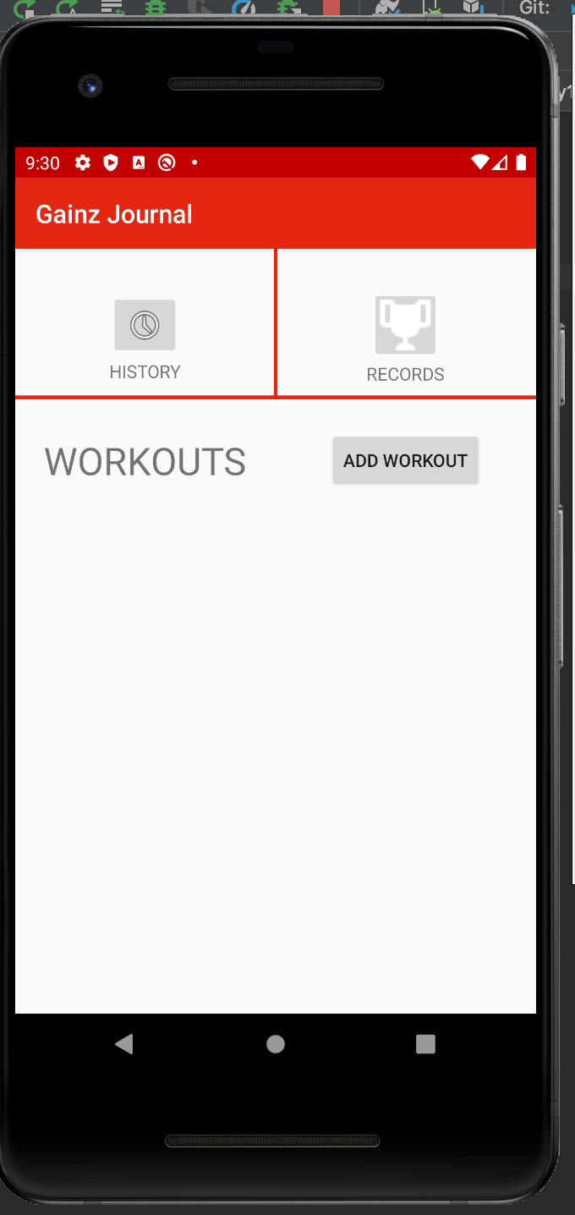 shown in the retro.

## Retrospective

I had some phenomenally poor planning for this sprint. I dd quite a bad job of breaking down tasks into smaller tasks. “Design home screen” and “Design workout screen” were not as straightforward as I thought. Due to having vague tasks, my progress felt someone “directionless”. I spent much time simply researching different layouts and finding out what would be appropriate for my app. I spent much time looking perhaps too far ahead into the app, question how my current choices would affect future decisions. This led to a lot of “paralysis by analysis”, where I felt unable to make design decisions. I ended up not even attempting to create screens for “workouts” or “exercises”. I do have a lot of research left to do in how to achieve the functionality I am lookin for. That being said, I do have a much better and cleaner idea for a home screen, and much of my analysis and research has made. I feel that next spring I essentially will be “restarting”, but with a much clearer picture on how to progress.

# Sprint #2

Sprint Backlog

|  |  |  |  |
| --- | --- | --- | --- |
| **Story ID** | **Story / Task** | **Estimated**  **Hours** | **Actual**  **Hours** |
| 1 | Redesign home screen | 3 |  |
| 1 | Find images to use for buttons on home screen | 1 |  |
| 2 | Research how to connect app to database | 2 |  |
| 2 | Connect app to a db for workout creation | 3 |  |

## Review

[Screenshots, etc go here. This is where you discuss the product, describing what was done this sprint (potentially shippable product increment) and what was planned for the sprint but was not done. ]

## Retrospective

[This is where you discuss the process. What went well (and are you planning to do more of that?) What didn’t go so well (and do you have a way to do less of that)? What changes are you planning to make in how you plan & carry out the next sprint?]

# Sprint #3

Sprint Backlog

|  |  |  |  |
| --- | --- | --- | --- |
| **Story ID** | **Story / Task** | **Estimated**  **Hours** | **Actual**  **Hours** |
|  |  |  |  |
|  |  |  |  |
|  |  |  |  |
|  |  |  |  |
|  |  |  |  |
|  |  |  |  |
|  |  |  |  |

## Review

[Screenshots, etc go here. This is where you discuss the product, describing what was done this sprint (potentially shippable product increment) and what was planned for the sprint but was not done. ]

## Retrospective

[This is where you discuss the process. What went well (and are you planning to do more of that?) What didn’t go so well (and do you have a way to do less of that)? What changes are you planning to make in how you plan & carry out the next sprint?]

# Sprint #4

Sprint Backlog

|  |  |  |  |
| --- | --- | --- | --- |
| **Story ID** | **Story / Task** | **Estimated**  **Hours** | **Actual**  **Hours** |
|  |  |  |  |
|  |  |  |  |
|  |  |  |  |
|  |  |  |  |
|  |  |  |  |
|  |  |  |  |
|  |  |  |  |

## Review

[Screenshots, etc go here. This is where you discuss the product, describing what was done this sprint (potentially shippable product increment) and what was planned for the sprint but was not done. ]

## Retrospective

[This is where you discuss the process. What went well (and are you planning to do more of that?) What didn’t go so well (and do you have a way to do less of that)? What changes are you planning to make in how you plan & carry out the next sprint?]

# Sprint #5

Sprint Backlog

|  |  |  |  |
| --- | --- | --- | --- |
| **Story ID** | **Story / Task** | **Estimated**  **Hours** | **Actual**  **Hours** |
|  |  |  |  |
|  |  |  |  |
|  |  |  |  |
|  |  |  |  |
|  |  |  |  |
|  |  |  |  |
|  |  |  |  |

## Review

[Screenshots, etc go here. This is where you discuss the product, describing what was done this sprint (potentially shippable product increment) and what was planned for the sprint but was not done. ]

## Retrospective

[This is where you discuss the process. What went well (and are you planning to do more of that?) What didn’t go so well (and do you have a way to do less of that)? What changes are you planning to make in how you plan & carry out the next sprint?]

# Sprint #6

Sprint Backlog

|  |  |  |  |
| --- | --- | --- | --- |
| **Story ID** | **Story / Task** | **Estimated**  **Hours** | **Actual**  **Hours** |
|  |  |  |  |
|  |  |  |  |
|  |  |  |  |
|  |  |  |  |
|  |  |  |  |
|  |  |  |  |
|  |  |  |  |

## Review

[Screenshots, etc go here. This is where you discuss the product, describing what was done this sprint (potentially shippable product increment) and what was planned for the sprint but was not done. ]

## Retrospective

[This is where you discuss the process. What went well (and are you planning to do more of that?) What didn’t go so well (and do you have a way to do less of that)? What changes are you planning to make in how you plan & carry out the next sprint?]