**Internet Speed Checker**

Project Report

**Team Leader:**

1. Jimmy Blundell

**Team Members:**

1. Ali Alyami
2. Jimmy Blundell
3. Christopher Aram Swayne

**Project Story:**

1. **Problem Statement:**

Everyone is using the internet nowadays and it is becoming vastly common in our day-to-day life. As the use of the internet is increasing, people want to ensure that they are receiving the connection speeds that they are paying for. Additionally, the usage of the internet with smartphones is becoming nearly universal, especially with advancement in the form of 3G and 4G, and now 5G networks- oftentimes, using a smartphone is faster and easier than one’s home connection. It is imperative that phone users be able to check their speeds to ensure the service they are paying for is not only meeting their needs, but also verifying the service has kept the contracted speeds.

1. **Data:**

**What is the Dataset about?**

In today’s era, the internet continues to grow rapidly. As such, there are many surveys done on such data which give us the information of usage of the internet with respect to past years. Home broadband connections are increasing over time according to a report from PEW Research Center:

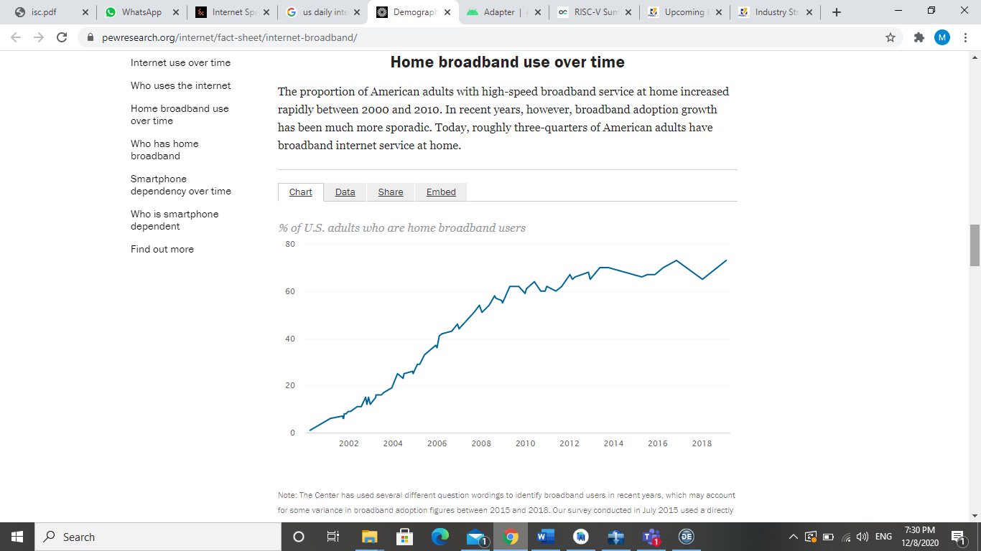

Going further, the same report shows the percentages of different age groups in regards to their smartphone usage over the past several years: As you can see, all are generally trending upwards.

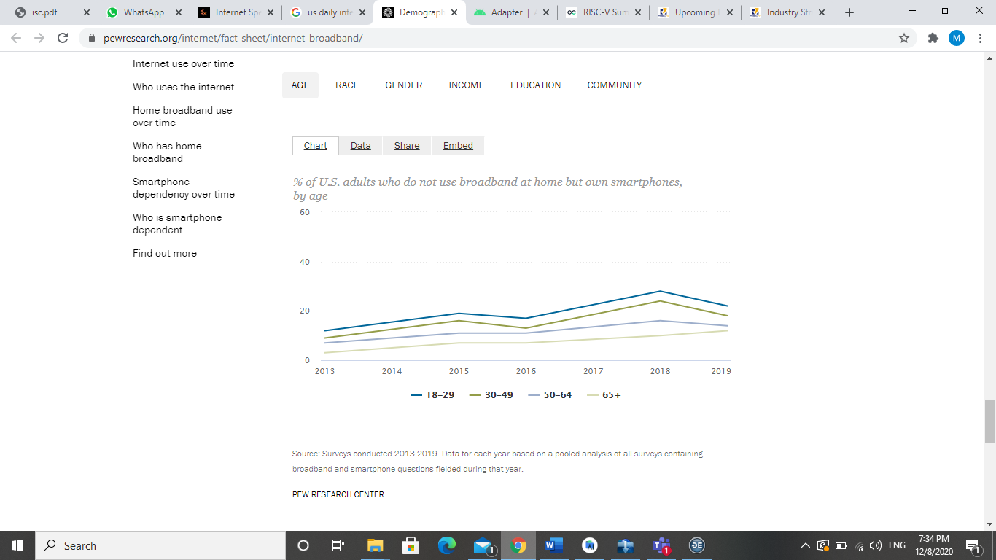

Here is a chart that shows the necessary speeds for various tasks- note, these apply to mobile devices as well.

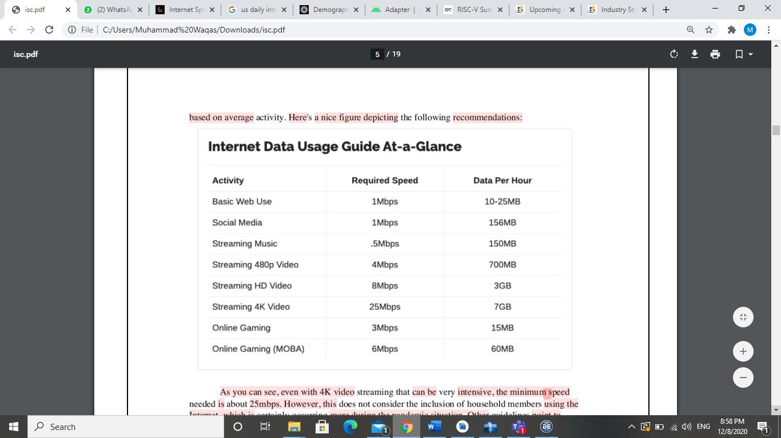

For example, if we are streaming a 4K video over the internet we require a speed of at least 25Mbps. There are many streamers in the U.S. who stream games and other content such as webinars and much more. They need to know what the internet speed is they are currently getting so that they can stream well. Most of such people use the internet with a bandwidth of 50Mbps for a better quality and to avoid any lag. Moving on to mobile devices, we can see that nowadays mobile gamers are becoming popular and others watch them streaming live on YouTube and many such platforms. They need to know the internet speed before they start streaming so that they have a smooth experience for both themselves and users. For example, you can expect an average speed of ~ 29 Mbps using 4G connection during quiet hours, but you may find your speed during busier hours is only roughly half of that.

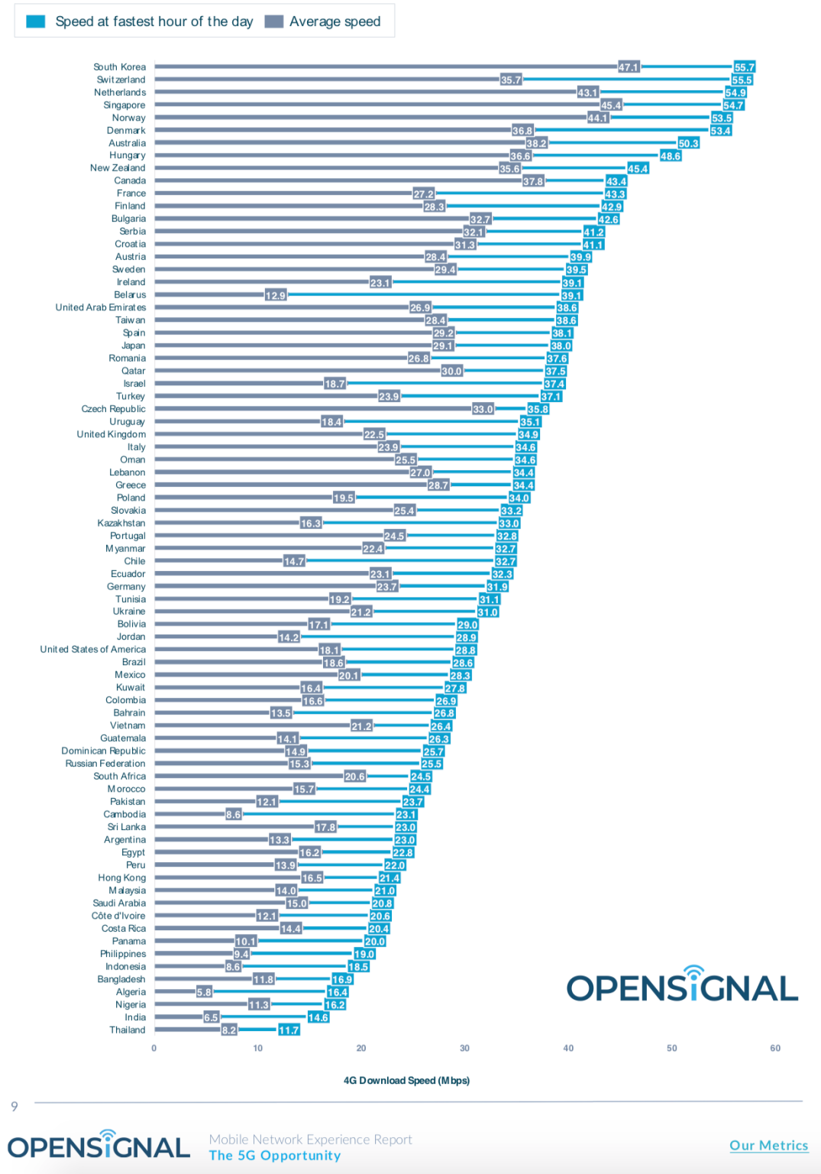

Above chart indicates the internet speed at quietest hours and busiest hours in 77 countries around the globe.

**Where the Observations are taking place?**

These observations have been taken across the United States of America. Although this data may be similar to many other countries, we are focused on the US.

**When did the observation take place?**

The observations have been taken from 2003 up to 2019. Some of the readings are from 2013 up to 2019. We have demographics readings from 2018-19.

**Why is the Data being collected?**

The data is being collected to get to know about how many percentages of adults are using broadband at their home. While other is to know how many percentages of adults are not using broadband but using a cellular network. Also, we got data about the internet speed required for certain applications to run. Such as for 4K video streaming we need up to 25Mbps. This thing helps us to get to know the basic information. At the end we got a data of internet speed provided by 4G in different countries.

1. **Application:**

**Who is the target audience?**

Individuals want to know their internet speed for the reasons listed above. Additionally, companies want to know the internet speed at a deployment end. For example, an ISP (Internet Service Provider) can test the internet speed of the latest deployed connection by just connecting to that network and running a speed test on an android device.

**What can the application do?**

The application can test the internet speed at an end point of the network, e.g. A person wants to check their internet speed on their current network and other information such as the download, upload, ping of the connected internet connection. It can either be a cellular connection or WiFi connection. Also, this app will help to get the usage statistics of the previous 30 days. From this data users can estimate what internet bundle they need based on their daily usage of the internet.

**When can the user use this application?**

They can use this application anytime in the day. As it is a mobile application, so they need only an internet connection either a 3G, 4G, 5G, or WiFi.

**Where will the application be deployed?**

The application can be deployed on the Google PlayStore from where everyone can download and use it to get the information about their connection.

**Why is Visualization/Application useful?**

The application provides clear information about the user’s internet information on the current network. We can see the information of network speed from the gauges and other information such as ping is also described in text. Users can also see a history of their internet tests to see how their connection stays consistent over time and in different hours of the day.

**How will the Users use this Application to Make Changes?**

If someone is using a 50 Mbps connection and getting speed of only 20Mbps to 30 Mbps or even lower, then they can challenge their ISP to provide them with the exact speed they are paying for. This application will also help them if they need to upgrade their connection or not, based on the usage statistics that our application can uncover. For example, if they need a higher data cap per month, or they need a internet speed plan. These are all very helpful features to the user to have all this data in one place.

**Technical Info:**

**Software Requirements:**

* Android Studio
* Java SDK
* SQLite
* Android Emulator
* Required Libraries
* Admob by Google

**Working Screens from Project:**

**Important Code Snippets:**

**Workflow of the Project:**

1. Ali Alyami was working with the UI of the app and Google Admob to show ads in the app. We have used test ads but we can get the actual ad]s and then we can earn by publishing the app to PlayStore.
2. Christopher Aram Swayne was working with SQLite integration and connections to save the data online.
3. Jimmy Blundell was working on the backend programming for the app to make all the functionalities possible as well as worked with UI and other components of the app.

**Issues or Blockages:**

At first there were problems with finding a solution for UI that we want to create but this problem was resolved using layouts. It took much time to fix this thing as we were unable to find the exact match for it. At last, we were able to find an exact match by creating a relative layout and then added multiple relative and relative layouts to get the desired output. For generating charts, we got achartengine library. I tried to do AdMob integration to this at my end but to me it was not working well. I tried to make some test adds so that it can integrate and work well.

**Links:**

GitHub Repository (Source Code)

<https://github.com/JimmyBlundell/internet-speed-checker>

Presentation

<https://github.com/JimmyBlundell/internet-speed-checker/tree/master/speed-test-project-code/documentation>

Video

<https://youtu.be/FqvcO0nV1QY>

**References:**

1. Demographics of Home broadbands and Internet Usage from <https://www.pewresearch.org/internet/fact-sheet/internet-broadband/>
2. Adapters in Android from <https://developer.android.com/reference/android/widget/Adapter>
3. 4G average Internet Speed in U.S and other 77 countries from <https://9to5mac.com/2019/02/20/4g-speeds-us-performance/#:~:text=At%20a%20national%20level%2C%20average,Mbps%20at%20the%20quietest%20hour>.
4. achartengine library <https://github.com/ddanny/achartengine>