University of Minnesota Logos
Copy and paste any of the RGB png logos below into your Word document.
- University graphic standards apply; learn more at www.umn.edu/brand/standards
- Additional logos are available for download from the Images Library at www.ur.umn.edu/imageslib

 | 
 | 
 | 
 | 
 | 
 | 

 |  |  | 
 |  |  | 
 |  |  | 

 | 
 | 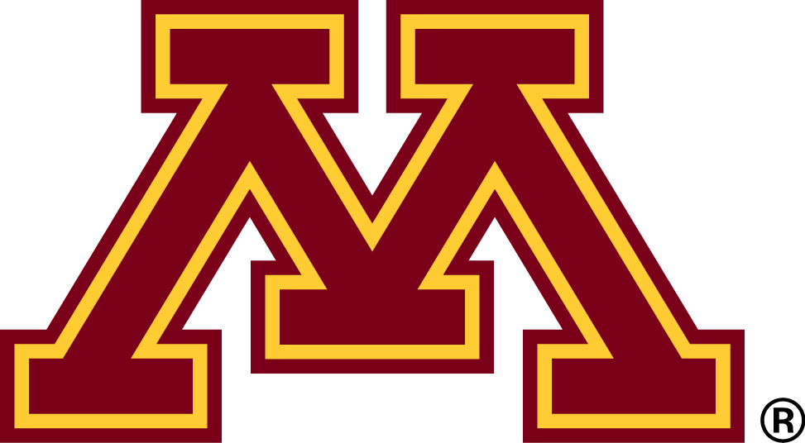
 | 
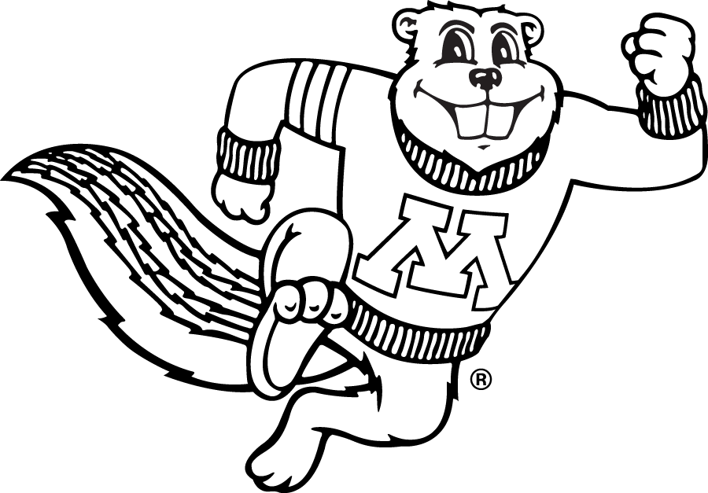 | 

Required statements for events
The University of Minnesota is an equal opportunity educator and employer. To request disability accommodations, please contact [name, department, e-mail address, phone number].  Printed on recycled and recyclable paper with at least 10 percent postconsumer material.

Required statements for publications
The University of Minnesota is an equal opportunity educator and employer. This publication/material is available in alternative formats upon request. Direct requests to [name, department, e-mail address, phone number]. Printed on recycled and recyclable paper with at least 10 percent postconsumer material.

