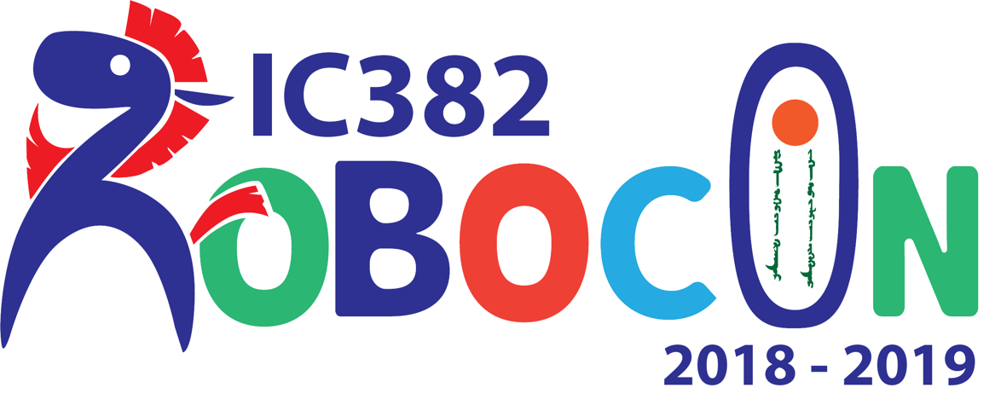**Introduction**

Multidisciplinary Manufacturing Project

Robocon Group

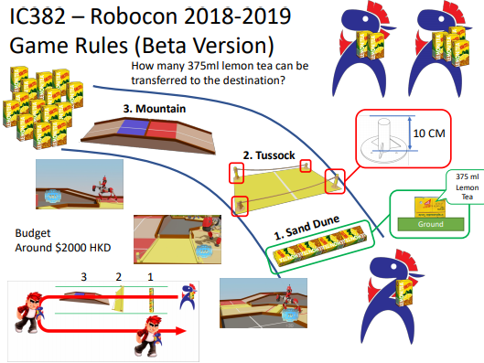 IC382 is a multidisciplinary project which provides students a chance to work with other disciplinary students. In this project, EIE students form a group with ME students, working on the “Robocon Project”. This project requires students to design a four legs robot, control the robot to cross the obstacles and transport a 375ml lemon tea to the destination. The obstacles include a Sand Dune, a 10cm-height Tussock and a rising Mountain Hill.

(Figure Source: IC382 Robocon 2018-2019 : Stage 01 - Week 01 - Game Field and Rules)

**Project Aim & Objectives**

Through the project, students can apply their school knowledge and practical skills to design an accurate and workable robot to complete the task. In this semester, students are focusing on the design of the robot. In the next semester, students are going to work on manufacturing, down to assembly, testing and evaluation.

During the project, students need to cooperate with other disciplinary students to work effectively. Since students have different ideas and solutions towards an engineering problems, they need to combine the ideas and sort out the most efficient way to work on. Students also have a great chance to familiarize to technology that IC Centre provided, such as 3D printing, Laser cutting, PCB NC Drills, to help them complete the testing of their design.

“Robocon Project” is different to others group, since the requirements of the rule, the specification, the limitation, the background decoration are just released, which is not cleared enough for us, and even the tutor to recognize. Students need to keep communicate with the tutor to get known with the latest information released at the first few weeks. It helps students to learn how to require a task details from their head or boss. Besides, driven to its new release, there is not much information that students can search through the Internet or groups from previous years. Students are need to think on their own way to make their creative robot. Therefore, this project can challenge students on how to work in an uncertain topic to work out a concrete solution.

**Technical Contents**

**Visual Studio – C#**

* An Integrated Development Environment (IDE) by Microsoft.
* Usually used for Windows Debugging
* Easy to build up a user interface for user
* With the aids of debugger, we do not need to flash the program into the MCU
* Directly drive the servo motor to perform action
* In our project, we have received a program code from supervisor
* We modified the user interface to make the testing more visualizing and efficient

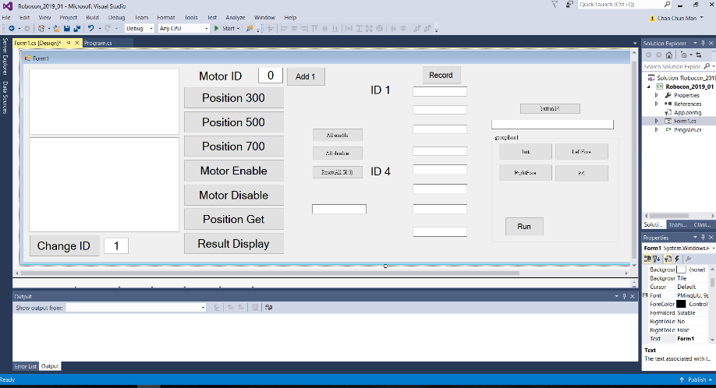

**CoIDE – C**

* An IDE for ARM Cortex-M microcontrollers
* Have full library support to STM32 MCU
* In our project, we focus on the testing parts of the robot
* We have successful build a program to tune the servo motor with different angle
* We have modified the program so that we can communicate the MCU using Bluetooth

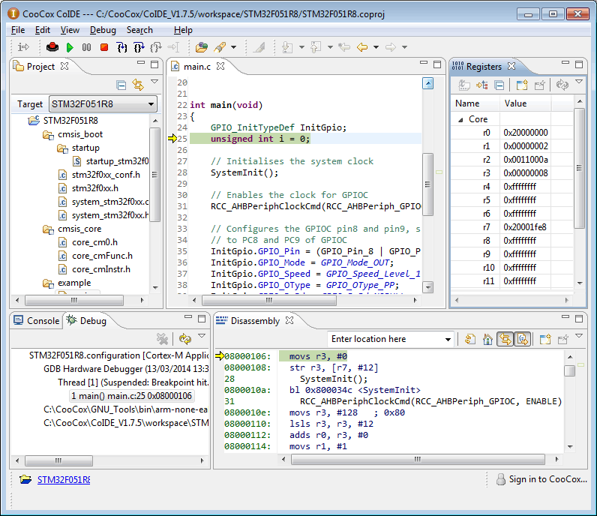

**Methodology**

**Confirm Design for Production (Week 1)**

* 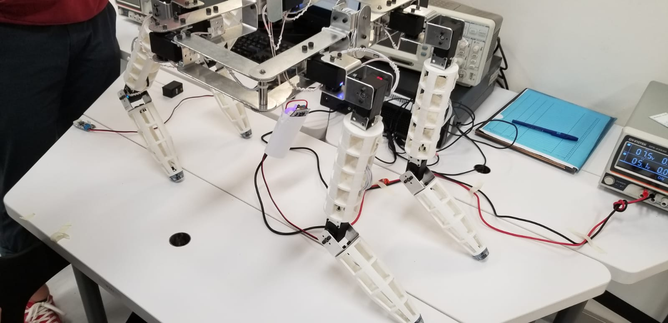At the first week, we have been given a real product designed by the supervisor. Since the robot are very similar to our design, we have discussed with the supervisor about the problems that our product may face, and whether we would change the product. Then, we make use of the sample robot and modified the leg model of our robot. After adjusting our robot design, we confirmed there is no problem, thus ME students go for production.

**Get familiar with testing environment (Week2)**

* At the second week, we have been given some sample code. There are four workshop station for us to do the testing. There are two station using CoIDE, two station using Visual Studio C#. We have read the program code and tried the testing of Motor motion, position feedback, Bluetooth connection, MCU program, and robot controlling in these stations.

**Divided parts and modified program code (Week3)**

* ME Students is still producing the legs for us to do the testing, hence at week 3 we are dividing the work into small pieces and try to work out one by one, at the following weeks.
* 1st stage: Knowing all the usage inside a function
* 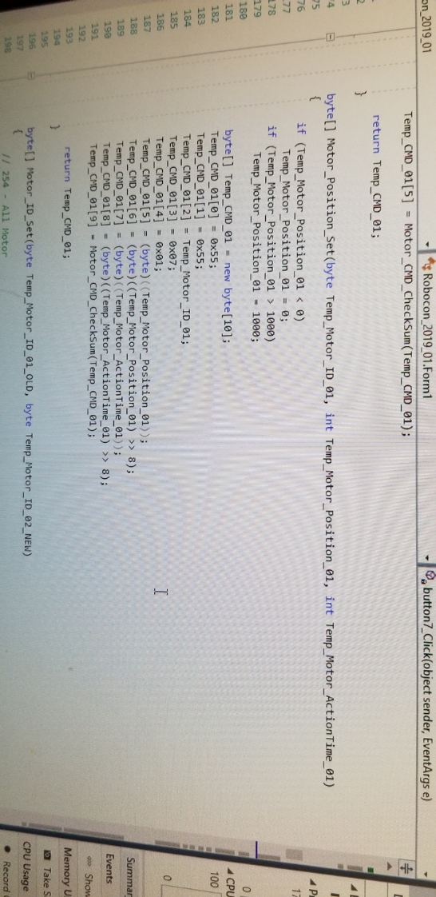一張含有 文字 的圖片

  自動產生的描述In order to build up linkage between CoIDE and Visual Studio, we focused on the function on the sample code and try out the use of the function. After we have figure out how to program one motors movement, we have modified the code for conversion between C# and CoIDE

**Works on differential parts (Week4-6)**

Motor

* At week4, ME students have prepared a leg for us to do the testing. We have jointed the connection cable to joint two motors.
* Since we have known the usage of the function, we tried to change the motor ID and drive the motor movement
* We successfully use our mobile phone to control the movement of the legs (joining two motors)

C# user interface

* 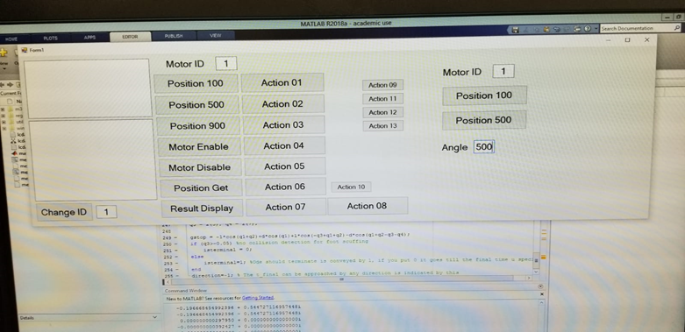At week 5, after we have finished the testing on motor and Bluetooth, we went into the testing on movements.
* Since we would like to test the robot in a efficient way, we mainly focus on the C# programing, as the user interface of C# is more clear and precise. Also, by using C#, we can get back the feedback angle of motor, so that we can set the angle more accurately.

Wire Connection

* At week 6, we have studied on the circuit schematic of the MCU, the function of UART, UART protocol TTL, USB-TTL converter, then we connect the motor debugger board and use our own legs to do the movement usig C#

**Works on integral parts (Week7-8)**

Combination of motor

* At week7, ME students have already produced four legs for us. Yet, since we have found that the motor angle is absolute value, which is not defined by the program. Hence, we communicate with them before joining the motor. Then, we help them to rename the motor ID of each motor and build up 4 legs.
* 一張含有 地板, 室內, 桌, 個人 的圖片

  自動產生的描述We also study on the error control method, PID control. By using PID, the accumulative error can be minimized, while obtaining the desired output more quickly, without overshooting
* Although we did not use PID control in our product finally, as the LX-15D itself already have a feedback system, it would benefit ourselves on the future development, mostly when we are going to design a system or maintain system stability

Optimization on User Interface

* At week 8, we have already built a robot for testing. Then, we modified the program to get all the position of the motor and save the motor position to an action in C#.
* We used Timer delay to perform different action to simulate the motion. And we have built perform a simple “stand-up” action

Optimization on hardware

* 一張含有 室內 的圖片

  自動產生的描述At week 9, we have rework on the soldering of the cable, to make the cable stronger to prevent hardware problem when we are doing the testing. ME students also help us to strengthen the mechanical structure such as tighten the screw, group together the cable.
* At week 10, since we have encounter difficulties on balancing the robot, ME students have added a sole under the robot leg for us to make the robot more stable in balancing.
* At week 12, since there has been serveral weeks gone from the last time we strengthen our model, so we check the structure and strengthen the robot once again.

Robot movement testing

* At week 11-12, we are mainly focus on the finishing the task given by the supervisor. We first focus on testing the motion of walking the robot. We cooperated with ME students on how to make the robot balance when performing action, such as shifting in center mass, the movement order of legs, the delay of legs movement, the friction of sole.
* At week 13, we do the final checking on both the hardware and software of the robot and perform different tasks. Finally, we can finish 3 out of 4 tasks given by the supervisor. But driven to the mechanical structure of the robot, we cannot cross the Tussock, which we think would be our future improvement if we have more time.

**Findings**

In the second parts of the project, our team has built up a strong bonding and relation inside the group. Unlike the first parts of the project, this time my role inside the team is not only a leader, but a cooperator. Usually I just used to give up some ideas and spread to my teammates to start the discussion. I find this working style very beneficial in an engineering project. At the first semester, the ideas of our groups are not well-developed enough. As we may be shy to give opinions, fear to point out the problems of other’s ideas, we usually cannot improve the ideas based on each other’s works.

Yet, starting from semester two, as we have cooperated in this project for half year, we get to know each other. Each member in our teams are willing to give out their own opinions. They will listen to other’s opinion and abstract the best parts to be the solution. For example, when we are doing the robot movement testing, the balancing problems is always a difficulty. Hence, supervisor has suggested us to add a pen under the robot leg to help the balance. We would probably accept the suggestions from the supervisor, if we are in semester one, since we would think it is the ‘Best Suggestions’ given by a person. However, after we discussed, we thought that the contact surface of the pen cannot meet the floor. We have given out the ideas and finally modified our own sole for the robot. To me, I think this is good for a team to work out a best solution, since it is more likely a summarize of the suggestions, rather than just the best opinions of someone.

Another thing I find it grateful is that when we are doing the testing, ME students offers us a lot of help, not only on their own mechanical parts. Since the production stage of ME students is faster than EIE students. When we are still testing on the motor parts, ME students has already finished the robot design. They then help us to solder the cable wire together, which saves us half of the time. Overall, in the production stage, every member in our team has contributed their work on the others’ area, not only focus on their own parts. Apart from semester one that everyone has their own works assigned by the leaders, this semester everyone works together to help each other finished the task.

**Challenges & Obstacles**

The major challenges that I observe when we are in testing, is that both ME and EIE students have a high expectation from each other. EIE students thought that ME students should have good knowledge in the mechanical movement, hence would be able to give out a clear suggestion on designing the robot movement. While ME students thought that EIE students can control the robot easily with one-click on the button in user interface. Therefore, when ME students gives out many suggestions for EIE students to program the motion of the robots, usually EIE students cannot catch up their ideas. EIE students have to convert their idea into a number, and consider about the order of movement, which takes lots of time to finished one suggestion coding. Also, since ME students may not be very clear to the concept of controlling robot movement, sometimes the suggestion is not workable. Hence, it takes time for us to cooperate on the testing stage.

**Comments/Conclusions**

Upon finishing the whole project, students would be able to know the procedures design, production, testing, and integration stages. In testing and integration stages, cooperation between different discipline is much more important. For example, EIE students may only know the controlling method of a robot, but lack of the sense of robot movement. Thus, EIE need ME students’ suggestions on improving the robot motion. On the other hands, ME students may not know the limitations on controlling, such as stability control, error control, which need to be considered by EIE students. Hence, EIE students also take parts in help ME students to make their design perfect. After finishing the project, I can know the standards and limitation of ME students, which help me to know the clarification of engineering subject as well.

This project offers students an opportunity to cooperate with other discipline students. Students can build up a strong bonding between each other and learn how to act as a team. With the experience of this project, students can get a first hand experience on the whole procedure of a team project. This benefits students’ career. As when students get into the society, there will be no clarification on which specific discipline that students belong to. There will only be task given and ask the students to finish before the deadline. As a result, if students could learn how to do a team project efficiently, students would get less trouble and behave as a expert engineer.

**Reflections and Recommendations**

After finishing the project, I found that there are still somethings that I need to improve. First, is the technical skills. Although I have learnt C/C++ programming, when I get into the real task programming, I still find I cannot master the programming very well. Also, C# programming is also challenging for me to program. I should also broaden the span of programming language.

Besides, team cooperation is also a thing I should perform better. Although my groupmates have performed a great teamwork, especially in the production and testing stages, sometimes the work distribution is uneven, which some of my groupmate has a slightly higher workload than the other. Especially when go into the technical parts, which a high-skilled teammate takes lead on the works. Although it can benefit the project, it would be better if we would distribute the work more evenly.

Time management is also what we need to improve. At the beginning of the production stage, we thought we would have enough time to do the testing. Thus, we want to get the things done perfectly and try to figure out the usage of function to build an efficient function. Since we have less experience in testing parts, we spend even half or more of the time in doing the debugging, rather than testing and modifying. Hence, with this project experience, next time I can consider which parts is much more important and focus on finishing that part first, so that we can meet the requirements on time.

Finally, I really want to thank my supervisor Eric sir, Ma sir and Nam sir. They always offer me lots of suggestions when I face problems. Their professional sense helps us to figure out the root of the bugs that we have made, which highly shorten our debug time. I also want to thank my ME groupmates, who help me on the testing even they have finished their own parts. Thanks to their help on the mechanical structure strengthening, we can have fewer workload in considering the hardware problems and focus on the software parts. We can finish almost 75% of the task at the end of the project. We thought it would be a great success. Hopefully this project experience can help me to handle the challenge in the future. I am looking to the new challenges in the future.

**List of Reference**

Outline:

IC382 Robocon 2018-2019: Stage 01 - Week 01 - Course Introduction

IC382 Robocon 2018-2019: Stage 01 - Week 01 - Game Field and Rules

IC382 Robocon 2018-2019: Stage 01 - Week 01 - How to Start

IC382 Robocon 2018-2019: Stage 01 - Week 02 - 01 - Electronic Hardware Design

IC382 Robocon 2018-2019: Stage 01 - Week 02 - 02 - Circuit Schematic and PCB Layout

IC382 Robocon 2018-2019: Stage 01 - Week 02 - 03 - PCBF_NCDrill

IC382 Robocon 2018-2019: Stage 01 - Week 04 - 01 - Software Development - ARM Nuvoton

IC382 Robocon 2018-2019: Stage 02 - Week 01 - How to Start

Circuit:

IC382 Robocon 2018-2019 : Stage 02 - Reference - 01 - Hardware - IC382_Robocon_Hardware_Circuit_PCB

Program:

IC382 Robocon 2018-2019 : Stage 02 - Reference - 02 - Software - IC382_Robocon_Software_MCU_Windows