**Part3**

**Code for “CreateDB.sql”**

DROP DATABASE IF EXISTS Lab1;

CREATE DATABASE IF NOT EXISTS Lab1;

Use Lab1;

-- MySQL Workbench Forward Engineering

SET @OLD_UNIQUE_CHECKS=@@UNIQUE_CHECKS, UNIQUE_CHECKS=0;

SET @OLD_FOREIGN_KEY_CHECKS=@@FOREIGN_KEY_CHECKS, FOREIGN_KEY_CHECKS=0;

SET @OLD_SQL_MODE=@@SQL_MODE, SQL_MODE='TRADITIONAL,ALLOW_INVALID_DATES';

-- -----------------------------------------------------

-- Schema mydb

-- -----------------------------------------------------

-- -----------------------------------------------------

-- Table `Customer`

-- -----------------------------------------------------

CREATE TABLE IF NOT EXISTS `Customer` (

`CustNo` CHAR(8) NOT NULL,

`FirstName` VARCHAR(45) NULL,

`LastName` VARCHAR(45) NULL,

`Street` VARCHAR(45) NULL,

`City` VARCHAR(45) NULL,

`State` VARCHAR(45) NULL,

`PhoneNo` VARCHAR(45) NULL,

`CustBal` VARCHAR(45) NULL,

PRIMARY KEY (`CustNo`))

ENGINE = InnoDB;

-- -----------------------------------------------------

-- Table `Employee`

-- -----------------------------------------------------

CREATE TABLE IF NOT EXISTS `Employee` (

`EmpNo` CHAR(8) NOT NULL,

`FirstName` VARCHAR(45) NULL,

`LastName` VARCHAR(45) NULL,

`PhoneNo` VARCHAR(45) NULL,

`Email` VARCHAR(45) NULL,

PRIMARY KEY (`EmpNo`))

ENGINE = InnoDB;

-- -----------------------------------------------------

-- Table `Order`

-- -----------------------------------------------------

CREATE TABLE IF NOT EXISTS `Order` (

`OrderNo` CHAR(8) NOT NULL,

`OrderDate` VARCHAR(45) NULL,

`Customer_CustNo` CHAR(8) NOT NULL,

`Employee_EmpNo` CHAR(8) NULL,

`CustName` VARCHAR(45) NULL,

`Street` VARCHAR(45) NULL,

`City` VARCHAR(45) NULL,

`State` VARCHAR(45) NULL,

`PhoneNo` VARCHAR(45) NULL,

PRIMARY KEY (`OrderNo`),

INDEX `fk_Order_Customer_idx` (`Customer_CustNo` ASC),

INDEX `fk_Order_Employee1_idx` (`Employee_EmpNo` ASC),

CONSTRAINT `fk_Order_Customer`

FOREIGN KEY (`Customer_CustNo`)

REFERENCES `Customer` (`CustNo`)

ON DELETE NO ACTION

ON UPDATE NO ACTION,

CONSTRAINT `fk_Order_Employee1`

FOREIGN KEY (`Employee_EmpNo`)

REFERENCES `Employee` (`EmpNo`)

ON DELETE NO ACTION

ON UPDATE NO ACTION)

ENGINE = InnoDB;

-- -----------------------------------------------------

-- Table `Product`

-- -----------------------------------------------------

CREATE TABLE IF NOT EXISTS `Product` (

`ProdNo` CHAR(8) NOT NULL,

`ProdName` VARCHAR(45) NULL,

`Mfg` VARCHAR(45) NULL,

`Stock` INT NULL,

`Price` VARCHAR(45) NULL,

PRIMARY KEY (`ProdNo`))

ENGINE = InnoDB;

-- -----------------------------------------------------

-- Table `ProductInOrder`

-- -----------------------------------------------------

CREATE TABLE IF NOT EXISTS `ProductInOrder` (

`Order_OrderNo` CHAR(8) NOT NULL,

`Product_ProdNo` CHAR(8) NOT NULL,

`Qty` INT NULL,

PRIMARY KEY (`Order_OrderNo`, `Product_ProdNo`),

INDEX `fk_ProductInOrder_Order1_idx` (`Order_OrderNo` ASC),

INDEX `fk_ProductInOrder_Product1_idx` (`Product_ProdNo` ASC),

CONSTRAINT `fk_ProductInOrder_Order1`

FOREIGN KEY (`Order_OrderNo`)

REFERENCES `Order` (`OrderNo`)

ON DELETE NO ACTION

ON UPDATE NO ACTION,

CONSTRAINT `fk_ProductInOrder_Product1`

FOREIGN KEY (`Product_ProdNo`)

REFERENCES `Product` (`ProdNo`)

ON DELETE NO ACTION

ON UPDATE NO ACTION)

ENGINE = InnoDB;

SET SQL_MODE=@OLD_SQL_MODE;

SET FOREIGN_KEY_CHECKS=@OLD_FOREIGN_KEY_CHECKS;

SET UNIQUE_CHECKS=@OLD_UNIQUE_CHECKS;

**Code for “LoadDB.sql”**

SET FOREIGN_KEY_CHECKS = 0;

LOAD DATA LOCAL INFILE 'C:/Users/16060132d/Desktop/EIE3112 Database/Lab1/Customer.txt'

INTO TABLE `Customer` FIELDS TERMINATED BY ',' ENCLOSED BY '"'

LINES TERMINATED BY '\r\n' STARTING BY '';

LOAD DATA LOCAL INFILE 'C:/Users/16060132d/Desktop/EIE3112 Database/Lab1/Employee.txt'

INTO TABLE `Employee` FIELDS TERMINATED BY ',' ENCLOSED BY '"'

LINES TERMINATED BY '\r\n' STARTING BY '';

LOAD DATA LOCAL INFILE 'C:/Users/16060132d/Desktop/EIE3112 Database/Lab1/Order.txt'

INTO TABLE `Order` FIELDS TERMINATED BY ',' ENCLOSED BY '"'

LINES TERMINATED BY '\r\n' STARTING BY '';

LOAD DATA LOCAL INFILE 'C:/Users/16060132d/Desktop/EIE3112 Database/Lab1/Product.txt'

INTO TABLE `Product` FIELDS TERMINATED BY ',' ENCLOSED BY '"'

LINES TERMINATED BY '\r\n' STARTING BY '';

LOAD DATA LOCAL INFILE 'C:/Users/16060132d/Desktop/EIE3112 Database/Lab1/ProductInOrder.txt'

INTO TABLE `ProductInOrder` FIELDS TERMINATED BY ',' ENCLOSED BY '"'

LINES TERMINATED BY '\r\n' STARTING BY '';

USE Lab1;

DELETE FROM `Customer` WHERE CustNo = 'C1234567';

INSERT INTO `Customer`

VALUES ("C1234567","Chun Man","Chan","Yuk Choi Rd","Hong Kong","HK","12345-6789","$100");

SELECT *FROM `Customer` WHERE LastName='Chan';

DELETE FROM `Order` WHERE OrderNo = 'O1234567';

DELETE FROM `Order` WHERE OrderNo = 'O1111111';

INSERT INTO `Order`

VALUES ("O1234567","5/25/2013","C1234567","E1329594","Chun-Man Chan","Yuk Choi Rd","Hong Kong","HK","12345-6789");

INSERT INTO `Order`

VALUES ("O1111111","10/1/2007","C1234567","E8544399","Chun-Man Chan","Yuk Choi Rd","Hong Kong","HK","12345-6789");

SELECT *FROM `Order` WHERE Customer_CustNo='C1234567';

**Part4**

Q1.

Use Lab1;

Select CustNo, FirstName, LastName, CustBal

FROM `Customer`

WHERE State = 'CO';

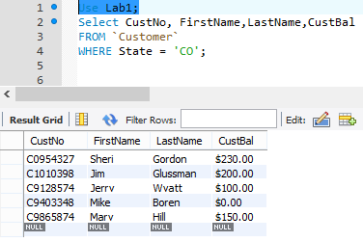

Q2.

Use Lab1;

Select CustNo, FirstName, LastName, Street, City

FROM `Customer`

WHERE State = 'HK';

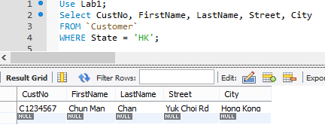

Q3.

Use Lab1;

Select OrderNo, OrderDate, CustName

FROM `Order`

WHERE City = 'Denver' OR City = 'Englewood' OR

City = 'HongKong'

ORDER BY CustName;

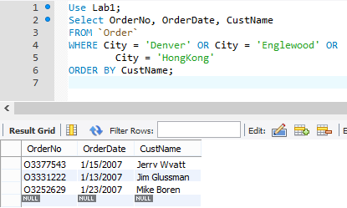

Q4.

Use Lab1;

Select * FROM `Order`

ORDER BY STR_TO_DATE(OrderDate,'%m/%d/%Y');

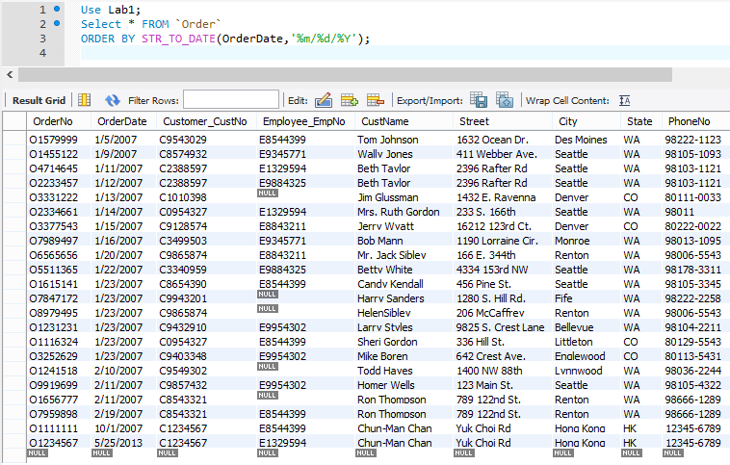

Q5.

Use Lab1;

Select * FROM `Order`

WHERE (STR_TO_DATE(OrderDate,'%m/%d/%Y') >= '2007-1-1') AND

(STR_TO_DATE(OrderDate,'%m/%d/%Y') <= '2007-1-14')

AND (Employee_EmpNo IS NULL);

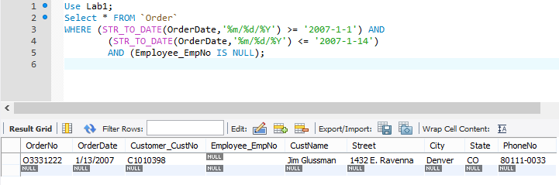

Q6.

Use Lab1;

Select * FROM `Order`

WHERE (STR_TO_DATE(OrderDate,'%m/%d/%Y') < '2014-1-1')

AND (Employee_EmpNo IS NOT NULL);

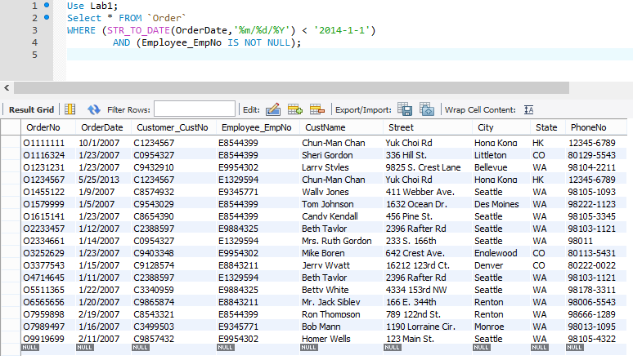

Q7.

Use Lab1;

Select * FROM `Product`

WHERE ProdName LIKE '%Ink Jet%';

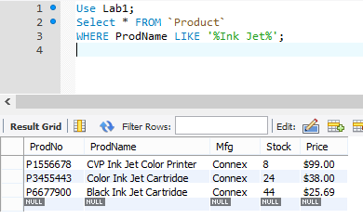

Q8.

Use Lab1;

Select * FROM `Product`

WHERE CAST(SubString(Price,2) AS DECIMAL) > 30;

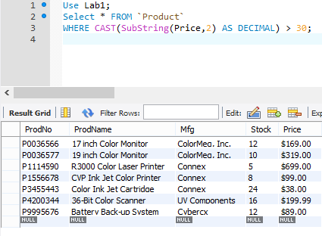

Q9.

Use Lab1;

Select CustNo,FirstName,LastName,City,CustBal

FROM `Customer`

WHERE (City = 'Seattle' AND

CAST(SubString(CustBal,2) AS DECIMAL) > 150)

OR (City = 'Hong Kong' AND

CAST(SubString(CustBal,2) AS DECIMAL) > 30);

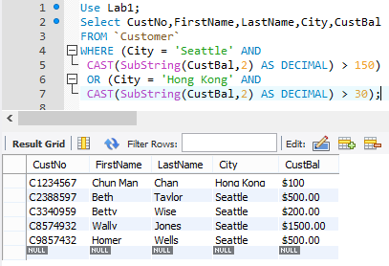

Q10.

Use Lab1;

Select DISTINCT City, State

FROM `Order`;

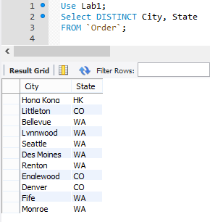

Q11.

Use Lab1;

Select CustNo, CONCAT(FirstName," ",LastName) AS Name, CustBal, State

FROM `Customer`;

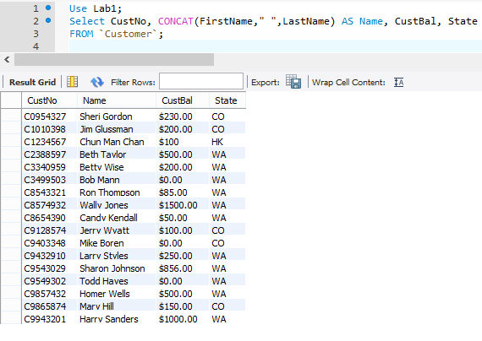

**Part5**

Q1.

Use Lab1;

Select OrderNo,OrderDate,CustNo, Customer.FirstName, Customer.LastName

From `Customer` INNER JOIN `Order`

ON `Customer`.CustNo = `ORDER`.Customer_CustNo

WHERE (`Customer`.State="CO")

AND (`Order`.State="WA");

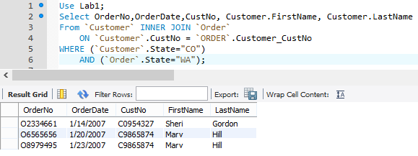

Q2.

Use Lab1;

Select OrderNo,OrderDate,CustNo, Customer.FirstName, Customer.LastName

From `Customer` INNER JOIN `Order`

ON `Customer`.CustNo = `ORDER`.Customer_CustNo

WHERE (STR_TO_DATE(`Order`.OrderDate,'%m/%d/%Y') > '2007-1-2')

AND (`Order`.State="WA" OR `Order`.State="HK");

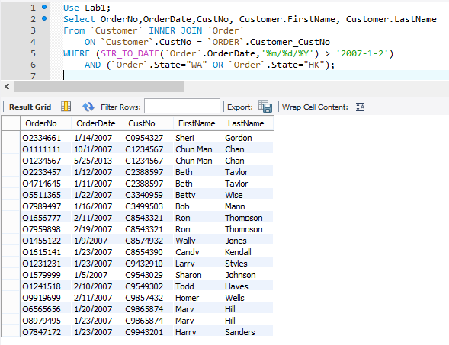

Q3.

Use Lab1;

Select DISTINCT EmpNo, Employee.FirstName,Employee.LastName, Employee.PhoneNo

From `Employee` INNER JOIN

( `Customer` INNER JOIN (`Order`)

ON `Customer`.CustNo = `ORDER`.Customer_CustNo

) ON `Employee`.EmpNo = `Order`.Employee_EmpNo

WHERE (STR_TO_DATE(`Order`.OrderDate,'%m/%d/%Y') >= '2007-1-1')

AND ( CAST(SubString(`Customer`.CustBal,2) AS DECIMAL) >200)

ORDER BY EmpNo;

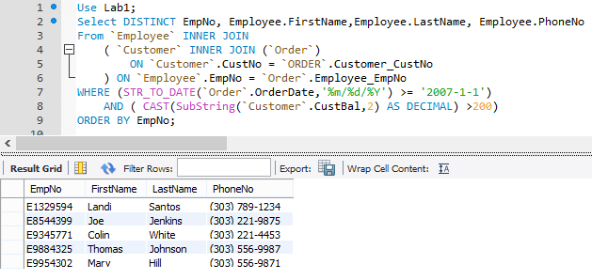

Q4.

Use Lab1;

Select CustNo, CONCAT(Customer.FirstName,' ',Customer.LastName) AS CustomerName,

OrderNo, OrderDate, EmpNo, CONCAT(Employee.FirstName,' ',Employee.LastName) AS EmployeeName,

ProdNo, ProdName, CONCAT('$',Qty*CAST(SUBSTRING(Price,2) AS DECIMAL)) AS OrderCost

From `Employee` INNER JOIN

( `Customer` INNER JOIN

( `Order` INNER JOIN

(`Product` INNER JOIN

(`ProductInOrder`)

ON `Product`.ProdNo = `ProductInOrder`.Product_ProdNo

)ON `Order`.OrderNo = `ProductInOrder`.Order_OrderNo

)ON `Customer`.CustNo = `ORDER`.Customer_CustNo

) ON `Employee`.EmpNo = `Order`.Employee_EmpNo

WHERE (STR_TO_DATE(OrderDate,'%m/%d/%Y') = '2007-1-23')

AND (Employee_EmpNo IS NOT NULL)

AND ( Qty*CAST(SUBSTRING(Price,2) AS DECIMAL) >150)

ORDER BY Qty*CAST(SUBSTRING(Price,2) AS DECIMAL) DESC;

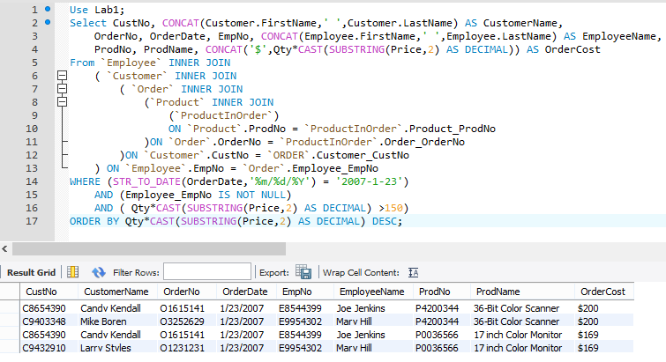

Q5.

Use Lab1;

Select ProdNo, ProdName, Price

From `Customer` INNER JOIN

( `Order` INNER JOIN

(`Product` INNER JOIN

(`ProductInOrder`)

ON `Product`.ProdNo = `ProductInOrder`.Product_ProdNo

)ON `Order`.OrderNo = `ProductInOrder`.Order_OrderNo

)ON `Customer`.CustNo = `ORDER`.Customer_CustNo

WHERE (STR_TO_DATE(OrderDate,'%m/%d/%Y') BETWEEN '2007-1-1' AND '2007-1-31')

AND ( CustNo = 'C0954327' )

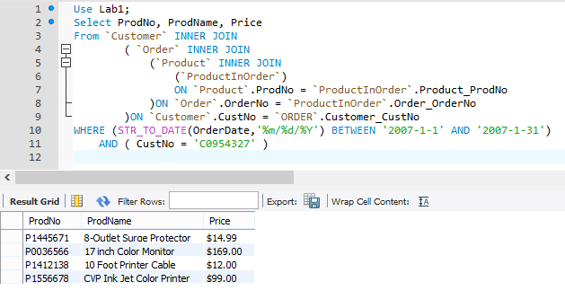

Q6.

Select Customer.FirstName, Customer.LastName

From `Employee` INNER JOIN

( `Customer` INNER JOIN

( `Order`

)ON `Customer`.CustNo = `ORDER`.Customer_CustNo

) ON `Employee`.EmpNo = `Order`.Employee_EmpNo

WHERE Employee.FirstName='Amy'

AND Employee.LastName= 'Tang';

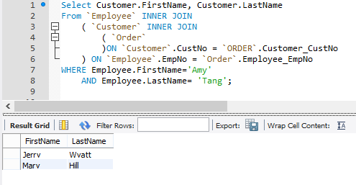

Q7.

Select Customer.FirstName,Customer.LastName

From `Employee`,`Customer`

WHERE Employee.FirstName= Customer.FirstName

AND Employee.LastName= Customer.LastName;

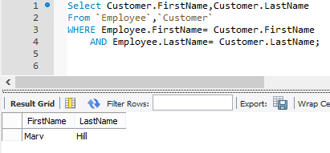

Q8.

