**Part1**

Q1.1

Select City, AVG(Substring(CustBal,2)) AS 'Average Balance'

From `Customer`

WHERE State= 'WA'

OR State= 'HK'

GROUP BY City;

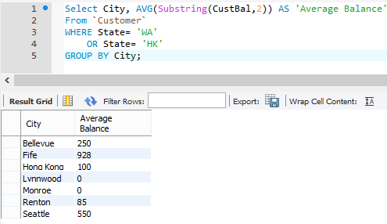

Q1.2.

Select City, AVG(Substring(CustBal,2)) AS 'Average Balance' ,

COUNT(*) AS 'No. of Customers'

From `Customer`

WHERE State= 'WA'

OR State= 'HK'

GROUP BY City;

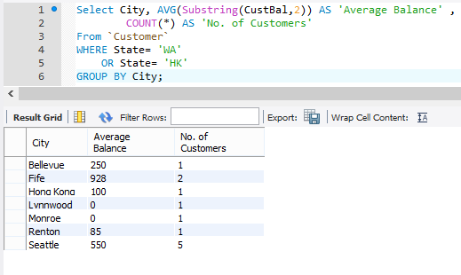

Q1.3.

Select OrderNo, (Sum(SubString(Price,2) * Qty)) AS 'Amount'

From `Order` INNER JOIN

(`Product` INNER JOIN

(`ProductInOrder`)

ON `Product`.ProdNo = `ProductInOrder`.Product_ProdNo

)ON `Order`.OrderNo = `ProductInOrder`.Order_OrderNo

WHERE STR_TO_DATE(OrderDate,'%m/%d/%Y') = '2007-1-23'

GROUP BY OrderNo;

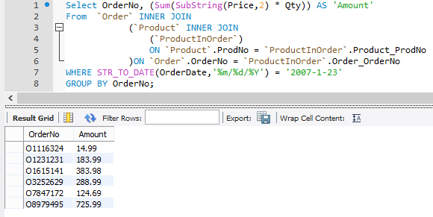

Q1.4

Select OrderNo, Customer.FirstName, Customer.LastName, (Sum(SubString(Price,2) * Qty)) AS 'Amount'

From `Customer` INNER JOIN

(`Order` INNER JOIN

(`Product` INNER JOIN

(`ProductInOrder`)

ON `Product`.ProdNo = `ProductInOrder`.Product_ProdNo

)ON `Order`.OrderNo = `ProductInOrder`.Order_OrderNo

)ON `Customer`.CustNo = `ORDER`.Customer_CustNo

WHERE STR_TO_DATE(OrderDate,'%m/%d/%Y') = '2007-1-23'

GROUP BY OrderNo;

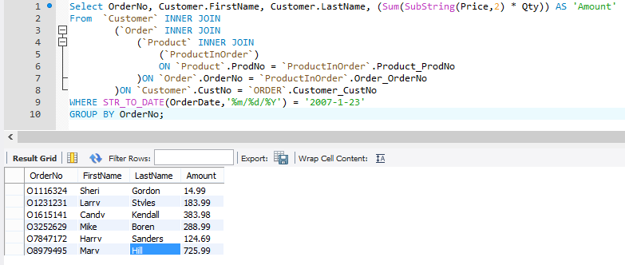

Q1.5.

Select CustNo, Customer.FirstName, Customer.LastName,

Sum(Qty) AS 'No. of Products',(Sum(SubString(Price,2) * Qty)) AS 'Cost'

From `Customer` INNER JOIN

(`Order` INNER JOIN

(`Product` INNER JOIN

(`ProductInOrder`)

ON `Product`.ProdNo = `ProductInOrder`.Product_ProdNo

)ON `Order`.OrderNo = `ProductInOrder`.Order_OrderNo

)ON `Customer`.CustNo = `ORDER`.Customer_CustNo

WHERE (ProdName LIKE '%Ink Jet%' OR ProdName LIKE '%Laser%') AND

(STR_TO_DATE(OrderDate,'%m/%d/%Y') BETWEEN '2007-1-01' AND '2007-1-31')

GROUP BY CustNo

ORDER BY Cost DESC;

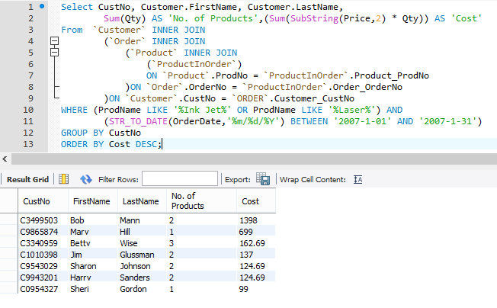

Q1.6

Select ProdNo, ProdName, Sum(Qty) AS 'Total Quantity',

(Sum(SubString(Price,2) * Qty)) AS 'Cost'

From `Customer` INNER JOIN

(`Order` INNER JOIN

(`Product` INNER JOIN

(`ProductInOrder`)

ON `Product`.ProdNo = `ProductInOrder`.Product_ProdNo

)ON `Order`.OrderNo = `ProductInOrder`.Order_OrderNo

)ON `Customer`.CustNo = `ORDER`.Customer_CustNo

WHERE (STR_TO_DATE(OrderDate,'%m/%d/%Y') BETWEEN '2007-1-01' AND '2007-1-31')

GROUP BY ProdNo

HAVING Sum(Qty)>4

ORDER BY Cost DESC;

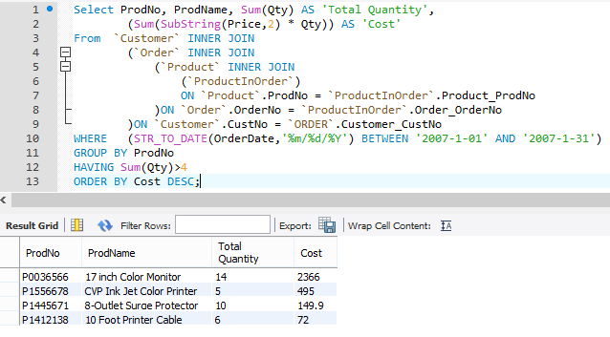

Q1.7.

Select CustNo, Customer.FirstName, Customer.LastName,

COUNT(DISTINCT OrderNo) AS 'No. of Orders'

From `Customer` INNER JOIN

(`Order` INNER JOIN

(`Product` INNER JOIN

(`ProductInOrder`)

ON `Product`.ProdNo = `ProductInOrder`.Product_ProdNo

)ON `Order`.OrderNo = `ProductInOrder`.Order_OrderNo

)ON `Customer`.CustNo = `ORDER`.Customer_CustNo

WHERE (Customer.State='CO') AND (Mfg = 'Connex') AND

(STR_TO_DATE(OrderDate,'%m/%d/%Y') BETWEEN '2007-1-01' AND '2007-1-31')

GROUP BY CustNo;

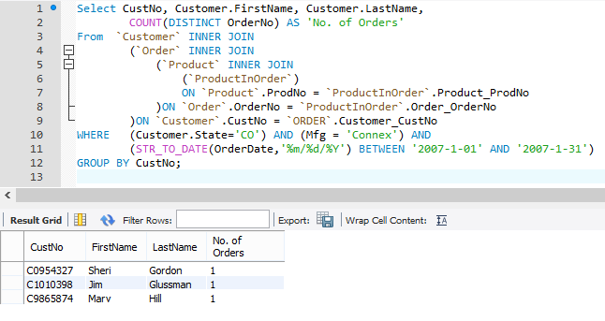

Q1.8.

Select MONTHNAME(STR_TO_DATE(OrderDate,'%m/%d/%Y')) AS 'Month', (Sum(SubString(Price,2) * Qty)) AS 'Amount'

From `Order` INNER JOIN

(`Product` INNER JOIN

(`ProductInOrder`)

ON `Product`.ProdNo = `ProductInOrder`.Product_ProdNo

)ON `Order`.OrderNo = `ProductInOrder`.Order_OrderNo

GROUP BY MONTHNAME(STR_TO_DATE(OrderDate,'%m/%d/%Y'))

ORDER BY month(OrderDate);

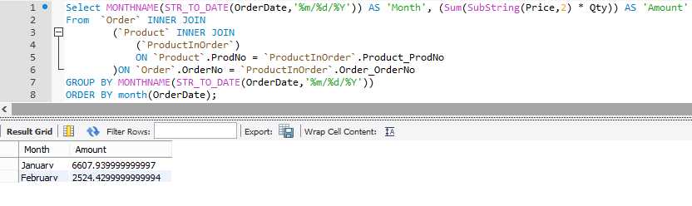

**Part2**

2.1.

SELECT OrderNo, OrderDate, EmpNo, Employee.FirstName, Employee.Lastname

From `Order` LEFT JOIN

`Employee` ON `Order`.Employee_EmpNo = `Employee`.EmpNo

WHERE (STR_TO_DATE(`Order`.OrderDate,'%m/%d/%Y') = '2007-1-23');

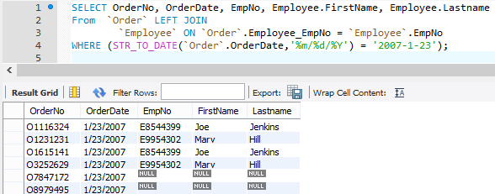

2.2

SELECT OrderNo, OrderDate, EmpNo, Employee.FirstName, Employee.LastName,

CustNo, Customer.FirstName, Customer.Lastname

From `Order` LEFT JOIN

`Employee` ON `Order`.Employee_EmpNo = `Employee`.EmpNo

INNER JOIN `Customer`

ON `Customer`.CustNo = `ORDER`.Customer_CustNo

WHERE (STR_TO_DATE(`Order`.OrderDate,'%m/%d/%Y') = '2007-1-23')

ORDER BY OrderNo;

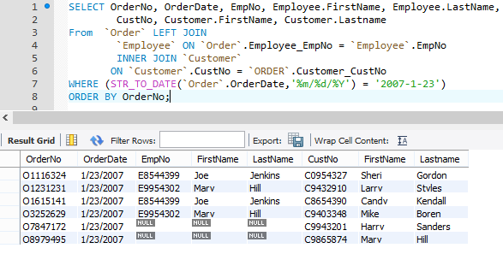

Q2.3.

SELECT * FROM `Customer` LEFT JOIN `Employee`

ON (`Customer`.FirstName = `Employee`.FirstName

AND `Customer`.LastName = `Employee`.LastName)

UNION

SELECT * FROM `Customer` RIGHT JOIN `Employee`

ON (`Customer`.FirstName = `Employee`.FirstName

AND `Customer`.LastName = `Employee`.LastName);

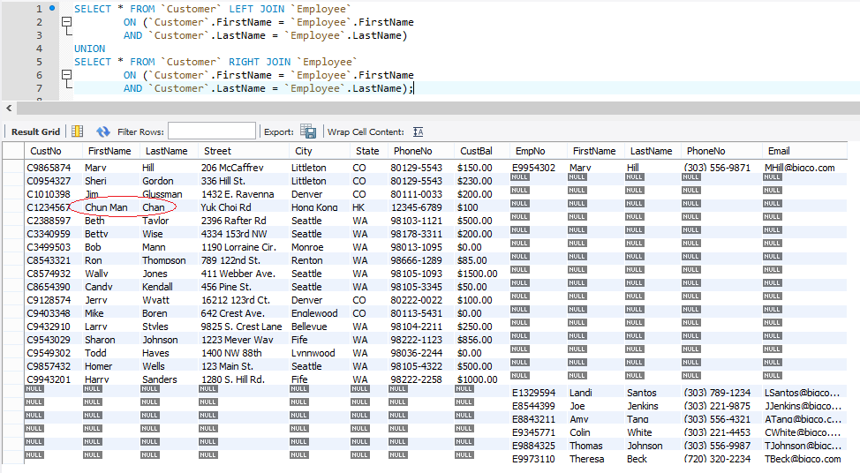

**Part3**

3.1

Select CustNo, FirstName, LastName,City

FROM `Customer`

WHERE (SUBSTRING(Custbal,2)>150) AND

Customer.CustNo IN

( Select `Order`.Customer_CustNo

FROM `Order`

WHERE (STR_TO_DATE(OrderDate,'%m/%d/%Y') BETWEEN '2007-2-1' AND '2007-2-29')

)

GROUP BY CustNo;

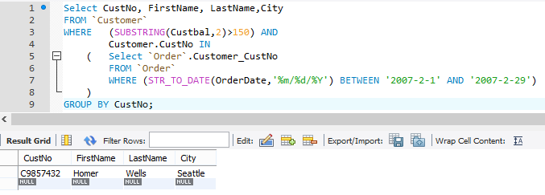

3.2

Select CustNo, FirstName, LastName

FROM `Customer`

WHERE (State = 'CO') AND

Customer.CustNo NOT IN

( Select `Order`.Customer_CustNo

FROM `Order`

WHERE (STR_TO_DATE(OrderDate,'%m/%d/%Y') BETWEEN '2007-2-1' AND '2007-2-29')

)

GROUP BY CustNo;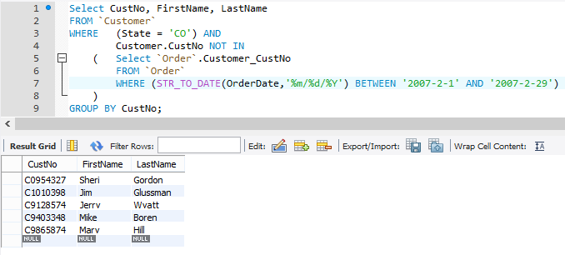

3.3

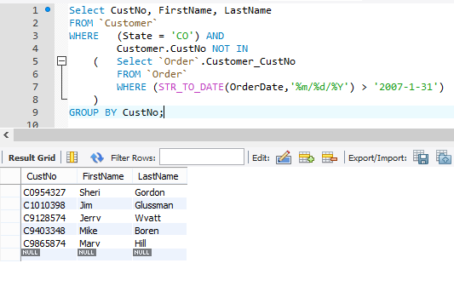

Q3.3

SELECT OrderNo, OrderDate, CustName

From `Order`

WHERE (STR_TO_DATE(OrderDate,'%m/%d/%Y')) IN

(

SELECT MAX(STR_TO_DATE(OrderDate,'%m/%d/%Y'))

From `Order`

);

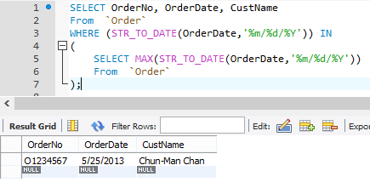

**Part4**

DELIMITER $$

DROP PROCEDURE IF EXISTS add_customer $$

CREATE PROCEDURE add_customer(IN p_CustNo CHAR(8), IN p_LastName VARCHAR(45), IN p_FirstName VARCHAR(45), OUT p_Message VARCHAR(45))

BEGIN

DECLARE error_key INT DEFAULT 0;

BEGIN

DECLARE EXIT HANDLER FOR 1062

SET error_key = 1062;

DECLARE EXIT HANDLER FOR 1048

SET error_key = 1048;

INSERT INTO `Customer` (CustNo, FirstName, LastName)

VALUES (p_CustNo, p_FirstName, p_LastName);

END;

CASE

WHEN error_key = 1062

THEN SET P_Message = CONCAT('Duplicated key for Customer ', p_CustNo);

WHEN error_key = 1048

THEN SET P_Message = CONCAT('PK Cannot be null; error code = 1048');

ELSE SET P_Message = CONCAT('Customer: ', p_CustNo, ' created');

END CASE;

END $$

DELIMITER ;

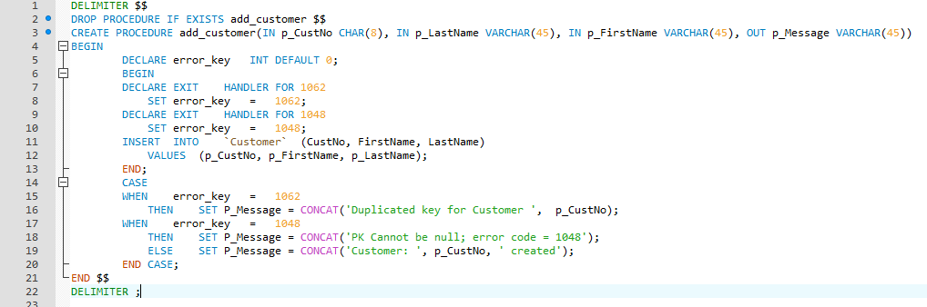

Q4.1(i)

SET @message =NULL;

call add_customer('C0000000','Tai-Man','Chan',@message);

SELECT @message AS 'Message';

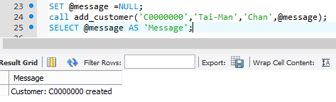

Q4.1(ii)

call add_customer('C0000000','Tai-Man','Chan',@message);

SELECT @message AS 'Message';

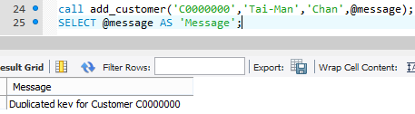

Q4.1(iii)

call add_customer(null,'Tai-Man','Chan',@message);

SELECT @message AS 'Message';

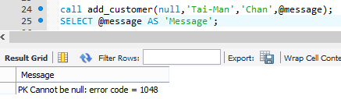

Q4.2

DELIMITER $$

DROP TRIGGER IF EXISTS `update_product` $$

CREATE TRIGGER `update_product`

BEFORE UPDATE ON `Product`

FOR EACH ROW

BEGIN

DECLARE Price_old DECIMAL(10, 2) DEFAULT 0;

DECLARE Price_new DECIMAL(10, 2) DEFAULT 0;

DECLARE Stock_diff DECIMAL(10, 2) DEFAULT 0;

DECLARE Revenue_old DECIMAL(10, 2) DEFAULT 0;

DECLARE Revenue_new DECIMAL(10, 2) DEFAULT 0;

SET Price_old = SUBSTRING(OLD.Price, 2);

SET Stock_diff = (NEW.stock - OLD.Stock) / OLD.Stock;

SET Price_new = Price_old - (Price_old * Stock_diff);

SET Revenue_old = (SELECT SUM(SUBSTRING(Price, 2) * Stock) FROM `Product`);

SET Revenue_new = Revenue_old - (Price_old * OLD.Stock) + (Price_New * NEW.Stock);

IF (Revenue_new > 17000)

THEN SET NEW.Price = CONCAT('$', Price_new);

ELSE SET NEW.Price = CONCAT('$', Price_old);

END IF;

END $$

DELIMITER ;

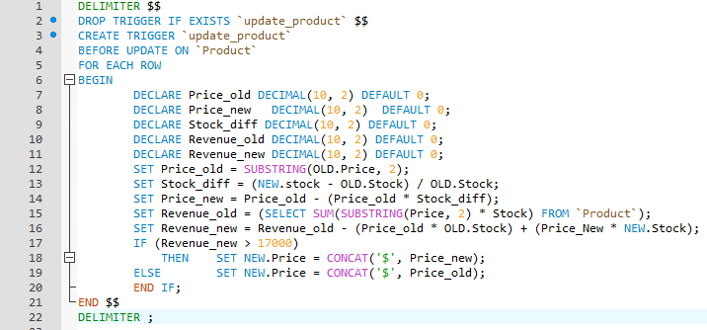

Q4.2(i)

SELECT * FROM product WHERE ProdNo = 'P0036577';

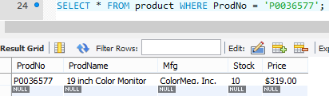

Q4.2(ii)

UPDATE Product SET Stock = 9 WHERE ProdNo = 'P0036577';

SELECT * from product where ProdNo = 'P0036577';

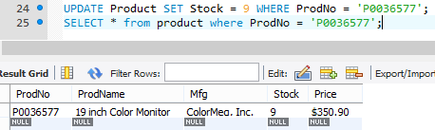

Q4.2(iii)

UPDATE Product SET Stock = 7 WHERE ProdNo = 'P0036577';

SELECT * from product where ProdNo = 'P0036577';

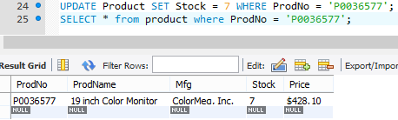

Q4.2(iv)

UPDATE Product SET Stock = 4 WHERE ProdNo = 'P0036577';

SELECT * from product where ProdNo = 'P0036577';

