# To-Do List Application in Kotlin

## Overview

This is a simple console-based To-Do List application written in Kotlin. It allows users to manage their tasks by adding, viewing, deleting, and marking them as complete.

## Features

* Add Task: Users can add new tasks with descriptions.
* View Tasks: Users can view all tasks with their statuses (Pending or Completed).
* Delete Task: Users can delete a task by its ID.
* Complete Task: Users can mark a task as completed by its ID.
* Exit: Exits the application.

## Installation

Download Kotlin: Visit the Kotlin website and download the latest version.

Extract the Zip File: Extract the downloaded zip file to a location on your system (e.g., C:\Kotlin on Windows or ~/Kotlin on macOS/Linux).

Set Up Environment Variables:

- Windows:  
 - Go to Control Panel > System and Security > System > Advanced system settings > Environment Variables.  
 - Under System variables, find the Path variable and click Edit. Add the path to the bin directory of your Kotlin installation (e.g., C:\Kotlin\kotlinc\bin).

- macOS/Linux:  
 - Open a terminal and edit your shell configuration file (e.g., .bashrc, .bash_profile, or .zshrc) and add:  
 export PATH=$PATH:/path/to/kotlin/bin  
 - Save the file and run source ~/.bashrc or source ~/.bash_profile to apply changes.

Verify Installation: Open a terminal and run:  
kotlinc -version  
This should display the version of Kotlin installed.

## How to Run the Application

Ensure that Kotlin is installed on your system.

Open a terminal and navigate to the project directory:  
cd path/to/ToDoListProject

Compile the application:  
kotlinc src/Main.kt -d ToDoList.jar

Run the application:  
java -jar ToDoList.jar

## Screenshots

### Adding a Task

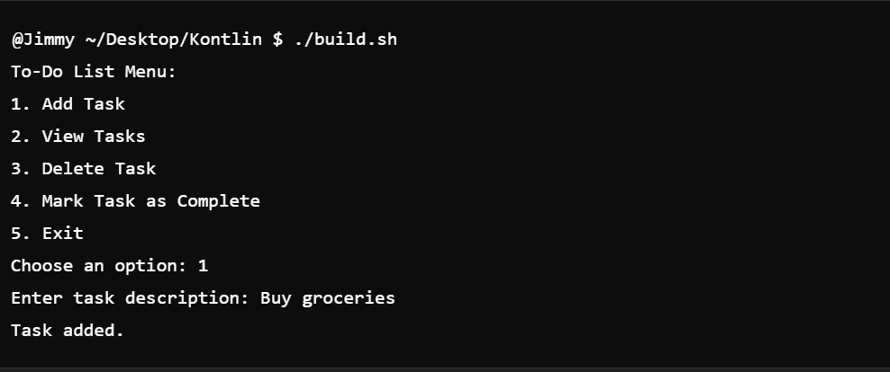

### Viewing Tasks

### 

### Deleting a Task

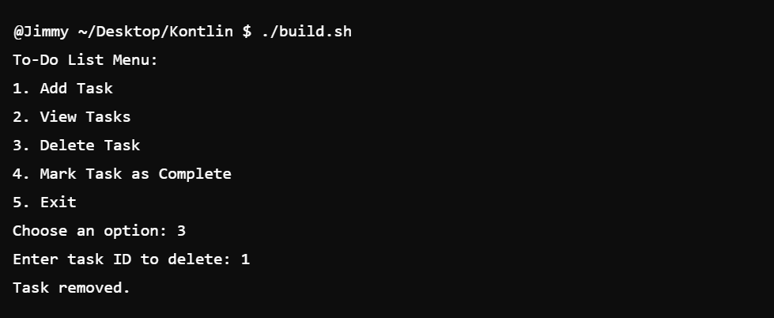

### Completing a Task

### 

### Exiting the Application

