# 

# 

# 

# XIO - 7Sx4

Specification 0.01

# 

# History

|  |  |  |  |
| --- | --- | --- | --- |
| **Ver.** | **Date** | **Description** | **Author** |
| 0.01 | 2021/2/9 | Initialize released | Jimmy Hwang |

# 

# Registers

* Base+0x00 (7-Segment Display control register)
* Base+0x01 (7-Segment Display control register)
* Base+0x02 (7-Segment Display control register)
* Base+0x03 (7-Segment Display control register)
  + Register index mapping is from right to left of display position
  + The bit to led segment mapping as below picture
  + 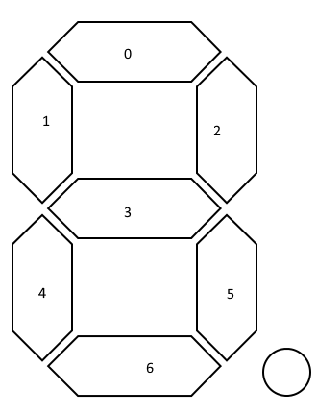
* Base+0x08 (Button status/control register)
  + Bit 0 - Second button
    - Read - the bit indicate the button be triggered
    - Write - set 1 to clear trigger status
  + Bit 1 - Minute button
    - Read - the bit indicate the button be triggered
    - Write - set 1 to clear trigger status
  + Bit 2 - Start button
    - Read - the bit indicate the button be triggered
    - Write - set 1 to clear trigger status
  + Bit 3 - Reset button
    - Read - the bit indicate the button be triggered
    - Write - set 1 to clear trigger status
  + Bit 4 - Mode button
    - Read - the bit indicate the button be triggered
    - Write - set 1 to clear trigger status