Jimmy Hickey

CS 385

10/4/16

Homework 6

**7-20 a.**

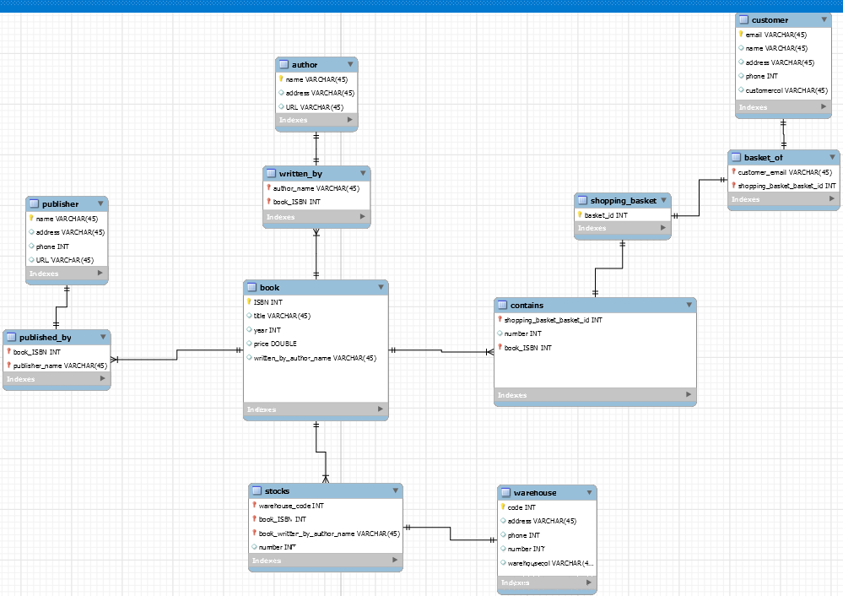

Author(name, address, URL)

Book(ISBN, title, year, price, author_name)

Publisher(name, address, phone, URL)

Customer(email, name, address phone)

Shopping_basket(basket_id)

Contains(basket_id, ISBN, number)

Warehouse(code, address, phone)

Stocks(code, ISBN, number)

Some relations were not necessary, so they were excluded from the reduced list.

b.

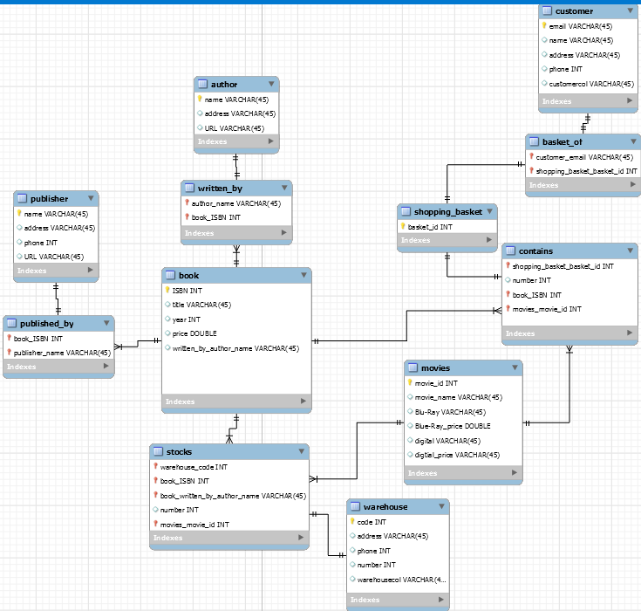

Author(name, address, URL)

Book(ISBN, title, year, price, author_name)

Publisher(name, address, phone, URL)

Customer(email, name, address phone)

Shopping_basket(basket_id)

Movies(movie_id, movie_name, Blu-Ray, Blu-Ray print, digital, digital_price)

Blu-Ray and digital would be true or false depending on whether the movie is available in that medium.

Contains(basket_id, ISBN, movie_id, number)

Warehouse(code, address, phone)

Stocks(code, ISBN, movie_id, number)

c.

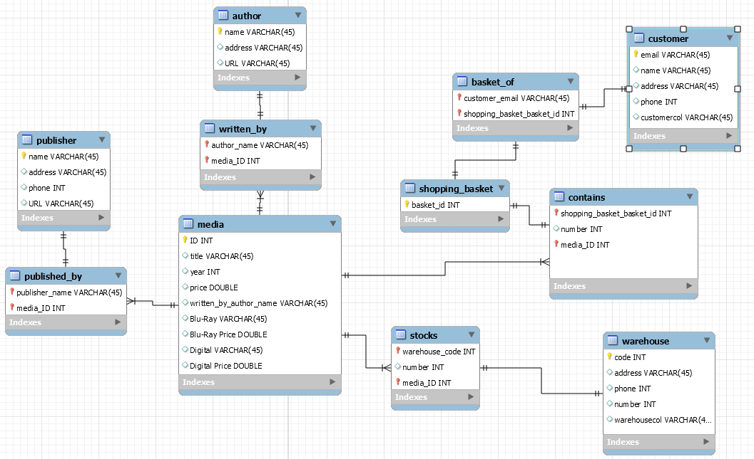

Author(name, address, URL)

Media(ID, title, year, price, author_name, Blu-Ray, Blu-Ray price, Digital, Digital_price)

Publisher(name, address, phone, URL)

Customer(email, name, address phone)

Shopping_basket(basket_id)

Contains(basket_id, media_ID, number)

Warehouse(code, address, phone)

Stocks(code, media_ID, number)