Description of Player-Unknown

*Player Unknown* is a side-scrolling video game in which the player controls ‘the captain’. The captain’s mission is to kill or avoid enemies on the way, survive, and reach the destination.

The captain has several basic movement functions which are jump, walk, and rampage rush. Rampage rush can be activated by killing at least five enemies. The captain also has two attacking functions which allow him to kill enemies: opening fire and throwing grenades.

Enemies cohort consists of nine basic types which are listed as below.

Scout soldiers: They stand still looking around. 

Patrol soldiers: They walk around slowly in a certain area. 

Mine soldiers: They roll fire balls on the ground which may explode and kill the captain. 

Artillery soldiers: They fire a shell which make the captain lose one life. 

Frog soldiers: They jump in a certain area.

Timid soldiers: They hide behind a wall and do not move.

Mad soldiers: They run fast in a certain area.

Talking soldiers: They stand still chatting.

The captain starts with three lives and he can collect the water bottle on the way to gain one life every time. Any contact with the enemies and enemies’ weapon mentioned above cost him one life. If the captain and an enemy comes into contact, both are killed.

The player can simply click ‘Play Game’ button to start the game. Also, he/she can click ‘Instruction’ button to see basic control instructions and so on. Basically, the player loses the game when then captain lose all his lives and he/she can restart the game by pressing enter key. The player wins the game when the captain completes all three missions and reaches the ultimate destination.

Some screen shots for the game:

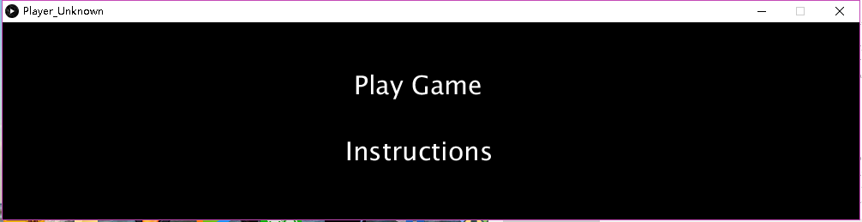

Main Menu

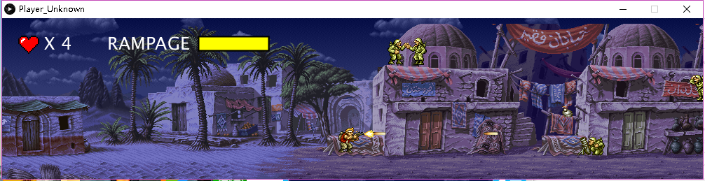

Mission 1

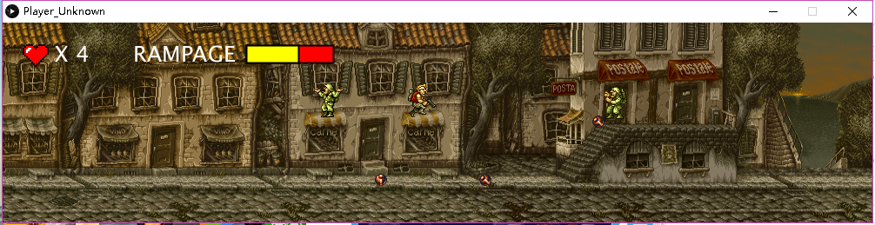

Mission 2

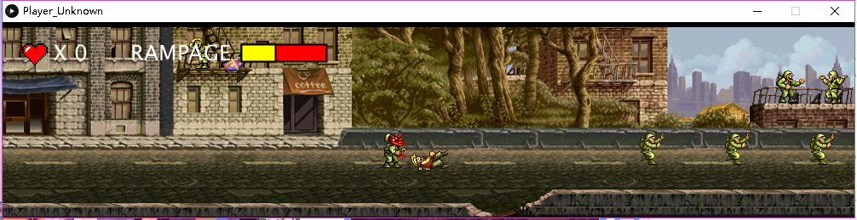

Mission3

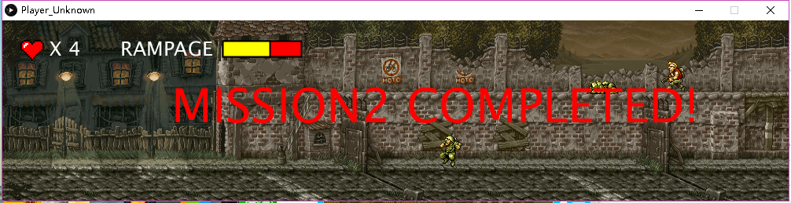

Completion Screen

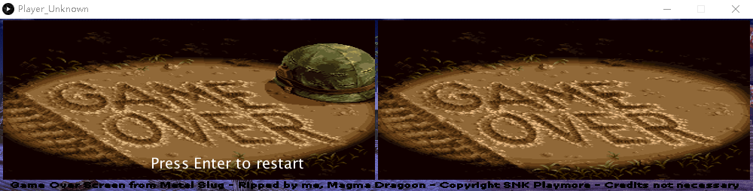

Game Over Screen