1. Payload with past timestamp

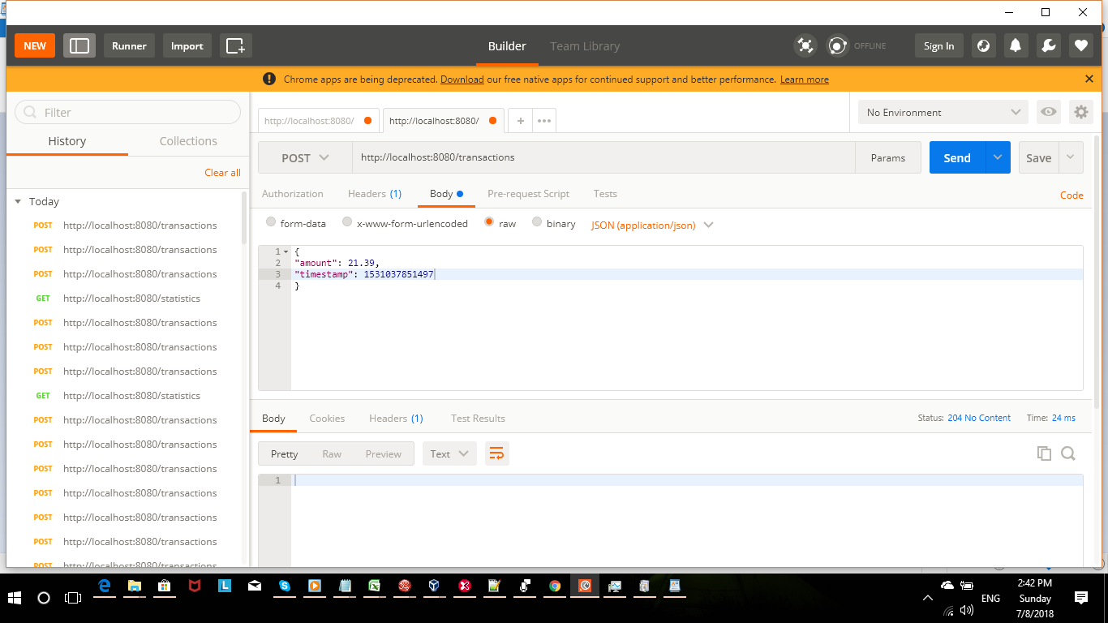

2. Real timestamp

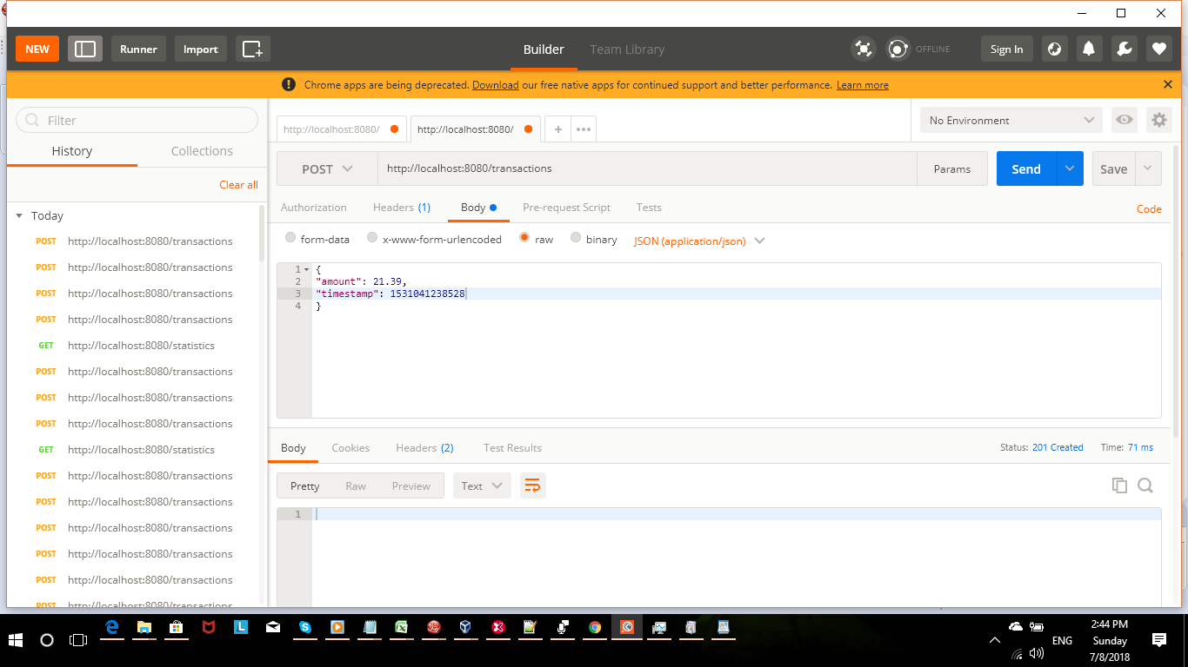

3. Statistics within 60 seconds
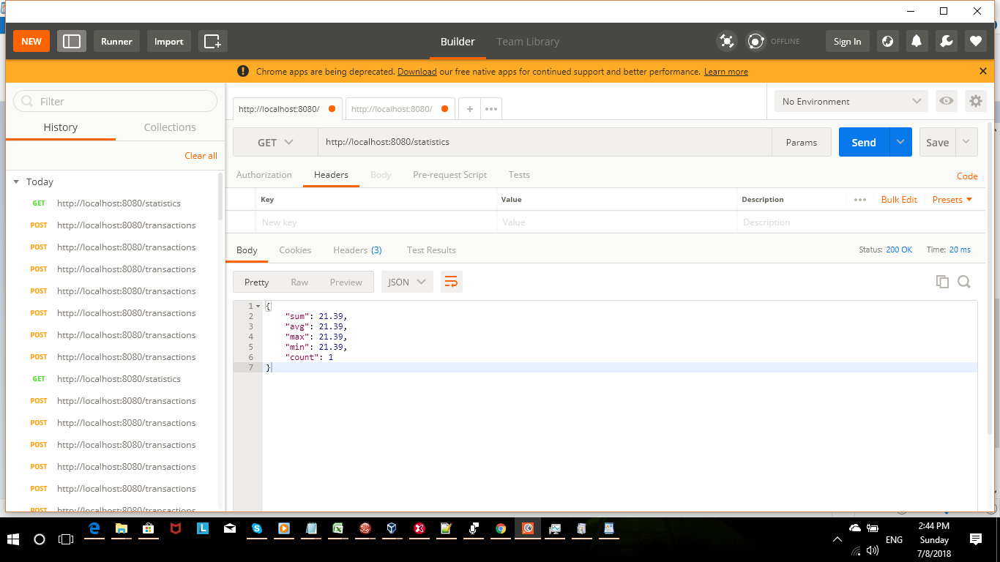

4. Statistics after 60 seconds without any transaction.

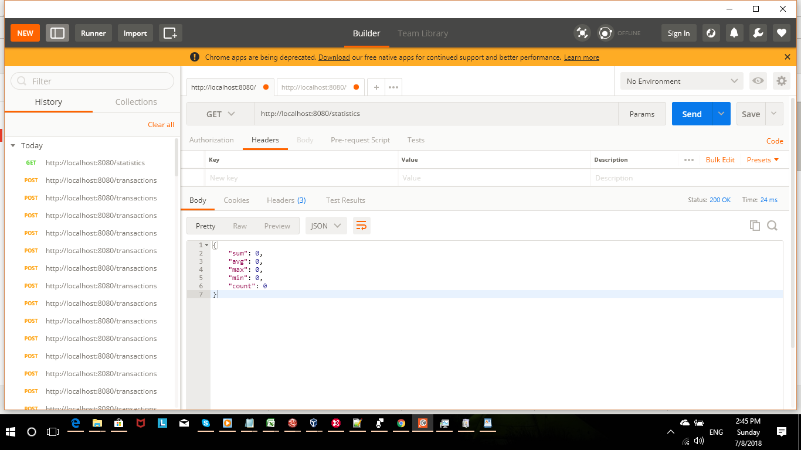

5. Statistics for last few transactions.

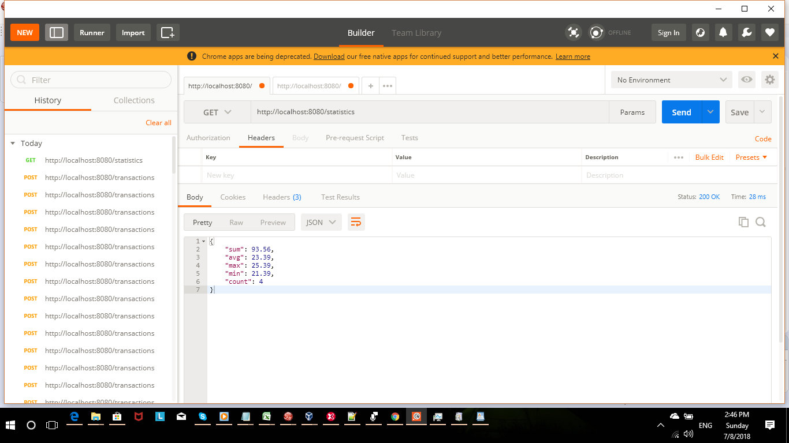

6. Payload
6.1 transactions
POST /transactions HTTP/1.1
Host: localhost:8080
Content-Type: application/json
Cache-Control: no-cache
Postman-Token: e971f6c7-7473-4a0a-ef07-5b6b9133b8f0
{
"amount": 25.39,
"timestamp": 1531041354019
}

7. Postman Collection


