General Assembly SF 17 – Purchase Power of Currency

By Jimmy Liang

This project aims to analyze/predict the purchasing power of currency.

Background Information:

The currency data is obtained from Oanda.com with 5 years and 6 months worth of value based on gold (XAU). I am analyzing on the following currencies: US Dollars, Euro, British Pound, Canadian Dollar, and Swiss Franc. The goal is to track the purchasing power of different currencies to determine whether a given currency is gaining or losing value.

The main idea is to find possible currency purchase power leverage to our advantage, which would be good for our traveling plan or such.

There are four ways to forecast currency changes:

1. Purchasing Power Parity (PPP): a theory in which countries determine the exchange rates between currencies to ensure equivalences so that the purchasing power amounts to the same value in each country.
2. Relative Economic Strength Approach: explore the strength of economic growth in different countries in order to forecast the direction of exchange rates.
3. Econometric Models

**USD/EUR(1-year) = z + a(INT) + b(GDP) + c(IGR)**

**z, a, b, c**: coefficient on how much a certain factor affects the exchange rate and direction of the effect (positive or negative) I**NT**: interest rate differential between US and EUR

**GDP**: GDP growth rates

**IGR**: Income growth rate

1. Time series model: a sequence of data points over a time interval in order to extract meaningful statistics and other characteristics of the data.

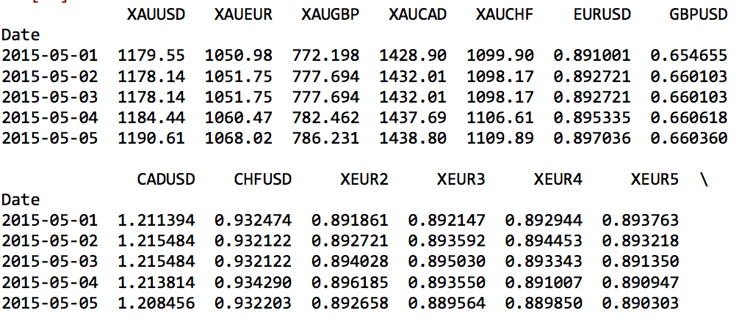

The data table above shows high-level overview of data, calculated currencies rate, and calculated moving average. I learned that there is nulls with moving average calculations so I replaced all null with the last calculated data for each respectively. XEUR2 and XEUR3 provided the most close correlations for a few of the models worked on. For your information, XEUR2 is the average of two days in sequences order.

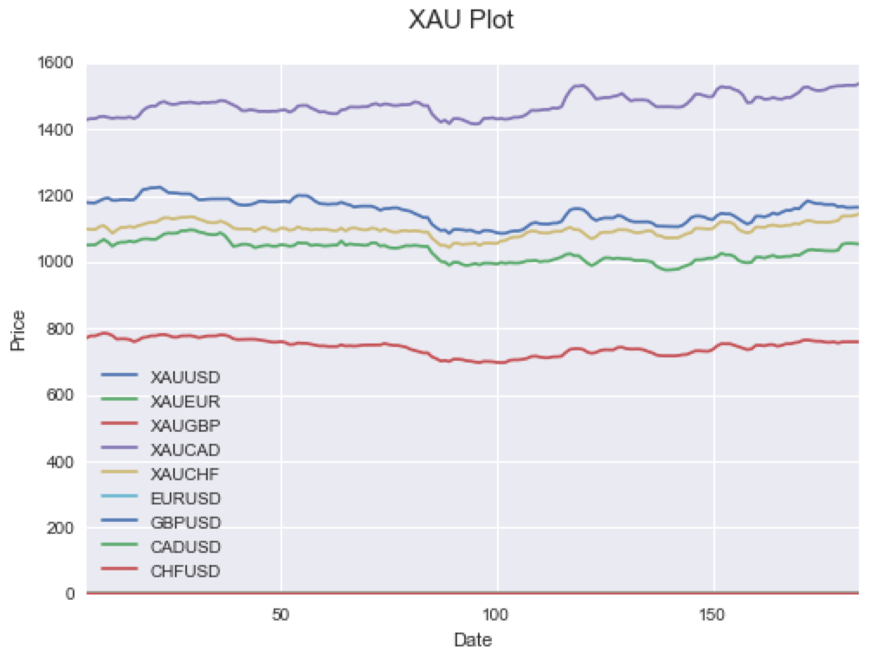

The graph shows overview of all XAU based currencies. As you see the fluctuations through out which can be result by possible key events from Federal Open Market Committee, Shocker Events, or Interest Rate announcement.

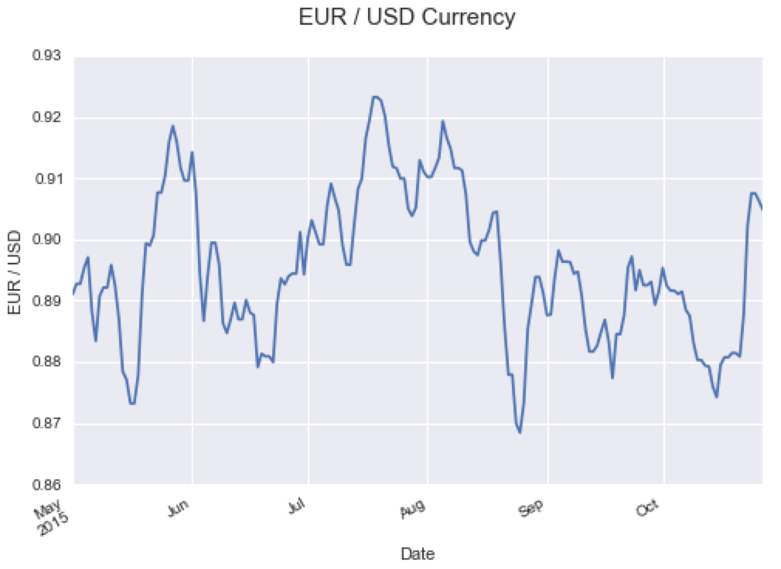

I derived EUR/USD to focus on as it had shown obvious fluctuation correlation with key events within 6 months data set. I snippet out May and August of EUR/USD data set to see significant upward gains and downward losses in purchasing power.

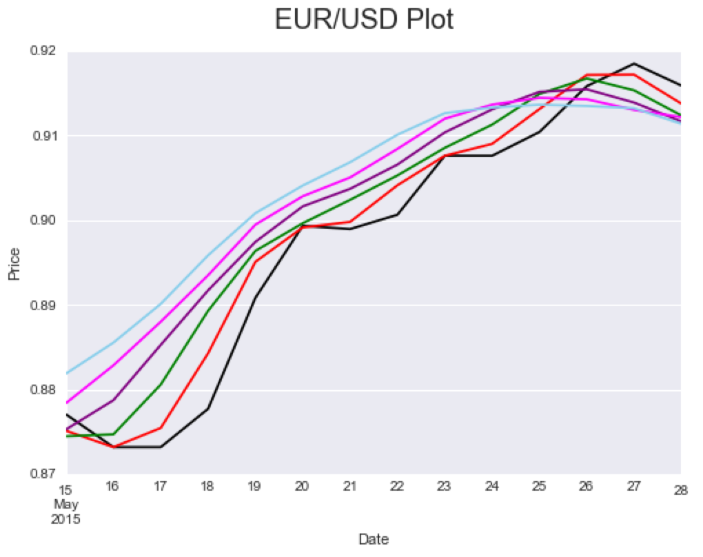

Black line represents original data set while colored lines represent the moving averages for 2 – 6 days range. The correlation shown that EUR currency had weaken during the month of May 2015 due to mixed US Economic Data, Greek Debt Crisis, and US GDP for 1st Quarter fell -0.7%.

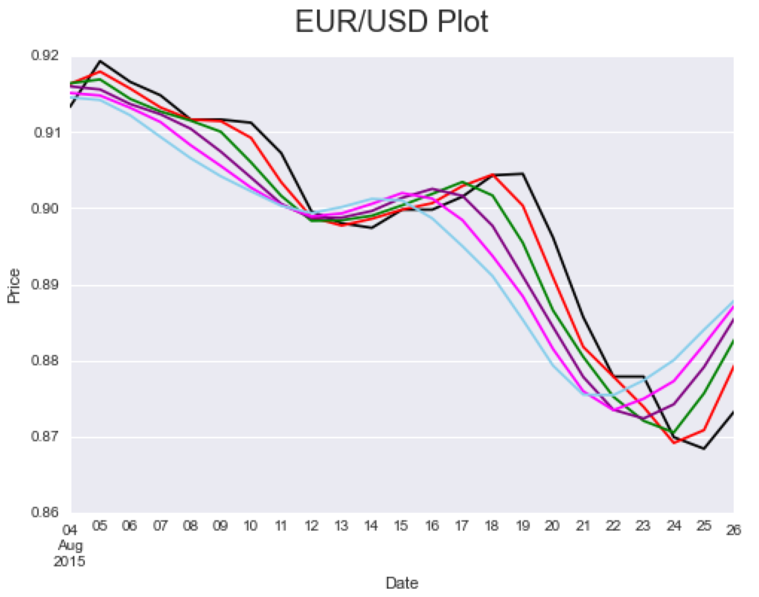

The correlation shown that EUR had gained during the month of August 2015 due to European Central Bank Chief Mario Draght’s Euro stimulus and expected Greece Debt Crisis: 3rd Bailout repayment by Aug 20, 2015.

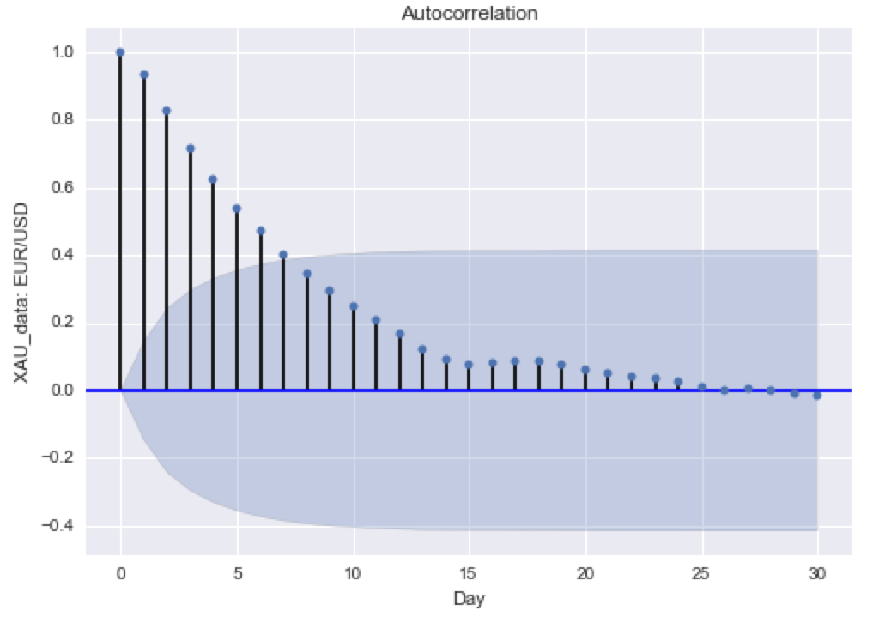

This plot better demonstrates an understanding about the correlation between days and random signals with regard to analyzed data. Ultimately, the smaller the plot is, the weaker the correlation signal will be.

I did few models as the following: Cross Validation, Linear Regression, and

Random Decision Forest. I went ahead investigate for Root Mean Squared Error (RMSE) between Linear Regression and random decision forest. Due to the better RMSE value, the linear regression model was determined to be better model with analyzing the purchasing power of currency.

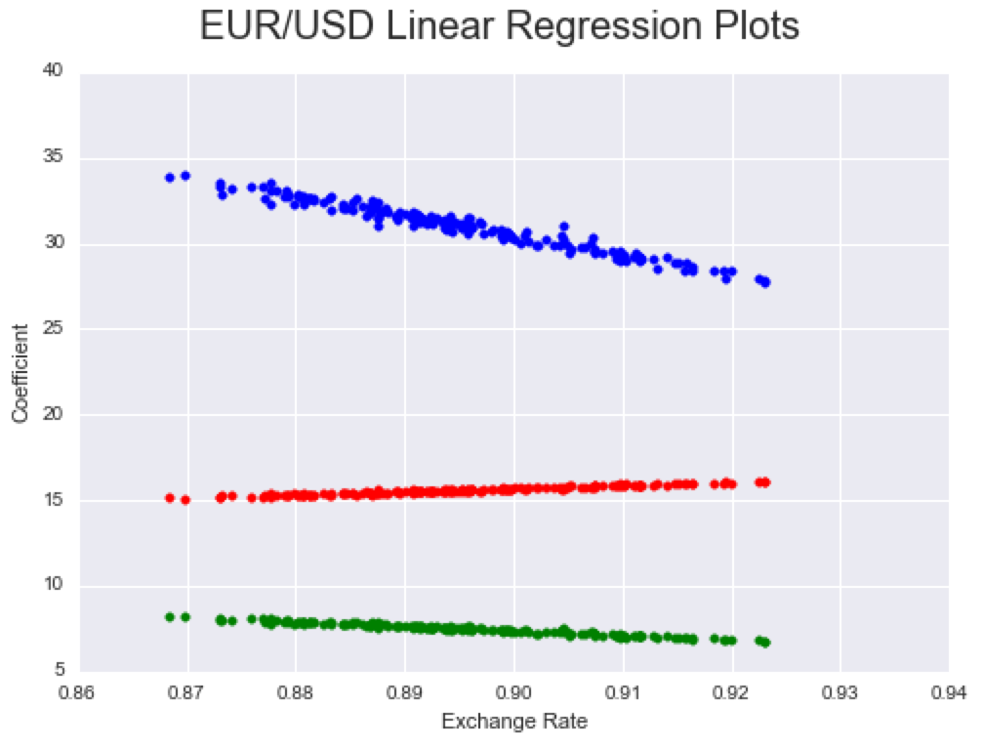

The EUR/USD Linear Regression had shown the different linear regression prediction between day, week, or month. The red colored represented linear regression by days, blue colored represented by weeks, and green colored represented by months.

Conclusion:

Forecasting the exchange rate is a challenging task as the currencies are sensitive to unexpected external events and can become difficult to measure.

There are predictive application model suggestions to consider:

* Smoothing with Exponentially Weighted Moving Average (EWMA)
* Time Series and Holt-Winters Forecasting
* Holt-Winters Second Order EWMA
* Autoregressive Integrated Moving Average (ARIMA)