Blog Monk- Blogging Platform

Blog Monk is a web-based platform designed for blogging enthusiasts. It allows users to search for blogs, sign up, sign in, create, edit, and delete their blogs. Additionally, users can view blogs posted by others. The platform also incorporates pagination functionality, displaying 10 blogs per page for ease of navigation.

## Features

Search Functionality : Users can search for blogs based on keywords or topics.

User Authentication: Users need to sign up and sign in to access the blogging features.

Blog Management :

Create : Authenticated users can create their own blogs.

Edit : Users can edit their existing blogs.

Delete : Users can delete their blogs.

View Blogs : Users can view blogs posted by themselves and others.

Pagination : Blogs are paginated, with 10 blogs displayed per page for better navigation.

## Usage

Search Blog : Users can utilize the search bar to find blogs based on specific keywords or topics.

Sign Up : New users need to sign up with their email address and password.

Sign In : After signing up, users can sign in using their credentials.

Create Blog : Once signed in, users can create their own blogs by providing relevant content.

Edit Blog : Users have the option to edit their existing blogs to update content or correct errors.

Delete Blog : If users wish to remove a blog, they can delete it from their profile.

View Blogs : Users can view their own blogs as well as blogs posted by others.

Pagination : Blogs are paginated, with 10 blogs displayed per page for easier browsing.

## Tech Stack

MERN STACK

* Frontend ▶ **ReactJS**
* Backend ▶ **NodeJS**
* Backend ▶ **ExpressJS**
* Database ▶ **MongoDB**
* Authentication ▶ **JWT**

## Screenshots of the Project

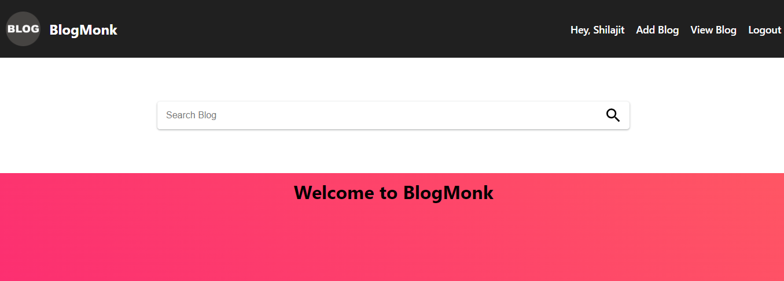

1

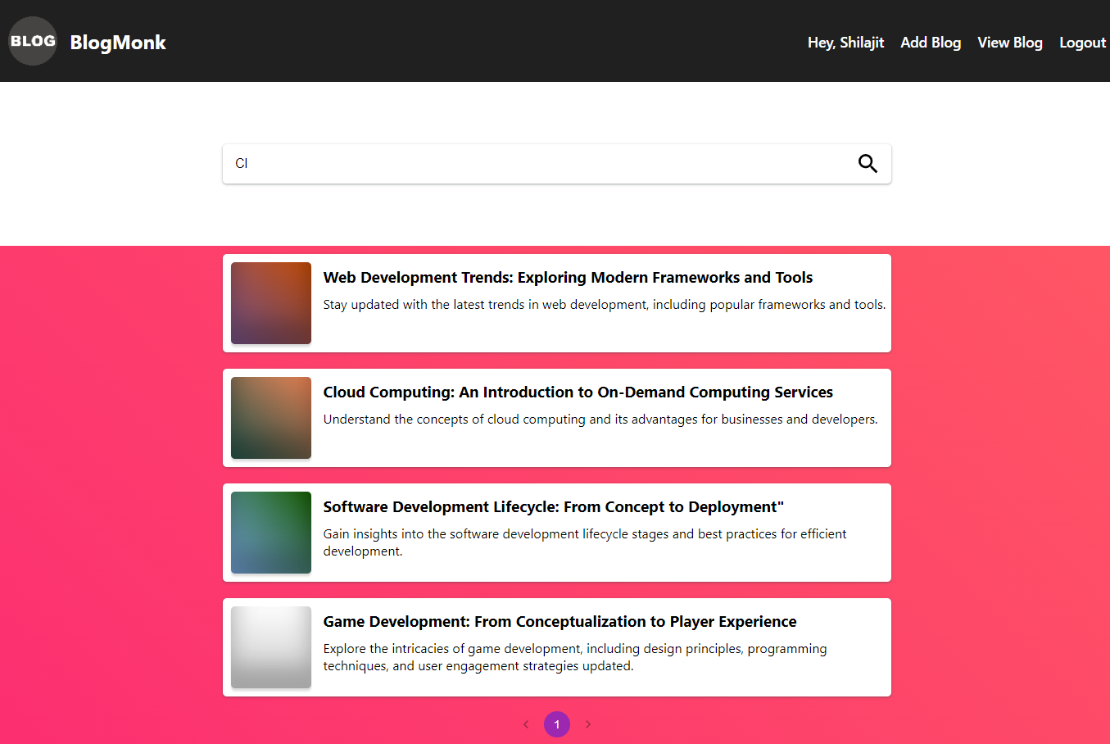

2

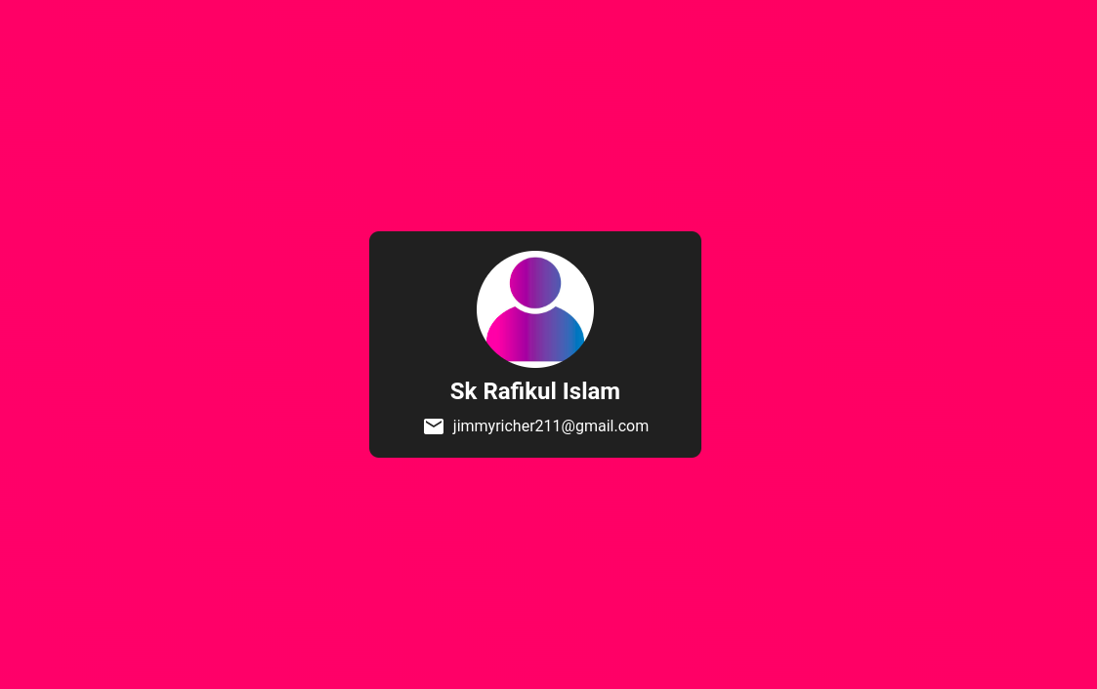3

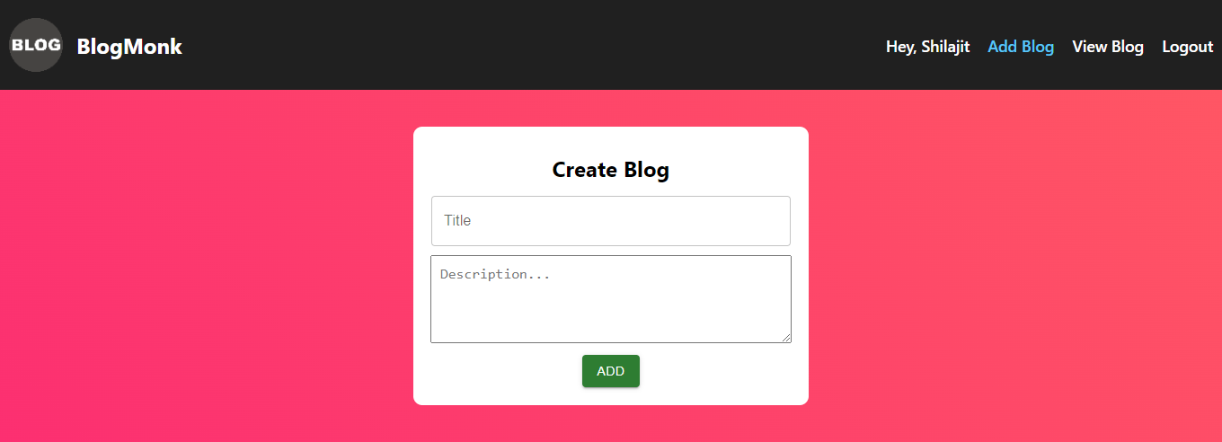

4

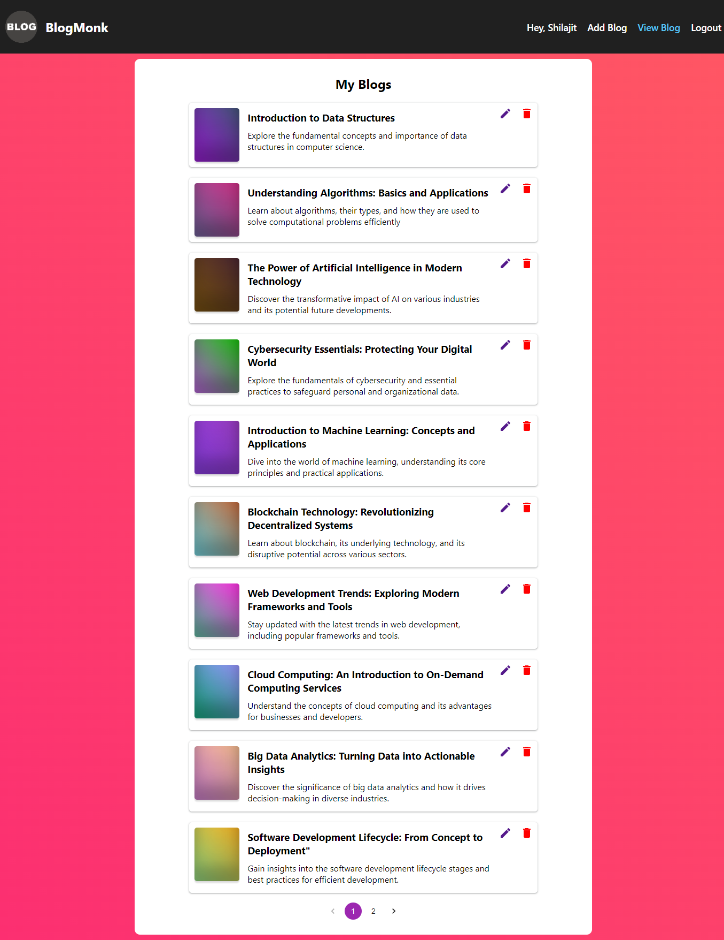

5

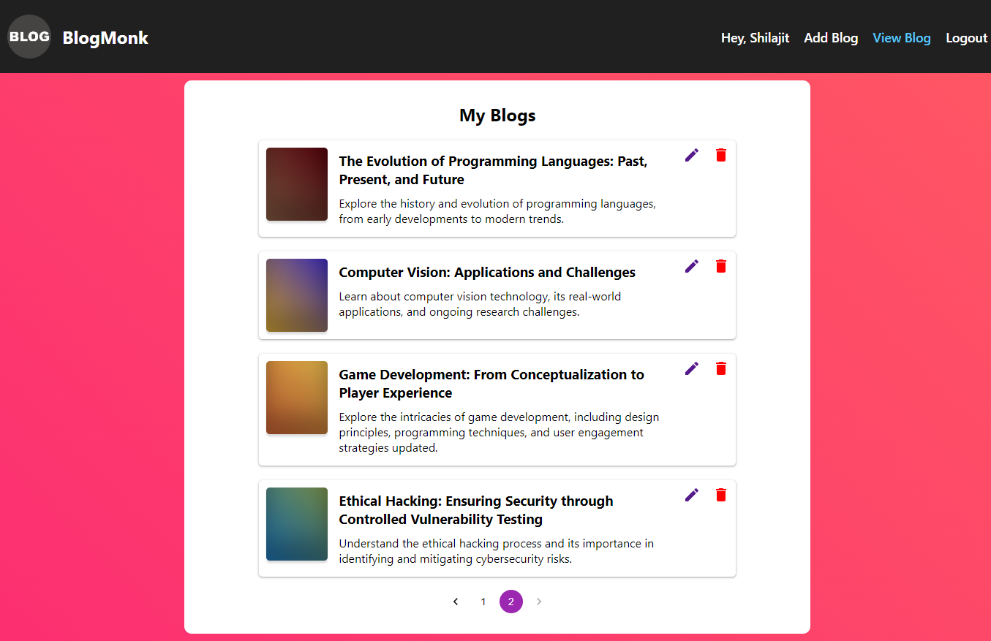

6

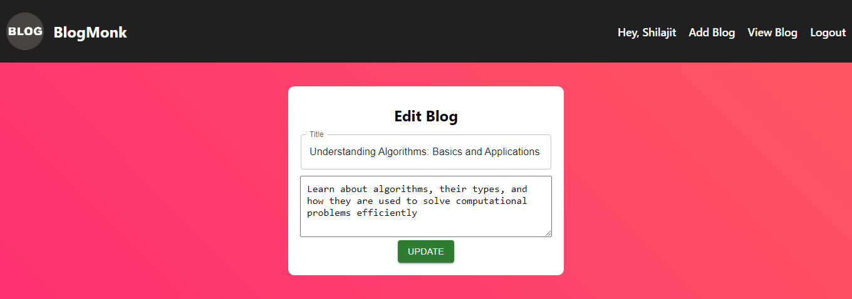

7

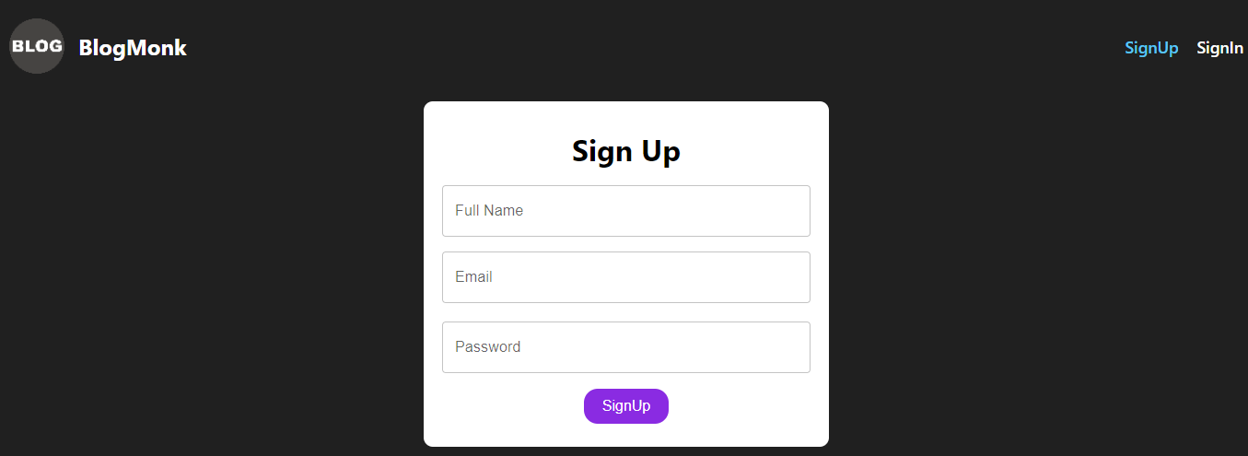

8

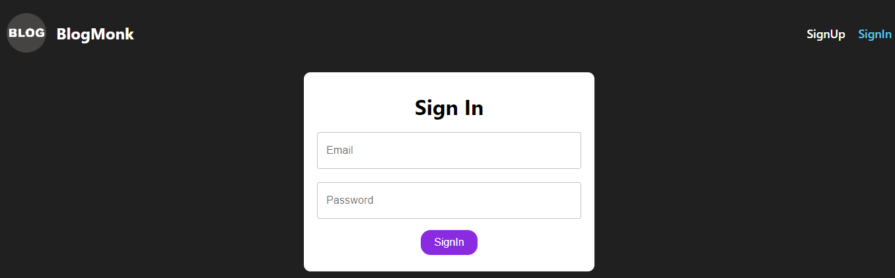

9

10

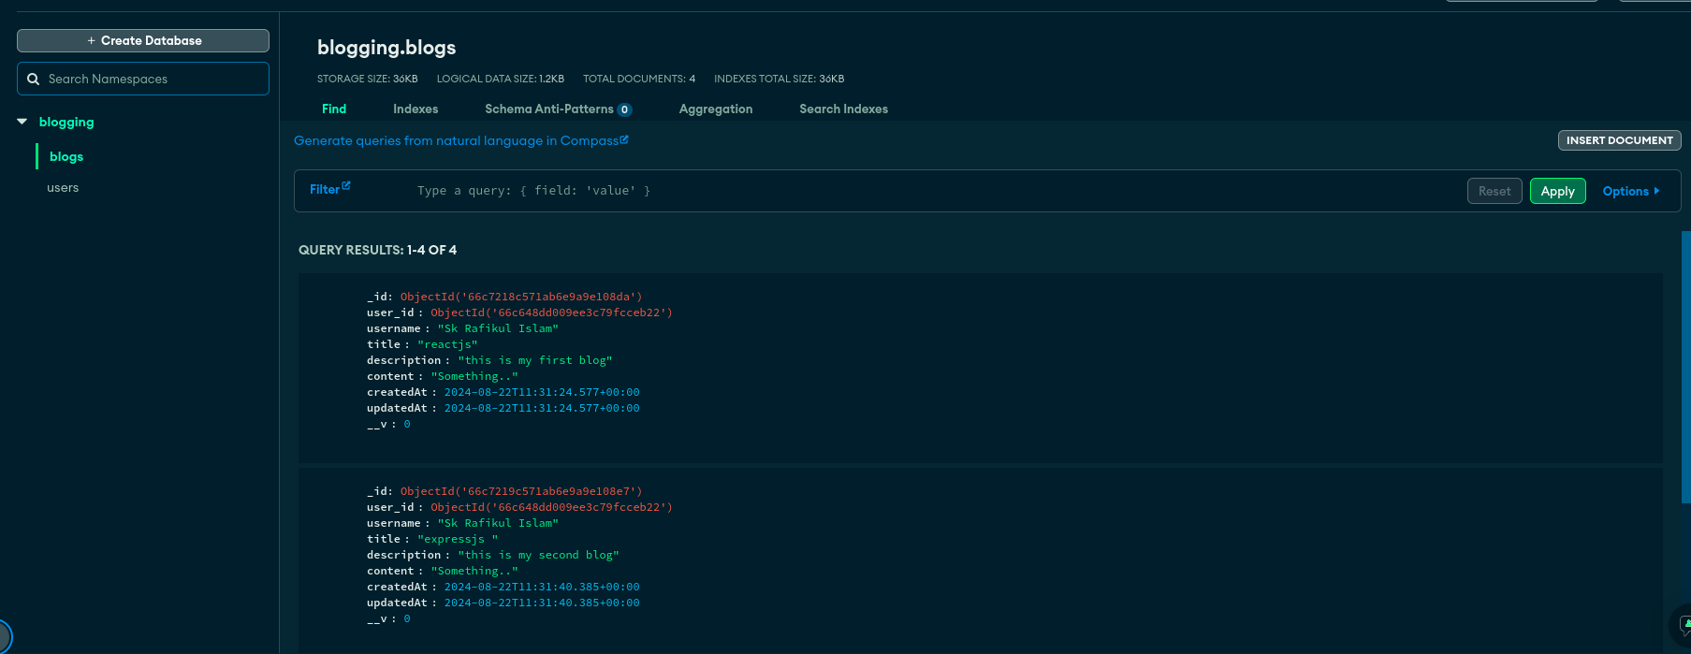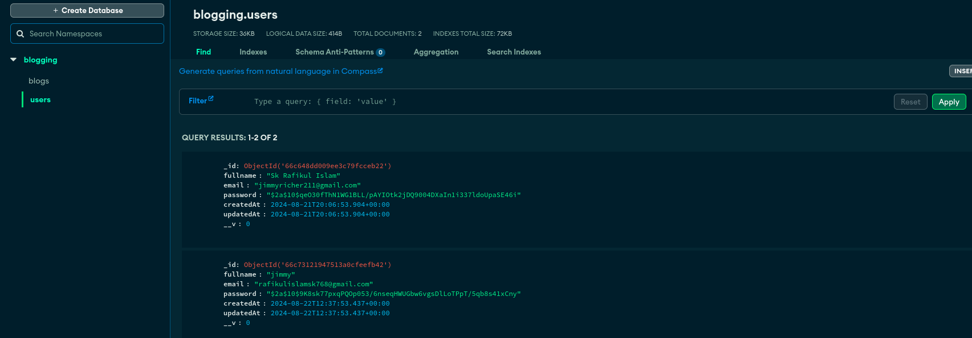

## 11

## Responsive

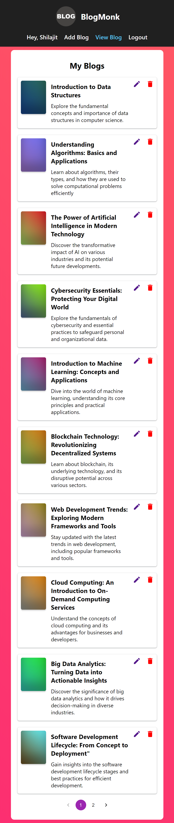

10

Env File

Backend = PORT=5000

MONGODB_URI=mongodb+srv://<your-username>:<your-password>@cluster0.ochms.mongodb.net/zupay?retryWrites=true&w=majority&appName=Cluster0

SECRET_KEY=rafikul

SALT=10