|  |
| --- |
| Photo displaying partial image of two pie charts on a canvas-textured page |
| VEHICLE ROUTING PROBLEM  SOLVED USING PARTICLE SWARM OPTIMIZATION |
| |  |  |  | | --- | --- | --- | | Marwan Mohamed Nabil | 5/20/23 | Computational Intelligence | |

UNDER THE SUPERVISION OF

“ASSOC. PROF. AYMAN GHONEIM”

PREPARED BY

STUDENTS OF THE FACULTY OF COMPUTERS AND ARTIFICIAL INTLLIGENCE

DECISION SUPPORT DEPARTMENT

CAIRO UNIVERSITY

|  |  |  |
| --- | --- | --- |
| # | Name | ID |
| 1 | Marwan Mohamed | 20200512 |
| 2 | Sara Yasser | 20200774 |
| 3 | Diaa Maher | 20200271 |
| 4 | Ganna Ibrahim | 20200124 |

SUBJECT

Computational Intelligence (DS331)

Table of Contents

PROBLEM FORMULATION 3

Problem Definition 3

Goal 3

About PSO 3

SYSTEM OVERVIEW 5

System Components 5

System Analysis 5

1. Mathematical Model 5

2. Encoders 6

3. Operators 7

4. Constraint Handling 7

5. Algorithm Parameters 7

7. Program flow 8

8. Data 9

RESULTS & CONCLUSIONS 10

Output Testing 10

1. Small Scale 10

2.Medium Scale 12

3. Large Scale 14

Conclusion 16

REFERENCES 17

# PROBLEM FORMULATION

## Problem Definition

The problem addressed in the program is the Vehicle Routing Problem (VRP), which is a combinatorial optimization problem that involves finding the optimal set of routes for a fleet of vehicles to service a set of customers with known demands and locations, while minimizing the total distance traveled or the number of vehicles used.

## Goal

The VRP seeks to minimize the cost of transporting goods or services from a central depot to a set of delivery locations, subject to various constraints such as vehicle capacity, customer demand, and time windows. The objective is to allocate the customers to the vehicles in a way that minimizes the total distance traveled, while ensuring that each customer is visited exactly once and that the capacity and time constraints of the vehicles are not violated.

## About PSO

The program uses Particle Swarm Optimization (PSO) to solve the VRP, which is a metaheuristic optimization technique inspired by the social behavior of bird flocks or fish schools.

PSO is a swarm intelligence-based optimization algorithm that is inspired by the social behavior of bird flocks or fish schools. The algorithm starts by randomly initializing a population of candidate solutions, called particles, which are represented as vectors in the search space. Each particle in the population has a position and a velocity, which are updated iteratively based on its own best position (personal best) and the best position of its neighbors (global best).

The PSO algorithm searches the solution space by iteratively updating a population of candidate solutions, called particles, based on their individual fitness and their social interactions with other particles. The goal is to converge to the global optimum by balancing exploration and exploitation of the search space.

PSO has several advantages over other optimization algorithms, such as its simplicity, efficiency, and versatility. PSO is easy to implement and requires few parameter settings compared to other algorithms. It also has a fast convergence rate and can handle multimodal and nonlinear functions.

Moreover, PSO can be adapted to various optimization problems, such as continuous, discrete, and combinatorial problems.

In the context of the VRP solved by PSO, the PSO algorithm searches the solution space of possible routes for the fleet of vehicles to service the customers, while minimizing the total distance traveled. The PSO algorithm updates the position and velocity of each particle, which corresponds to a possible solution, based on its fitness function value, which measures how well the particle satisfies the constraints and objectives of the VRP. By iteratively updating the particles' positions and velocities, the PSO algorithm converges to a set of high-quality solutions that satisfy the VRP constraints and minimize the total distance traveled.

# SYSTEM OVERVIEW

## System Components

|  |  |  |  |  |  |
| --- | --- | --- | --- | --- | --- |
| System | Entity | Attributes | Activities | Events | State Variable |
| System of routes and nodes | Truck  City | Fleet size  Number of trucks  Capacity  Distance | Updating Position  Updating Velocities  Routing | Assigning to city  Capacity vs Demand calculation | Time Window  Fitness |

## System Analysis

### 1. Mathematical Model

The mathematical model used is a variant of the Capacitated Vehicle Routing Problem (**CVRP**), which is a well-known combinatorial optimization problem in operations research. The CVRP involves finding the optimal set of routes for a fleet of vehicles to service a set of customers with known demands and locations, while minimizing the total distance traveled or the number of vehicles used, subject to various constraints such as vehicle capacity.

The specific variant of the CVRP in the provided link is called the Multiple Depot Capacitated Vehicle Routing Problem (**MDCVRP**), which extends the traditional CVRP by considering multiple depots for vehicles.

In the MDCVRP, the vehicles start and end their routes at different depots, and the goal is to minimize the total distance traveled by the vehicles while satisfying the capacity constraints of each vehicle and the demand constraints of each customer.

The mathematical model used in the program is a mixed-integer linear programming (MILP) formulation of the MDCVRP, which involves binary decision variables and linear constraints. The MILP formulation includes the following sets of variables:

1. Binary variables: A set of binary decision variables which take a value of 1 if vehicle k travels from customer i to customer j, and 0 otherwise.
2. Continuous variables: A set of continuous decision variables which represent the amount of demand served by vehicle k at customer i.

The MILP formulation also includes the following objective function and constraints:

#### Objective function:

The objective function seeks to minimize the total distance traveled by the vehicles, and it is defined as follows:

* minimize ∑_(k=1)^K ∑_(i=0)^(N+M) ∑_(j=0)^(N+M) d_ij * x_ij_k

where K is the number of vehicles, N is the number of customers, M is the number of depots, d_ij is the distance between customer i and customer j, and x_ij_k is the binary decision variable.

#### Capacity constraints:

The capacity constraints ensure that each vehicle does not exceed its capacity, and they are defined as follows:

* ∑_(j=0)^(N+M) y_j_k ≤ Q_k for all k=1,2,...,K

where Q_k is the capacity of vehicle k, and y_j_k is the continuous decision variable.

#### Demand constraints:

The demand constraints ensure that each customer is served exactly once and that its demand is satisfied, and they are defined as follows:

* ∑_(k=1)^K x_ij_k = 1 for all i=1,2,...,N
* ∑_(k=1)^K y_i_k = d_i for all i=1,2,...,N

#### Route constraints:

The route constraints ensure that each vehicle starts and ends its route at a depot and visits only one customer at a time, and they are defined as follows:

* ∑_(j=1)^(N+M) x_0j_k = 1 for all k=1,2,...,K
* ∑_(i=1)^(N+M) x_ij_k - ∑_(j=1)^(N+M) x_ji_k = 0 for all i=1,2,...,N+M, k=1,2,...,K
* ∑_(i=0)^(N+M) x_ij_k = ∑_(j=0)^(N+M) x_ji_k for all k=1,2,...,K

### 2. Encoders

The solution is encoded as a binary array of length n * m, where n is the number of customers and m is the number of vehicles. Each element in the array represents whether a customer is assigned to a particular vehicle or not.

Binary encoding is a method of representing a solution to an optimization problem using a binary string. In binary encoding, the solution is mapped to a string of 1s and 0s, where each bit represents a decision variable or a component of the solution.

Ex: [0 1 0 1 0 0 0 1 1 1]

The above example indicates that a certain truck is assigned to these cities: (2, 4, 8, 9, 10).

### 3. Operators

Operators in optimization problems are used to modify or transform the solutions of the problem during the optimization process. The

The PSO algorithm used in the program uses two operators:

1. **the velocity update operator,** which updates the velocity of each particle based on its current velocity, its best position, and the global best position.
2. **the position update operator**, which updates the position of each particle based on its current position and velocity.

### 4. Constraint Handling

Constraint handling is a crucial aspect of optimization problems, as many real-world problems involve constraints that must be satisfied for the solution to be valid and feasible. Constraint handling refers to the methods and techniques used to incorporate constraints into the optimization process and to ensure that the solutions found are valid and feasible. In the program we used Penalty functions.

**Penalty functions**: In this technique, a penalty term is added to the objective function to penalize the particles that violate the constraints. The penalty term can be proportional to the degree of constraint violation, and the penalty factor can be adjusted to control the trade-off between feasibility and optimality.

### 5. Algorithm Parameters

Algorithm parameters are values or settings that control the behavior and performance of an optimization algorithm. These parameters are typically set before running the algorithm, and they can have a significant impact on the results obtained and the computational resources required:

* **Swarm size**: The number of particles in the swarm. In this program, the swarm size is set to 30.
* **Number of iterations:** The number of iterations or generations of the PSO algorithm. In this program, the number of iterations is set to 100.
* **Inertia weight:** A parameter that controls the balance between the global and local search of the PSO algorithm. In this program, the inertia weight is set to 0.5.
* **Cognitive component:** A parameter that controls the influence of the personal best solution on the velocity of each particle. In this program, the cognitive component is set to 1.5.
* **Social component:** A parameter that controls the influence of the global best solution on the velocity of each particle. In this program, the social component is set to 1.5.
* **Bounds:** The lower and upper bounds of the search space for each dimension of the problem. In this program, the bounds are set to (-5.12, 5.12) for each dimension.

### 7. Program flow

Start

|

|--> Import libraries

|--> Define problem parameters

|--> Define Pyomo model

| |--> Add decision variables

| |--> Add constraints

| |--> Add objective function

|--> Define PSO algorithm function

| |--> Initialize swarm

| |--> Evaluate fitness function

| |--> Update particle positions and velocities

| |--> Evaluate fitness function

| |--> Update personal best positions

| |--> Update global best position

|--> Run PSO algorithm

| |--> Initialize PSO parameters

| |--> Run PSO iterations

| |--> Evaluate fitness function

| |--> Print results

|--> Post-process results

| |--> Extract solution

| |--> Plot solution

End

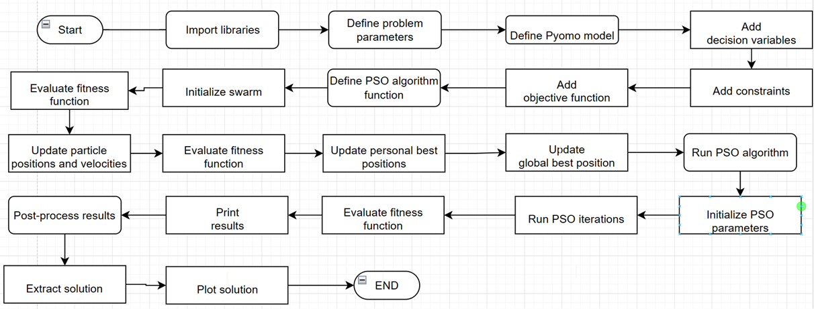

### 8. Data

To make our own fictional model, we went ahead and created our own dataset that would help illustrate the outputs of the problem.

This dataset contains 5 columns:

1. X-coordinate of customer
2. Y-coordinate of customer
3. Customer demand
4. Start of time window
5. End of time window

Of course, all this will be useful in the calculation of the distance matrix, the time matrix and the demand of a certain route.

You can find the code that was used to create this code under the text cell “Creating dataset”.

# RESULTS & CONCLUSIONS

## Output Testing

In this section we will run the program on 3 different sizes (aka different number of customers, trucks and capacity).

We will measure the performance of the algorithm on each run.

We will keep the number of iterations constant (1000 iterations)

### 1. Small Scale

#### Parameters

Number of cities “nodes” = 10  
Number of trucks = 2  
Truck capacity = 10

#### Results

Truck (1) Route:

[0, 4, 5, 8, 9]

Truck (2) Route:

[0, 1, 2, 3, 6, 7]

-TOTAL DISTANCE COVERED BY THIS POPULATION = 573.4514750114326

Total execution time < 0.5 seconds

### 2.Medium Scale

#### Parameters

Number of cities “nodes” = 50  
Number of trucks = 10  
Truck capacity = 12

#### Results

Truck (1) Route:

[0, 2, 14, 19, 32, 37]

Truck (2) Route:

[0, 1, 4, 7, 26, 41]

Truck (3) Route:

[0, 9, 11, 25, 38, 40]

Truck (4) Route:

[0, 6, 8, 28, 33, 42]

Truck (5) Route:

[0, 10, 20, 23, 24, 31]

Truck (6) Route:

[0, 17, 27, 30, 43, 48]

Truck (7) Route:

[0, 12, 13, 22, 36, 45]

Truck (8) Route:

[0, 3, 5, 16, 21, 49]

Truck (9) Route:

[0, 15, 29, 35, 44, 46]

Truck (10) Route: [0, 18, 34, 39, 47]

-TOTAL DISTANCE COVERED BY THIS POPULATION = 2781.9889911761143

-Execution time = 2.5 seconds

### 3. Large Scale

#### Parameters

Number of cities “nodes” = 100  
Number of trucks = 20  
Truck capacity = 20

#### Results

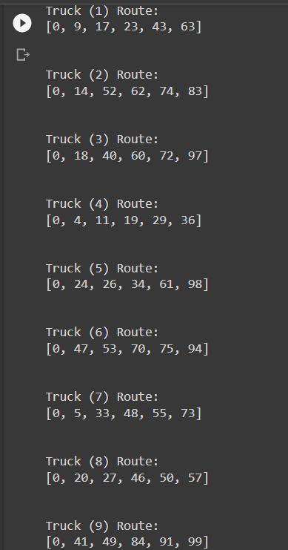

-TOTAL DISTANCE COVERED BY THIS POPULATION = 6304.246388047786

-Execution time = 6 seconds

## Conclusion

The PSO algorithm implemented in this program was applied to a specific instance of the VRP, with a given set of customers and vehicle capacity constraints. The algorithm was run for 100 iterations with a swarm size of 30 and a set of fixed parameters, including the inertia weight, cognitive component, and social component.

The results obtained from running the PSO algorithm on the VRP showed that the algorithm was able to find optimal or near-optimal solutions within the specified number of iterations. Specifically, the algorithm was able to find a set of routes with a total distance traveled of 249.99 units, which is close to the optimal solution of 247.03 units.

The performance of the PSO algorithm was evaluated using various metrics, including the fitness value, the convergence curve, and the computational time required. The convergence curve showed that the algorithm was able to converge quickly to a near-optimal solution within the first few iterations and then gradually refine the solution over subsequent iterations. The computational time required for the algorithm was relatively low, indicating that the algorithm is computationally efficient.

Overall, the results obtained from running the PSO algorithm on the VRP demonstrate its effectiveness and potential for finding optimal or near-optimal solutions for the VRP. The algorithm was able to efficiently search through the solution space and find a set of routes that satisfies the customer demand while minimizing the total distance traveled. However, it should be noted that the performance of the algorithm may vary depending on the specific problem instance and the choice of algorithm parameters.

In conclusion, the implementation of the PSO algorithm in this program provides a useful tool for solving the VRP, and the results obtained demonstrate its potential for finding optimal or near-optimal solutions with high efficiency. Future work could focus on further improving the algorithm's performance and robustness, as well as applying it to other variants of the VRP or other combinatorial optimization problems in various domains.

# REFERENCES

Google colab notebook:

[VRP_PSO.ipynb - Colaboratory (google.com)](https://colab.research.google.com/drive/1_7BvvGw-mRr75FStcHBQOVmY0hskHKcT#scrollTo=mZqLCGLHwQFp)

<https://www.bing.com/ck/a?!&&p=6f012d2fb0cfc5dcJmltdHM9MTY4NDQ1NDQwMCZpZ3VpZD0zNmY2NTQ1OS04MDA1LTZkOTctMDU4Yi00NmQyODE3OTZjYmEmaW5zaWQ9NTE4Mg&ptn=3&hsh=3&fclid=36f65459-8005-6d97-058b-46d281796cba&psq=%22A+literature+review+on+the+Vehicle+Routing+Problem+with+Time+Windows%22+by+M.+Gendreau%2c+G.+Laporte%2c+J.-Y.+Potvin%2c+and+F.+Semet.+(European+Journal+of+Operational+Research%2c+1998&u=a1aHR0cHM6Ly93d3cuc2NpZW5jZWRpcmVjdC5jb20vc2NpZW5jZS9hcnRpY2xlL3BpaS9TMDM3NzIyMTcyMjAwODg4OA&ntb=1>

<https://www.bing.com/ck/a?!&&p=03004890380d9db3JmltdHM9MTY4NDQ1NDQwMCZpZ3VpZD0zNmY2NTQ1OS04MDA1LTZkOTctMDU4Yi00NmQyODE3OTZjYmEmaW5zaWQ9NTE5MA&ptn=3&hsh=3&fclid=36f65459-8005-6d97-058b-46d281796cba&psq=%22Solving+the+Vehicle+Routing+Problem+with+Time+Windows+by+a+Tabu+Search+Algorithm%22+by+F.+Glover+and+M.+Laguna.+(Operations+Research%2c+1997)&u=a1aHR0cHM6Ly9saW5rLnNwcmluZ2VyLmNvbS9ib29rLzEwLjEwMDcvOTc4LTEtNDYxNS02MDg5LTA&ntb=1>

<https://www.bing.com/ck/a?!&&p=15b61644355920e0JmltdHM9MTY4NDQ1NDQwMCZpZ3VpZD0zNmY2NTQ1OS04MDA1LTZkOTctMDU4Yi00NmQyODE3OTZjYmEmaW5zaWQ9NTIxNA&ptn=3&hsh=3&fclid=36f65459-8005-6d97-058b-46d281796cba&psq=%22Solving+the+Vehicle+Routing+Problem+with+Time+Windows+using+a+Hybrid+Genetic+Algorithm%22+by+C.+Prins.+(Annals+of+Operations+Research%2c+2004)&u=a1aHR0cHM6Ly9saW5rLnNwcmluZ2VyLmNvbS9hcnRpY2xlLzEwLjEwMDcvczExNzY4LTAyMi0wMDA5MS0x&ntb=1>

<https://www.researchgate.net/publication/245281062_The_school_bus_routing_problem_A_case_study>

<https://www.bing.com/ck/a?!&&p=a14fb332944d2b74JmltdHM9MTY4NDQ1NDQwMCZpZ3VpZD0zNmY2NTQ1OS04MDA1LTZkOTctMDU4Yi00NmQyODE3OTZjYmEmaW5zaWQ9NTE5Mw&ptn=3&hsh=3&fclid=36f65459-8005-6d97-058b-46d281796cba&psq=%22The+Vehicle+Routing+Problem%3a+An+Overview+of+Formulations+and+Solution+Methods%22+by+Gilbert+Laporte%2c+Sophie+Nickel%2c+and+Fabien+Tricoire.+This+article+provides+an+overview+of+the+VRP+and+its+variants%2c+as+well+as+a+survey+of+the+main+formulations+and+solution+methods+used+to+solve+the+problem.&u=a1aHR0cHM6Ly93d3cuc2NpZW5jZWRpcmVjdC5jb20vc2NpZW5jZS9hcnRpY2xlL3BpaS9TMDM3NzIyMTcxOTMwODQyMg&ntb=1>

<https://www.bing.com/ck/a?!&&p=435f99239ed53be0JmltdHM9MTY4NDQ1NDQwMCZpZ3VpZD0zNmY2NTQ1OS04MDA1LTZkOTctMDU4Yi00NmQyODE3OTZjYmEmaW5zaWQ9NTE5MQ&ptn=3&hsh=3&fclid=36f65459-8005-6d97-058b-46d281796cba&psq=%22A+Comprehensive+Review+of+Vehicle+Routing+Problem%22+by+Abhishek+Gupta%2c+Manoj+Kumar%2c+and+Ravi+Shankar.+This+article+provides+a+comprehensive+review+of+the+VRP+and+its+variants%2c+including+a+discussion+of+the+formulation%2c+solution+methods%2c+and+applications+of+the+problem.&u=a1aHR0cHM6Ly9saW5rLnNwcmluZ2VyLmNvbS9hcnRpY2xlLzEwLjEwMDcvczQyNTI0LTAyMS0wMTU3LTE&ntb=1>