# Experiment 3

h =

g =

Re(0)

|  |  |  |  |  |
| --- | --- | --- | --- | --- |
|  |  |  |  |  |

Re(15)

|  |  |  |  |  |
| --- | --- | --- | --- | --- |
| Max: | Min: |  |  |  |

Re(30)

|  |  |  |  |  |
| --- | --- | --- | --- | --- |
| Max: | Min: |  |  |  |

Re(45)

|  |  |  |  |  |
| --- | --- | --- | --- | --- |
| Max: | Min: |  |  |  |

Re(60)

|  |  |  |  |  |
| --- | --- | --- | --- | --- |
| Max: | Min: |  |  |  |

Re(75)

|  |  |  |  |  |
| --- | --- | --- | --- | --- |
| Max: | Min: |  |  |  |

Re(0)

|  |  |  |  |  |
| --- | --- | --- | --- | --- |
|  |  |  |  |  |

$$\overline{Re\left(0\right)}=\sum^{10}{Re(0)}=$$

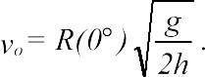 =

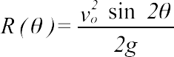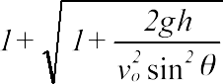

Rt(15)=

Rt(30)=

Rt(45)=

Rt(60)=

Rt(75)=

The angle, $\overline{θ}$, that maximizes the range is given by

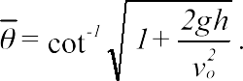

The maximum range is then

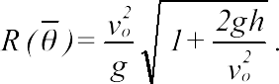

$$R(\overline{θ})=$$

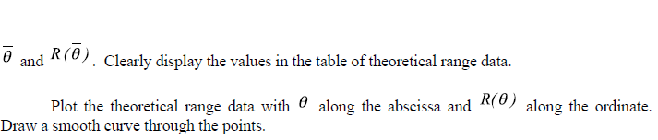

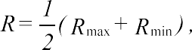

Re(15)=

Re(30)=

Re(45)=

Re(60)=

Re(75)=

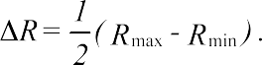

$$∆Re\left(15\right)=$$

$$∆Re\left(30\right)=$$

$$∆Re\left(45\right)=$$

$$∆Re\left(60\right)=$$

$$∆Re\left(75\right)=$$

On the graph of the theoretical values of the ranges, plot the experimental ranges, *R*, and their uncertainties, . Use points and error bars. Do not draw a curve through the experimental data.

# Conclusions

# Questions

1. Derive (2) from the basic equations of motion, (1). Note: The derivation of (2) involves the solution of a quadratic equation in which two roots emerge. Explain why the negative root is discarded and what it represents.
2. Derive (4) from (2), assuming .
3. Derive (5). Hint: Using (2), find such that . Or, it is easier to let and find such that . Note that .



1. According to the theoretical range curve, the maximum does not occur at . Why not?
2. Due to the component of the gravitational force along the shaft of the gun, the initial speed of the projectile actually varies according to . Why? Give a qualitative sketch of the effect this has upon a plot of the theoretical ranges. Does the actual plot exhibit such a deviation?