Lab 8 The Ballistic Pendulum

M=240[mg]
m=65.9[mg]
L=29.46[cm]
H(table)=81.86[cm]

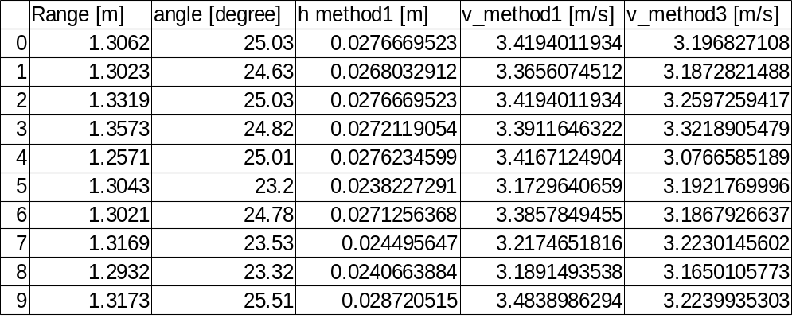

average_value of_v_method1=3.346 m/s
uncertainty_ v_method1=9.342 %
average_value_v_method3=3.203 m/s
uncertainty_v_method3=7.665 %
standard_deviation_ v_method1=0.1105
standard_deviation_ v_method3=0.06348
difference_between_velocity=4.465%

